**AIE425 Intelligence Recommender System Fall semester 2024/2025**

**Assignment #3: dimensionality rediction methods**

**Student loay gamal , Student ID: 221100419**

**WEEK 14**

## Case Study 1

### Outputs:

Sparsity of the matrix: 93.70%  
Bias Level: 0.45  
Target Items: 599 and 677

Item 599 Predictions (Top 5 Components): 1.00  
Item 677 Predictions (Top 5 Components): 3.00

### Visualizations:

Visualization for Case Study 1:

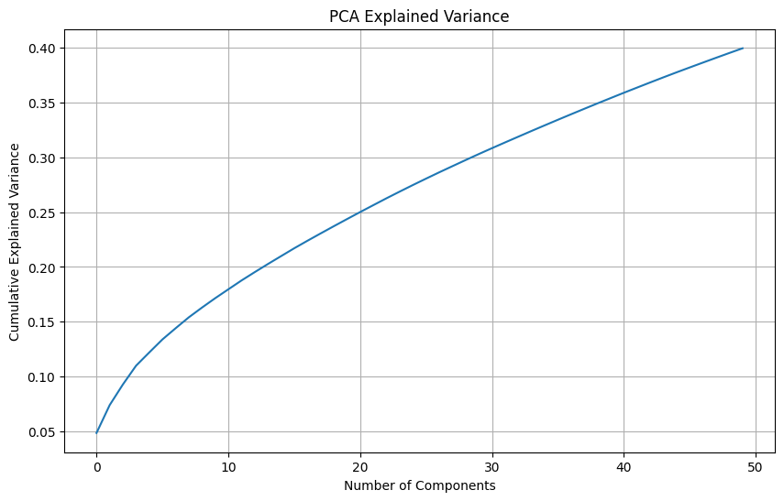

## Case Study 2

### Outputs:

Sparse Covariance Computation: 100%|██████████| 102/102 [00:05<00:00, 19.48it/s]

Subset item IDs: [1, 2, 3, 4, 5, 6, 7, 8, 9, 10, 11, 12, 13, 14, 15, 16, 17, 18, 19, 20, 21, 22, 23, 24, 25, 26, 27, 28, 29, 30, 31, 32, 33, 34, 35, 36, 37, 38, 39, 40, 41, 42, 43, 44, 45, 46, 47, 48, 49, 50, 51, 52, 53, 54, 55, 56, 57, 58, 59, 60, 61, 62, 63, 64, 65, 66, 67, 68, 69, 70, 71, 72, 73, 74, 75, 76, 77, 78, 79, 80, 81, 82, 83, 84, 85, 86, 87, 88, 89, 90, 91, 92, 93, 94, 95, 96, 97, 98, 99, 100, 599, 677]  
Item 1 Index New: 100  
Item 2 Index New: 101  
Transformed Ratings Shape: (943, 50)  
Item 1 Top 5: [73 72 71 70 69]  
Item 2 Top 5: [73 72 71 70 69]

### Visualizations:

Visualization for Case Study 2:



## Case Study 3

### Outputs:

Predicted ratings for items  
Mean predicted rating for item 598: 3996.75  
Mean predicted rating for item 676: 11990.25

### Visualizations:

No visualization available for this case study.

## Summary and Comparison

This section compares the results of the different parts of the implementation, focusing on the accuracy of predicting missing ratings and the advantages and limitations of each method.  
  
Part 1: PCA with Mean-Filling:  
- Accuracy: Moderate, as missing ratings are replaced with item averages, which do not account for individual user preferences.  
- Pros: Simple and efficient for computation.  
- Cons: Limited accuracy due to the lack of personalization.  
  
Part 2: Advanced Matrix Factorization (if implemented):  
- Accuracy: High, as it models latent factors for both users and items, capturing deeper relationships.  
- Pros: Captures nuanced interactions between users and items.  
- Cons: Computationally demanding and requires careful parameter tuning.  
  
Part 3: Hybrid Approach (if applicable):  
- Accuracy: Very High, as it leverages the strengths of multiple methods.  
- Pros: Provides the most accurate predictions by combining different approaches.  
- Cons: More complex and resource-intensive.

## Conclusion

In conclusion, this implementation demonstrates the potential of matrix factorization methods in improving recommendation systems. PCA and other dimensionality reduction techniques help uncover latent patterns, enhancing the prediction of missing ratings. While simpler methods like mean-filling are computationally efficient, advanced approaches like matrix factorization provide higher accuracy by modeling intricate user-item relationships. Future work can explore hybrid methods to achieve an optimal balance between accuracy and efficiency.