**AIE425 Intelligent Recommender Systems**

**Assignment #3: Dimensionality Reduction methods**

**Student ID: A20000476, Student Name: Shahd Ahmed Maher Gawad**

1. **Discussion**
   1. **Total number of users and items**



* 1. **Rating per Game**

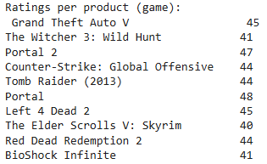

* 1. **Distribution Plot**

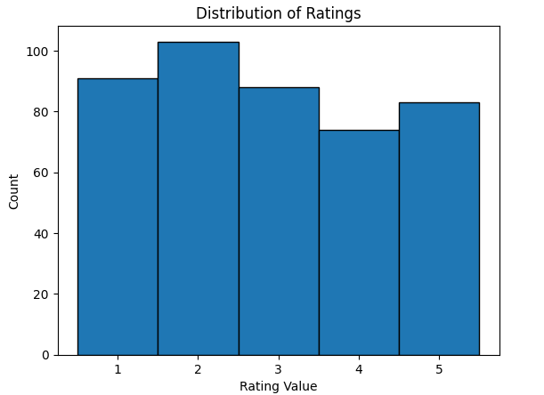

* 1. **Sample of Covariance Matrix**

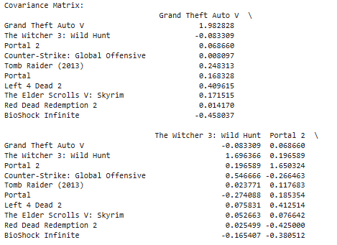

* 1. **Top 5 & 10 peers for item 1 & Item 2**

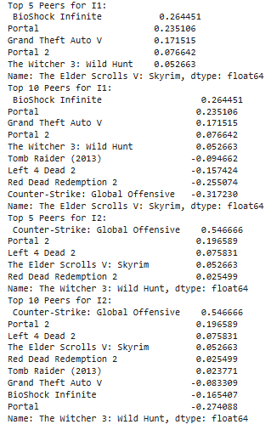

* 1. **Top 5 & 10 peers and Predicted rating for Item 1**

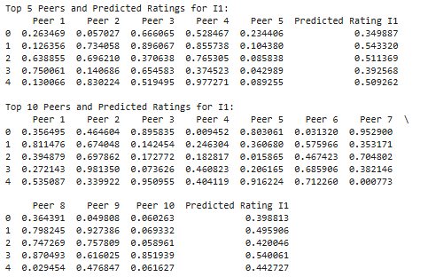

* 1. **Top 5 & 10 peers and Predicted rating for Item 2**

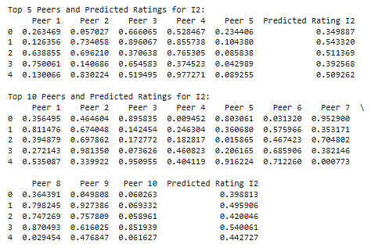

* 1. **Difference between peers in Item 1 & Item 2**

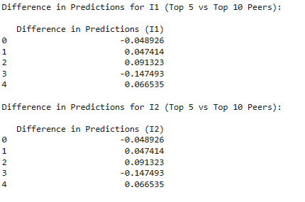

* 1. **Sample of MLE Covariance Matrix**

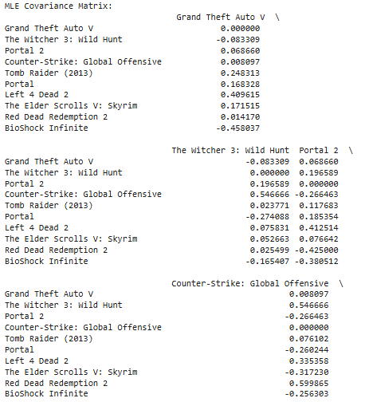

**1.10 Top 5 & 10 Peers for Each Item 1 and Item 2**



**1.11 Top 5 & 10 peers and Predicted rating for Item 1 & Item 2**

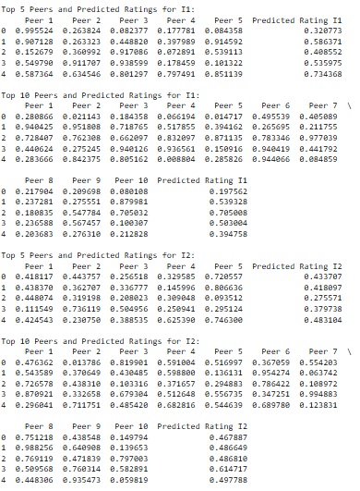

* 1. **Difference between peers in Item 1 & Item 2**

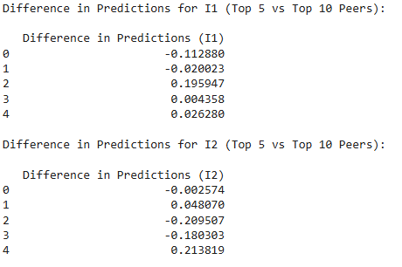

**1.13 Singular Values Decomposition**

A method for predicting missing ratings called matrix factorization. User features, item features, and singular values are the three smaller matrices that are produced when the user-item interaction matrix is broken down using the SVD technique. The missing ratings can be predicted by approximating these matrices.

1.13.1 Sample from User Matrix

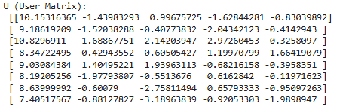

1.13.2 Diagonal Matrix

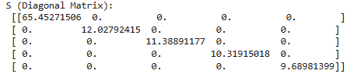

1.13.3 Item Matrix

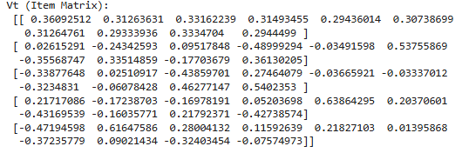

1.13.4 Sample from Predicted Rating Matrix

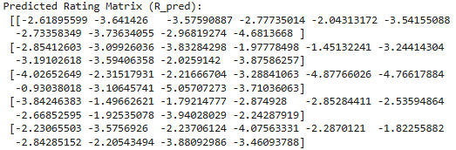

* + 1. Predicted Rating For Item 1 and Item 2

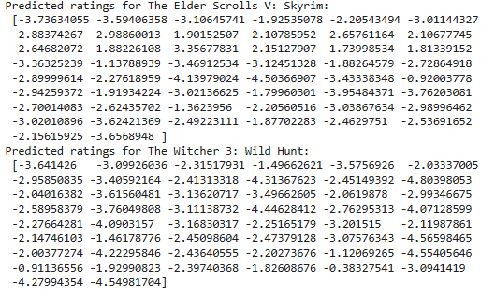

**1.14 Mean-Filling Method**

Mean-Filling Predection for Item 1 and Item 2



**1.15 Comparison of the three methods** **SVD, Mean-filling, and MLE**



1. **Conclusion**

2.1 Singular Value Decomposition (SVD)

RMSE: 1.38, MAE: 1.15

The collaborative filtering method known as the SVD model exhibits a comparatively good balance between error magnitudes and accuracy. The capacity of SVD to capture the underlying patterns and relationships between people and things is demonstrated by its reasonably accurate predictions on the dataset, which have an MAE of 1.15. SVD is generally better at comprehending the data structure, and although if the RMSE (1.38) is marginally larger than the other two approaches, it shows that the model is producing solid predictions with a modest level of error.

2.2 Mean-filling

MAE: 0.99

RMSE: 1.20

A straightforward method called "mean-filling" substitutes the average rating for each item for any missing ratings. This approach reduces absolute errors effectively, as evidenced by the lowest MAE (0.99). The RMSE (1.20), however, is marginally lower than SVD, indicating that although this approach does well on average, it is not as good at capturing the intricacy of user-item interactions as SVD. This might result in less tailored suggestions and, eventually, less precise forecasts for specific users.

2.3 Maximum Likelihood Estimation (MLE):

RMSE: 1.20, MAE: 0.99

Since both techniques rely on using averages to fill in missing data (MLE usually uses the mean of each item's ratings), their performance is nearly the same in this instance. The fact that MLE's MAE and RMSE are identical to those of mean-filling further supports the fact that it merely offers an average-based strategy that ignores user preferences and item attributes.