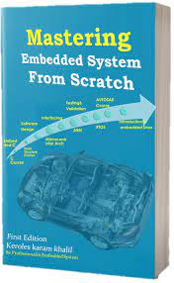

Pressure Detection Project

**Mastering Embedded System Online Diploma**

[**www.learn-in-depth.com**](http://www.learn-in-depth.com)

**First Term Project ( Final Project 1 )**

**Eng. Ahmed Nabil Mahmoud**

[**https://www.learn-in-depth.com/online-diploma/ahmed.nabil.9711%40gmail.com**](https://www.learn-in-depth.com/online-diploma/ahmed.nabil.9711%40gmail.com)

Contents

1. case study 2

• Requirements 2

• Assumptions 2

• Versioning 2

2. Method 3

•Software developing life cycle & software testing life cycle 3

3. Requirement Diagram 4

4. Space Exploration 5

• Features 5

5. System Analysis 6

• Use Case Diagram 6

• Activity Diagram 7

• Sequence Diagram 8

6. System Design **9**

• Block Diagram 9

• State Machine For Pressure_Sensor 10

• State Machine For Main Algorithm 11

• State Machine For Alarm_Control 12

• State Machine For Alarm_Actuator 13

7. C codes **14**

• Pressure_sensor_.c/.h 14

• Main_algorithm_.c/.h 16

• Alarm_control_.c/.h 18

• Alarm_actuator_.c/.h 20

• States.h 22

• App.c 23

8. Building_Files 24

• startup.c 24

• linker_script 25

• makefile 26

9. Software_analysis 27

• .map file 27

• Symbols table 28

• Sections table 29

10. Simulation 30

• Pressure less than threshold 30

• Pressure more than threshold 31

# 1. case study

## Requirements

1. Pressure detector that informs the cabin crew when pressure exceeds a threshold of 20 Bar.

2. The system informing is acting by a Led-alarm which should last for 60 sec.

3. The system should keep tracking for pressure values.

## Assumptions

1. No setup or shut down for micro-controller.

2. No maintenance for micro-controller.

3. Pressure sensor provides accurate readings.

4. Both sensor & actuator never fail.

5. No power constrains

## Versioning

The probability of adding a feature to store pressure values versus time in a flash memory in the next version.

# 2. Method

## Software developing life cycle & software testing life cycle

The ( SDLC ) & ( STLC ) will be approached according to the V-Model.

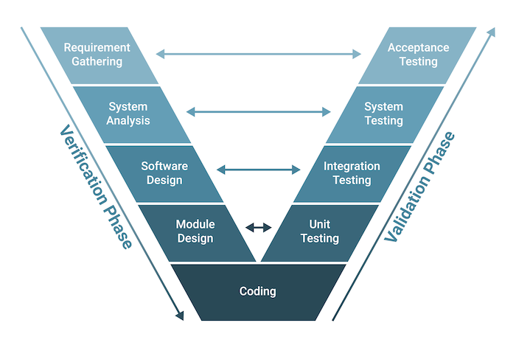

# 3. Requirement Diagram

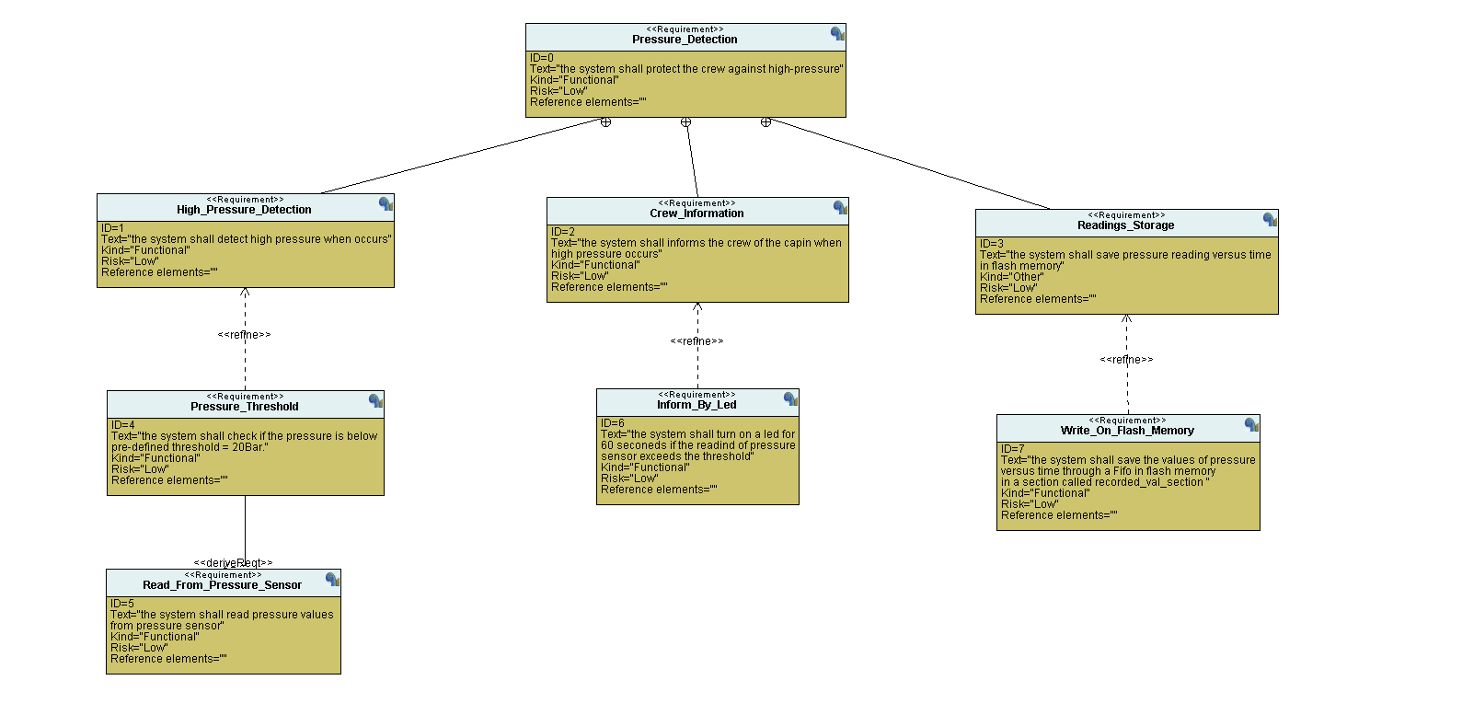

# 4. Space Exploration

Micro-controller : **stm32f103c8t6** SoC as it meets all technical requirments needed for this project as it is marked by : small size and contains acceptable flash memory as well as being cost efficient and have a suitable processor which is : **ARM Cortex-M3** 32bit with 72 MHz operating frequency.

## Features

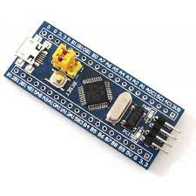operating voltage range -> 2 : 3.6 V.

64Kbytes Flash memory.

20KbytesSRam.

CRC calaculation unit , 96bit unique id.

Two 12bit, 1µs A/D converter (up to 10 channels).

7 channel DMA controller , 3 genral purpose timer & 1 advanced

Controller timer.

37 fast I/O ports.

Serial wire debug (SWD) & JTAG Interfaces .

Two SPI , two I2C , three USART , one USB & one CAN interfaces.

Ambient operating temperature range from -40˚C to 85˚C.

# 5. System Analysis

## Use Case Diagram

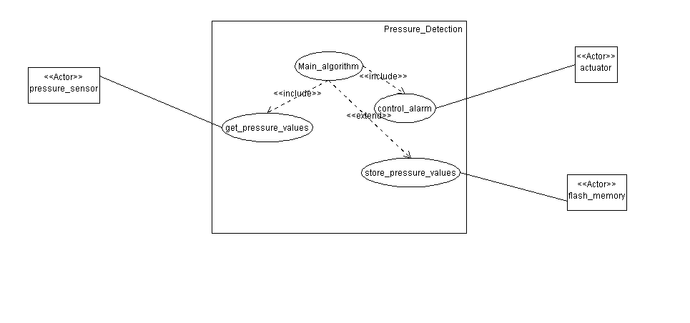

## Activity Diagram

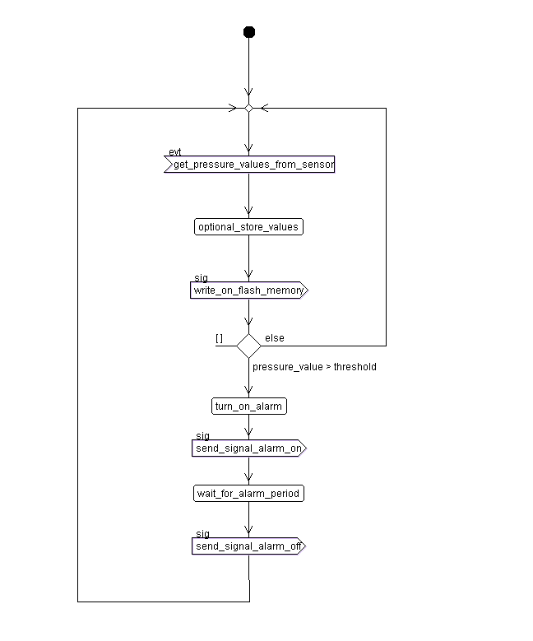

## Sequence Diagram

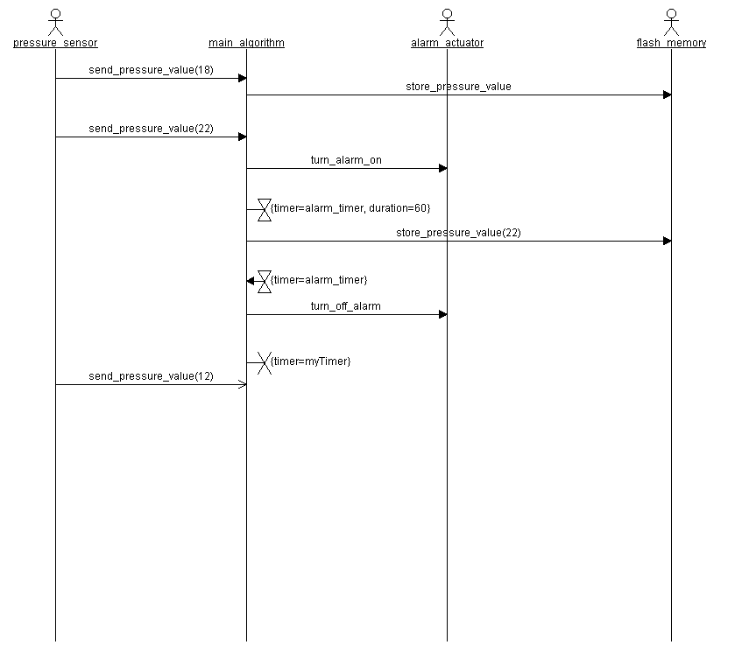

# 6. System Design

## Block Diagram

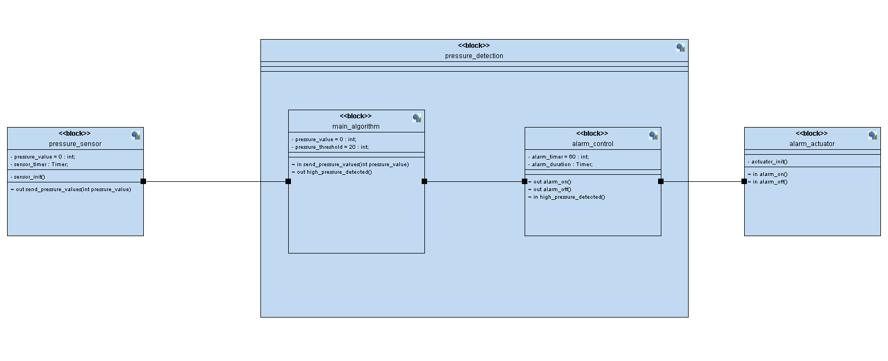

## State Machine For Pressure_Sensor

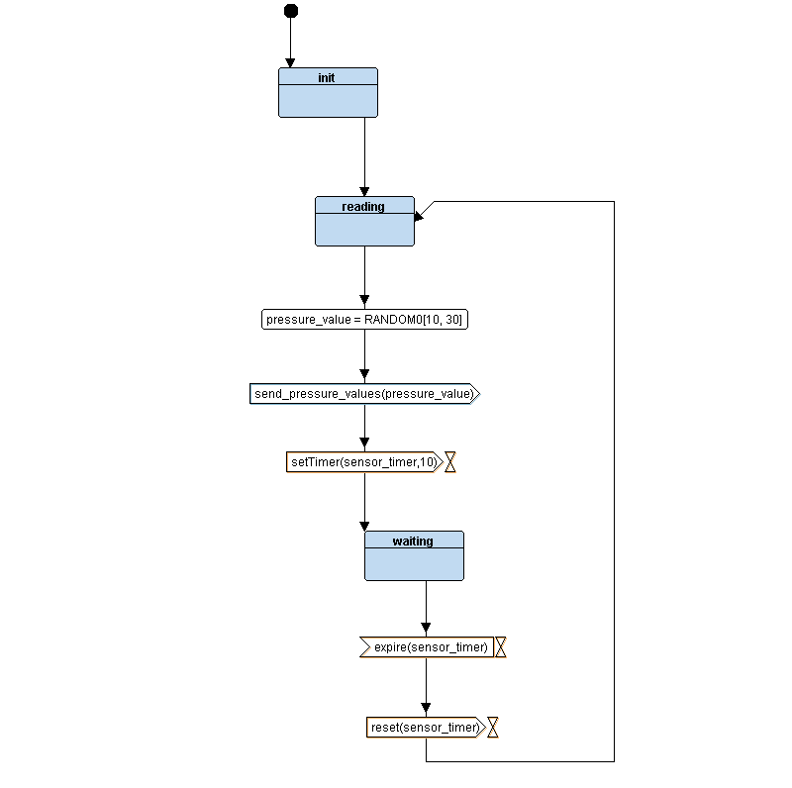

## State Machine For Main Algorithm

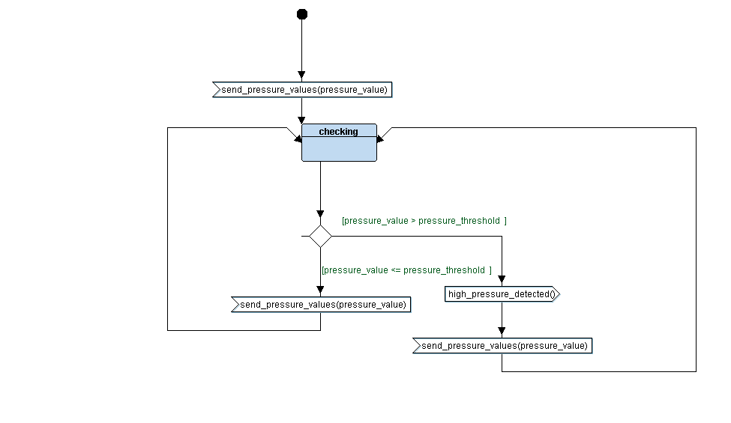

## State Machine For Alarm_Control

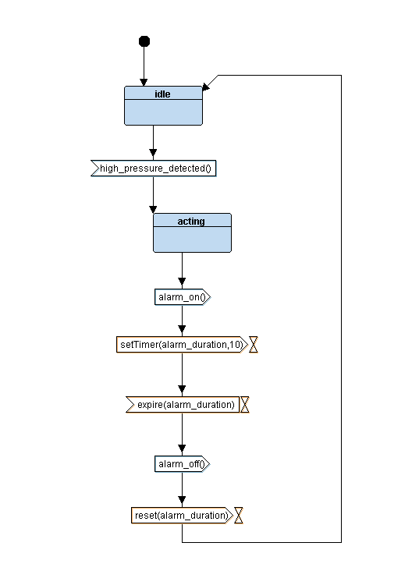

## State Machine For Alarm_Actuator

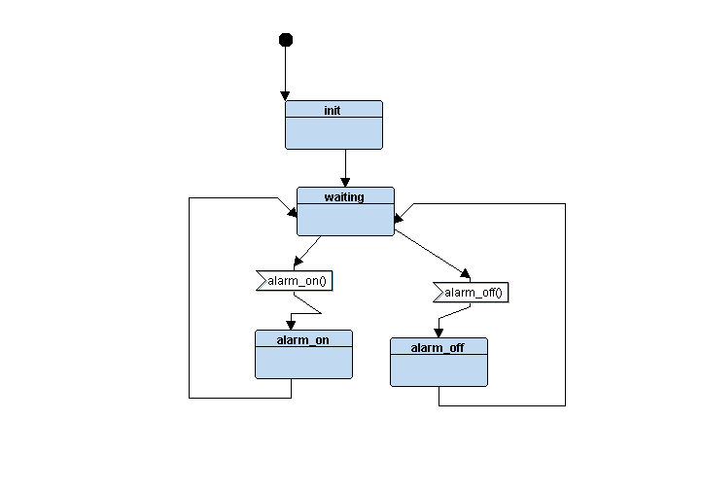

# 7. C codes

## Pressure_sensor_.c/.h

.h file

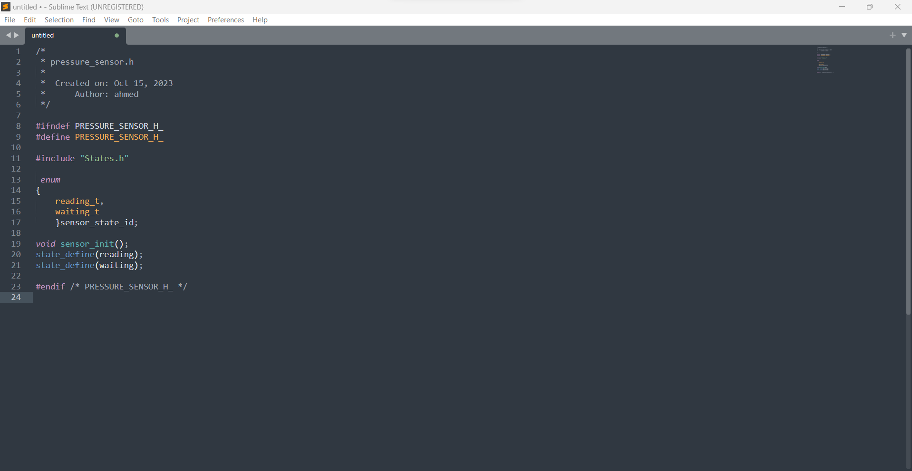

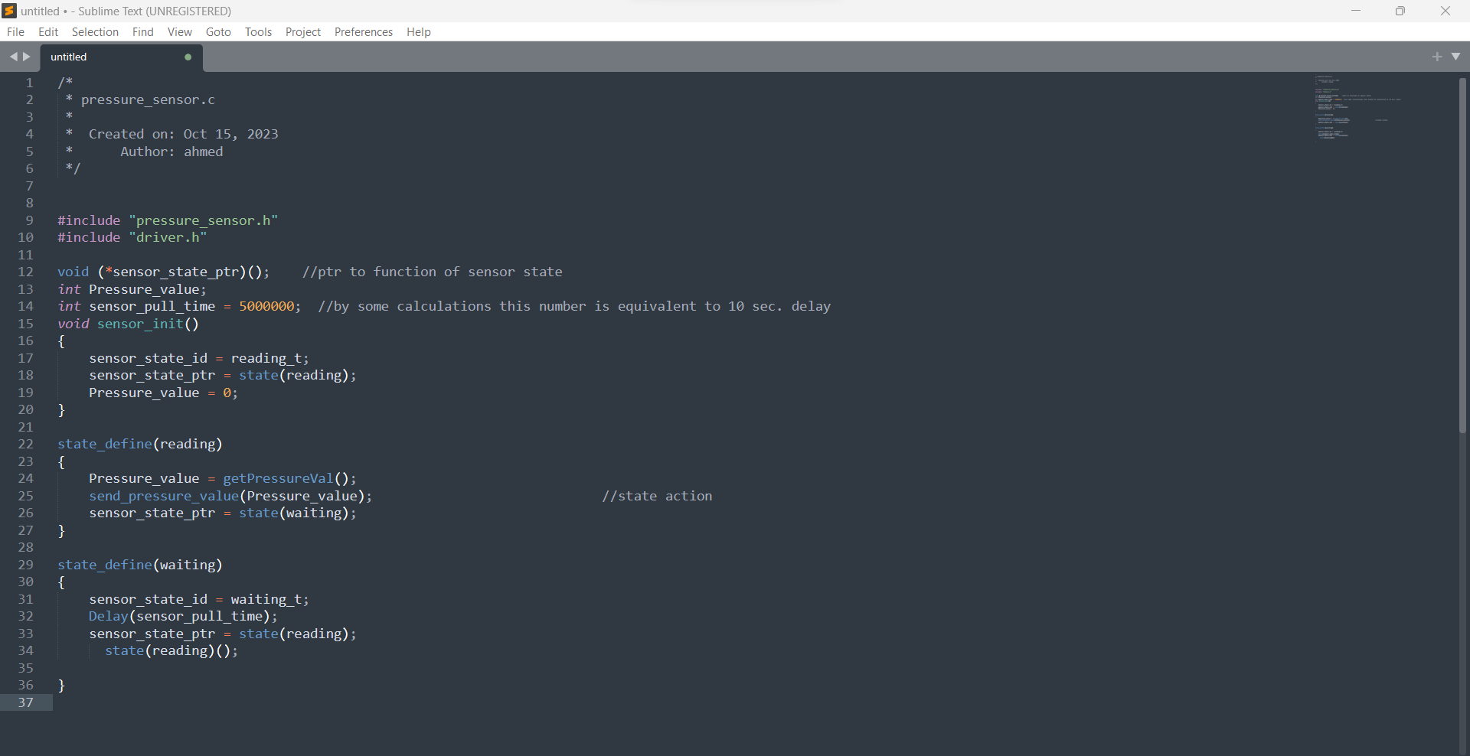.c file

## Main_algorithm_.c/.h

.h file

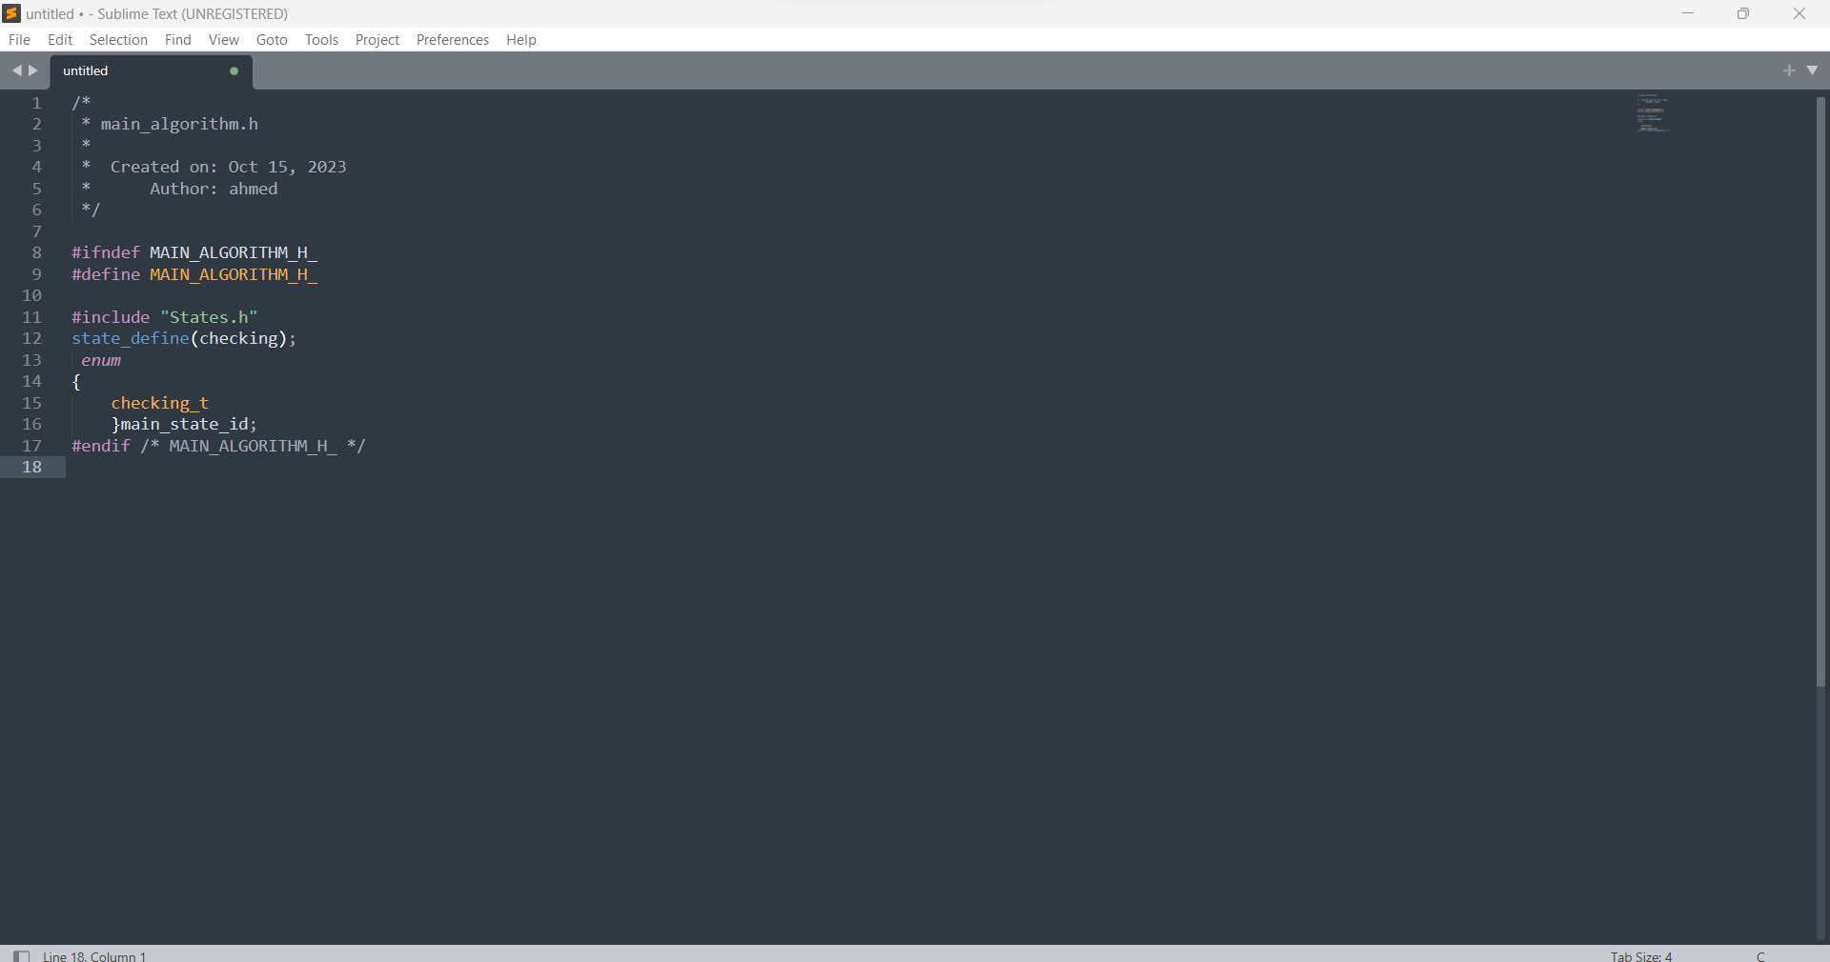

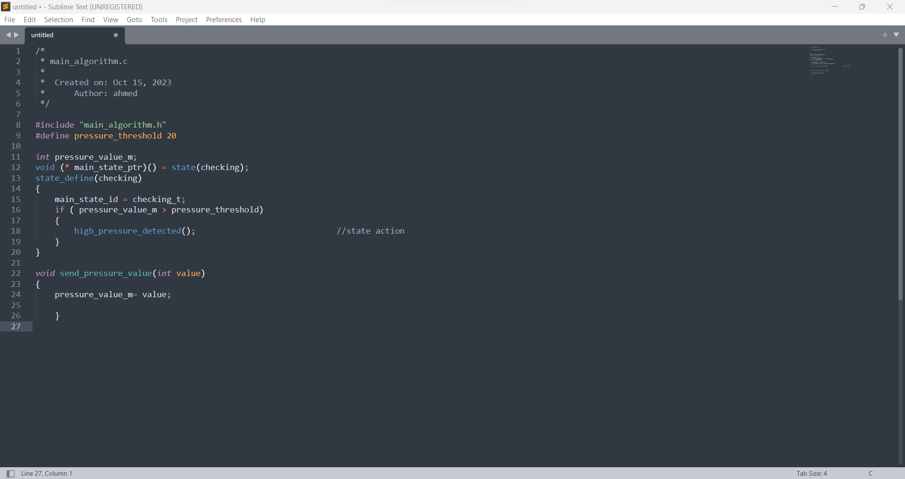.c file

## Alarm_control_.c/.h

.h file

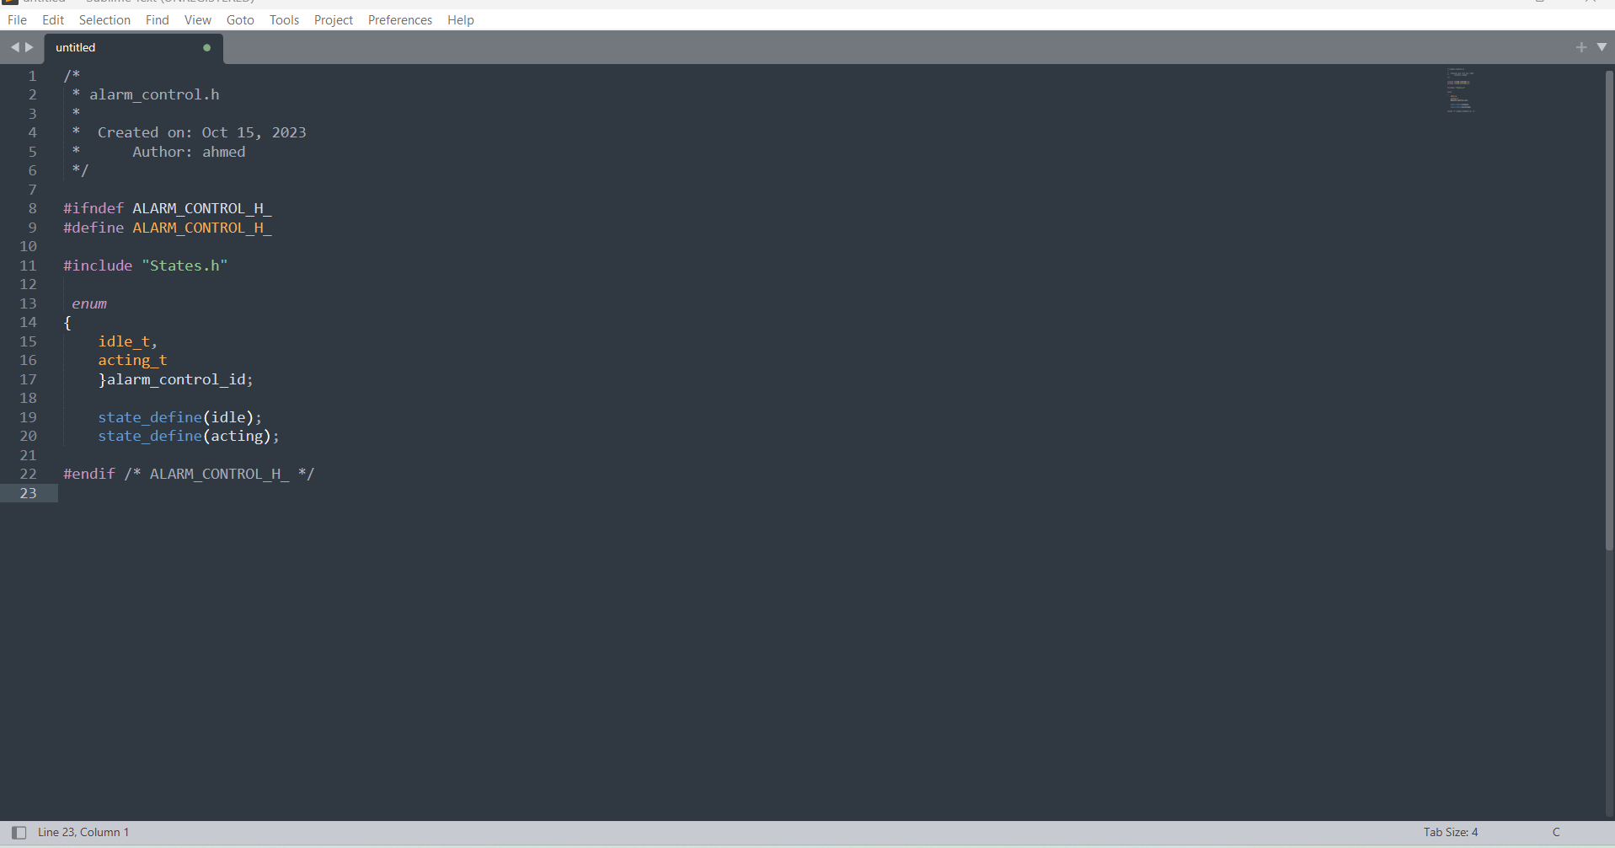

.c file

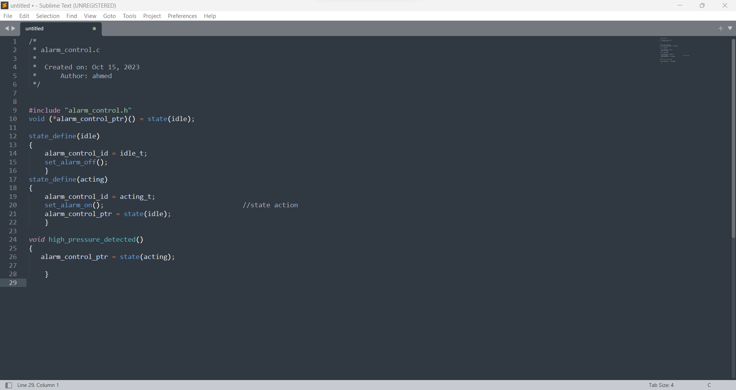

## Alarm_actuator_.c/.h

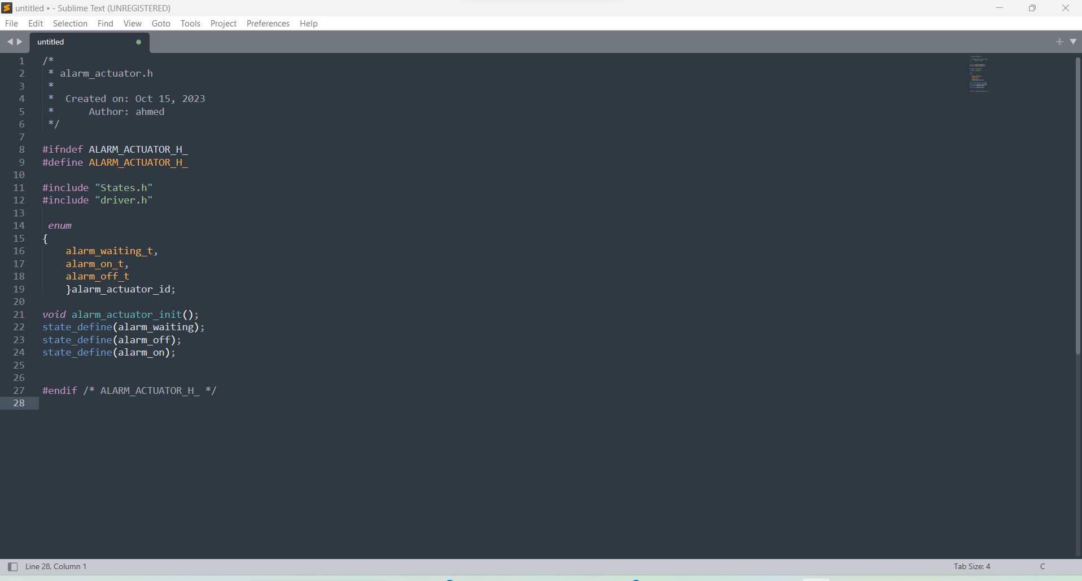.h file

.c file

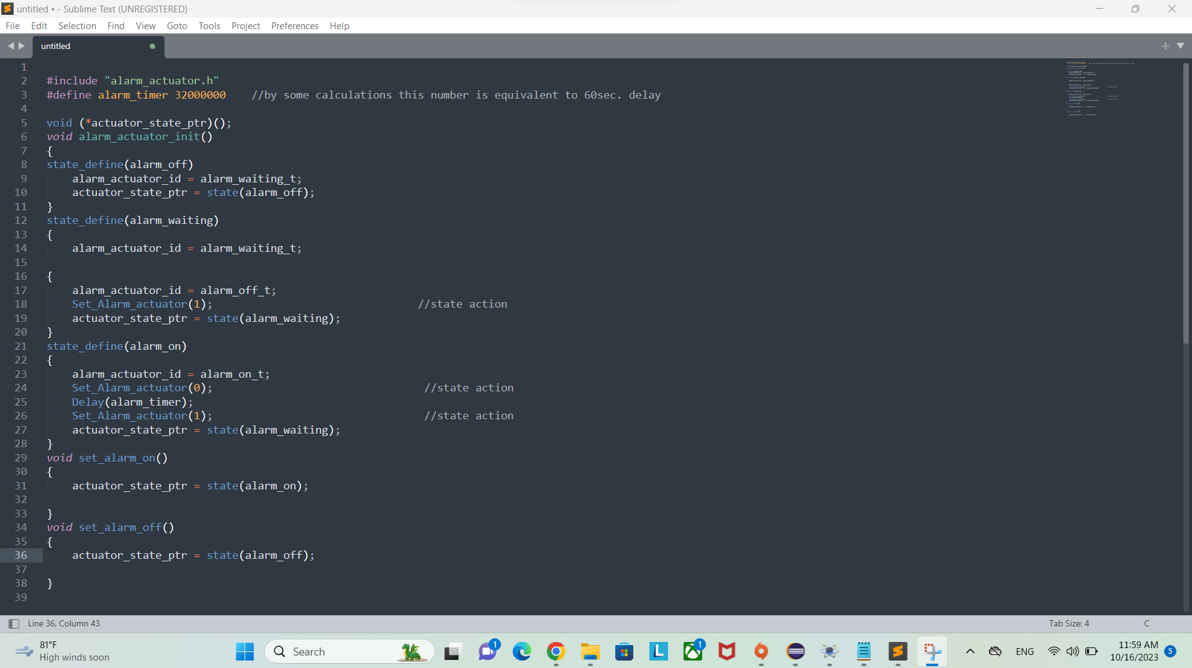

## States.h

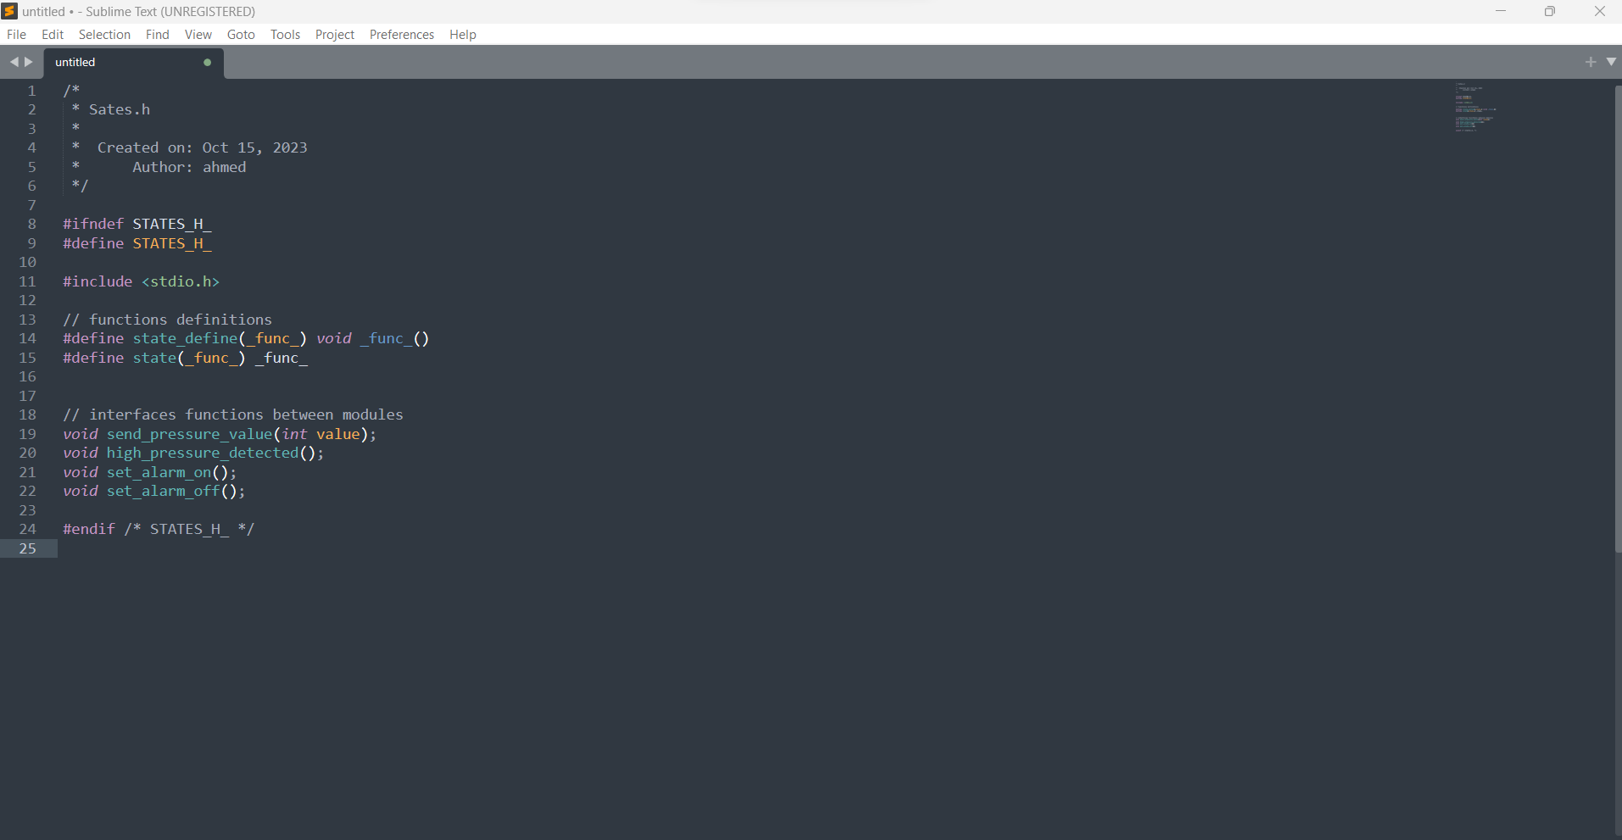

## App.c

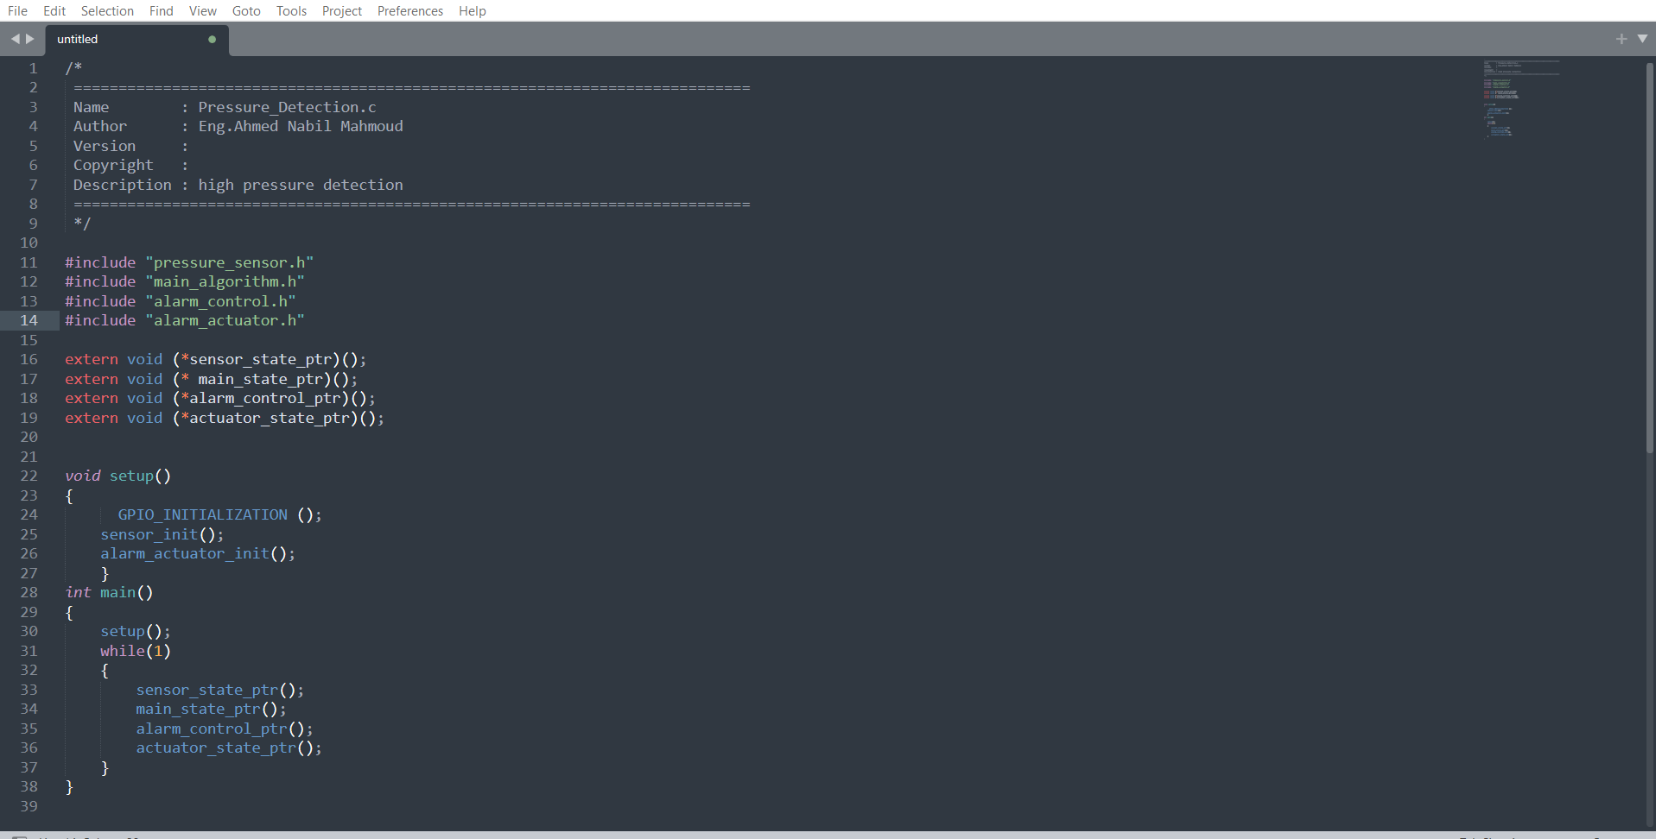

# 8. Building_Files

## startup.c

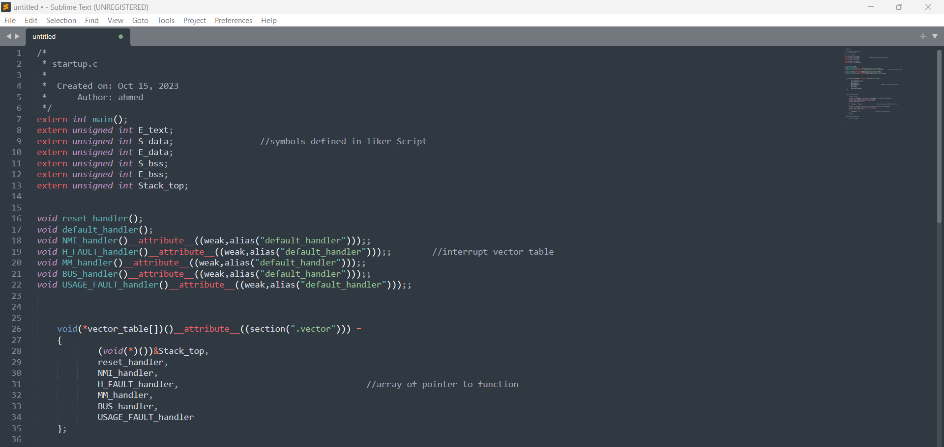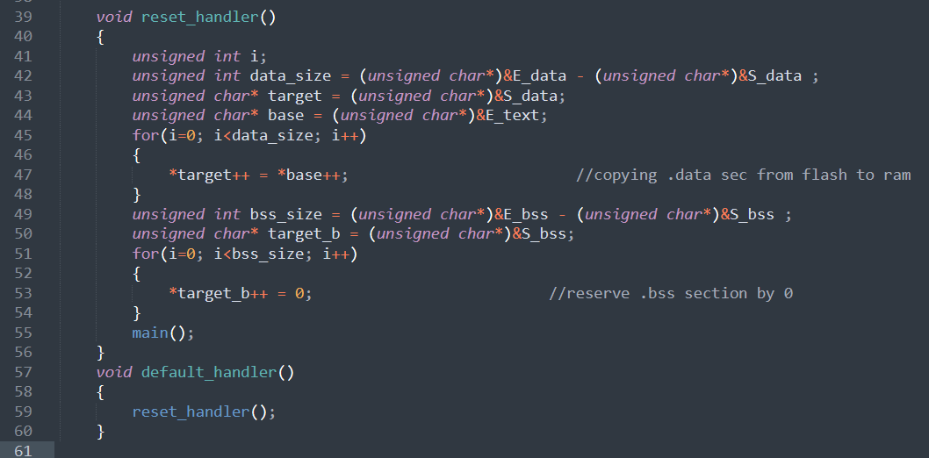

## linker_script

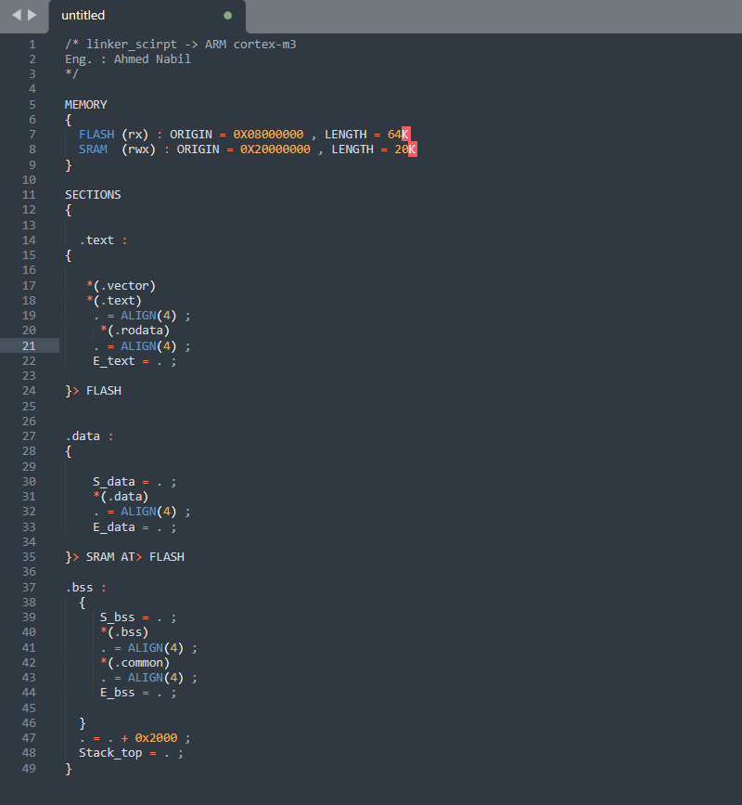

## makefile

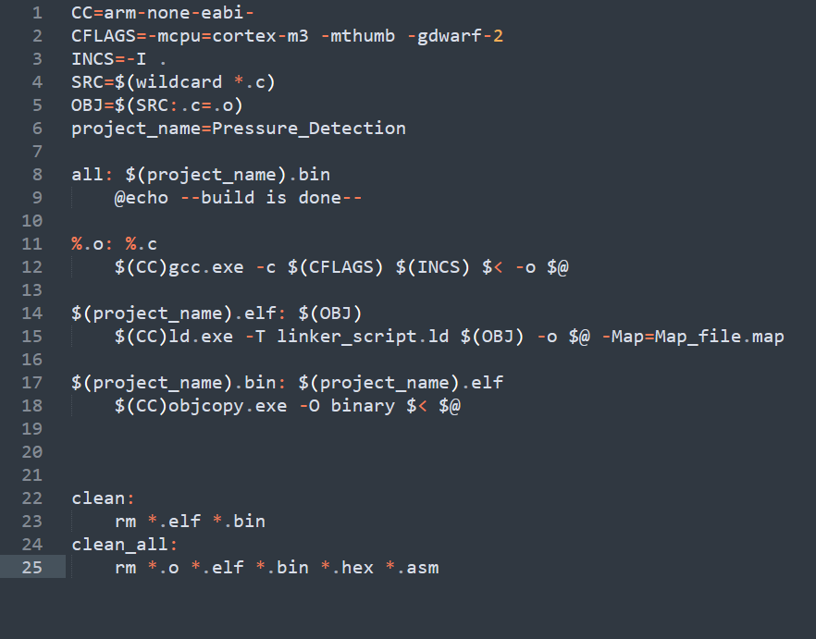

# 9. Software_analysis

## .map file

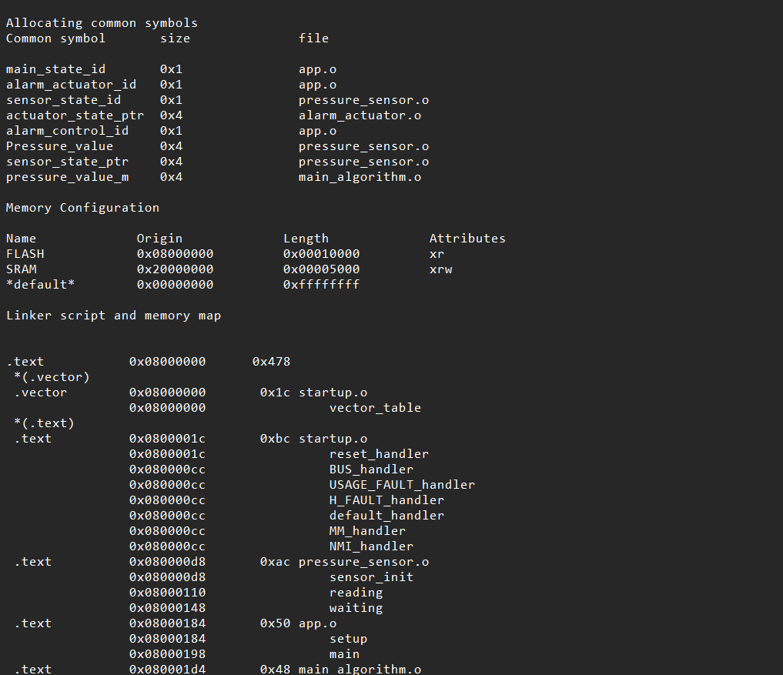

## Symbols table

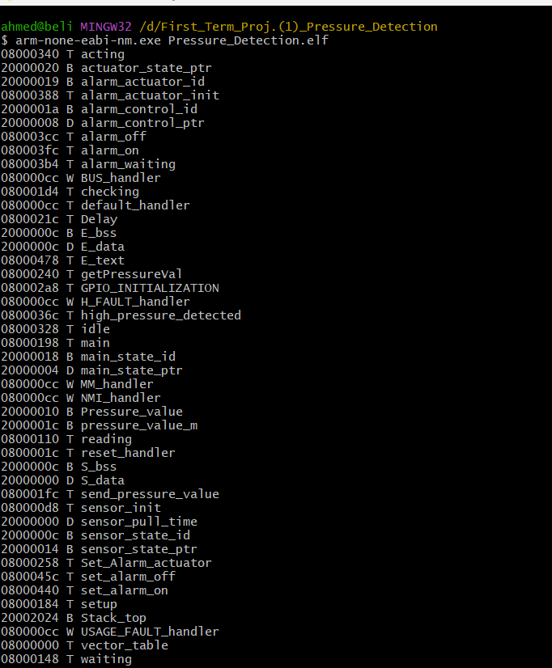

## Sections table

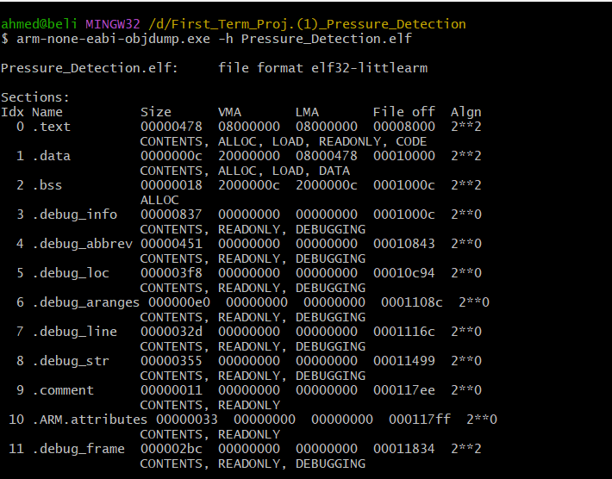

# 10. Simulation

## Pressure less than threshold

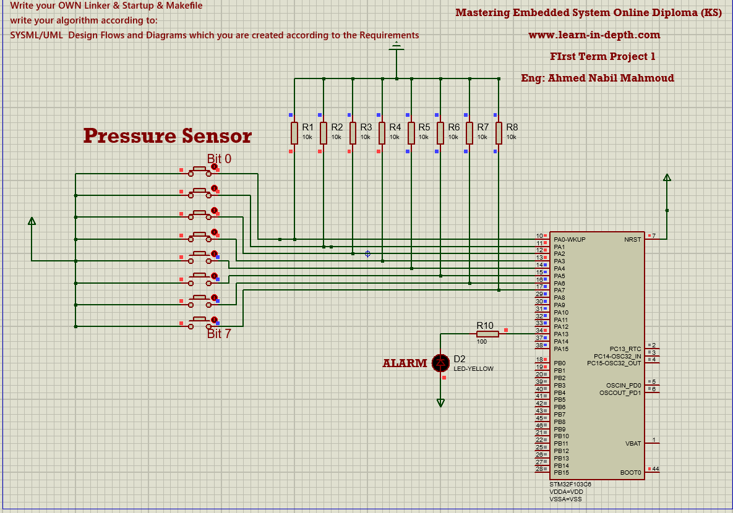

## 

## Pressure more than threshold

