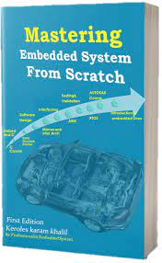

Student Management System

**Mastering Embedded System Online Diploma**

[**www.learn-in-depth.com**](http://www.learn-in-depth.com)

**First Term Project ( Final Project 2 )**

**Eng. Ahmed Nabil Mahmoud**

[**https://www.learn-in-depth.com/online-diploma/ahmed.nabil.9711%40gmail.com**](https://www.learn-in-depth.com/online-diploma/ahmed.nabil.9711%40gmail.com)

Contents

1. case study 2

• Requirements 2

• Assumptions 2

• Versioning 2

2. Method 3

• Software developing life cycle & software testing life cycle 3

3. Requirement Diagram 4

4. Space Exploration 5

• Standards 5

5. System Analysis 6

• Use Case Diagram 6

6. C codes 7

• Students.h 7

• Add student from file 8

• Add student from manually 9

• Find student by roll number 10

• Find student by First name 11

• Find student by Course id 12

• Find total number of students 13

• Delete student 14

• Update student 15

• Show all information 16

# 1. case study

## Requirements

The client request is to implement a student management system through which students data could be stored and program user could have control over these data & some features like :-

1. students information could be added manually or from a text file.

2. student’s information could be displayed by roll number or by first name .

3. Displaying number of students applied for a certain course.

4. Displaying total number of students and all students information.

5. delete or update student by roll number.

## Assumptions

1. Data will be erased when the program terminates.

2. maximum number of students could be added is 50.

3. Data validity is user’s responsibility.

4. Data values that will be Entered have a logic limit.

## Versioning

The probability of adding a feature to store students data in rom memory in the next version.

# 2. Method

## Software developing life cycle & software testing life cycle

The ( SDLC ) & ( STLC ) will be approached according to the V-Model.

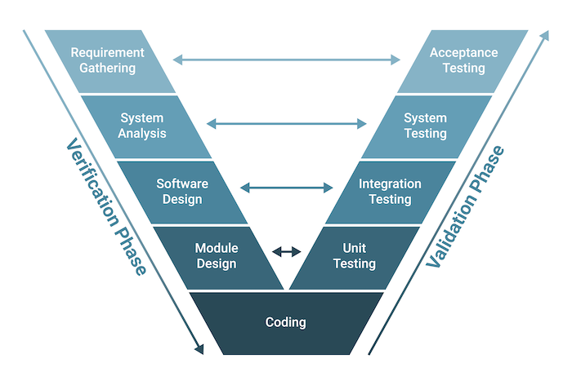

# 3. Requirement Diagram

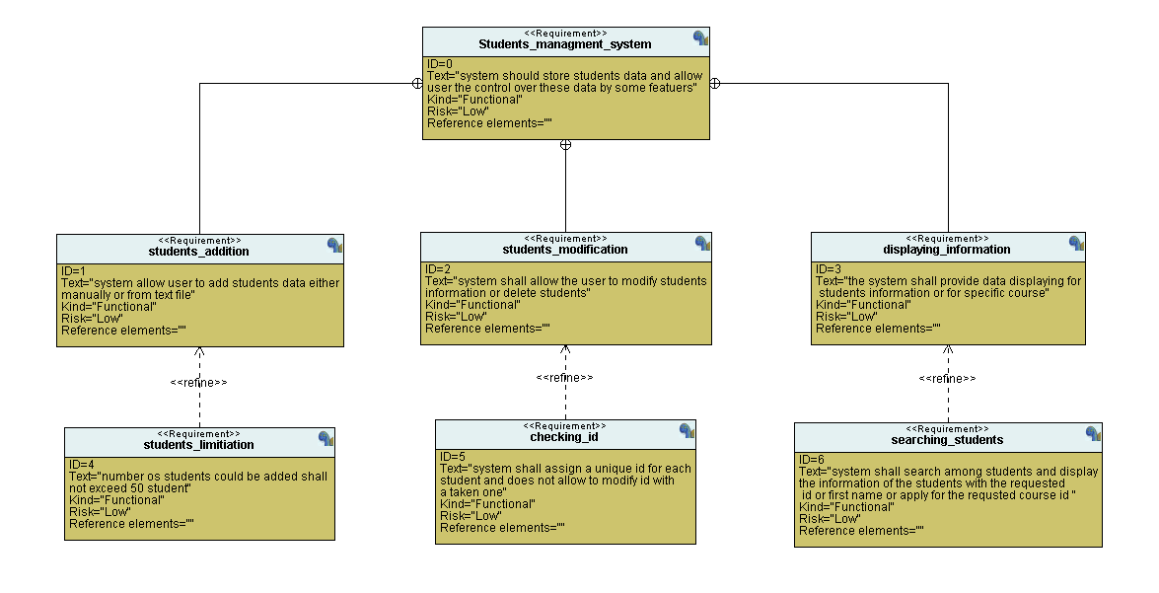

# 4. Space Exploration

The system will be run on either pc or laptop with these minimum standards :-

## Standards

CPU : core i3 7th generation.

RAM : 4GB.

Compiler : gcc

OS : windows 10

# 5. System Analysis

## Use Case Diagram

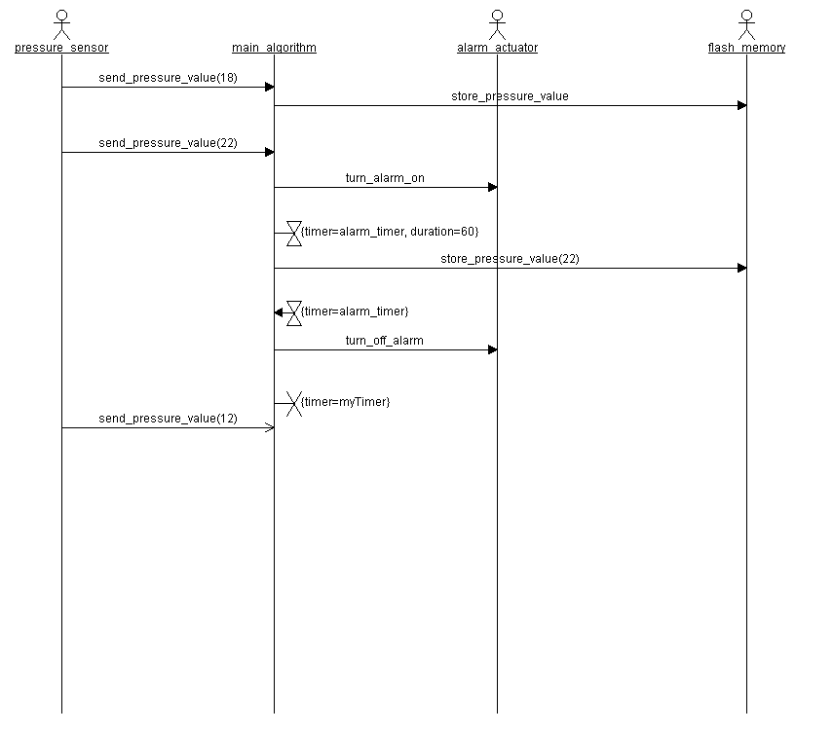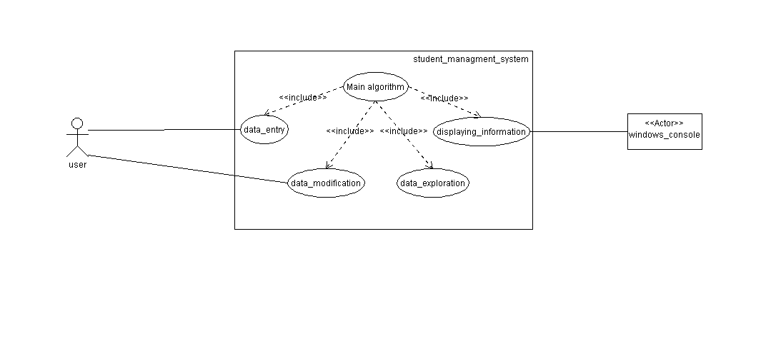

# 6. C codes

## Students.h

## Add student from file

## Add student from manually

## Find student by roll number

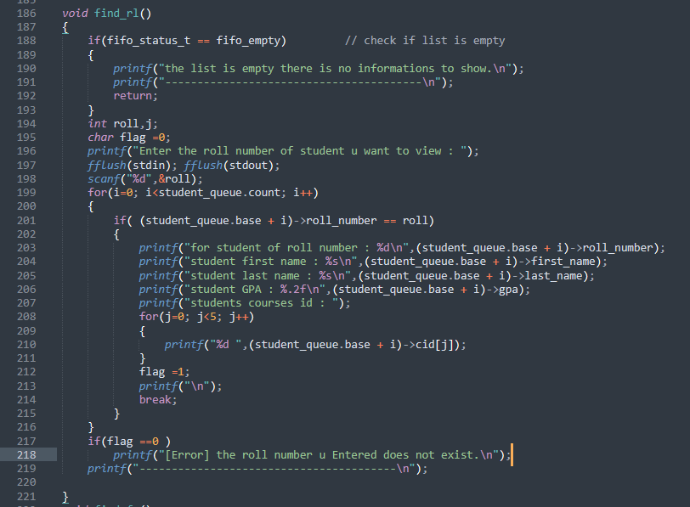

## Find student by First name

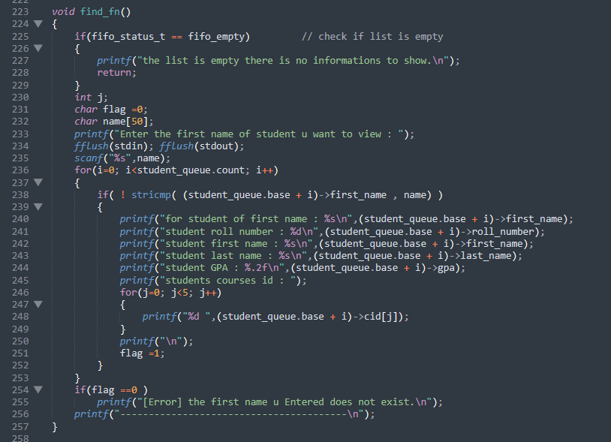

## Find student by Course id

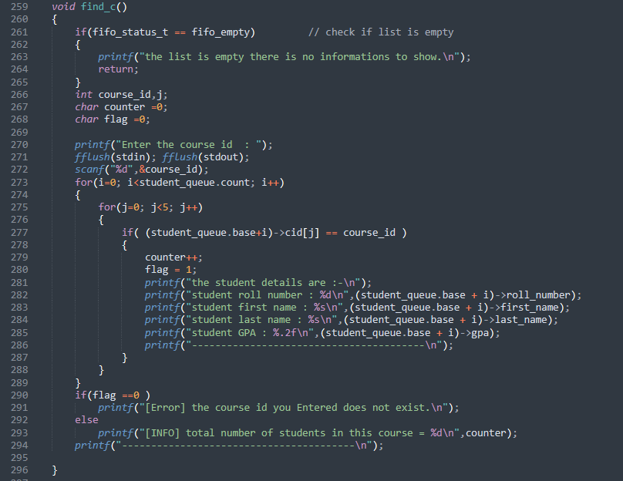

## Find total number of students

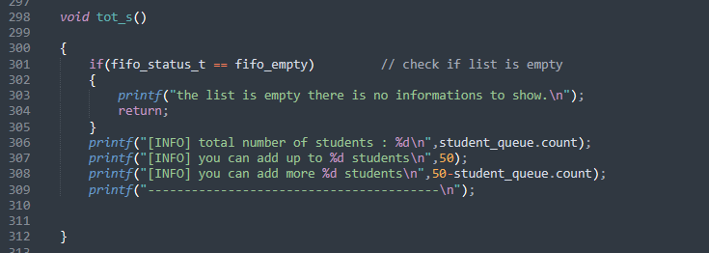

## 

## Delete student

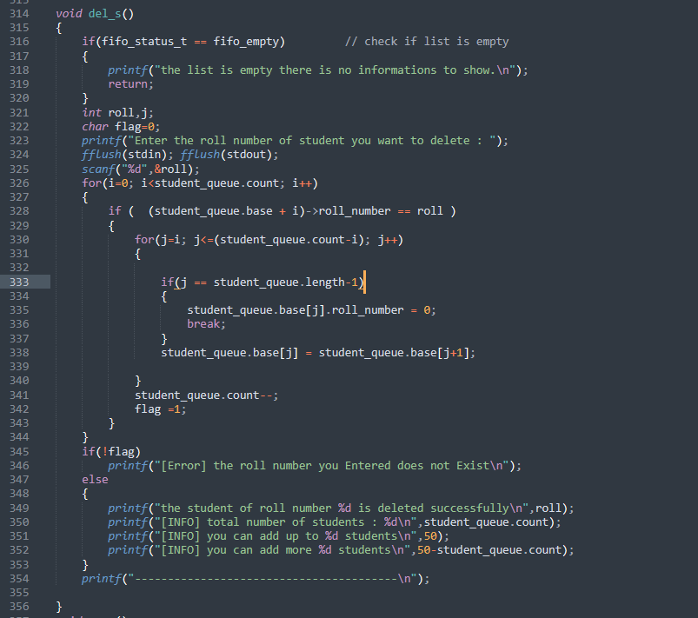

## Update student

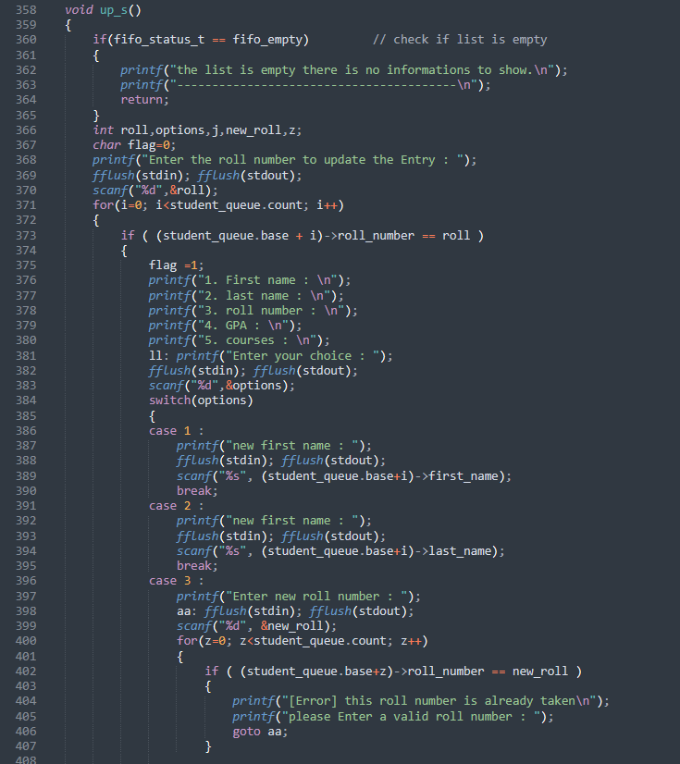

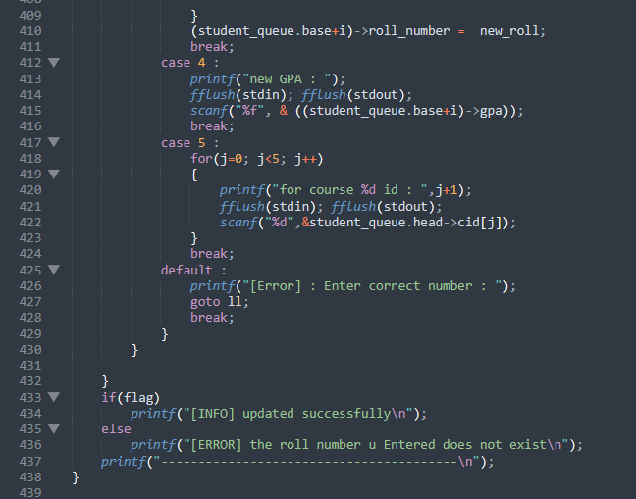

## Show all information

