**One sample t-test**

-Is there a difference in incident_rate?

df = read.csv("altadatacovid_19-csv.csv")

head(df)

t.test(df$incident_rate, mu =31432)

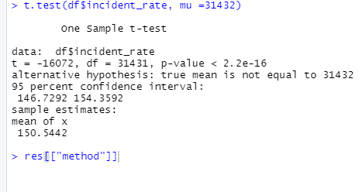

-We can reject null hypothesis and cannot reject alternative hypothesis

Because the p-value less than 0.05.

**Paired Two Samples T-Test**

-Is there a difference between the number of injuries(active) and recovery?

df<- read.csv("altadatacovid_19-csv.CSV",header = TRUE , sep = ",")

before <- test1[1:31432,5]

after <- test1[1:31432,7]

t.test(before,after ,data = df,paired=TRUE)

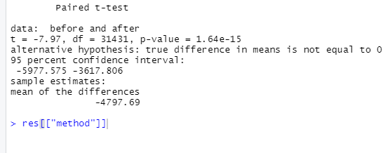

We can reject null hypothesis and cannot reject alternative hypothesis

Because the p-value less than 0.05 and there are significant difference between the means of two groups

**Unpaired two-sample t-test**

-Is there a difference between the number of injuries(active) and deaths?

df<- read.csv("altadatacovid_19-csv.CSV",header = TRUE , sep = ",")

active <- test1[1:31432,5]

deaths <- test1[1:31432,6]

t.test(active,deaths ,data = df,var.equal=TRUE)

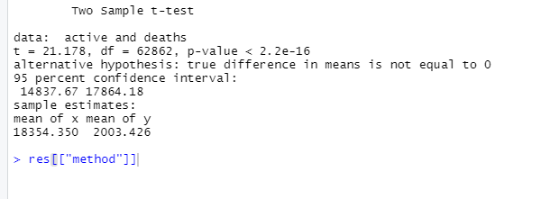

We can reject null hypothesis and cannot reject alternative hypothesis

Because the p-value less than 0.05 and there are significant difference between the means of two groups