ALZCare: A Speech-Based Multi-Task Mood Detection System with a Retrieval-Augmented Clinical Assistant for Alzheimer’s Care
Ahmed Nada, Omar Ibrahim, Ahmed Fathy, Aya Abdelmagid, Negma, Rokia Islam
Department of Computer Engineering
Alamein International University, Alamein, Egypt

Abstract—Mood and arousal are clinically meaningful signals for monitoring patients living with Alzheimer’s disease, yet they are difficult to capture continuously and objectively in everyday care. We present ALZCare, an integrated clinical decision-support platform that estimates a patient’s mood directly from short voice recordings and exposes the results to clinicians and family caregivers through role-based dashboards. The mood estimator is a custom multi-task neural network built on a self-supervised WavLM-Base-Plus speech encoder, an attentive masked-pooling layer, and two prediction heads that jointly produce a six-class mood label (Calm, Neutral, Content, Anxious, Agitated, Low) and a coarse low/high arousal signal. The model is trained on four merged acted-emotion corpora under class-balanced focal loss with mild, domain-aware audio augmentation, and its probabilities are calibrated by post-hoc temperature scaling. On a speaker-disjoint test split the system reaches approximately 0.74–0.77 six-class accuracy, 0.73–0.76 macro-F1, and 0.86–0.88 low/high arousal accuracy, with a peak validation macro-F1 of 0.82 and an expected calibration error reduced from 0.041 to 0.039 after calibration. Alongside the acoustic model, a retrieval-augmented generation (RAG) assistant grounds a large language model in a curated Alzheimer’s knowledge base and the patient’s own medical record; on a held-out query set it attains 0.95 retrieval precision, 0.95 mean reciprocal rank, 0.97 normalized discounted cumulative gain, 1.00 routing accuracy, and a 0.96 mean answer–reference semantic similarity. We describe the end-to-end MERN architecture, the inference pipelines, the evaluation methodology, and the strengths and limitations of the deployed prototype.
Index Terms—speech emotion recognition, mood detection, WavLM, self-supervised learning, multi-task learning, model calibration, retrieval-augmented generation, large language models, Alzheimer’s disease, clinical decision support.
I. Introduction
Alzheimer’s disease and related dementias progressively impair memory, communication, and emotional regulation. Among the most burdensome aspects of the disease for both patients and caregivers are the behavioural and psychological symptoms of dementia—agitation, anxiety, apathy, and depressed mood—which fluctuate over time and are strongly predictive of caregiver stress and institutionalisation. Continuous, objective monitoring of a patient’s affective state would allow clinicians and families to detect distress earlier and to respond before episodes escalate. In practice, however, mood is assessed sporadically through subjective questionnaires and brief clinical visits, leaving most of a patient’s daily emotional trajectory unobserved.
Speech is an attractive modality for this problem. It is non-invasive, can be captured with commodity devices, and carries rich paralinguistic information—prosody, energy, and timbre—that correlates with affect independently of the words spoken. Recent advances in self-supervised speech representation learning have made it possible to build accurate acoustic models from limited labelled data, and parallel advances in large language models (LLMs) and retrieval-augmented generation (RAG) have made it possible to deliver grounded, trustworthy clinical information to non-expert users. The challenge is to combine these capabilities into a single, safe, and usable system.
This paper presents ALZCare, a deployed full-stack prototype that does exactly this. A patient records a short voice clip; a speech mood model estimates the patient’s mood and arousal; the result is stored, surfaced to the patient’s doctor and family in real time, and flagged when it indicates possible distress. A complementary RAG assistant answers clinical and caregiving questions, grounded strictly in the patient’s record and a curated medical knowledge base so that it cannot fabricate patient facts. The system is explicitly a decision-support tool—it produces calibrated probabilities and abstains when uncertain, rather than issuing diagnoses.
The contributions of this work are as follows:
• A multi-task speech mood model. a WavLM-Base-Plus backbone with attentive masked pooling and joint mood/arousal heads, trained with class-balanced focal loss and calibrated by temperature scaling, that produces six-class mood estimates together with a more reliable coarse arousal signal.
• An integrated, role-aware care platform. a MERN-stack application that captures voice check-ins in the browser, serves model inference through Python micro-services, persists calibrated results, and broadcasts distress alerts to clinicians and caregivers over WebSockets.
• A clinically-safe RAG assistant. a semantically-routed retrieval pipeline that grounds an LLM in a FAISS knowledge base and the MongoDB patient record, with explicit anti-hallucination guardrails and role-adaptive (clinician vs. family) responses.
• An empirical evaluation. a quantitative characterisation of both subsystems—classification accuracy, macro-F1, calibration, per-class confusion for the mood model, and retrieval precision, MRR, NDCG, routing accuracy, and answer semantic similarity for the RAG assistant.
The remainder of the paper is organised as follows. Section II reviews related work. Section III describes the system architecture. Section IV details the methodology of both AI subsystems. Section V reports the experimental evaluation. Section VI discusses strengths and limitations, and Section VII concludes with directions for future work.
II. Related Work
A. Speech Emotion Recognition
Speech emotion recognition (SER) has a long history rooted in hand-crafted acoustic descriptors—pitch, energy, mel-frequency cepstral coefficients (MFCCs), and their statistical functionals—fed to classical classifiers. The field shifted decisively with self-supervised speech representation models such as wav2vec 2.0 [1], HuBERT [2], and WavLM [3], which are pre-trained on large unlabelled corpora and then fine-tuned for downstream tasks. WavLM in particular augments masked-prediction pre-training with denoising and overlapped-speech simulation, yielding representations that are robust to noise and speaker variation; it is a strong performer across the SUPERB benchmark [4], including emotion recognition. ALZCare adopts WavLM-Base-Plus as its acoustic backbone for these reasons.
A recurring difficulty in SER is that prosody encodes arousal far more strongly than valence: high-arousal states such as happiness and anger are acoustically similar, as are low-arousal negative states such as sadness and fear. Much of the residual error on acted emotion data is therefore irreducible label ambiguity rather than model underfitting. This motivates our multi-task design, in which a coarse arousal axis is predicted jointly with fine mood and treated as the more reliable clinical signal.
B. Emotion Datasets and Robust Training
Publicly available emotional-speech corpora are predominantly acted. RAVDESS [5], CREMA-D [6], TESS, and SAVEE provide categorical emotion labels under controlled recording conditions; they differ markedly in speaker count and balance. Training a robust classifier across such heterogeneous, imbalanced sources requires care: class-balanced losses based on the effective number of samples [7] and focal loss [8] mitigate imbalance and hard-example dominance, while SpecAugment [9] and waveform-level augmentation improve generalisation. Because neural classifiers are typically over-confident, post-hoc temperature scaling [10] is a standard, effective calibration step. ALZCare combines all of these techniques.
C. Retrieval-Augmented Generation for Clinical Assistance
Large language models are fluent but prone to hallucination, which is unacceptable in a clinical setting. Retrieval-augmented generation [11] addresses this by conditioning generation on documents retrieved from an external store, improving factuality and traceability. Practical RAG systems pair a dense sentence encoder such as Sentence-BERT [12] or MiniLM [13] with an approximate nearest-neighbour index such as FAISS [14], and an instruction-tuned generator such as Llama 3 [15]. ALZCare’s assistant follows this recipe but adds a semantic router and strict grounding rules that make the patient’s database record—not the language model—the sole source of truth for patient-specific facts.
III. System Architecture
ALZCare is a full-stack MERN application (MongoDB, Express, React, Node.js) organised around three role-based clients—patient, doctor, and family caregiver—and two dedicated Python AI micro-services. Fig. 1 shows the high-level architecture. The design separates the stateless application tier (which handles authentication, persistence, and real-time messaging) from the compute-heavy AI tier (which runs the speech model and the RAG pipeline), so that model inference can be scaled, restarted, or replaced independently of the web application.
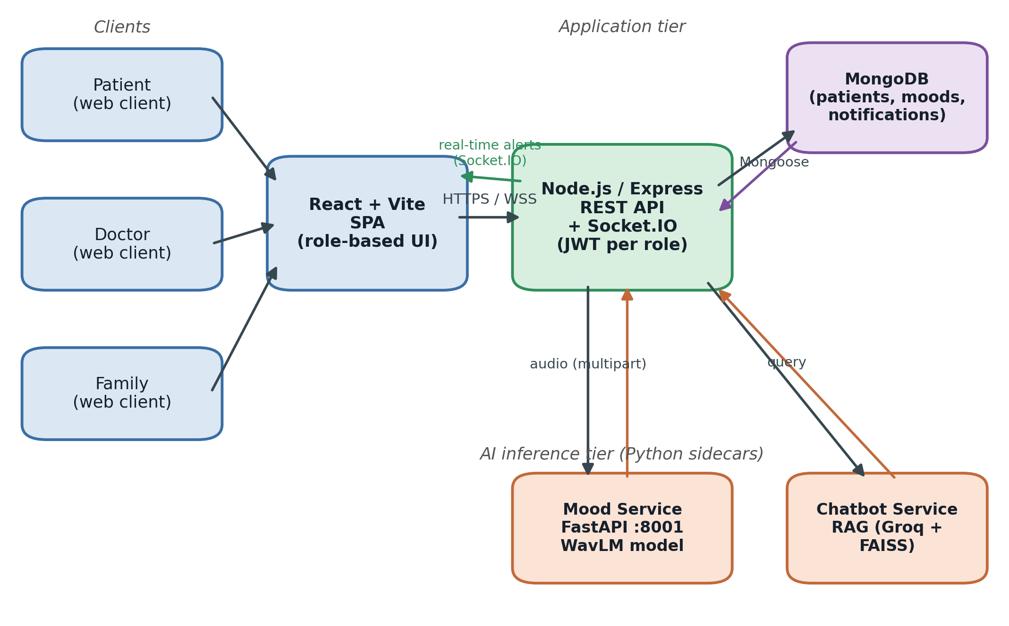
Fig. 1. End-to-end ALZCare architecture. Role-based React clients communicate with a Node.js/Express API over HTTPS and Socket.IO. The API persists data in MongoDB and delegates AI workloads to two Python sidecars: a FastAPI mood-detection service hosting the WavLM model, and a retrieval-augmented chatbot service. Distress alerts are pushed back to clinician and caregiver clients in real time.
A. Application Tier
The backend is a Node.js/Express service (port 5001) using Mongoose as the MongoDB object document mapper. Three user roles—doctor, family, and patient—are authenticated independently through dedicated middleware that validates a signed JSON Web Token carrying a role claim; tokens are issued with a seven-day lifetime. A doctor manages many patients, whereas a family account is linked one-to-one to a single patient and is further constrained by granular permissions (for example, the ability to view medications, confirm a dose, add a mood entry, or contact the doctor). The React/Vite single-page application renders a distinct dashboard per role.
Real-time communication uses Socket.IO over WebSockets with a polling fallback. Each patient is associated with a logical room (“patient:{id}”) that both the patient client and the linked family client join; the server pushes mood updates, scheduled check-in prompts, and abnormal-mood alerts into this room. The principal MongoDB collections include patients, doctors, families, AI-mood records, mood schedules, medications and their logs, appointments, and notifications.
B. AI Inference Tier
Two Python services run alongside the Node backend. The mood-detection service is a FastAPI application (default port 8001) that hosts the WavLM multi-task model and exposes a “/mood/analyze” endpoint accepting an uploaded audio file and a “/health” probe. The chatbot service (default port 8000) hosts the RAG pipeline and exposes a “/chat/ask” endpoint. The Node backend never executes PyTorch itself; it forwards the raw audio buffer or the user question to the relevant service over localhost HTTP and returns the structured result. Service URLs are configured through environment variables, and the client wraps each call with explicit timeouts (45 s for mood inference, 60 s for chat) and health checks so that a failure in the AI tier degrades gracefully rather than blocking the application.
C. Data Flow of a Voice Mood Check-in
A check-in begins either on demand or when the scheduler fires a prompt. The patient client records roughly twelve seconds of audio through the browser’s getUserMedia API and, using the Web Audio API, re-samples it to 16 kHz mono and encodes it as WAV, applying a basic silence/duration sanity check before upload. The clip is sent as multipart form data to the Node API, which (a) validates the file, (b) forwards it to the mood service, (c) persists the returned mood, arousal, confidence, and top-k probabilities as an AI-mood document, (d) creates a notification for the care team if the result is flagged abnormal, (e) emits a “mood:updated” event to the patient room, and (f) returns the result to the client. Abnormal flagging is triggered for the mood classes Anxious, Agitated, and Low, or when the top confidence falls below 0.35. Doctor and family dashboards aggregate the stored records into thirty-day mood trends and summary statistics.
TABLE I
Deployment and Integration Configuration
Component | Configuration
Backend | Node.js / Express, port 5001
Database | MongoDB via Mongoose ODM
Frontend | React 18 + Vite, Socket.IO client
Real-time | Socket.IO (WebSocket + polling)
Roles | Doctor, Family, Patient (JWT, 7-day)
Mood service | FastAPI, port 8001, /mood/analyze
Chatbot service | RAG, port 8000, /chat/ask
Audio upload | ≤25 MB; wav/webm/ogg/m4a/mp3/…
Mood timeout | 45 s (inference), 5 s (health)

IV. Methodology
A. Audio Capture and Pre-processing
All audio is reduced to a canonical form before inference: a single-channel waveform sampled at 16 kHz, the native rate of the WavLM feature extractor. Browser-recorded audio is converted client-side, and the mood service additionally decodes and resamples any accepted container server-side. Clips longer than the configured maximum duration (approximately six seconds) are truncated, and the WavLM feature extractor normalises the waveform and produces an attention mask that marks valid versus padded frames. Two lightweight quality gates reject unusable input: a root-mean-square energy below 0.001 is reported as silence, and a duration below 0.5 s is reported as too short, so that empty or near-empty recordings are surfaced to the user rather than scored.
B. Speech Mood Model
The core estimator is a custom multi-task network, illustrated in Fig. 2. It is deliberately not a standard audio-classification head; rather, it shares one acoustic representation across two related tasks. The components are:
• WavLM backbone. a microsoft/wavlm-base-plus encoder (hidden size 768). Following standard practice the convolutional feature encoder is frozen and the transformer layers are fine-tuned with a lower learning rate than the heads.
• Attentive masked pooling. a learned attention layer aggregates the variable-length frame sequence (B×T×768) into a single utterance embedding (B×768), respecting the padding mask so that padded frames receive zero weight.
• Mood head. a two-layer MLP (Linear–GELU–Dropout–Linear) producing six mood logits for Calm, Neutral, Content, Anxious, Agitated, and Low.
• Arousal head. a single linear layer producing two logits for low versus high arousal. The arousal target for each example is derived deterministically from its mood label (Calm/Neutral/Low → low; Content/Anxious/Agitated → high).
• Calibration. a single scalar temperature T, fit on the validation set after training and stored with the checkpoint, divides the logits before the softmax so that the reported probabilities are calibrated.
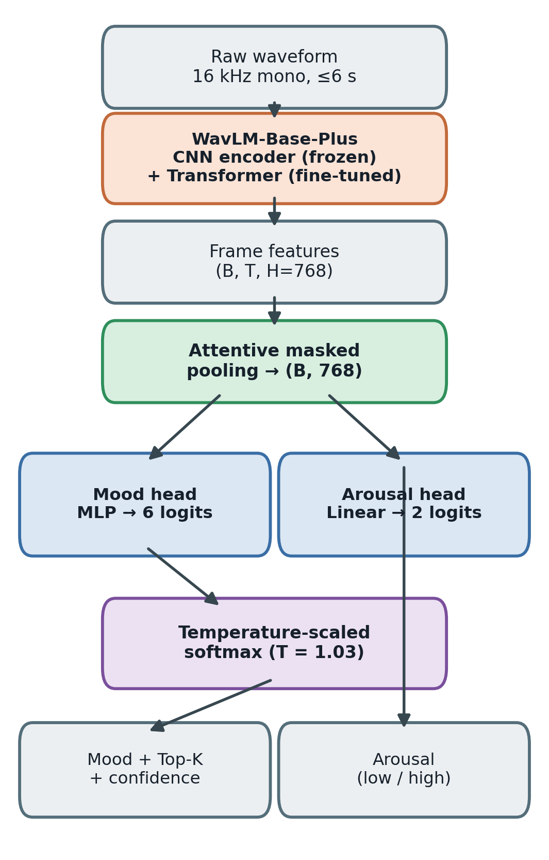
Fig. 2. Multi-task speech mood model. A frozen WavLM-Base-Plus feature encoder with fine-tuned transformer layers produces frame features that are aggregated by attentive masked pooling into a single embedding, which feeds a six-class mood head and a binary arousal head. Logits are divided by a fitted temperature (T ≈ 1.03) before the softmax.
At inference, the calibrated softmax yields a probability distribution over the six moods and over the two arousal levels. The service returns the top-1 mood, its confidence, the full top-k distribution, the arousal-head prediction, and the arousal implied by the top mood as a cross-check. Two optional variance-reduction mechanisms are supported: test-time augmentation (TTA), which averages predictions over several augmented views of the same clip, and multi-seed ensembling, which averages calibrated probabilities across checkpoints. Both are disabled by default in the deployed service to minimise latency. An abstention threshold can be applied so that low-confidence clips are labelled uncertain and escalated to a human instead of acted upon.
C. Training Strategy
The model is trained on four merged public acted-emotion corpora—RAVDESS, CREMA-D, TESS, and SAVEE—whose original emotion labels are remapped to the six clinical mood classes (for example, happy→Content, fearful→Anxious, angry/disgust→Agitated, sad→Low). Splits are speaker-disjoint and corpus-aware: no speaker appears in more than one split, and the validation set is sized realistically at roughly 15%. This protocol prevents the speaker leakage that would otherwise inflate accuracy. Table II summarises the architecture and training configuration.
The training objective and regularisers target imbalance, calibration, and robustness:
• Class-balanced focal loss. effective-number class weighting combined with focal loss handles the heavy imbalance (Calm is a small minority) without the degenerate over-prediction of naive inverse-frequency weighting.
• Auxiliary arousal task. the arousal head is trained jointly as a weighted auxiliary loss, regularising the shared representation and yielding the reliable coarse signal.
• Domain-aware augmentation. mild waveform augmentation (additive noise, gain, ≤2-semitone pitch shift, time-stretch) plus telephony band-pass (300–3400 Hz) and reverberation to simulate real microphones and channels; intensity is ramped over early epochs. SpecAugment masking is applied on hidden states during training only.
• Optimisation. discriminative learning rates, a cosine schedule with warm-up, progressive unfreezing of the encoder, gradient clipping, mixed precision, and early stopping on validation macro-F1. Model selection and calibration use the validation set only; the test set is read once.
TABLE II
Mood Model Architecture and Training Configuration
Item | Value
Backbone | WavLM-Base-Plus (hidden 768)
Feature encoder | Frozen (CNN); transformer fine-tuned
Pooling | Attentive masked pooling
Mood head | Linear-GELU-Dropout-Linear → 6
Arousal head | Linear → 2 (low / high)
Sample rate | 16 kHz mono, ≤6 s
Loss | Class-balanced focal + aux. arousal
Augmentation | Noise, gain, pitch, telephony, reverb
Calibration | Temperature scaling, T ≈ 1.03
Selection | Early stop on val. macro-F1

D. RAG Clinical Assistant
The assistant, shown in Fig. 3, answers clinical and caregiving questions while guaranteeing that patient-specific statements are grounded in the database. Incoming questions are first classified by a semantic router: the question is embedded with a Sentence-Transformers all-MiniLM-L6-v2 encoder (384 dimensions) and compared by cosine similarity against three intent prototypes—patient, knowledge, and hybrid. If the two top intents are within 0.05 of each other the query is treated as hybrid; if the best similarity is below 0.65 the router defers to the LLM for a single-word classification; otherwise the highest-scoring intent is used.
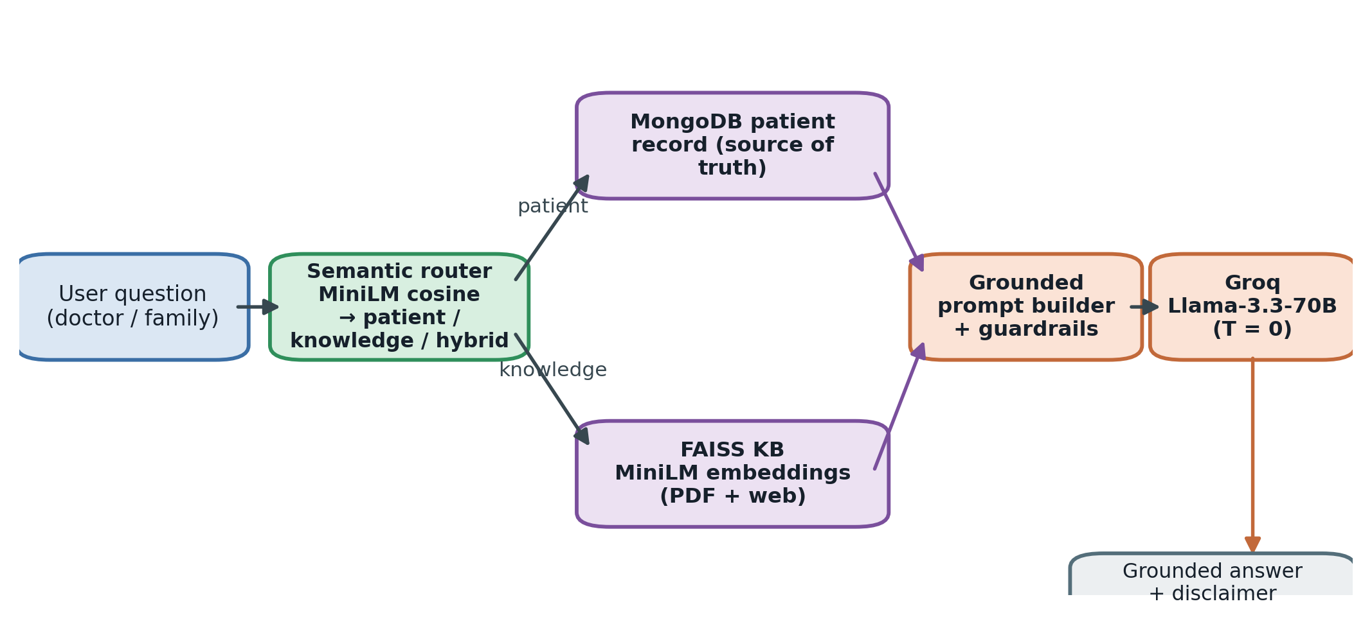
Fig. 3. Clinically-safe RAG pipeline. A MiniLM semantic router classifies each question as patient, knowledge, or hybrid. Patient facts are read verbatim from the MongoDB record (the sole source of truth); general medical context is retrieved from a FAISS knowledge base of curated PDFs and web sources. A guarded prompt is generated for a deterministic Groq-hosted Llama-3.3-70B model, and every answer carries a safety disclaimer.
General medical context is retrieved from a FAISS vector store built from approximately ninety Alzheimer’s and dementia PDFs (organised across eight topical folders) together with a small number of authoritative web sources, chunked with a recursive character splitter (500-character chunks, 100-character overlap) and embedded with the same MiniLM model. Retrieval fetches the six nearest chunks, keeps those below an L2 distance threshold of 1.20 (with a floor of two results), and returns at most four chunks as context.
Generation uses a Groq-hosted Llama-3.3-70B model at temperature 0 for deterministic, reproducible output. Three modes are supported. In patient mode (clinician audience) and family mode (compassionate, jargon-free audience) the prompt embeds the MongoDB patient record as the source of truth; in general mode, with no patient selected, only the knowledge base is used. A set of explicit anti-hallucination rules is enforced in the prompt: every patient claim must be traceable to a database field, the recorded Alzheimer’s stage must be reproduced verbatim, missing fields must be reported as “not recorded in the patient’s file,” retrieved knowledge may enrich but never override a database fact, and user claims that contradict the record are politely corrected. A short conversational memory (the last ten exchanges, isolated per user-and-patient session) provides continuity, and a medical disclaimer is appended to every response. Table V lists the configuration.
V. Experiments and Evaluation
We evaluate the two subsystems independently. The mood model is assessed on a speaker-disjoint test split of the merged corpora using accuracy, macro-F1, per-class confusion, training dynamics, and calibration error. The RAG assistant is assessed on a held-out set of twelve clinical/caregiving queries using standard retrieval metrics and an embedding-based semantic similarity between generated answers and reference answers.
A. Mood Model: Setup and Metrics
Reported figures span the range observed with and without TTA and ensembling. Six-class accuracy and macro-F1 measure fine mood recognition; low/high arousal accuracy measures the coarser, clinically prioritised signal; expected calibration error (ECE) measures how well the reported confidences match empirical correctness. Macro-F1 is the early-stopping criterion, which is appropriate given the class imbalance.
TABLE III
Speech Mood Model Performance
Metric | Result
6-class accuracy | 0.74 – 0.77
6-class macro-F1 | 0.73 – 0.76
Arousal accuracy (low/high) | 0.86 – 0.88
Peak validation macro-F1 | 0.82 (epoch 9)
ECE before calibration | 0.041
ECE after calibration (T≈1.03) | 0.039

Fig. 4 plots validation macro-F1 over training for the primary seed. Performance rises steeply in the first epochs and plateaus around 0.79–0.82, peaking at epoch 9; the chosen checkpoint achieves a validation macro-F1 of 0.816. The early plateau is consistent with the label-ambiguity ceiling of acted emotion data rather than with under-training.
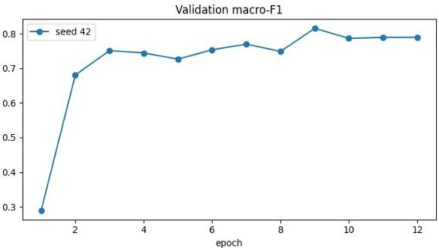
Fig. 4. Validation macro-F1 across training epochs (seed 42). The model converges quickly and peaks near epoch 9 at a macro-F1 of approximately 0.82.
Fig. 5 shows the row-normalised confusion matrix on the test split. The diagonal recalls—Calm 0.97, Neutral 0.87, Agitated 0.78, Content 0.68, Low 0.68, and Anxious 0.66—reveal the structure of the residual error. The dominant confusions are within-arousal: Content is most often confused with the other high-arousal classes, and the low-to-moderate-arousal negative states (Anxious, Low) are confused with their neighbours. This pattern confirms that fine mood error concentrates where valence is acoustically under-determined, and that collapsing to arousal recovers accuracy. The exceptionally high Calm recall partly reflects a corpus confound—Calm originates from a single corpus—and should be read with caution.
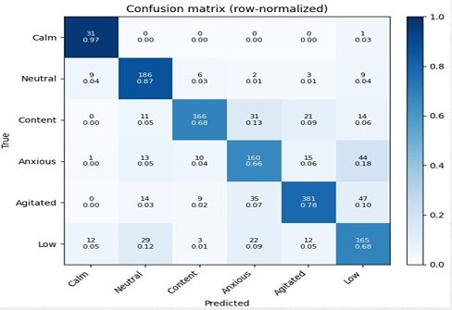
Fig. 5. Row-normalised confusion matrix on the speaker-disjoint test split. Errors concentrate within the same arousal band, e.g. Content↔Agitated and Anxious↔Low.
Fig. 6 presents reliability diagrams before and after temperature scaling. The model is already well calibrated—the curves track the diagonal closely—and a fitted temperature of 1.03 lowers the expected calibration error marginally from 0.041 to 0.039. The near-unity temperature indicates that the class-balanced focal objective produces confidences that are intrinsically reliable, which is important because downstream alerting and abstention act on these probabilities.
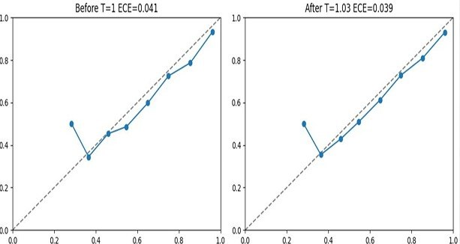
Fig. 6. Reliability diagrams before (left) and after (right) temperature scaling. Calibration is good a priori; the fitted temperature T = 1.03 reduces ECE from 0.041 to 0.039.
B. RAG Assistant: Setup and Metrics
The RAG assistant is evaluated on twelve held-out queries spanning patient-specific, general-knowledge, and hybrid intents. Retrieval quality is measured by precision (the fraction of retrieved chunks that are relevant), mean reciprocal rank (MRR, the rank of the first relevant chunk), and normalized discounted cumulative gain (NDCG, which rewards placing relevant chunks early). Routing accuracy measures whether the semantic router assigns the correct intent. Answer quality is measured by the cosine semantic similarity between the generated answer and a reference answer in the MiniLM embedding space. Table VI summarises the results.
TABLE IV
RAG Retrieval and Generation Results (n = 12)
Metric | Score
Retrieval precision | 0.95
Mean reciprocal rank (MRR) | 0.95
NDCG | 0.97
Routing accuracy | 1.00
Mean answer semantic similarity | 0.96

Fig. 7 summarises the four retrieval/routing metrics as a bar chart, and Fig. 8 presents the same scores on a radar plot, where the near-maximal enclosed area visualises uniformly strong performance across precision, MRR, NDCG, and routing. Routing accuracy reaches 1.00 on this set, indicating that the lightweight cosine-similarity router correctly separates patient-specific from general-knowledge intents.
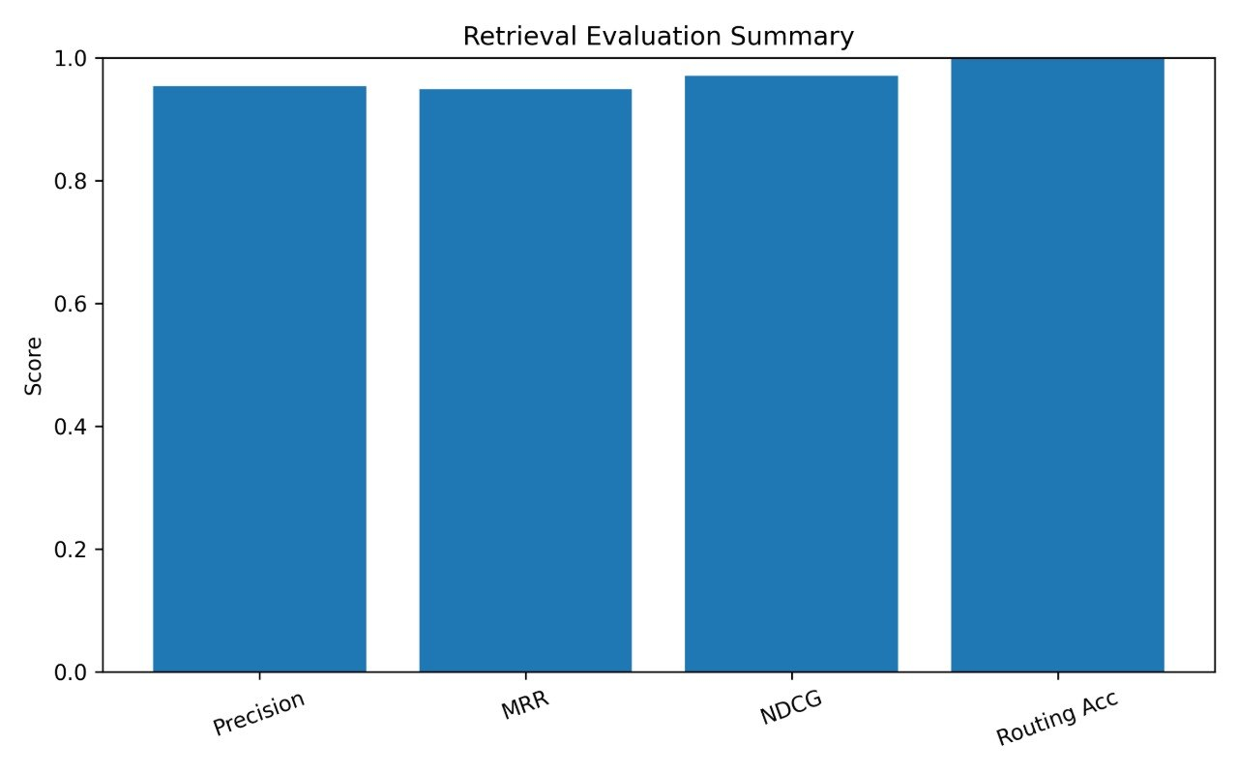
Fig. 7. Retrieval evaluation summary: precision, MRR, NDCG, and routing accuracy, all at or above 0.95.
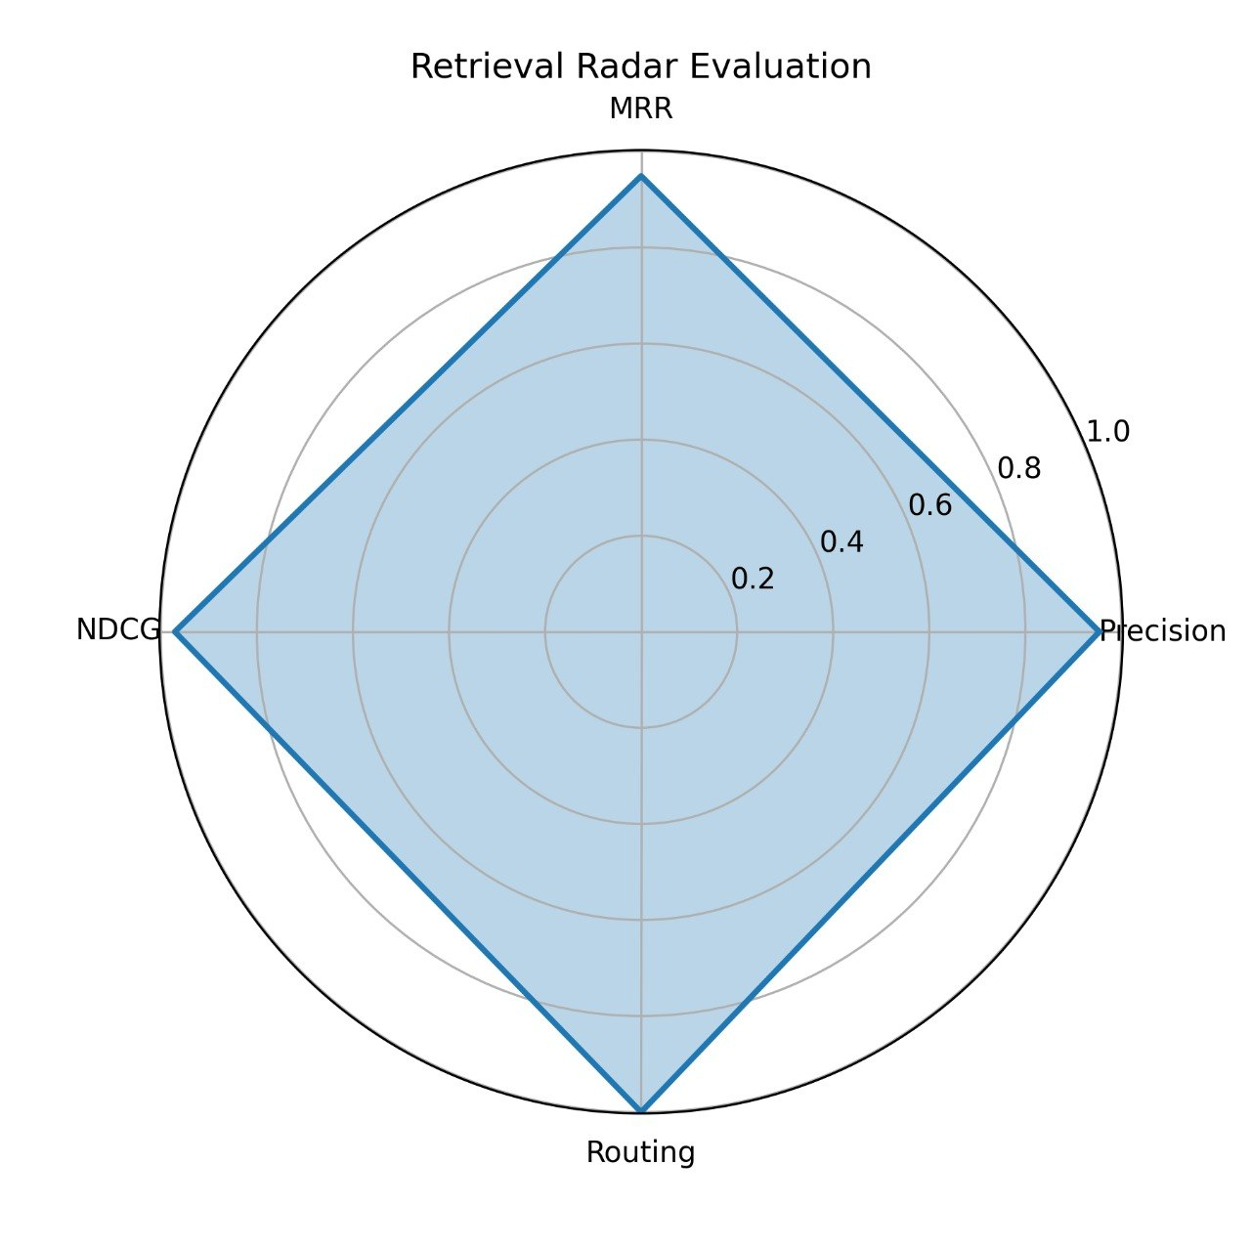
Fig. 8. Radar view of the four retrieval metrics; the near-maximal area indicates uniformly strong retrieval and routing.
Figs. 9–11 examine answer–reference semantic similarity in detail. The per-sample scatter (Fig. 9) shows that every one of the twelve queries scores between 0.82 and 1.00, with most near 1.0; the distribution (Fig. 10) is tightly concentrated with a median near 0.96; and the cumulative curve (Fig. 11) confirms that the bulk of probability mass lies above a 0.96 similarity threshold. Together these indicate that the grounded generator reproduces reference answers faithfully, with no catastrophic failures on the evaluated queries.
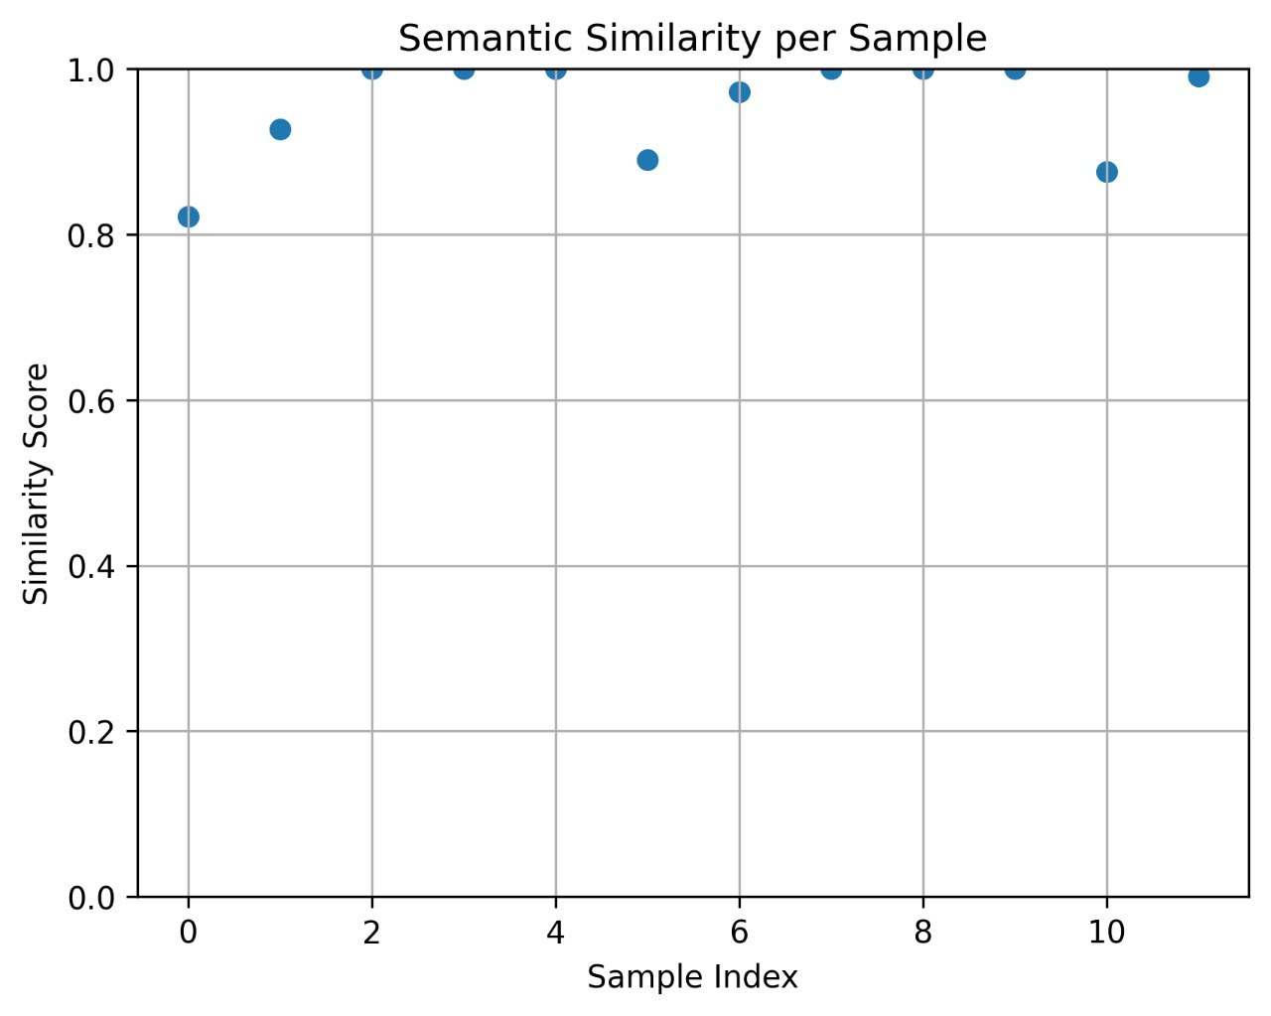
Fig. 9. Per-sample answer–reference semantic similarity for the twelve evaluation queries; all scores fall between 0.82 and 1.00.
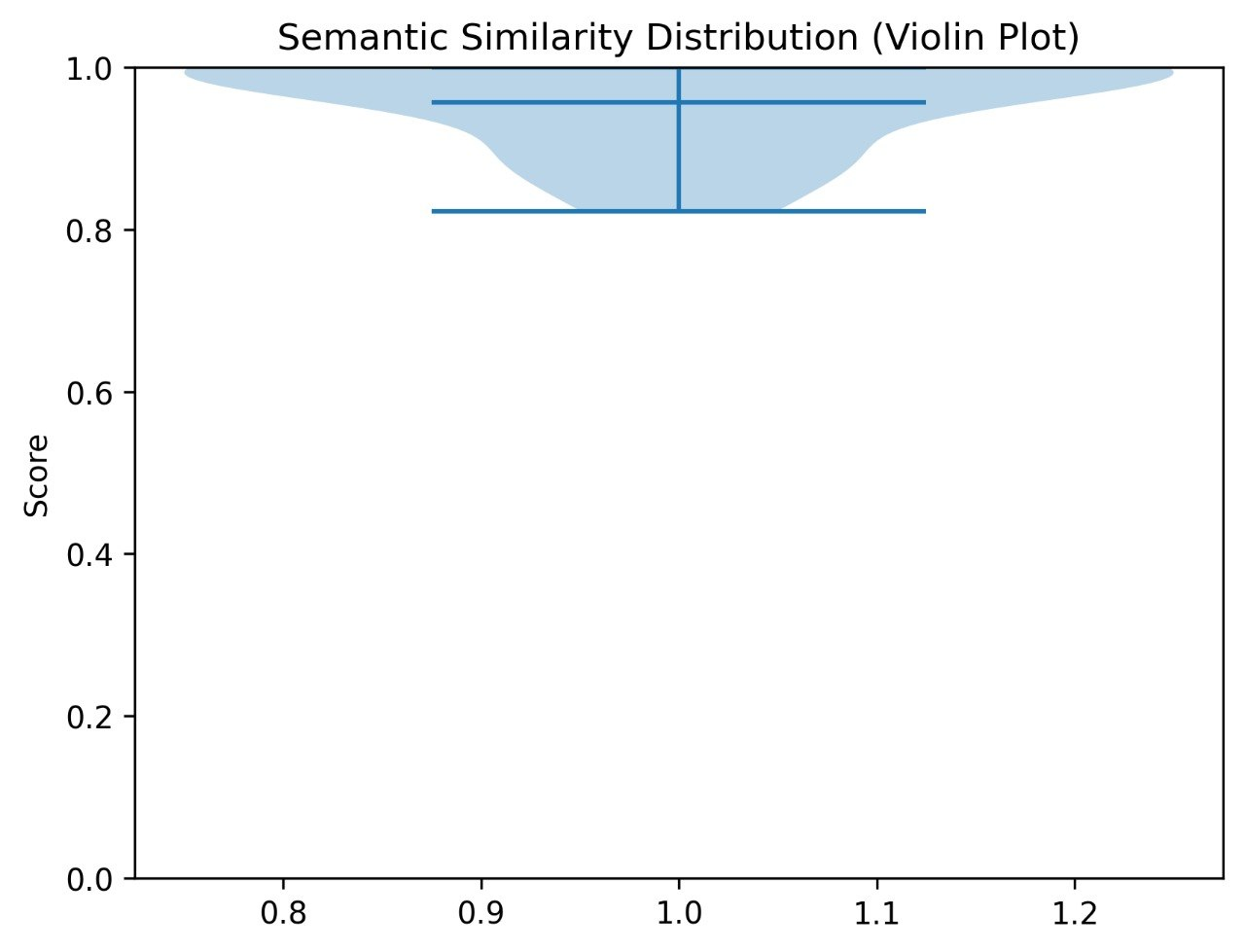
Fig. 10. Distribution of semantic-similarity scores (violin plot), concentrated near a median of approximately 0.96.
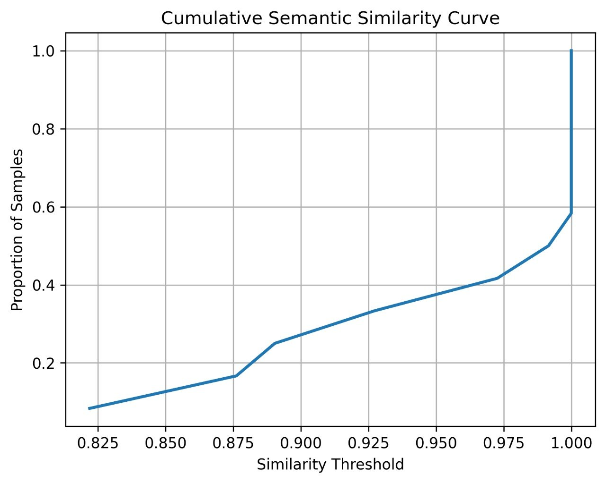
Fig. 11. Cumulative semantic-similarity curve: the proportion of samples meeting or exceeding each similarity threshold.
Finally, Fig. 12 plots the cumulative (running-average) retrieval metrics as queries are added. After an initial transient over the first few queries, precision, MRR, and NDCG all stabilise above 0.94, indicating that the reported averages are not driven by a small number of favourable cases but reflect consistent behaviour across the query set.
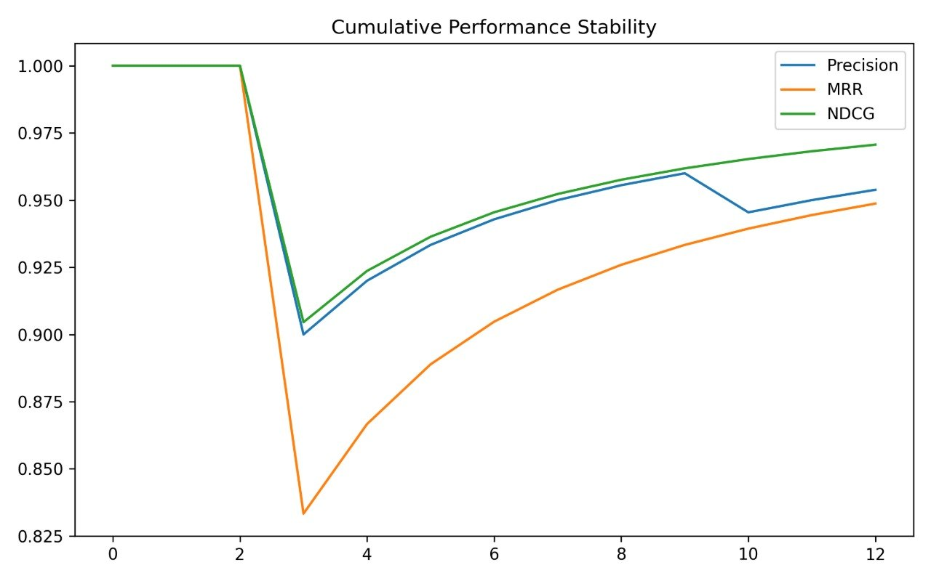
Fig. 12. Cumulative (running-average) precision, MRR, and NDCG. All three stabilise above 0.94 after the first few queries.
VI. Discussion
A. Strengths
The system’s principal strength is that it turns an otherwise unobserved signal—a patient’s moment-to-moment affective state—into a calibrated, queryable, and shareable record without specialised hardware. The multi-task design is well matched to the problem: by predicting arousal jointly with mood, the model exposes a coarse signal (0.86–0.88 accuracy) that is substantially more reliable than fine six-class mood and that aligns with the clinical priority of detecting agitation or distress. Calibrated probabilities and an abstention mechanism make the output safe to act on, and the strict grounding rules in the RAG assistant directly target the dominant risk of clinical LLMs—fabricated patient facts. Architecturally, decoupling inference into Python sidecars keeps the model independent of the web stack and allows the acoustic model to be upgraded without touching the application.
B. Limitations
Several limitations bound the interpretation of our results. First, the mood model is trained and evaluated on acted emotional speech recorded in clean conditions, mostly from younger speakers; real spontaneous speech from elderly patients in noisier settings constitutes an unmeasured domain shift, and real-world accuracy should be expected to be lower than the reported in-distribution figures. Second, a meaningful share of the six-class error is irreducible label ambiguity in perceived-emotion data, and some per-class results (notably Calm) are corpus-confounded. Third, the RAG evaluation set is small (twelve queries); the near-perfect retrieval and routing scores are encouraging but warrant a larger, independently-labelled benchmark before strong claims are made, and the similarity metric measures agreement with reference answers rather than clinical correctness per se. Finally, the system is a research prototype: it is not a medical device, has not undergone prospective clinical validation, and must not be used for autonomous clinical decisions.
C. Interpretation
Read together, the results support a clear design stance: treat fine mood as a soft, uncertain hint, treat arousal as the dependable monitoring signal, act on calibrated probabilities with abstention, and aggregate over time rather than over-interpreting any single clip. The RAG assistant should likewise be understood as a grounded information layer that surfaces and explains recorded facts and curated knowledge, not as an autonomous reasoner over patient care.
VII. Conclusion and Future Work
We presented ALZCare, an integrated platform that estimates patient mood and arousal from short voice recordings and delivers grounded clinical assistance through a retrieval-augmented language model. The speech model—a calibrated WavLM multi-task network—achieves 0.74–0.77 six-class accuracy, 0.73–0.76 macro-F1, and 0.86–0.88 arousal accuracy, while the RAG assistant attains 0.95 retrieval precision, 0.97 NDCG, perfect routing, and 0.96 mean answer similarity on a held-out query set. The whole system is deployed as a role-aware MERN application with real-time distress alerting.
Future work follows directly from the limitations. The highest-value next step is domain adaptation to clinician-labelled spontaneous patient speech, accompanied by honest leave-one-corpus-out and prospective evaluation. A dedicated, calibrated binary distress/agitation detector may prove both more reliable and more clinically useful than fine mood classification. Temporal modelling—aggregating predictions across a monitoring window with uncertainty propagation—would convert noisy per-clip estimates into trustworthy trends. On the assistant side, a larger independently-labelled evaluation benchmark, citation of retrieved passages in answers, and subgroup fairness analysis are the natural priorities. Scalability and real-world deployment would further benefit from containerised, horizontally scalable inference services and on-device pre-processing to reduce the transmission of raw audio.
TABLE V
RAG Assistant Configuration
Item | Value
Embedding model | all-MiniLM-L6-v2 (384-d)
Vector store | FAISS (local)
Chunking | 500 chars, 100 overlap
Retrieval | k = 6, L2 < 1.20, ≤4 kept
Knowledge base | ≈90 PDFs + web sources
Generator | Groq Llama-3.3-70B (T = 0)
Router thresholds | conf. 0.65, gap 0.05
Memory | last 10 exchanges / session

References
[1] A. Baevski, H. Zhou, A. Mohamed, and M. Auli, “wav2vec 2.0: A framework for self-supervised learning of speech representations,” in Adv. Neural Inf. Process. Syst. (NeurIPS), vol. 33, 2020, pp. 12449–12460.
[2] W.-N. Hsu, B. Bolte, Y.-H. H. Tsai, K. Lakhotia, R. Salakhutdinov, and A. Mohamed, “HuBERT: Self-supervised speech representation learning by masked prediction of hidden units,” IEEE/ACM Trans. Audio, Speech, Lang. Process., vol. 29, pp. 3451–3460, 2021.
[3] S. Chen et al., “WavLM: Large-scale self-supervised pre-training for full stack speech processing,” IEEE J. Sel. Topics Signal Process., vol. 16, no. 6, pp. 1505–1518, 2022.
[4] S. Yang et al., “SUPERB: Speech processing universal performance benchmark,” in Proc. Interspeech, 2021, pp. 1194–1198.
[5] S. R. Livingstone and F. A. Russo, “The Ryerson audio-visual database of emotional speech and song (RAVDESS),” PLoS ONE, vol. 13, no. 5, e0196391, 2018.
[6] H. Cao, D. G. Cooper, M. K. Keutmann, R. C. Gur, A. Nenkova, and R. Verma, “CREMA-D: Crowd-sourced emotional multimodal actors dataset,” IEEE Trans. Affect. Comput., vol. 5, no. 4, pp. 377–390, 2014.
[7] Y. Cui, M. Jia, T.-Y. Lin, Y. Song, and S. Belongie, “Class-balanced loss based on effective number of samples,” in Proc. IEEE/CVF CVPR, 2019, pp. 9268–9277.
[8] T.-Y. Lin, P. Goyal, R. Girshick, K. He, and P. Dollár, “Focal loss for dense object detection,” in Proc. IEEE Int. Conf. Comput. Vis. (ICCV), 2017, pp. 2980–2988.
[9] D. S. Park et al., “SpecAugment: A simple data augmentation method for automatic speech recognition,” in Proc. Interspeech, 2019, pp. 2613–2617.
[10] C. Guo, G. Pleiss, Y. Sun, and K. Q. Weinberger, “On calibration of modern neural networks,” in Proc. Int. Conf. Mach. Learn. (ICML), 2017, pp. 1321–1330.
[11] P. Lewis et al., “Retrieval-augmented generation for knowledge-intensive NLP tasks,” in Adv. Neural Inf. Process. Syst. (NeurIPS), vol. 33, 2020, pp. 9459–9474.
[12] N. Reimers and I. Gurevych, “Sentence-BERT: Sentence embeddings using Siamese BERT-networks,” in Proc. Conf. Empirical Methods Nat. Lang. Process. (EMNLP), 2019, pp. 3982–3992.
[13] W. Wang, F. Wei, L. Dong, H. Bao, N. Yang, and M. Zhou, “MiniLM: Deep self-attention distillation for task-agnostic compression of pre-trained transformers,” in Adv. Neural Inf. Process. Syst. (NeurIPS), vol. 33, 2020, pp. 5776–5788.
[14] J. Johnson, M. Douze, and H. Jégou, “Billion-scale similarity search with GPUs,” IEEE Trans. Big Data, vol. 7, no. 3, pp. 535–547, 2021.
[15] A. Dubey et al., “The Llama 3 herd of models,” arXiv preprint arXiv:2407.21783, 2024.
[16] K. He, X. Zhang, S. Ren, and J. Sun, “Deep residual learning for image recognition,” in Proc. IEEE/CVF CVPR, 2016, pp. 770–778.
[17] P. Khosla et al., “Supervised contrastive learning,” in Adv. Neural Inf. Process. Syst. (NeurIPS), vol. 33, 2020, pp. 18661–18673.
[18] A. Vaswani et al., “Attention is all you need,” in Adv. Neural Inf. Process. Syst. (NeurIPS), vol. 30, 2017, pp. 5998–6008.
[19] K. Järvelin and J. Kekäläinen, “Cumulated gain-based evaluation of IR techniques,” ACM Trans. Inf. Syst., vol. 20, no. 4, pp. 422–446, 2002.
[20] G. M. McKhann et al., “The diagnosis of dementia due to Alzheimer’s disease,” Alzheimer’s & Dementia, vol. 7, no. 3, pp. 263–269, 2011.
[21] C. Ballard, J. Corbett, and S. Reichelt, “Management of neuropsychiatric symptoms in people with dementia,” CNS Drugs, vol. 25, no. 9, pp. 729–739, 2011.
[22] J. Devlin, M.-W. Chang, K. Lee, and K. Toutanova, “BERT: Pre-training of deep bidirectional transformers for language understanding,” in Proc. NAACL-HLT, 2019, pp. 4171–4186.

