**Hyperlordosis**

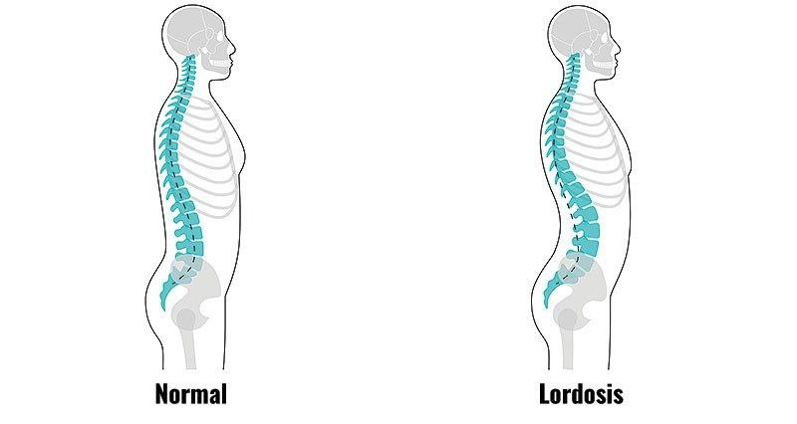**Symptoms:-**

**⁕⁕**An increase in lumbar lordosis, and an increase in the anterior pelvic tilt and hip flexion. It is often seen with increased thoracic kyphosis and forward head and is called *kypholordotic posture.*

1. Increased curving of the spine.
2. a protruding stomach, and buttocks that are pushed outwards
3. Sever lower back pain
4. Difficulty moving due to muscle tightening and stiffness in lower back
5. Numbness →some individuals may notice a tingling sensation
6. Loss of bladder control

**Causes:-**

1. Tightness of posterior longitudinal ligament and lower back extensor and hip flexor
2. Weakness hamstring muscle
3. Stretched anterior longitudinal ligament and lower abdominal
4. Sitting or standing for extended period
5. Compressed vertebrae posterior
6. **Slouching** → can contribute to hyperlordosis and back pain.
7. Obesity
8. pregnancy
9. Lack of exercise
10. Wearing high heeled shoes for extended period
11. Spondylolisthesis
12. Spinal injury
13. Neuromuscular disease
14. Rickets
15. Osteoporosis

**Treatment :-**

⁕⁕You can check your posture with **a simple test:**

* Stand up straight against a wall.
* Your head, shoulder blades, and bottom should touch the wall. There should be just enough space to slip your hand between the wall and the small of your back.
* With hyperlordosis, there will be more than one hand space between the wall and your back.
* **Strength the abdominal muscle:**
* <https://youtu.be/8VAE4p8C5RM>
* <https://u.pcloud.link/publink/show?code=XZiASCVZrAkeyk8vg9F0f6k4YbI82kGgXVMk>
* **Strength the gluteus muscle:**
* <https://youtu.be/4Gdh_Go2tAw>
* <https://youtu.be/YaXPRqUwItQ> (for squat)
* **Stretch the back muscles:**
* <https://youtu.be/buF1v8aiTvM>
* **Stretch the hip flexor muscles:**
* <https://youtu.be/7bRaX6M2nr8>