***Scoliosis***

* ***Symptoms of scoliosis***
* ***A visibly curved spine.***
* ***Leaning to 1 side.***
* ***Uneven shoulders.***
* ***1 shoulder or hip sticking out.***
* ***The ribs sticking out on 1 side.***
* 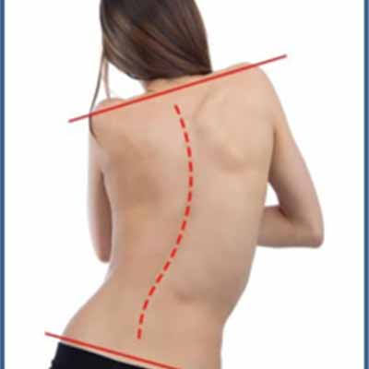***Clothes not fitting well.***
* ***How do you describe scoliosis posture?***

***‏***

***Often someone with scoliosis will lean forwards and to the side either slightly or a lot. They will often try to avoid doing this, which can lead to slightly bent knees and the pelvis tilting backwards. The ideal posture when standing is to have weight evenly spread***

* ***Causes***

***Certain neuromuscular conditions, such as cerebral palsy or muscular dystrophy.***

***Birth defects affecting the development of the bones of the spine.***

***Previous surgery on the chest wall as a baby.***

***Injuries to or infections of the spine.***

***Spinal cord abnormalities***

* ***How to avoid scoliosis***

***Most cases of scoliosis have no known cause.***

***“Parents tend to ask what they could have done to prevent scoliosis,” says Sponseller, “but scoliosis is a very interesting disease because there is currently no known cause or prevention method***

* ***Treatment***

***.Painkillers. Painkilling tablets may help relieve the pain that can be associated with scoliosis. …***

***.Exercise. Activities that strengthen and stretch your back may help reduce your pain. …***

***.Spinal Injections. …***

***.Back braces. …***

***.Surgery.***

* ***Home exercises***

[***https://youtu.be/wmk5Mvz4pe8***](https://youtu.be/wmk5Mvz4pe8)

[***https://youtu.be/k9wph_-iKys***](https://youtu.be/k9wph_-iKys)