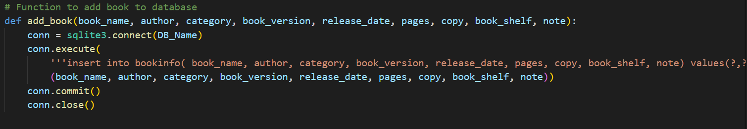**backnd.py:-**   
1.

this function used to add information of book to database.

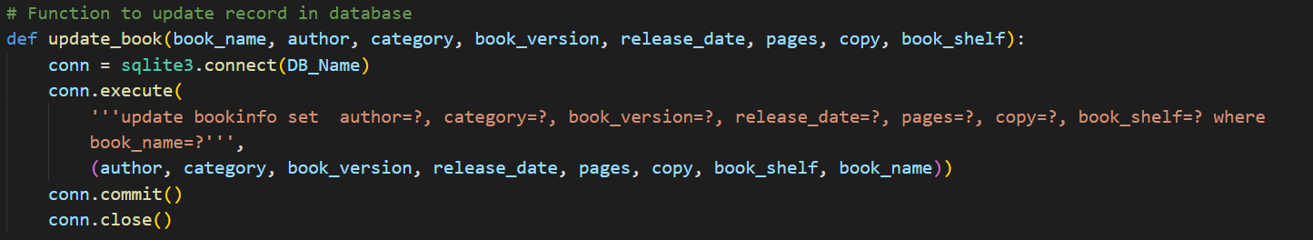2.

this function used to update information of book in database.

3.

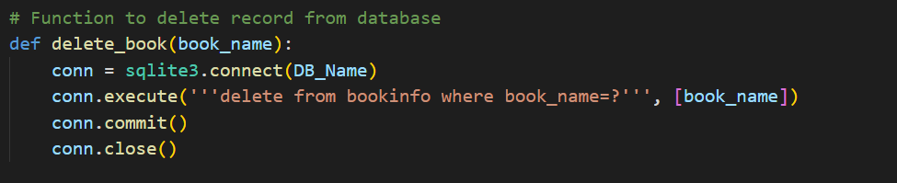

this function used to delete a book from database.

4.

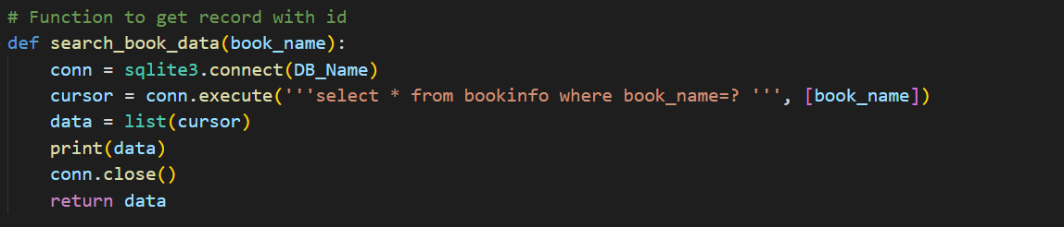 this function used to search about book in database.

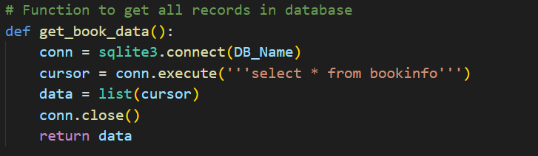5.

this function used to return data of all books from database.

6.

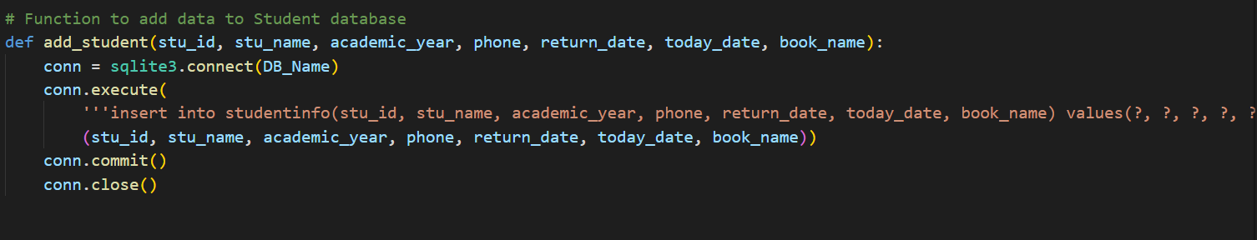 this function used to add student information to database.

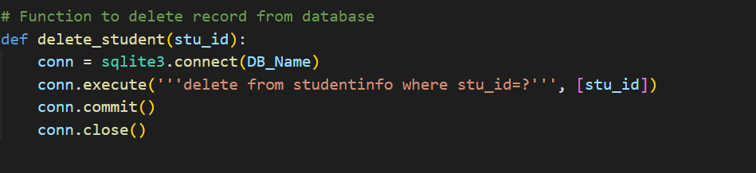7.

this function used to delete a student from database.

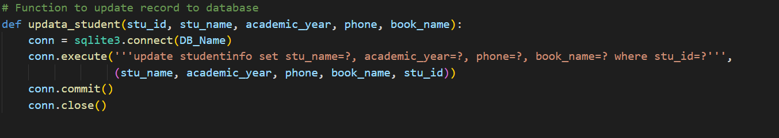8.

this function used to update information of student in database.

9.

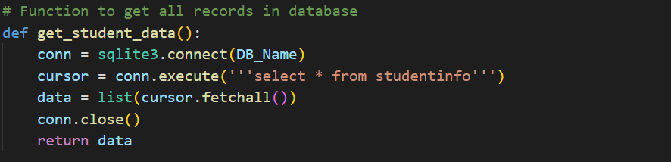

this function used to return data of all students from database.

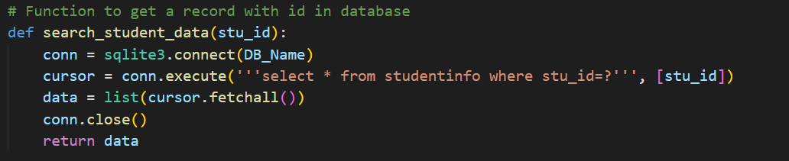10.

this function used to search about student in database.

11.

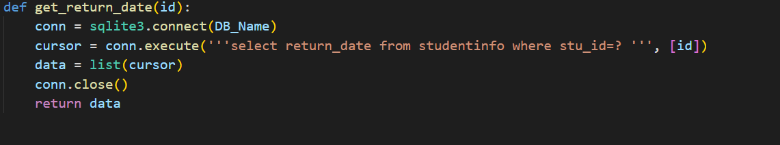this function used to return all ids of students in database.

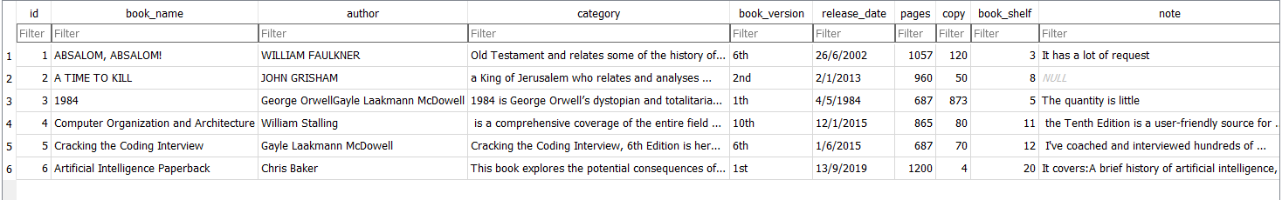Book database table:-

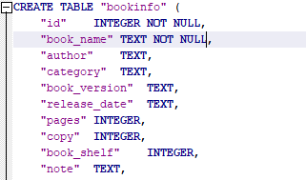 Code:-

Student database table:-

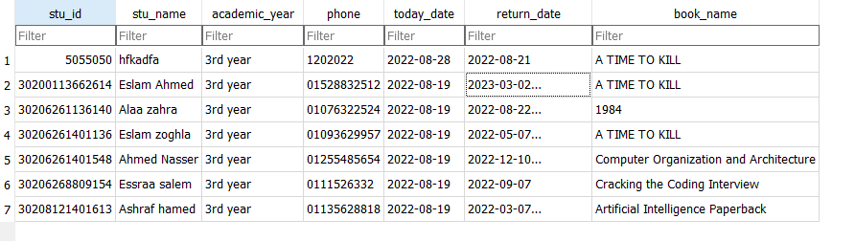code:-

