**Faculty of Computers & Artificial Intelligence Benha University**

**Software Requirements**

**Specification for Smart Irrigation**

**System**

**Team Members**

* أحمد ناصر امام ابراهيم إسماعيل (Section 2)
* عاصم صابر محمد عراقي (Section 4)
* أمجد محمد سالم طايل (Section 2)
* عبد الرحمن محمد على بدر (Section 4)
* عبد الرحمن عبده حسن احمد (Section 4)
* آية رجب حسين علي (Section 2)
* إسراء محمد سالم سالم على (Section 1)

**Dr. Tarek El-Sheshtawy**

**Table of Contents**

Contents

**1.** **Preface** 2

**2.** **Glossary** 2

**3.** **Introduction** 3

**4.** **User requirements definition** 5

**5.** **System Architecture** 5

**6.** **System requirements specification** 6

**6.1** **Functional Requirements:** 6

**6.2** **Non-functional requirements:** 7

**6.3** **Safety requirements:** 7

**7.** **System models** 8

**7.1** **Use case Diagram** 8

**7.2** **Activity Diagram** 15

**7.2.1** **Login Activity** 16

**7.2.2** **Modify Activity** 17

**7.2.3** **Automated Activity** 18

**7.3** **Class Diagram** 19

**7.4** **Sequence Diagram** 20

**7.4.1** **Login Sequence** 20

**7.4.2** **Modify Sequence** 21

**7.4.3** **Automated Sequence** 22

**7.5** **ERD** 23

**7.6** **DFD** 24

**7.6.1** **Context Diagram** 24

**7.6.2** **Level 0** 25

**7.6.3** **Level 1** 25

**7.7** **Context Model** 26

**7.8** **State Machine Diagram** 27

**8.System evolution** 28

**9.Appendices** 28

**10.Database for Agricultural Crops** 29

1. **Preface**

The key objective of the paper is to monitor the soil’s moisture content during its dry and wet conditions with the aid of a moisture sensor circuit, calculate the corresponding relative humidity and irrigate it based on its nature using a **pc based LABVIEW system, NI My RIO** which can monitor and record temperature, humidity and sunlight, which Is constantly modified and can be controlled in future to optimize these resources so that the plant growth and yield is maximized.

A record of soil moisture, temperature, rainfall is maintained in a database for backup. This backup is used for weather forecasting and directs the farmers regarding the type of crop to be cultivated in future. IOT gives the whole information to the operator about the irrigation. In this paper, we experiment for different soils suitable for different crops in various climatic parameters that govern plant growth and allow information to be collected at high frequency and with less labor requirements.

1. **Glossary**

**TWR**: Total Water Requirement

**NIR**: Net Irrigation Requirement

**IOT**: Internet of Things

**Ni my RIO**: National Instruments my Reconfigurable Input Output

1. **Introduction**

Agriculture is an important industry as well as the foundation of the economy.  Agriculture automation is a major concern and emerging topic for all countries. The world's population is rapidly increasing, and as the population grows, the demand for food increases Especially a country the size of **Egypt.**

The importance of implementing the smart irrigation system in Egypt has increased after the problem of water shortage resulting from the construction of the Renaissance Dam and the Egyptian state’s keenness to make maximum use of every water point. One of the methods of water conservation is the application of the irrigation system and its application for large farms and small fields instead of old irrigation methods such as ditch irrigation, terraced irrigation, drip irrigation, these ancient methods caused a very large amount of water to be lost.

 The developing need for food, as well as changing consumer demands, have made it extremely difficult for the agriculture industry to develop techniques and practices that will allow them to fully satisfy the increasing needs and requirements. It is critical to make use of the agricultural resources **Egypt** rely on the agricultural sector; **Smart irrigation** is emerging as new scientific disciplines that use data-intensive methods to increase agricultural productivity while reducing its environmental impact.

**Aim** is to develop a wireless three level controlled ***smart irrigation system*** to provide irrigation system which is automatic for the plants which help in saving water and money. The main objective is to apply the system for improvement of health of the soil and hence the plant via multiple sensors.

Appropriate soil water level is a necessary pre-requisite for optimum plant growth. Also, water being an essential element for life sustenance, there is the necessity to avoid its undue usage. Irrigation is a dominant consumer of water. This calls for the need to regulate water supply for irrigation purposes. Fields should neither be over-irrigated nor under-irrigated. The objective of this thesis is to design a simple, easy to install methodology to monitor and indicate the level of soil moisture that is continuously controlled in order to achieve maximum plant growth and simultaneously optimize the available irrigation resources on monitoring software LabVIEW and the sensor data can be seen on Internet.

**The Internet of Things (IoT)** is transforming the agriculture industry and enabling farmers to contend with the enormous challenges they face.

In order to replace expensive controllers in current available systems, the Arduino Uno will be used in this project as it is an affordable microcontroller. **NI My RIO** can be programmed to analyze some signals from **sensors** such as moisture, temperature, and rain. A pump is used to pump water into the irrigation system. The use of easily available components reduces the manufacturing and maintenance costs. This makes the proposed system to be **an economical, appropriate and a low maintenance solution for applications, especially in rural areas and for small scale agriculturists**. This research work enhanced to help the small-scale cultivators and will be increase the yield of the crops then will increase **government economy.**

Automating farm or nursery irrigation permits farmers to use the correct quantity of water at the correct time, regardless of the provision of labor to show valves on and off. Additionally, farmer’s mistreatment automation instrumentation is able to scale back runoff from over watering saturated soils, avoid irrigating at the incorrect time of day which will improve crop performance by making certain adequate water and nutrients once required.

By saving the water that comes from rain, we can transport the exceeded amount of water to external tanks. Those valves are also simply automated by mistreatment controllers. Automating farm or nursery irrigation permits farmers to use the correct quantity of water at the correct time, no matter the provision of labor to show valves on and off. They lack in an exceedingly featured **Desktop application** developed for users with acceptable user interface. It solely permits the user to observe and maintain the wetness level **remotely using PC LABVIEW.** We can determine the needed amount of water for each crop through using a specific database.

1. **User requirements definition**

This is system emphasizes on the fact that it can help monitoring the soil’s nature, enables agriculturalists feasibility of humidity measurements, and estimating the monitoring the soil’s moisture content and controlling it concurring to the necessity for the purpose of optimizing these resources so that the plant growth and yield is maximized.

1. **System Architecture**

1. **System requirements specification** 
   1. **Functional Requirements:**

* What the system does:

It is an automatic irrigation system that receives sensors such as temperature, soil moisture level, light, and rain coming from the sensors in the field continuously and sends them to the microcontroller (RIO), so it translates these sensors and deals with them. The microcontroller controls the amount of water in the soil using sensor measurements and turns on and off the motor. If the water rises to a dangerous level, the microcontroller will automatically stop the motor. If excess water is found in the soil, it is stored in the tanks

and sends the report continuously to the system. The user can control the system and add any modifications.

* The component of the system
* **NI myRIO 1900:**

Microcontroller connected to the sensors (Soil moisture sensor, Temperature sensor, Light sensor, Rain sensor) to receive signals from them and collaborate with the system.

* **Soil moisture sensor:**

It is used to measure the soil moisture level and send the measurements to the microcontroller.

.

* **Temperature sensor**:

It is used to measure temperatures and send readings to the microcontroller.

* **Rain Sensor:**

It determines the rainfall in the field and sends a signal to the microcontroller.

* **Light sensor**:

This sensor determines day from night and sends the sensor to the microcontroller.

* **Motor Driver:**

This motor controls the (on/off) of the pumps and receives commands from the microcontroller and the user.

* **Tanks:**

There are tanks to store the exceeded amount of water that comes from rain.

* **PC with LABVIEW:**

There is a lab for analyzing the data and determining the water level in a specific range determined by the system.

* **Human resources:**

1. Users trained to use the system.
2. Developers install, modify, maintain the system.
   1. **Non-functional requirements:**
   * **Operational requirements:**
     + the system will operate within windows environment.
     + The analysis will be viewed on the system.
   * **Performance requirement:** 
     + The system should be available to provide crops with water when the crops need it.
     + The system should perform reliability and deliver the correct amount of water for the crops.
     + The system should act upon the exceeded amount of water through storing it in tanks and may use it for irrigation if needed.
   1. **Safety requirements:**

* the essential safety requirements is the amount of water used should not exceed the need of the crop.
* For security reasons, when there is a large amount of water, the system should reduce it by transferring it to external tanks.

1. **System models**
   1. **Use case Diagram**

|  |  |
| --- | --- |
| Login | Use Case Name: |
| The user must enter a password and a username so as not to use this system who are not qualified for that | Introduction: |
| Farmer, analyst | Actors: |
| Farmer and analyst must have username and password to enter the system  Famer must be trained to use the system | Preconditions: |
| 1. User inserts his username and password  2. Determine you are farmer or analysts  3.if the user is a farmer  monitor the system by lab_view and control pump | Normal Flow: |
| If the user is an analyst he can add, access and maintain database (type of the crops, the right amount of water for crops, ...etc.) | Alternative Flows: |
| In step 1 in the normal flow: If user enters invalid username and password  1. Transaction is disapproved  2. Message to user to re-enter username and password | Exceptions: |

|  |  |
| --- | --- |
| Modify Database | Use Case Name: |
| It is the database in which all information related to the crop is stored in terms of the type of crop and the amount of water it needs | Introduction: |
| Analyst | Actors |
| the analyst must have sufficient experience about the crop and the appropriate conditions for it | Preconditions: |
| Provide the correct information about the types of crops in the database to build a correct database | Postconditions: |
| 1-search for the crop  2- if the crop is found, you can update the information of the crop or delete it  Else add information for a new crop. | Normal Flow: |
| When there is an error in the database, for example if the amount of water is more than the crop needs, warn the user that this will harm the crop | Exceptions: |

|  |  |
| --- | --- |
| Control by NI my_RIO | Use Case Name: |
| NI my_RIO is the main controller of the system as it is able to make decisions based on the readings taken from the sensors and the information in the database | Introduction: |
| It must be connected to all parts of the system, such as sensors, and receive correct readings from these components | Preconditions: |
| Be able to make the right decisions that are appropriate to the need of the crop | Postconditions: |
| 1. The readings are taken from the sensors in the field 2. The database is checked to find out the appropriate amount of water for the crop based on the readings taken from the sensors 3. it decides how much water is needed 4. It sends orders for motor driver to open the pump and pump water 5. When the crop gets the required amount of water, it gives orders to motor driver to close the pumps | Normal Flow: |
| In the event of receiving a signal from the rain sensor that it is raining, orders must be given to close the pumps | Alternative Flows: |
| 1-control by NI my_RIO includes modify database case.  2-control by NI my_RIO includes sensors process | Relations: |
| If the readings coming from the sensors do not match the readings stored in the database, it gives a message to update the database and add the new readings. | Exceptions: |

|  |  |
| --- | --- |
| System monitoring by lab_view | Use Case Name: |
| These laboratories are connected to all components of the system, providing the user with comprehensive monitoring of all parts of the system | Introduction: |
| Analyst, farmer | Actors: |
| it must have knowledge of all the components of the system and analyze the readings coming from the sensor, as well as the commands directed to the system and follow up on everything that happens in the system. | Preconditions: |
| The user is able to monitor everything that is happening in the system | Postconditions: |
| Presents a report about the amount of water used on the crops | Normal Flow: |
| 1-system monitoring by lab_view includes control by NI my_RIO case  2-system monitoring by lab_view includes modify database case | Relationships: |
| When any error occurs in the system, it gives a warning message to the user | Exceptions: |

|  |  |
| --- | --- |
| Open and close by motors driver | Use Case Name: |
| This motor controls the opening and closing of pumps and sprinklers as it receives these commands from NI my_RIO | Introduction: |
| The motor driver must be connected to the pumps | Preconditions: |
| It can directly control the opening and closing of pumps | Postconditions: |
| 1-Receives orders from my RIO to pump water  22-He opens the pumps and pumps water into the soil  3-When the amount of water required for the crop is pumped, it receives an order from NI my_RIO to stop pumping water into the soil  4-He shuts down the pumps and stops pumping water into the soil | Normal Flow: |
| If no commands are received from NI my_RIO, the motor will continue to turn off the pump | Alternative Flows: |
| open and close by motors driver excludes control by NI my_RIO | Relationships: |

|  |  |
| --- | --- |
| pumping water by pump and sprinklers | Use Case Name: |
| These pumps and sprinklers control the amount of water flowing into the soil by opening and closing them by the motor driver | Introduction: |
| they must be well connected to the motor driver | Preconditions: |
| They are controlled by the motor and are opened and closed according to the system's request | Postconditions: |
| 1-When the system needs to pump water, these pumps and sprinklers are opened by the motor driver  2-When the required amount of water is pumped, these pumps and sprinklers are closed by the motor driver too | Normal Flow: |
| Pumping water by pump and sprinklers excludes open and close by motors driver | Relationships: |

|  |  |
| --- | --- |
| Sensor process | Use Case Name: |
| These sensors are present in the soil and carry out various measurements such as measuring humidity, temperature, and rainfall. There are four types in the system (**Soil moisture sensor, Temperature sensor, Rain Sensor, and Light sensor**). | Introduction: |
| They must be properly connected on the hardware side | Preconditions: |
| They provide correct readings to control NI my_RIO | Postconditions: |
| 1- Read environmental factors such as soil moisture and temperature  2- It sends the readings to NI my_RIO | Normal Flow: |

* 1. **Activity Diagram**
     1. Diagram

        Description automatically generated**Login Activity**

* + 1. Diagram

       Description automatically generated**Modify Activity**

* + 1. **Automated Activity**

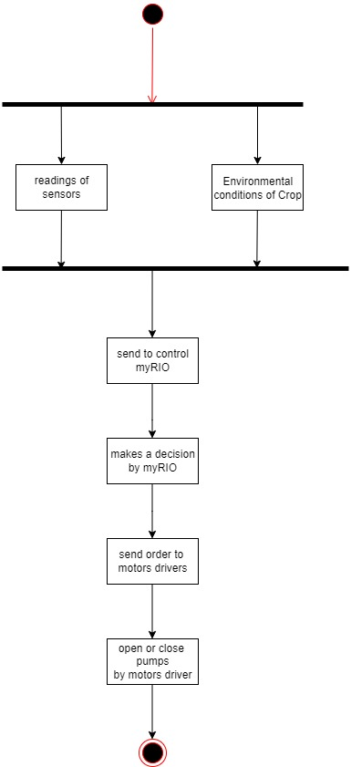

* 1. **Class Diagram**

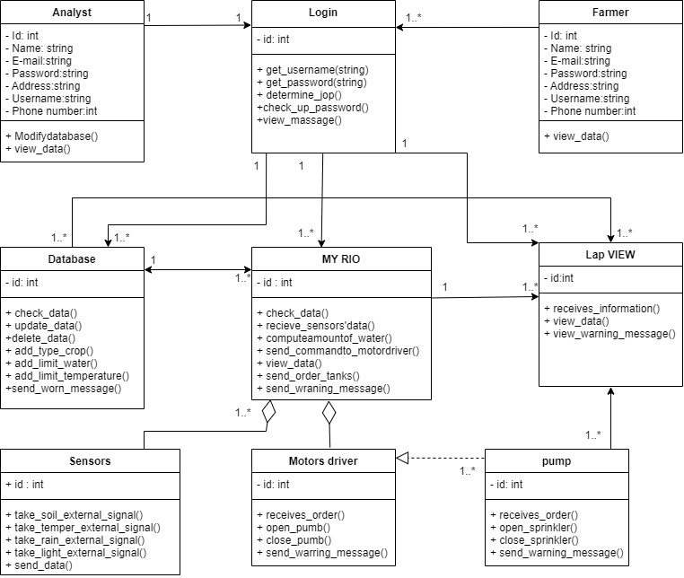

* 1. **Sequence Diagram**
     1. **Login Sequence**

* + 1. 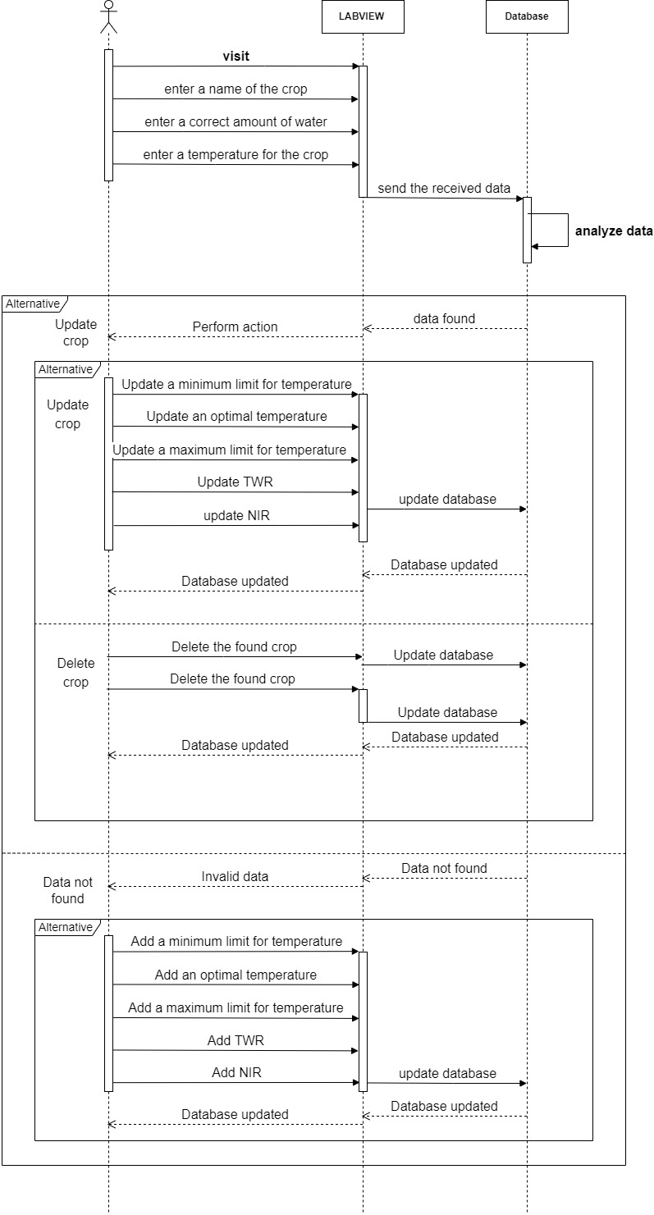**Modify Sequence**
    2. **Automated Sequence**

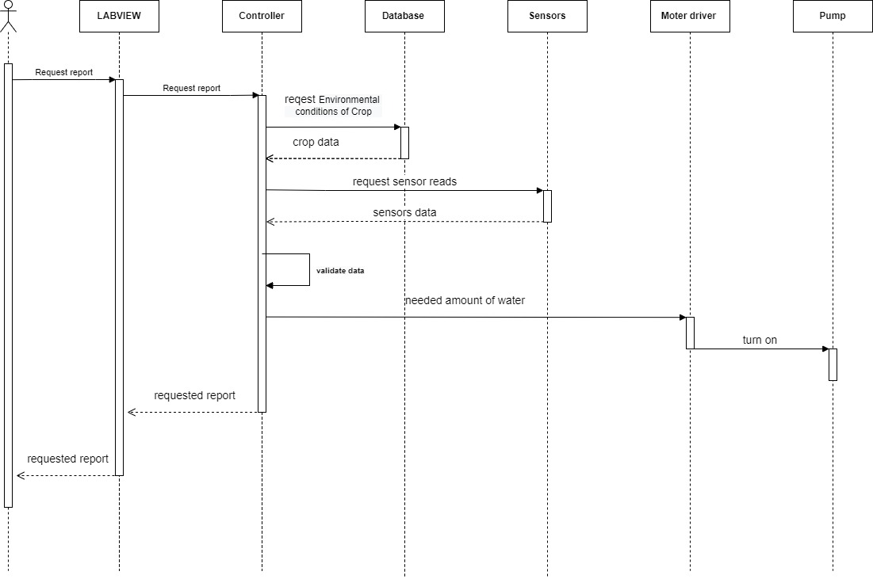

* 1. **ERD**

* 1. **DFD**
     1. **Context Diagram**

* + 1. **Level 0**
    2. Diagram

       Description automatically generatedDiagram, engineering drawing

       Description automatically generated**Level 1**
  1. **Context Model**

* 1. **State Machine Diagram**

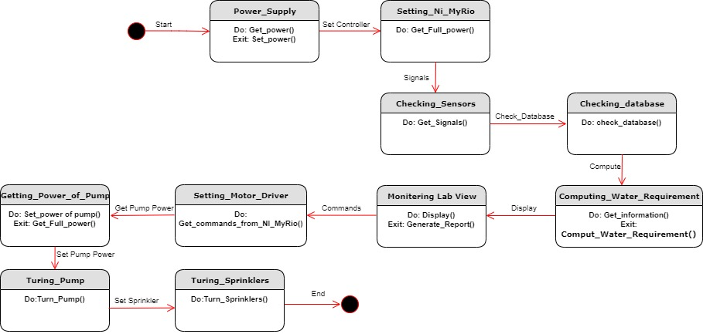

**8.System evolution**

We can interface LCD screen in order to display the current status of the soil moisture content levels, percentage of water utilized to water the plant, duration of time for which the water pump is ON, etc. We can also show the graphical representation of the moisture content levels in the soil. To improve the efficiency and effectiveness of the system, the following recommendations can be put into consideration. Option of controlling the water pump can be damaged due to adverse weather conditions. In such cases farmer may need to stop the system farming such as cattle management, fire detection and climate control. This would minimize human intervention in farming activities.

**9.Appendices**

* **“Monitoring and Control of Relative Humidity in Soil using LabVIEW”, International Journal of Engineering Trends and Technology (IJETT) – Volume 9 Number 10 – Mar 2014**
* [**http://ethesis.nitrkl.ac.in/3342/1/Hardware_Impelementation_of_Soil_Moisture_Monitoring_System**](http://ethesis.nitrkl.ac.in/3342/1/Hardware_Impelementation_of_Soil_Moisture_Monitoring_System)
* **http://en.wikipedia.ord/wiki/LabVIEW#Interfacing_to_devices**

**10.Database for Agricultural Crops**

|  |  |  |  |  |  |
| --- | --- | --- | --- | --- | --- |
| **Crop Name** | **Minimum (°C)** | **Optimum range (°C)** | **Maximum (°C)** | **TWR** | **NIR** |
| Beans, Lima | 16 | 24-29 | 29 | 1419 | 825 |
| Beans, Snap | 16 | 24-29 | 35 | 1239 | 236 |
| Beets | 4 | 18-29 | 35 | 1446 | 536 |
| Broccoli | 4 | 19-29 | 35 | 1289 | 256 |
| Cabbage | 4 | 16-29 | 35 | 1892 | 368 |
| Carrots | 4 | 18-29 | 35 | 1536 | 305 |
| Cauliflower | 4 | 18-29 | 35 | 1895 | 602 |
| Celery | 4 | NA | NA | 1126 | 125 |
| Garlic | 0 | 18-29 | 35 | 1286 | 325 |
| Leeks | 0 | 18-29 | 35 | 1589 | 458 |
| Okra | 16 | 29-35 | 41 | 1695 | 563 |
| Onions | 0 | 18-29 | 35 | 1459 | 653 |
| Asparagus | 10 | 24-29 | 35 | 1564 | 548 |
| Parsley | 4 | 18-29 | 35 | 1286 | 356 |
| Peppers | 16 | 18-24 | 35 | 1786 | 426 |
| Tomatoes | 10 | 18-29 | 35 | 1365 | 899 |
| Watermelons | 16 | 25-35 | 41 | 1486 | 263 |
| Eggplant | 16 | 24-29 | 35 | 1789 | 536 |
| Chard, Swiss | 4 | 18-29 | 35 | 1456 | 541 |
| Corn | 10 | 18-35 | 41 | 1269 | 458 |
| Lettuce | 0 | 19-24 | 29 | 1698 | 8565 |