Maze Runner Report

OOP | 21/12

(Names)

1. Ahmed Nasser Abdelkareem Mohamed (9)
2. Ahmed Khaled abdelsayed abdelaal (5)
3. Mohamed esmail Mohamed Ali (53)
4. Bassam Ashraf elsayed Mattar (16)
5. UML MODELS:

USE CASE DIAGRAM

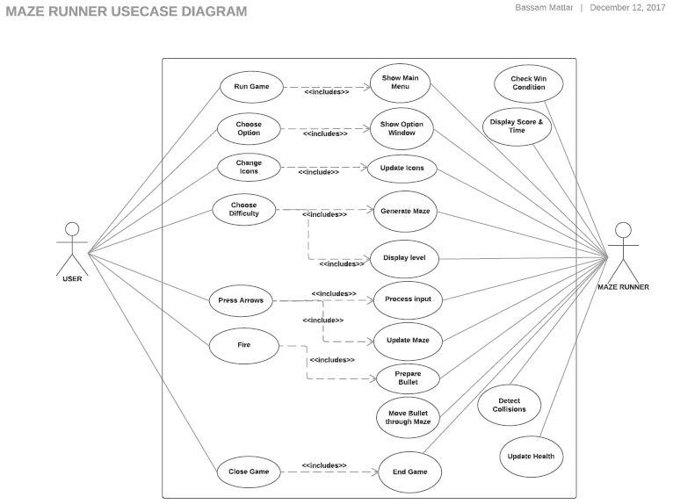

CLASS DIGARAM

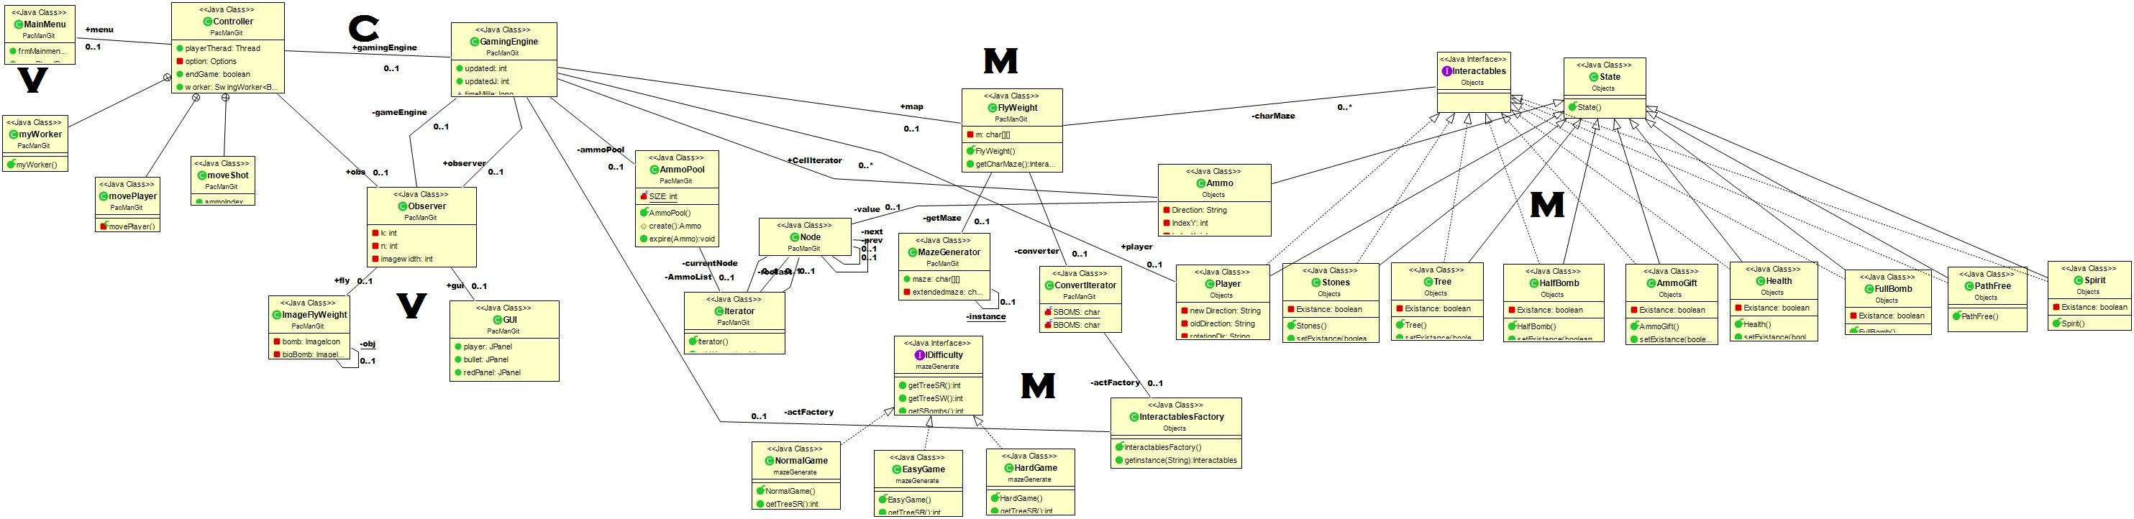

SEQUENCE DIAGRAM

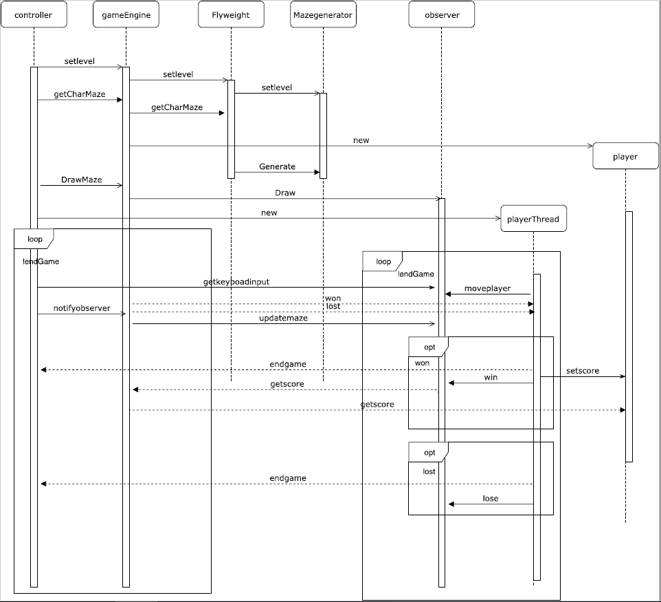

STATE DIAGRAM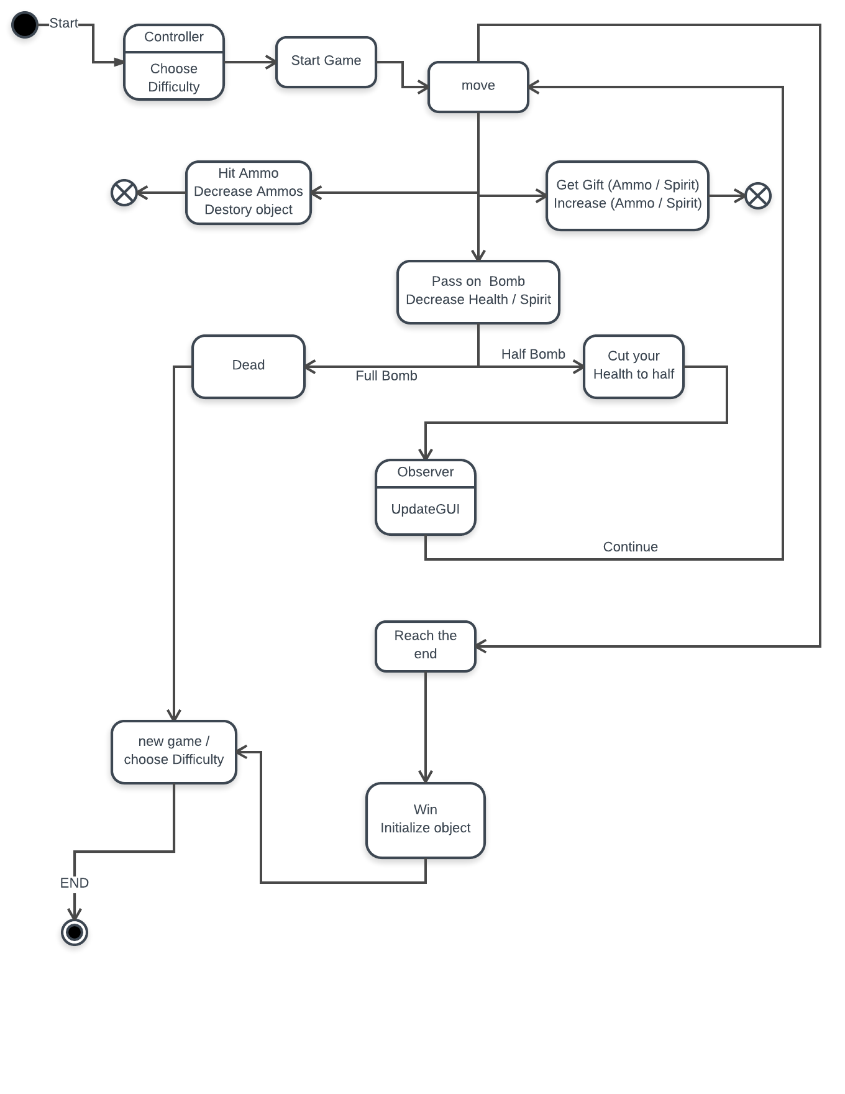

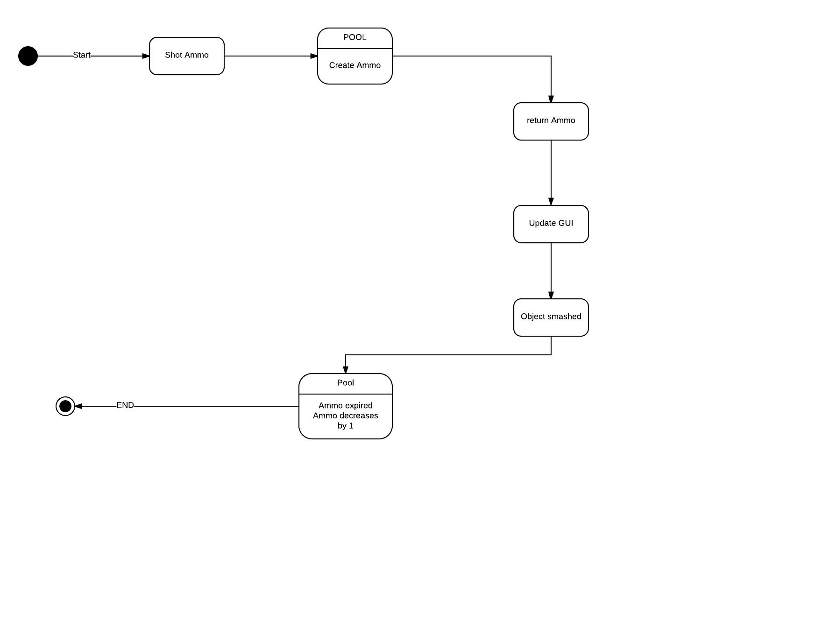

1. Design Description :

Design patterns

**1) Factory**

in InteractablesFactory class

**2) Pool**

in AmmoPool class

**3) Strategy**

In ( IDifficulty interface – EasyLevel class – NormalLevel class – HardLevel class)

**4) Iterator**

In Iterator class

**5) Flyweight**

In ImageFlyweight class

**6) Dynamic Linkage**

In ImageFlyweight class

**7) Singleton**

In imageFlyweight class

**8) Façade**

In GamingEngine class

**9) State**

In (State class – Ammo class – AmmoGift class –

Tree class – Player class – Stones class – Health class –

Spirit class – HalfBomb class – FullBomb class –

FreePath class)

**10) Observer**

In Observer class

Classes Description

1. MazeGenerator :

It is the class which is responsible for generating maze randomly with dimension n * m and specific difficulty.

1. ImageFlyWeight :

It is the class which is responsible for holding image resources of each maze component.

1. Interactables :

It is an interface that has the common functionality of each component of maze and all components implement this interface -to apply polymorphism-.

1. GameEngine :

It holds all game data.

1. ConvertIterator :

It converts the maze array to array of interactable interface.

1. Iterator :

It is used to iterate over Ammo array to avoid for loop boring structure.

1. Controller

Class that holds all user program and in the back it deals with many other classes like game engine and observer .

1. IDifficulty

Using strategy we make interface and implements 3 types of difficulty in the game .

1. Observer

It is responsible for updating, drawing and deleting the components of the HI

1. GUI

It holds all the Jpanels, Jlabels, Jbuttons and Clips of the project

1. GUI

MAIN MENU

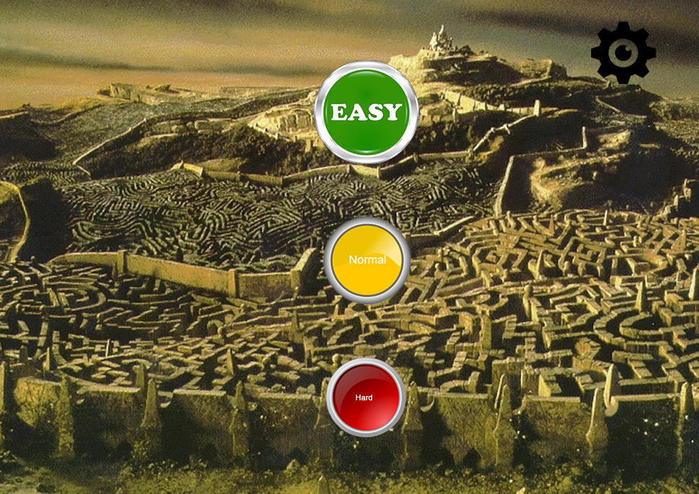

OPTIONS

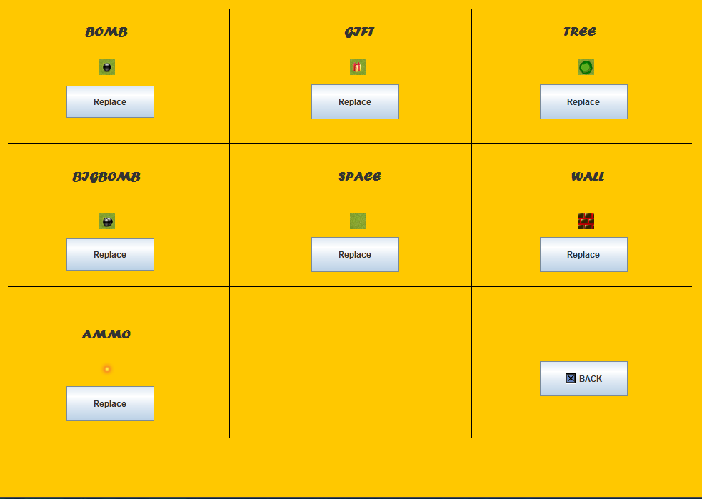

INSIDE GAME

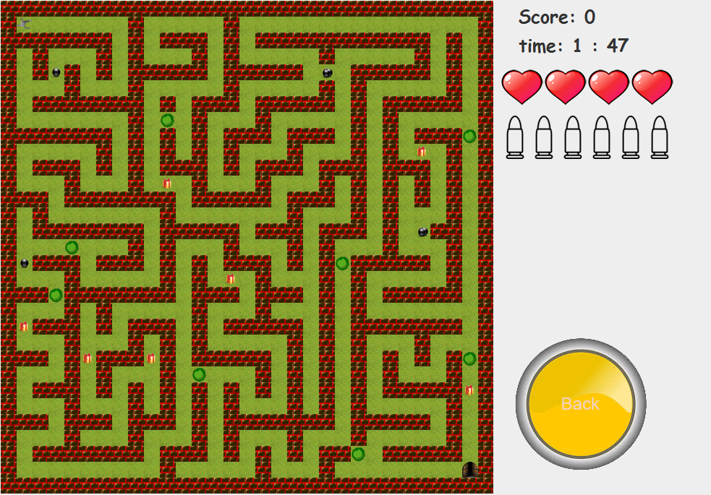

1. User Guide
2. Choose Settings or Difficulty from Main Menu.
3. On Settings choice you can set preference like setting images.
4. On Other choices, you will be able to choose level of difficulty to play.
5. The difficulty is set according to number of obstacles during your journey.
6. Aim of each level is to finish maze and finally exit the maze through door which will be in the lower right corner. 
7. There is a character you can control by moving it with keyboard arrows and shooting by keyboard space and rotate with (W-D-S-A) keys. 
8. To finish the level without being hurt you should avoid obstacles such as Big Bomb & Small one.  
9. Big bomb will kill you at once but small one will reduce your health by specific damage.
10. You can make your own path with your weapon by destroying Shootable objects in maze which are bombs & trees. 
11. Use your weapon wisely as you have only six bullets in your ammo.
12. During your journey you will find useful items. 
13. Collectable items have different effects :
14. Increase your health.
15. Give an extra life.
16. 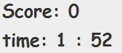Increase your ammo by one bullet.
17. Your score is calculated by the time you take.
18. Enjoy The Game!