Arithmetic Logic Unit (ALU)
Project Description Report
Name: Abdelrahman Hany Elatroush ID: 231001741
Name: Ahmed Ashraf Mokhtar ID: 231001773
Name: Ahmed Hassan Shata ID: 231000267
Name: Ahmed Mohamed Nour ID: 23100 2375
Name: Moaz Khaled Ibrahim ID: 231001564

ECE322 – Electronic Circuits

Table of Contents
1. Verilog Architecture and Module Hierarchy 3
1.1 Architecture Overview 3
1.2 Module Hierarchy Implementation 4
1.2.1 Mux21 4
1.2.2 Mux41 4
1.2.3 full_adder 5
1.2.4 AddSub (operation 0 - 1) 6
1.2.5 multiplier (operation 2) 7
1.2.6 block1_mod 8
1.2.7 sign_mux 8
1.2.8 Reminder_b 9
1.2.9 Modulus (operation 3) 10
1.2.10 selectors 11
1.2.11 shifting_circuit 11
1.2.12 ASR (operation 4) 12
1.2.13 ALU_top (Top module for ALU) 13
2. ModelSim Waveform Verification 14
2.1 Simulation Setup 14
2.2 Files used 15
2.2.1 Golden Model 15
2.2.2 Testbench 16
2.2.3 Source list 17
2.2.4 Do file 18
2.3 Simulation log and waveforms 19
3. Conclusion 19
4. Appendix 20

1. Verilog Architecture and Module Hierarchy

1.1 Architecture Overview
The designed Arithmetic Logic Unit (ALU) operates on two 4-bit signed inputs, denoted as A and B, encoded using two’s complement representation. The operation is selected using a 3-bit control signal (Sel).
The ALU produces an 8-bit signed output, which is required to correctly represent the result of signed multiplication.
In addition to the main output, the ALU generates three status flags:
- Sign_flag: Indicates whether the result is negative. It is directly taken from the most significant bit (MSB) of the output.
- Zero_Flag: Asserted when the output value equals zero.
- DZ_Flag (Divide-by-Zero Flag): Asserted only when a modulus operation is requested and the divisor B = 0.
All operations are evaluated in parallel, and the final result is selected using multiplexers controlled by the Sel signal.
A behavioral reference model (ALU_Gm) is used as a golden model for verification, while the actual design under test (ALU_top) is fully gate structurally.

1.2 Module Hierarchy Implementation

1.2.1 Mux21
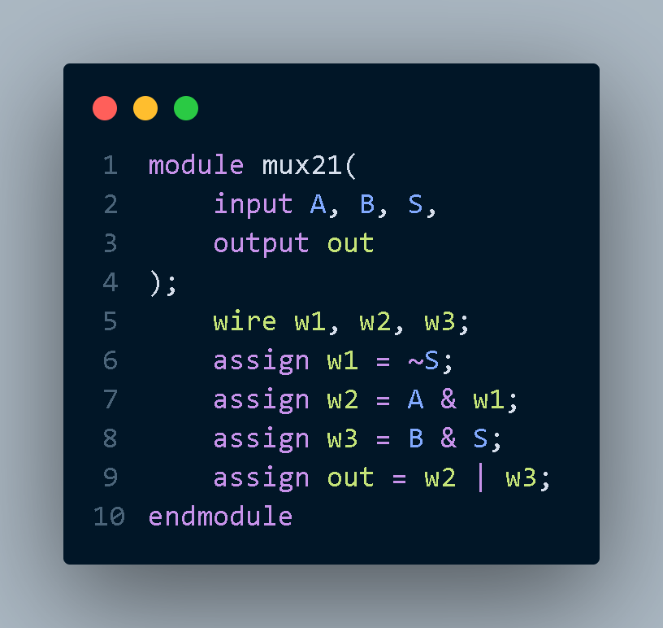
=========================================================================

1.2.2 Mux41
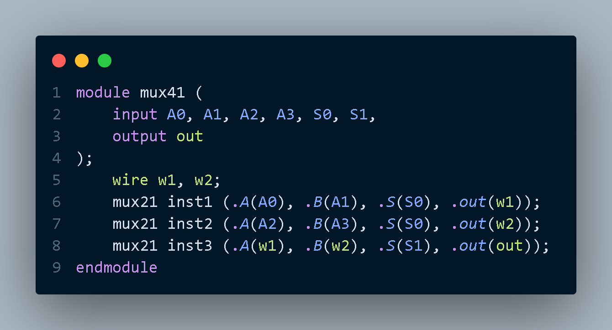

1.2.3 full_adder
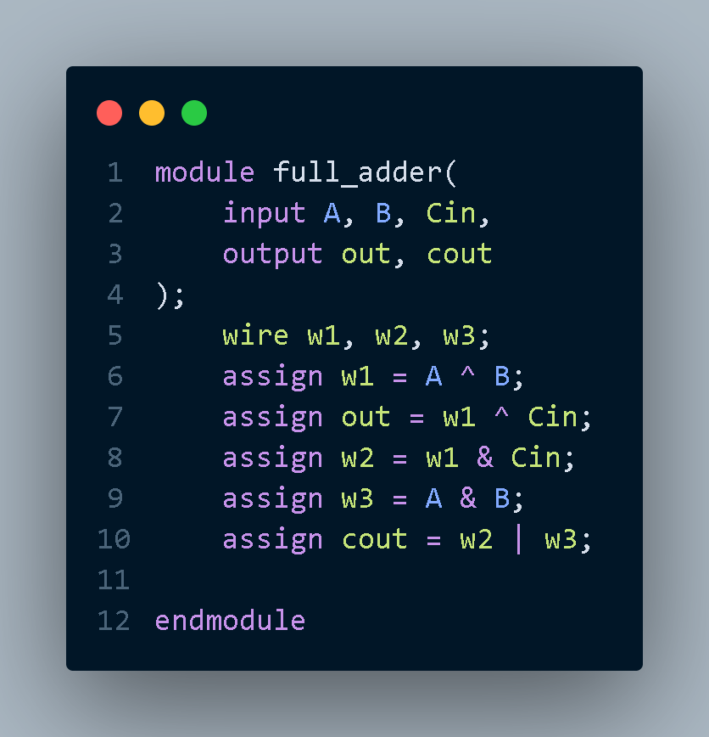

1.2.4 AddSub (operation 0 - 1)
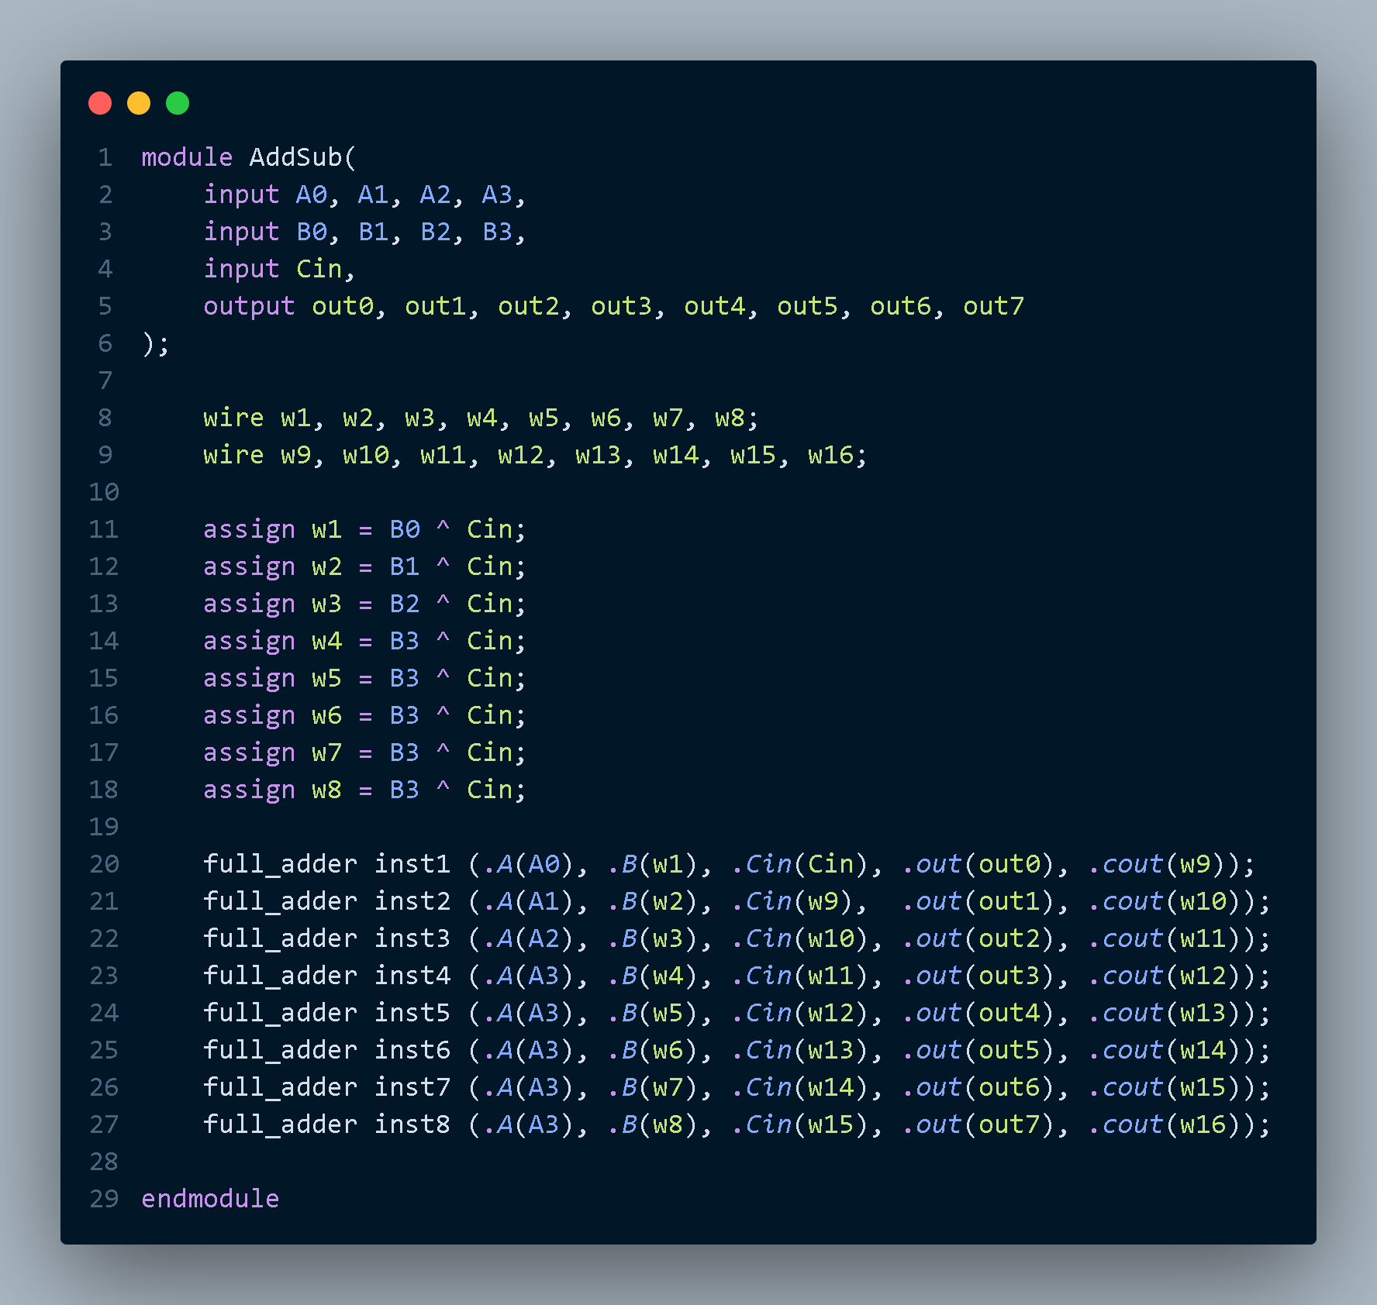

1.2.5 multiplier (operation 2)
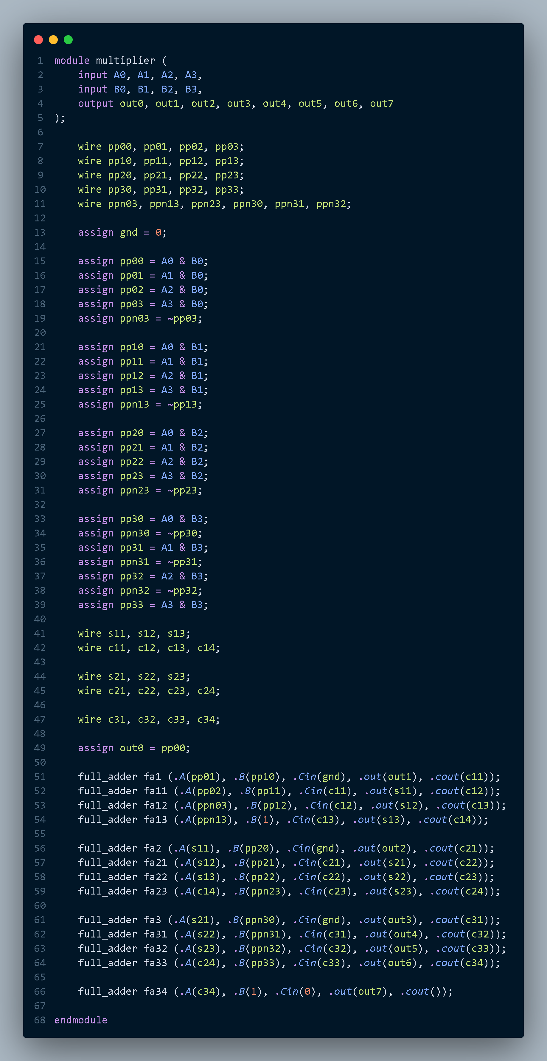

1.2.6 block1_mod
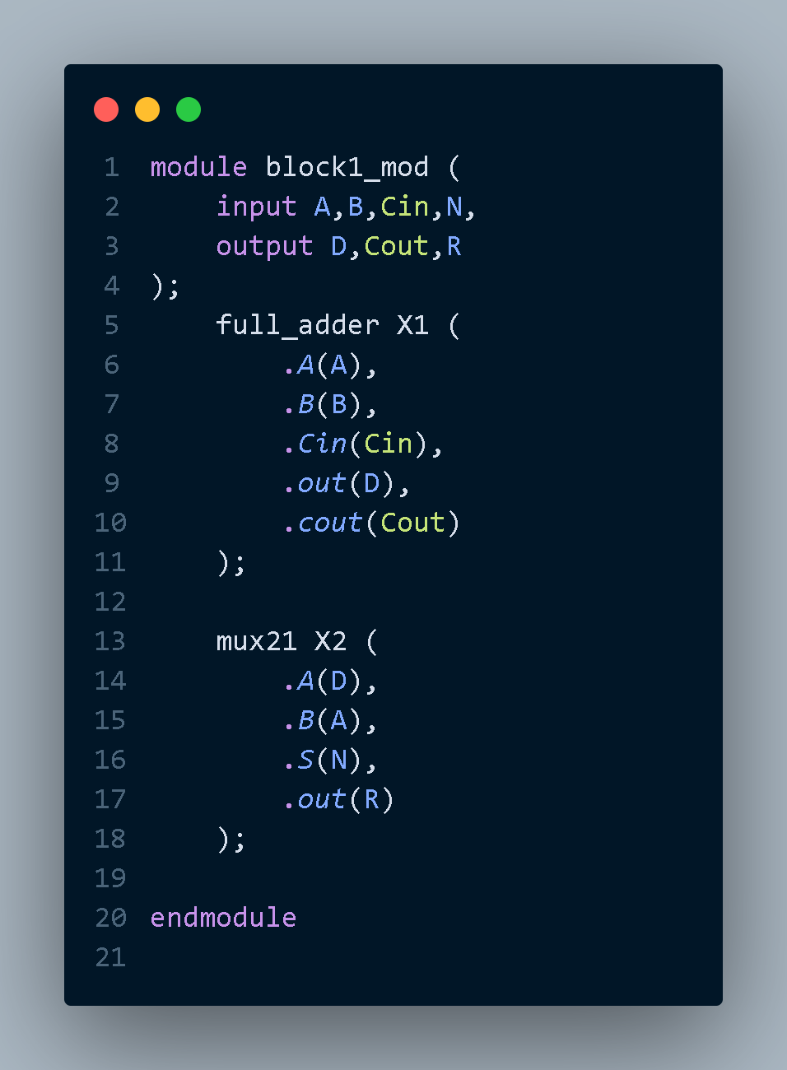
=========================================================================

1.2.7 sign_mux
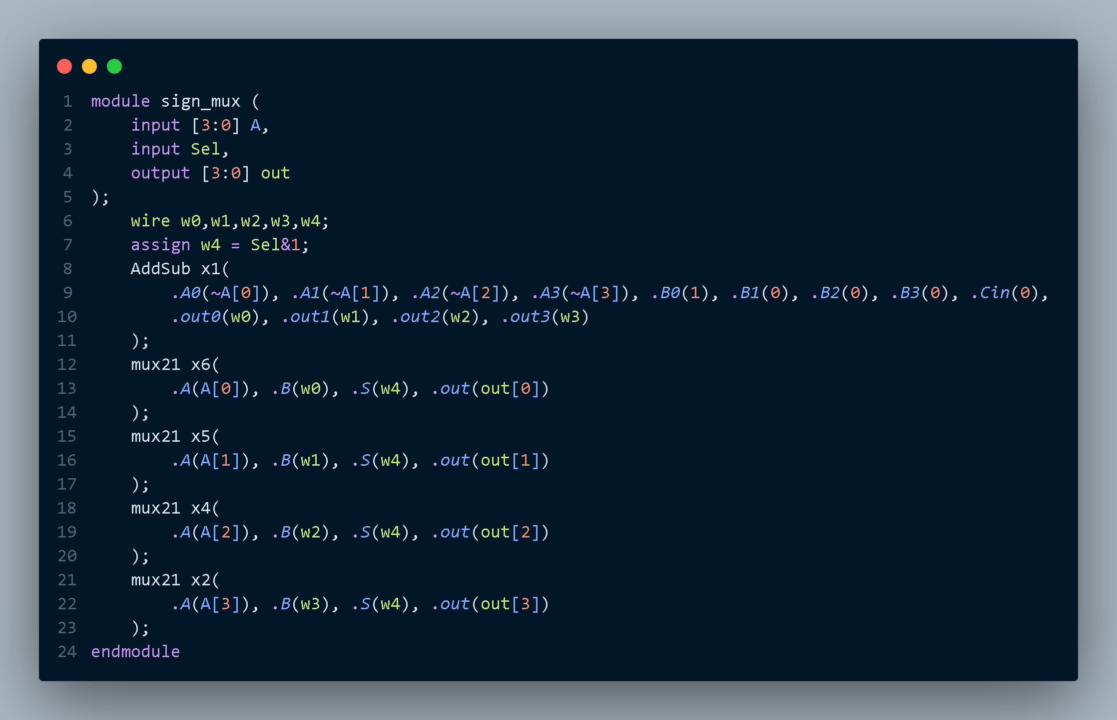

1.2.8 Reminder_b
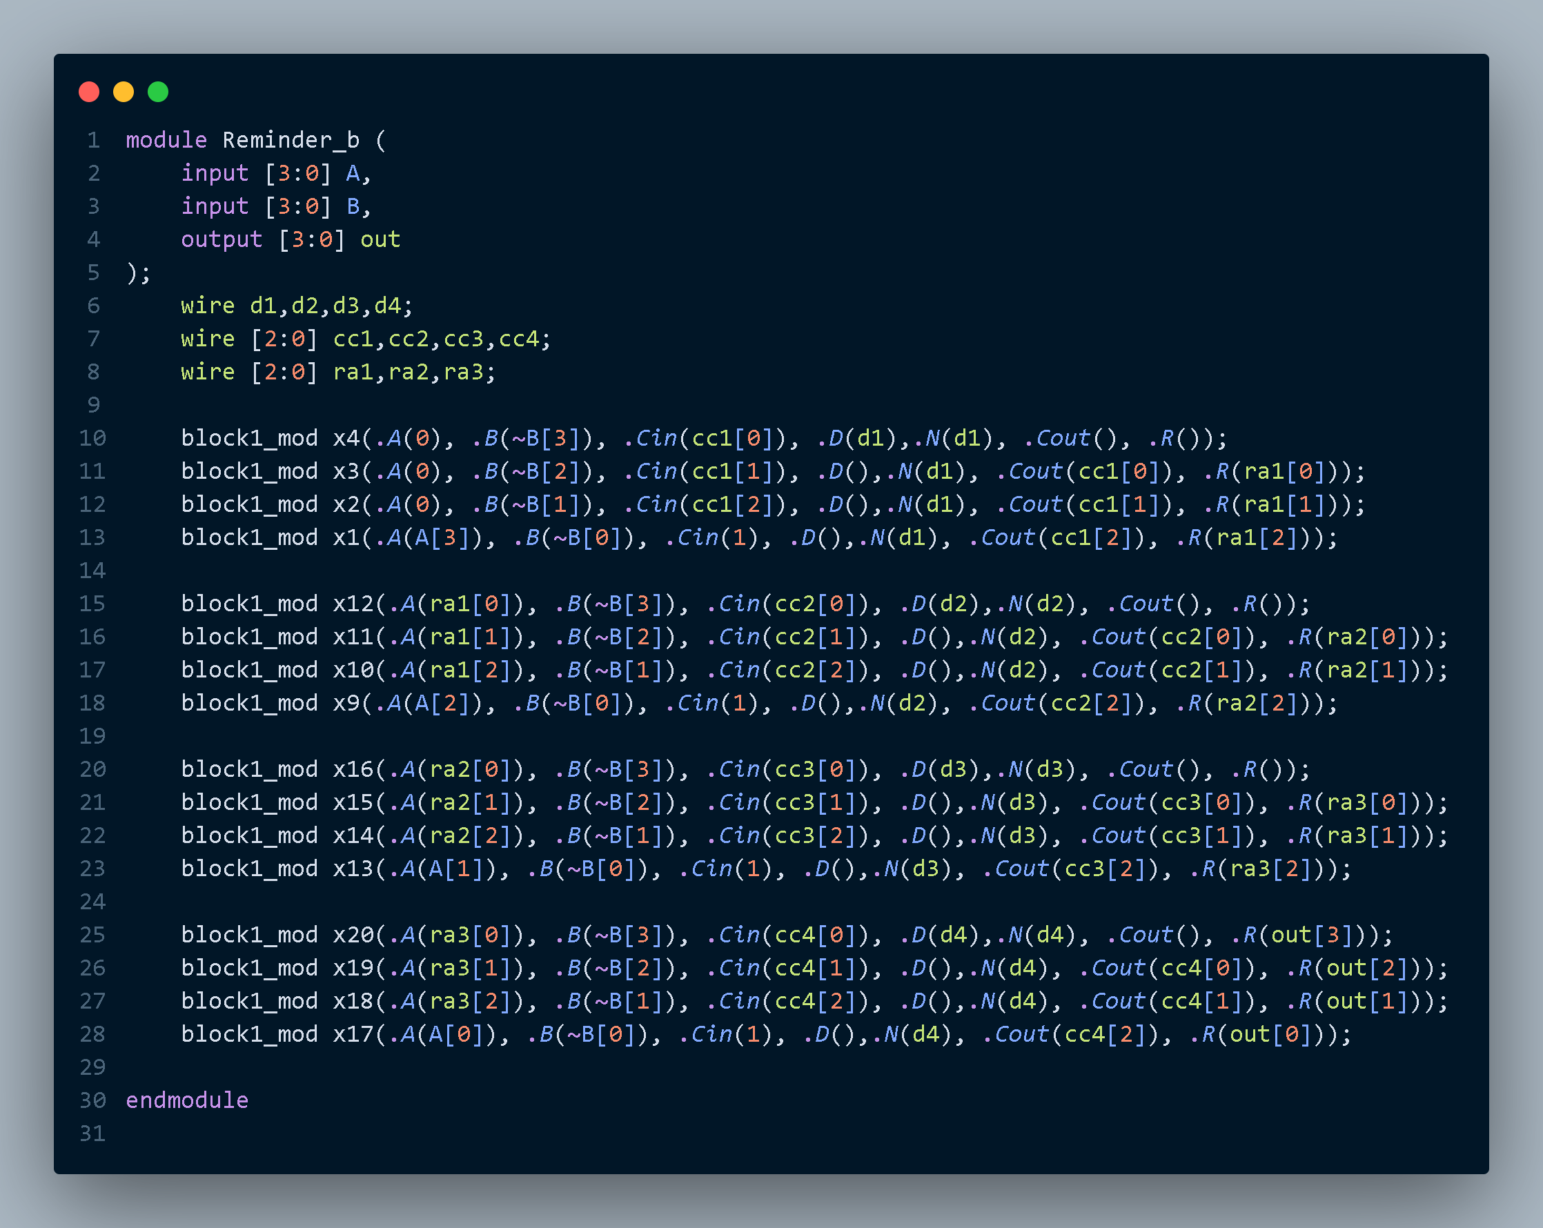

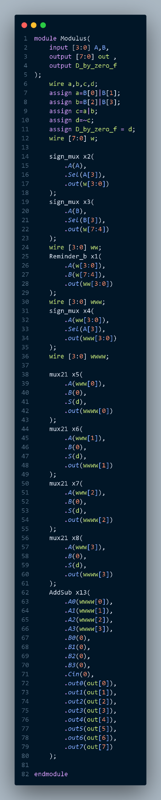
1.2.9 Modulus (operation 3)

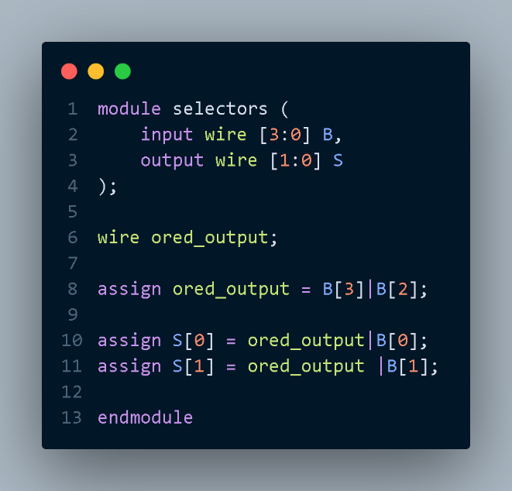
1.2.10 selectors

=========================================================================

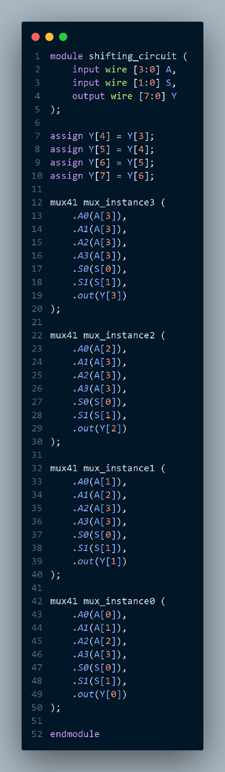
1.2.11 shifting_circuit

1.2.12 ASR (operation 4)
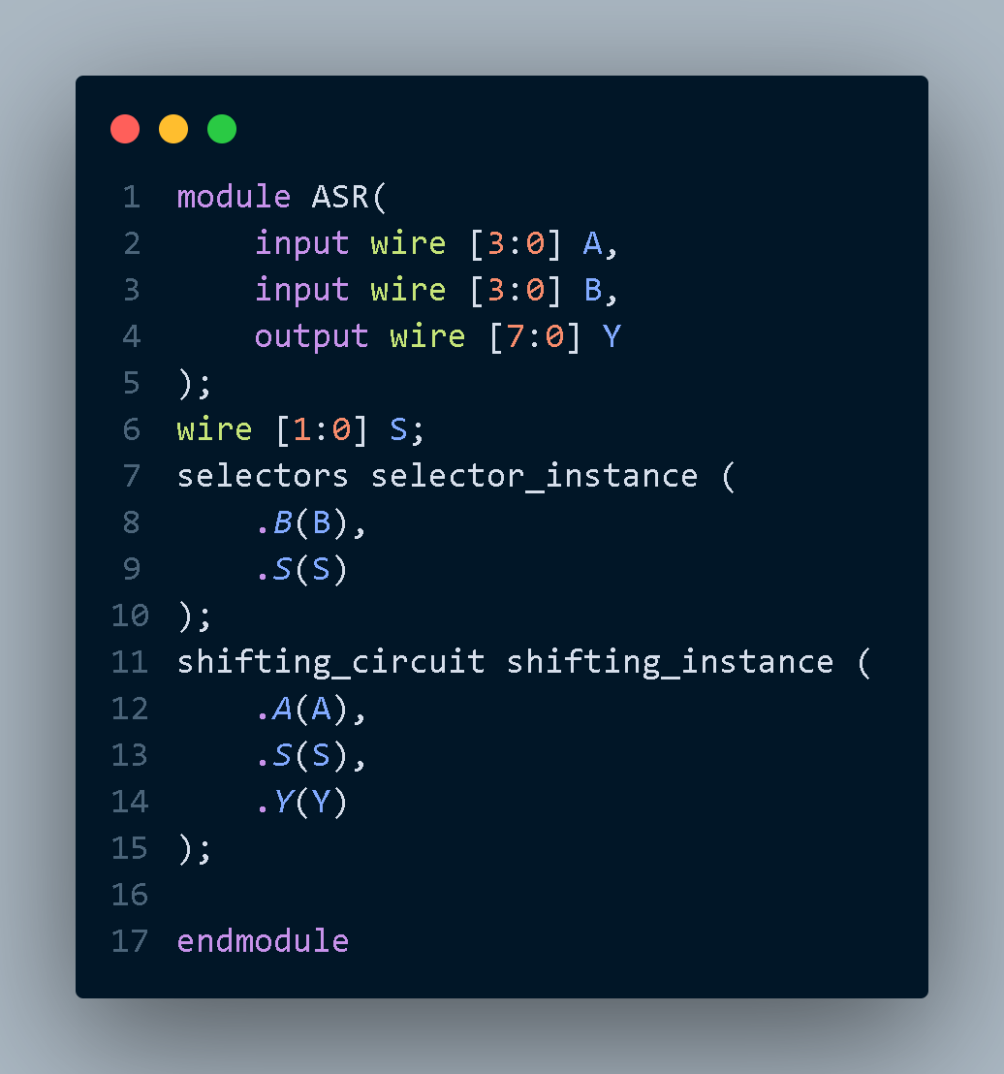

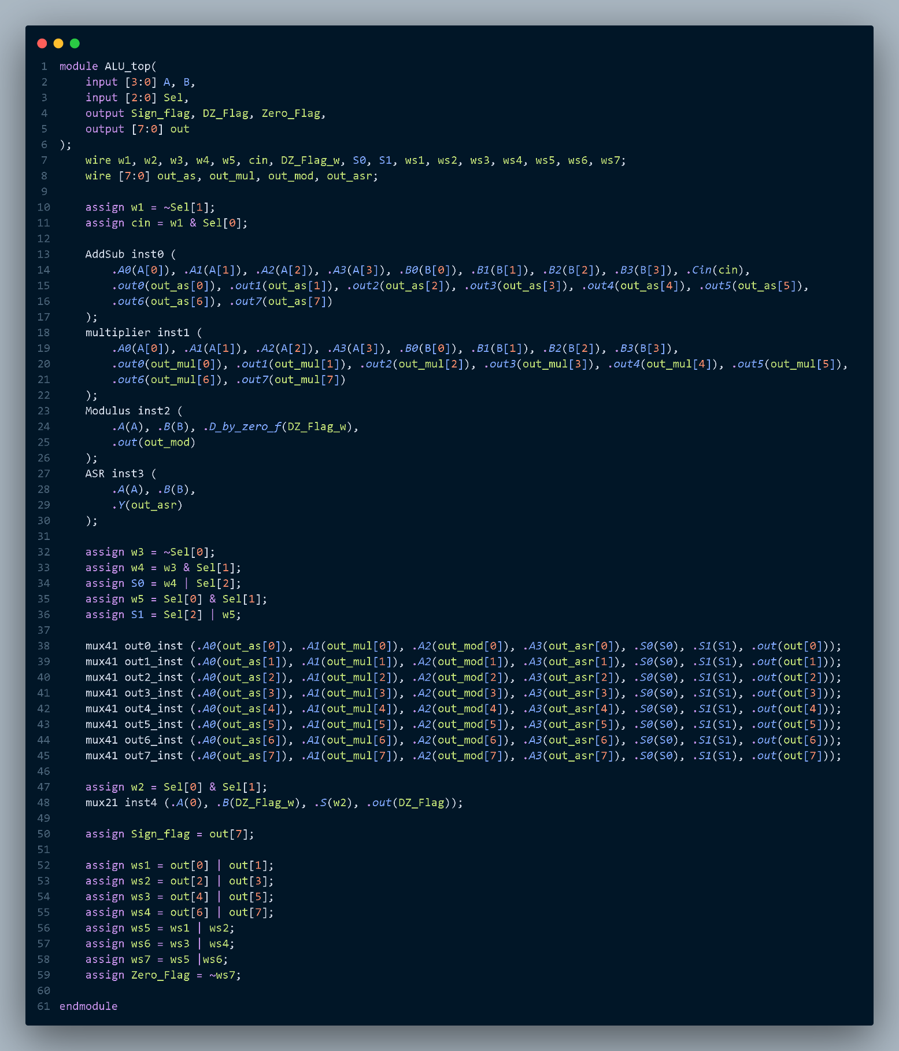
1.2.13 ALU_top (Top module for ALU)

2. ModelSim Waveform Verification

2.1 Simulation Setup
The ALU was verified using ModelSim with a dedicated testbench (ALU_tb). The simulation procedure was as follows:
- All design files listed in src_files.list were compiled.
- The testbench instantiated both ALU_top (DUT) and ALU_Gm (golden model as reference).
- Input signals A and B were driven using binary counters at different frequencies to cover all possible combinations - 128 test case for every Sel.
- The control signal Sel cycled through values 0 to 4.
- Outputs were compared against the golden model every 1 ns.
- Any mismatch was immediately reported.
A total of 640 test cases were executed. No mismatches were detected during simulation.

2.2 Files used

2.2.1 Golden Model
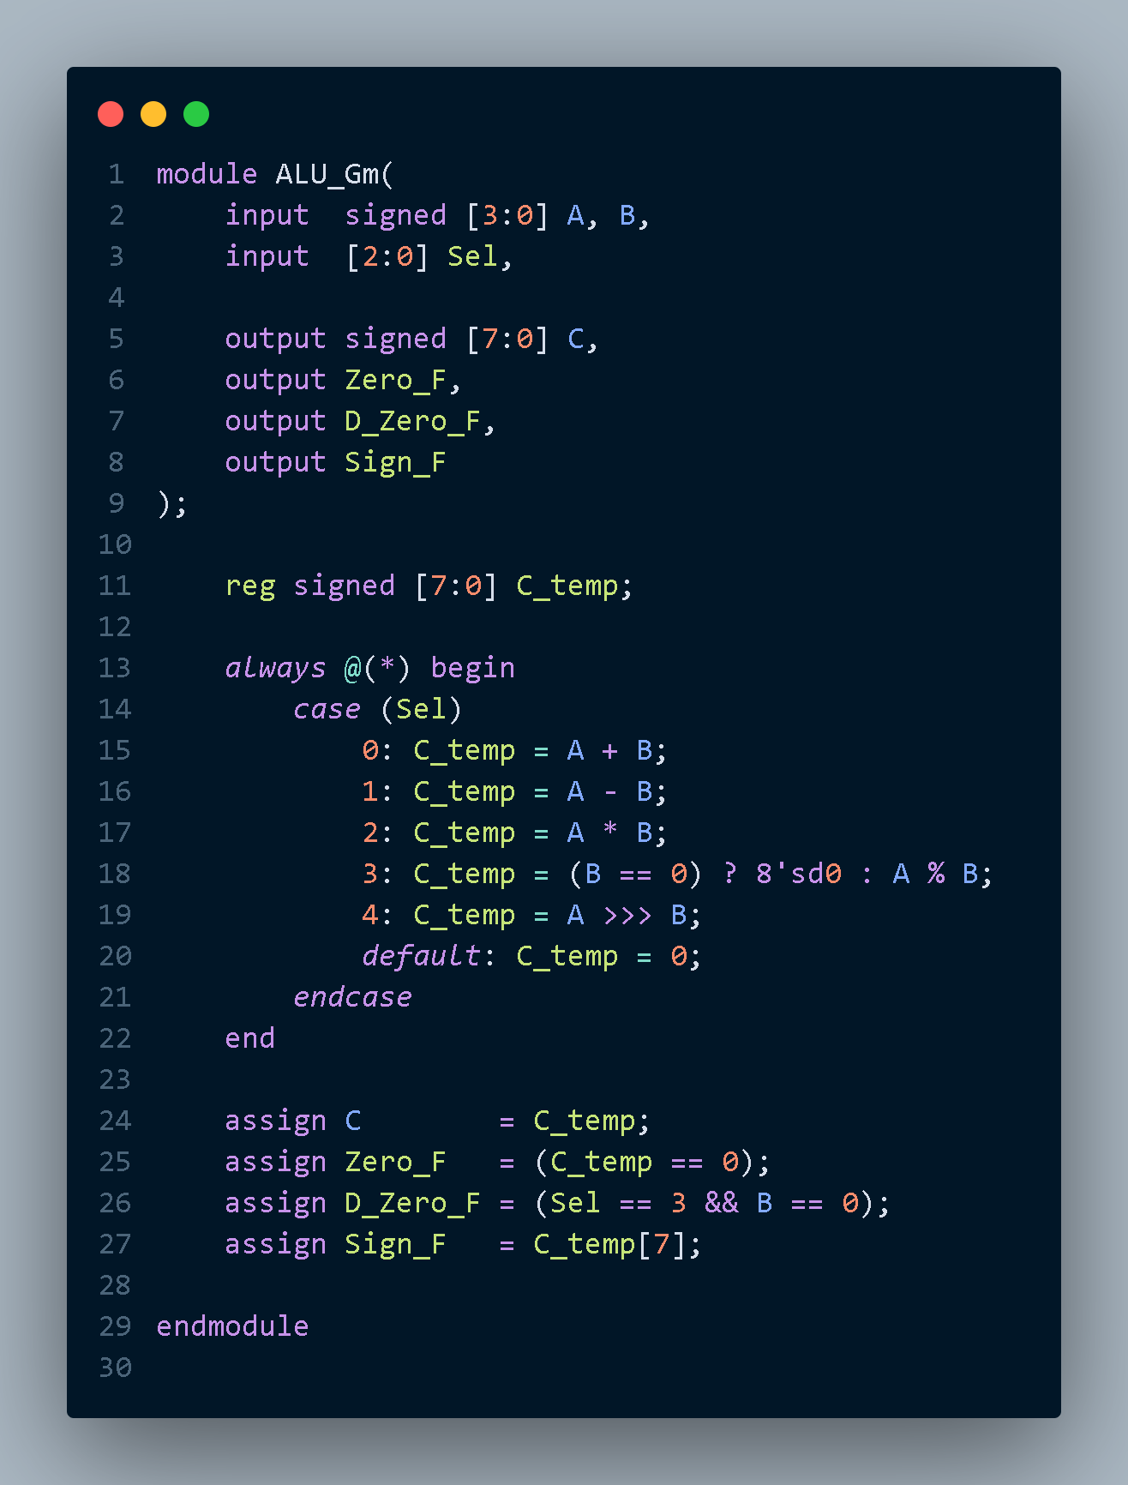

2.2.2 Testbench
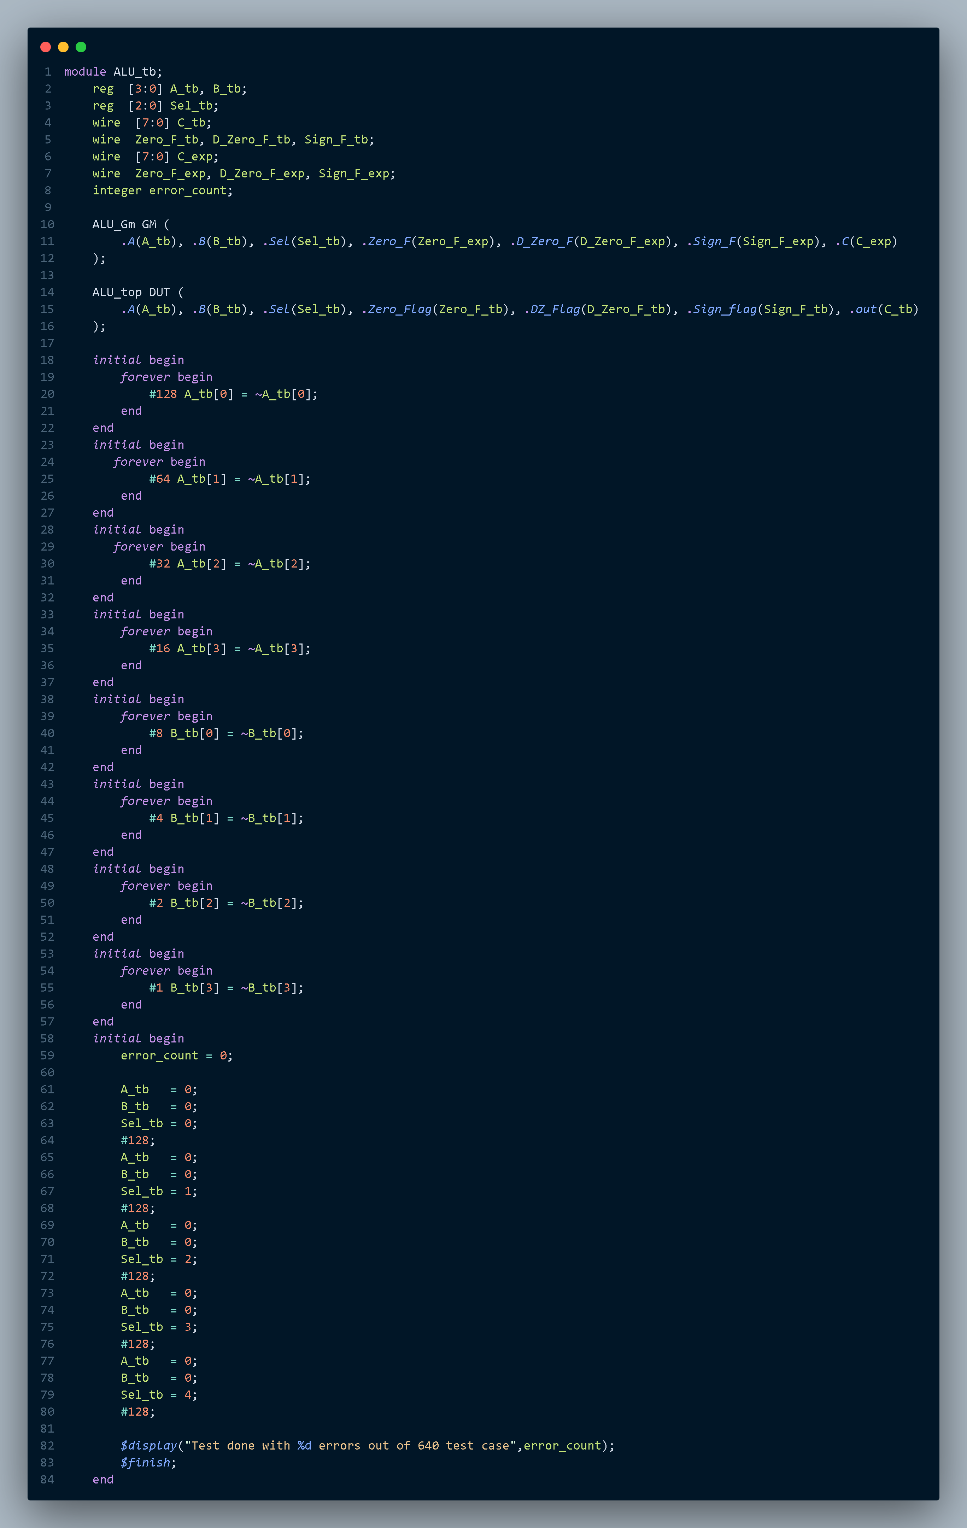

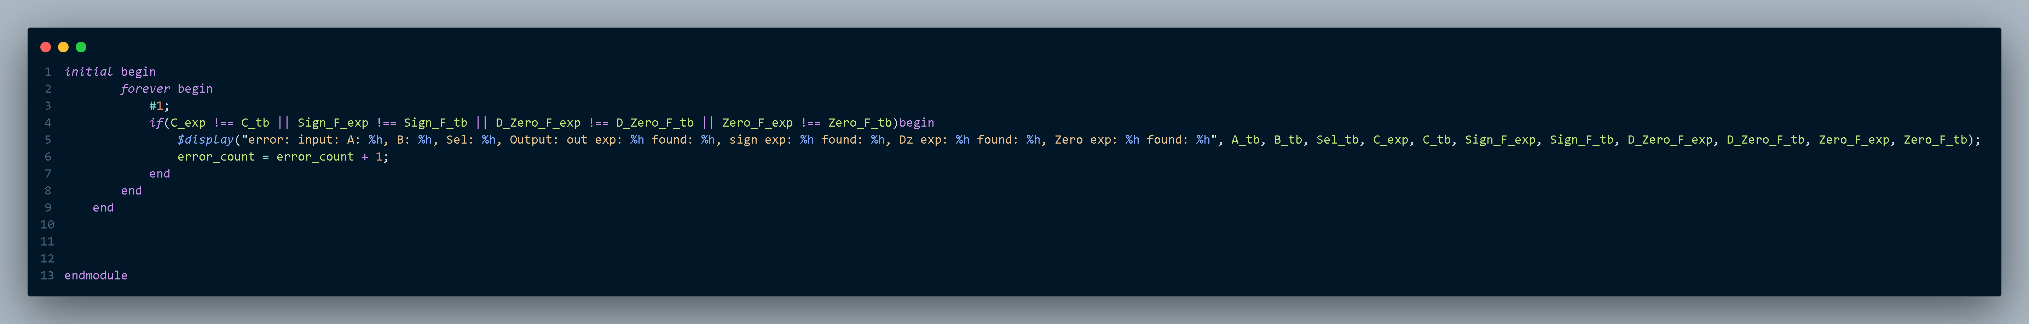

2.2.3 Source list
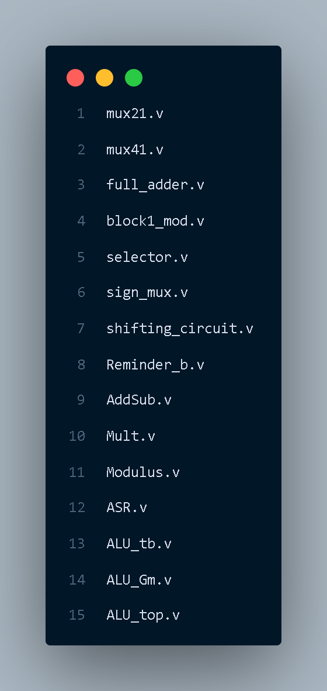

2.2.4 Do file
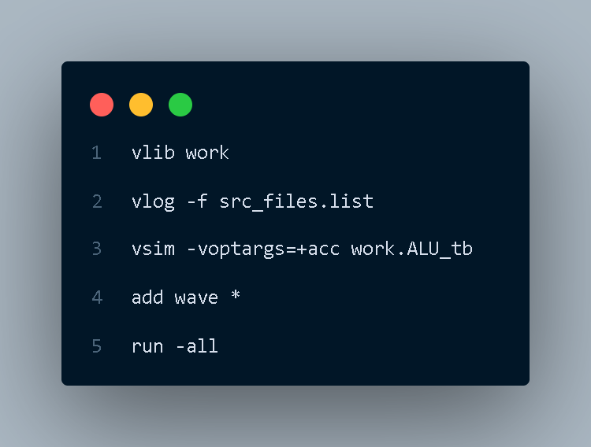

2.3 Simulation log and waveforms
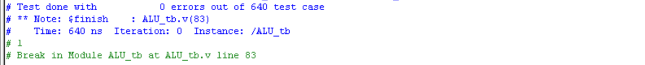

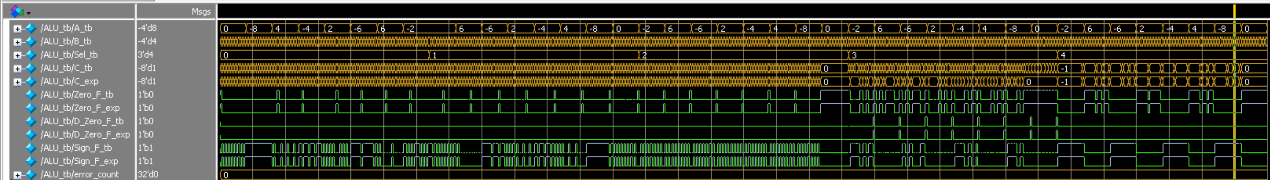
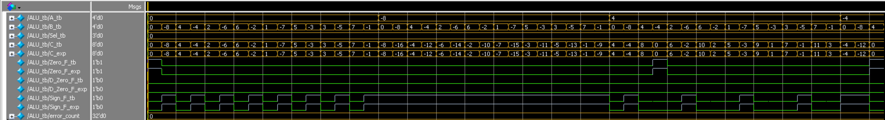
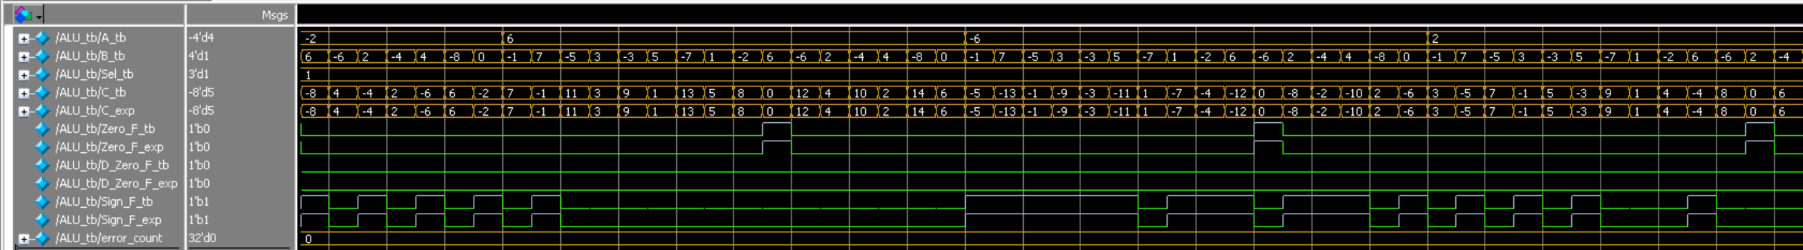
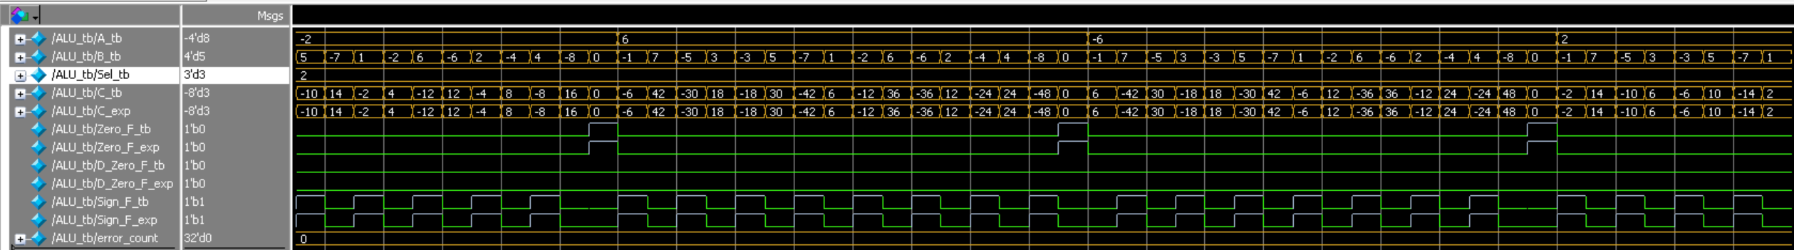
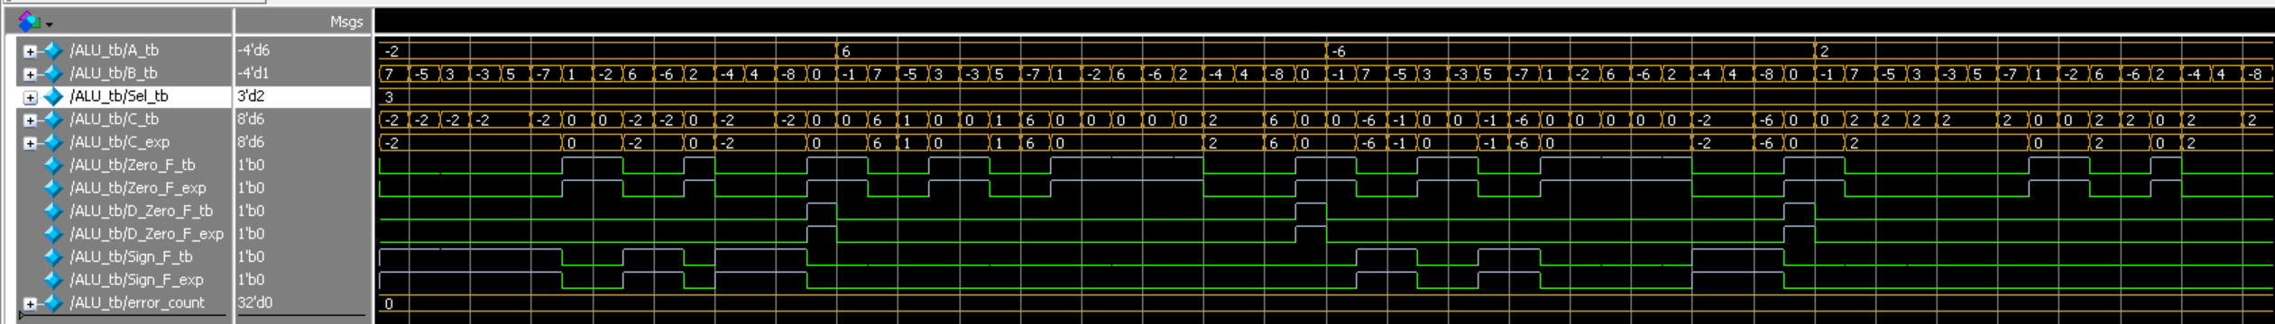
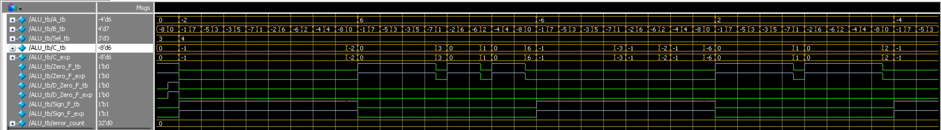

3. Conclusion
The designed ALU successfully meets all functional requirements using a fully structural, modular Verilog architecture. Comprehensive simulation and comparison against a behavioral golden model confirm the correctness of arithmetic operations and flag generation.

4. Appendix
Team Workload Distribution: Part B (Verilog & ModelSim)
Member Name | Assigned Work
Ahmed Shata | Design and implementation of the structural Verilog modules for addition and subtraction
Ahmed Ashraf | Design and implementation of the multiplication module using structural Verilog
Abdelrahman Elatroush | Design and implementation of the modulus operation using structural Verilog
Ahmed Nour | Development of the main ALU testbench, implementation of the golden behavioral model, design of all multiplexers and basic building blocks, and overall verification and debugging of the system
Moaz Khaled | Design and implementation of the arithmetic shift right (ASR) module using structural Verilog

