Assignment_2_Extra
====================================================================
Name: Ahmed Nour
Sheet ID: 16
Email: ahmedmohamednoour@gmail.com
====================================================================
Q1)
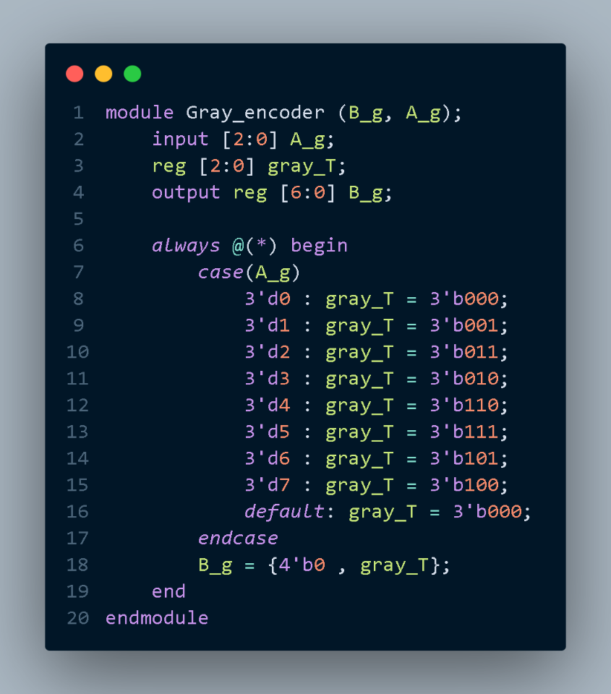
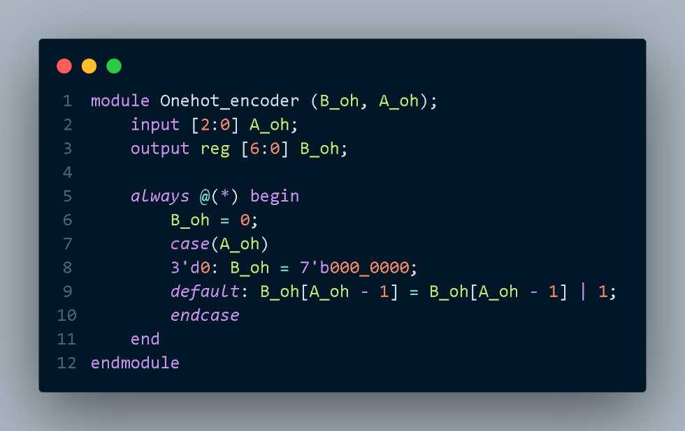
Models Code:

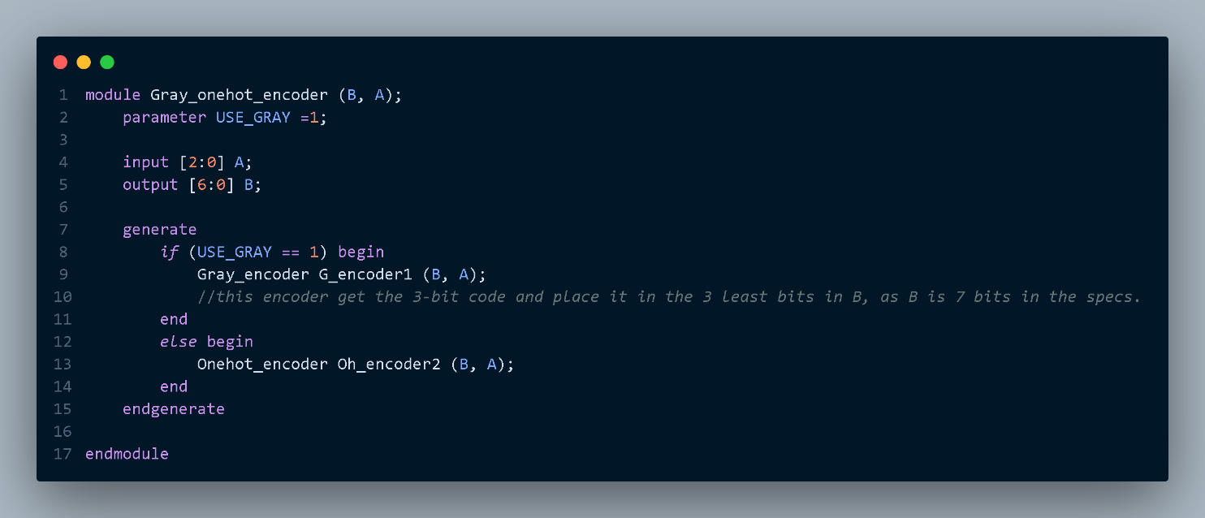

Testbench Codes:
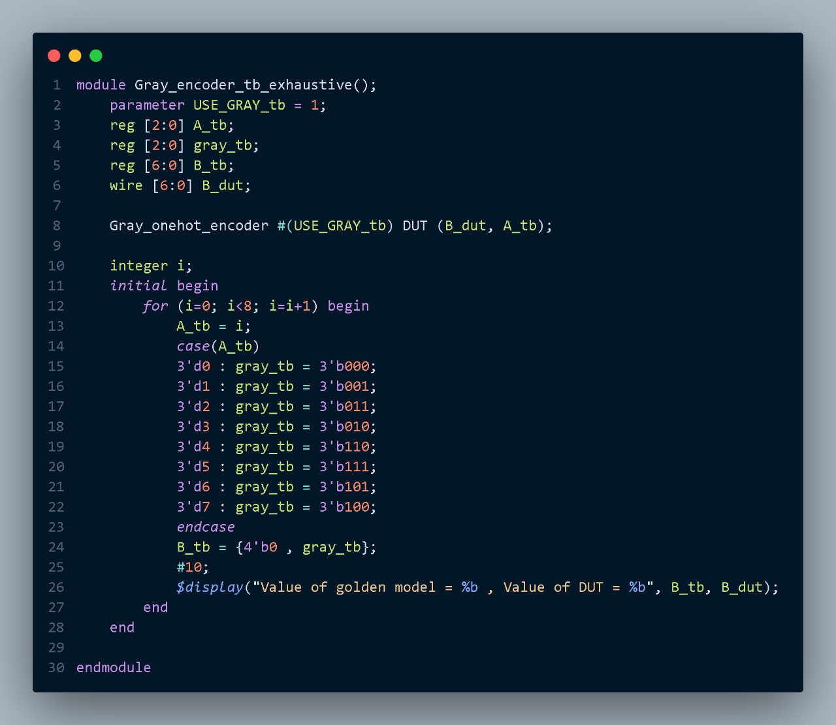

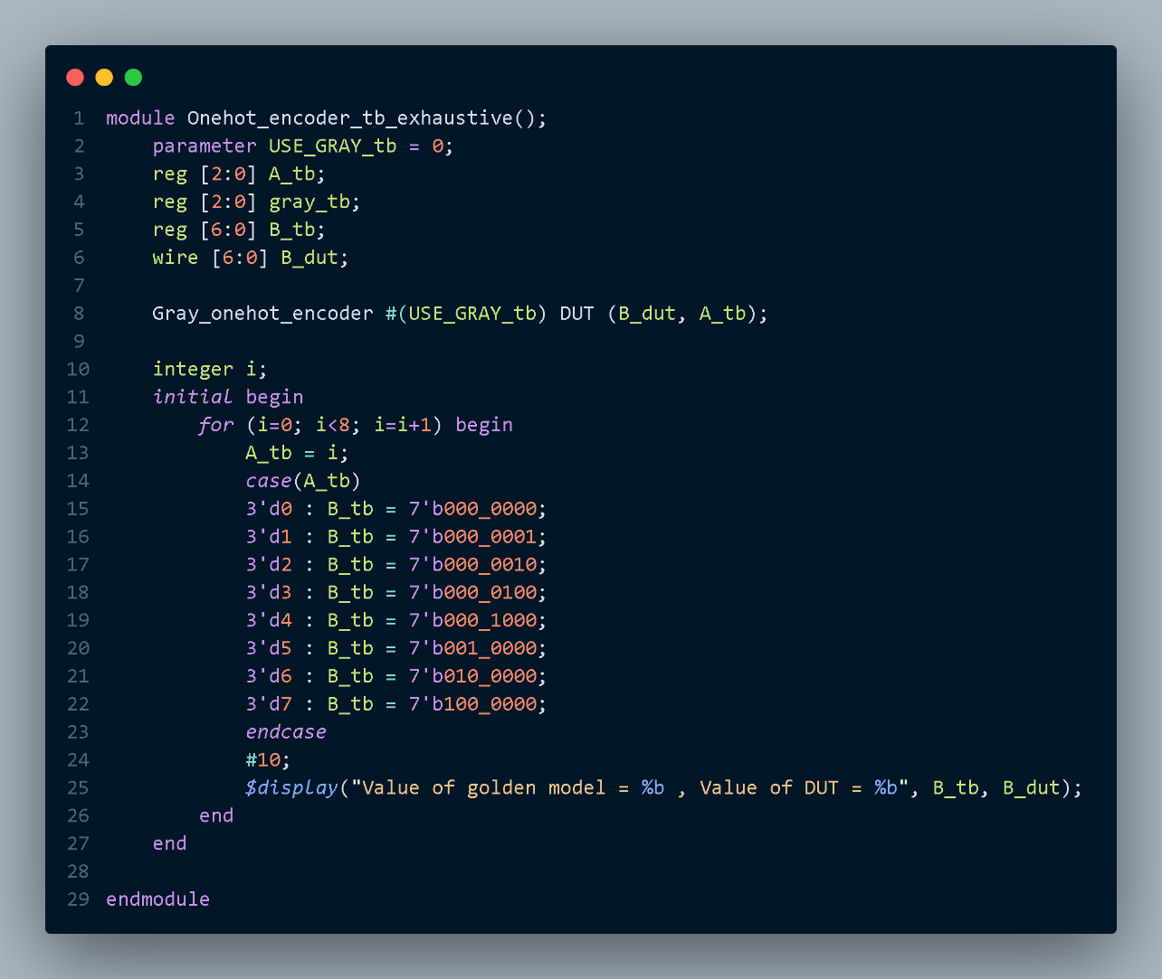

Simulation:
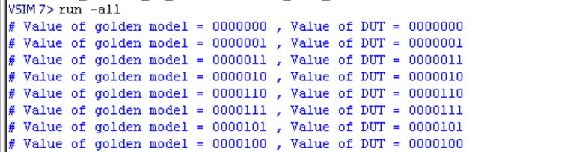
Grey Encoder test, Successful.
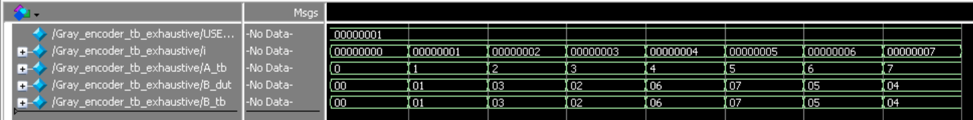

One-hot Encoder test, Successful.
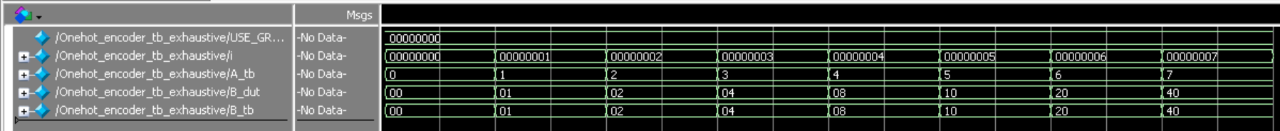
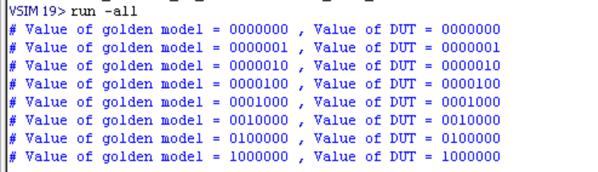

Q2)
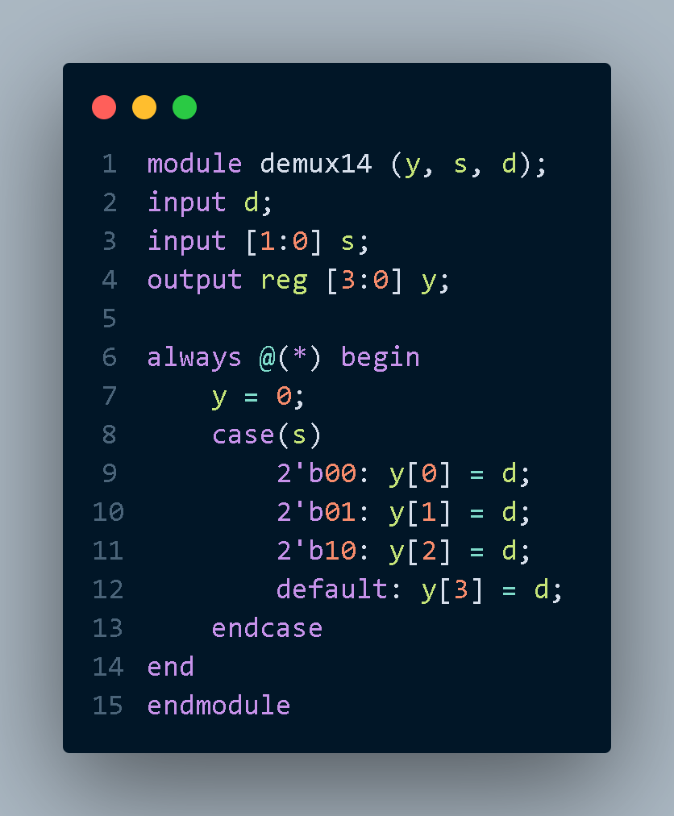
Code:

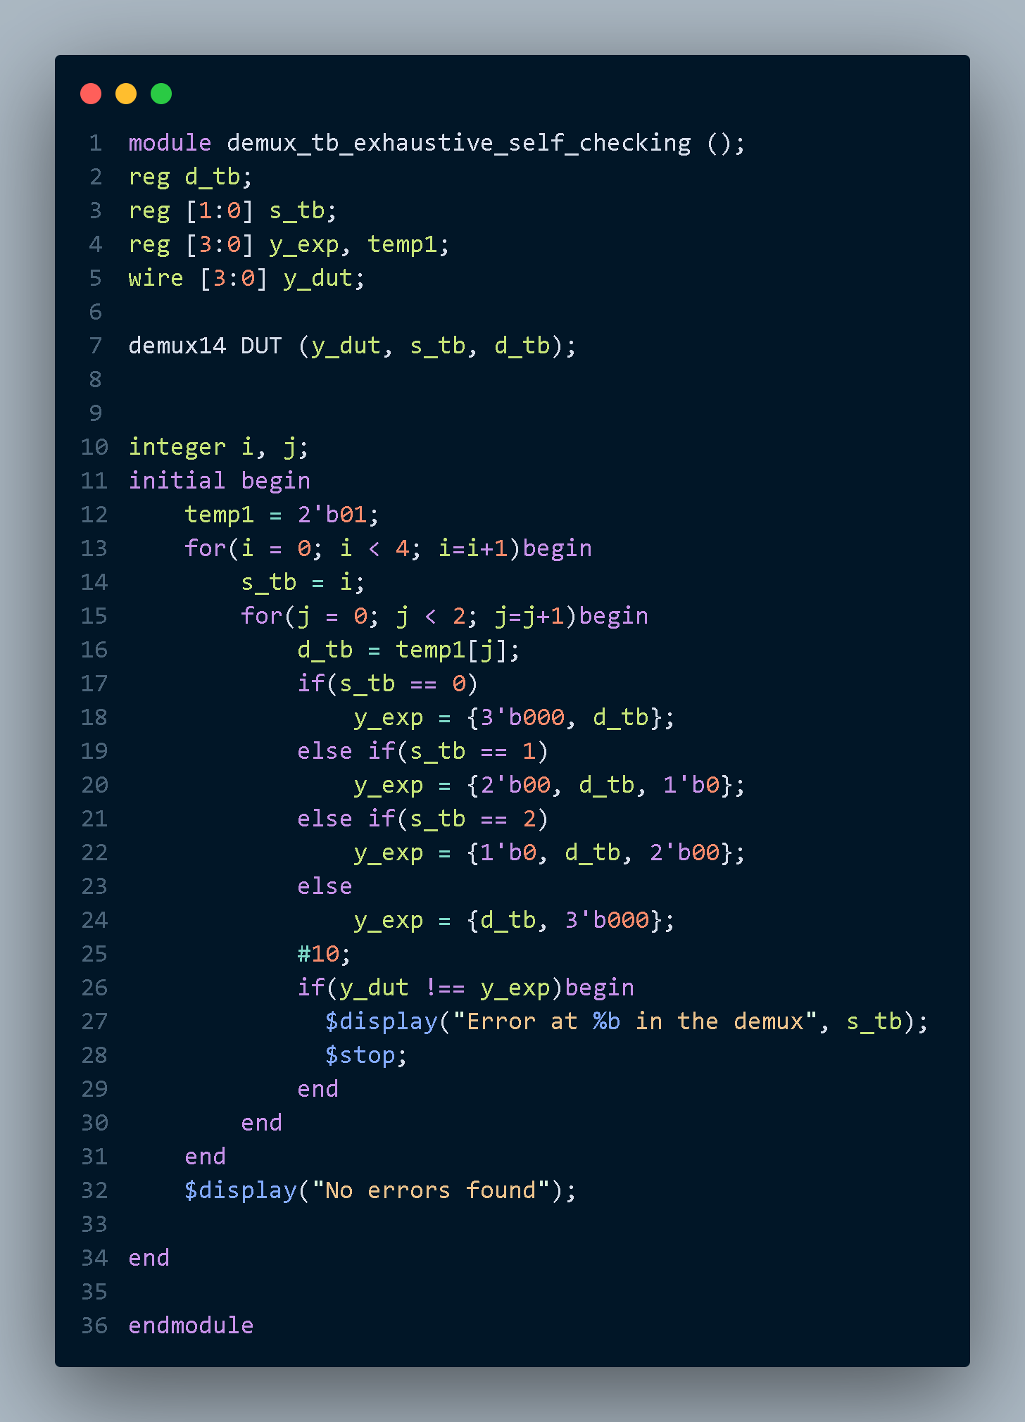
Testbench:

Simulation:
