Digital Design Assignment 1
Name: Ahmed Nour
ID in sheet: 16

Q1)
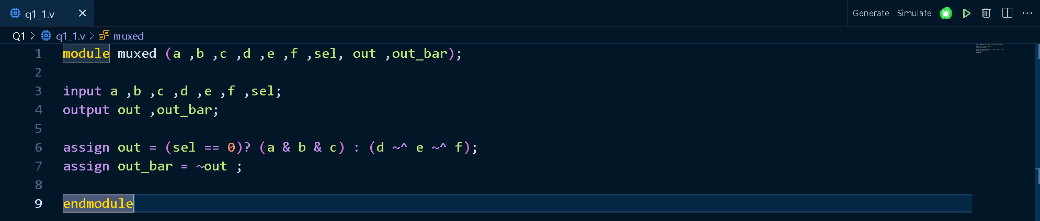
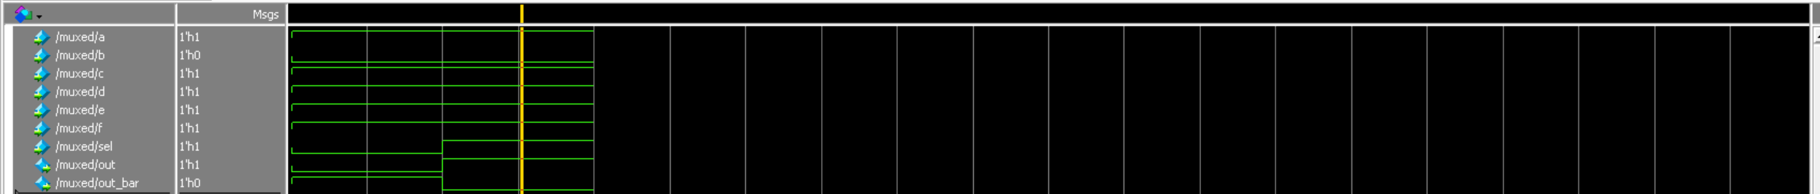

Q2)
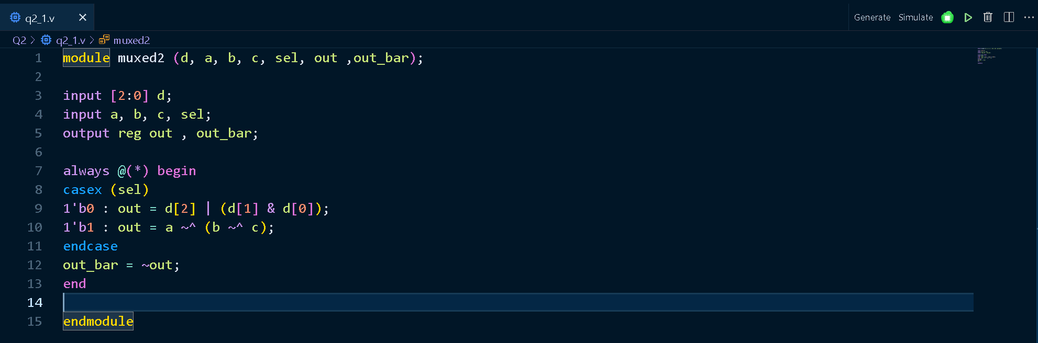
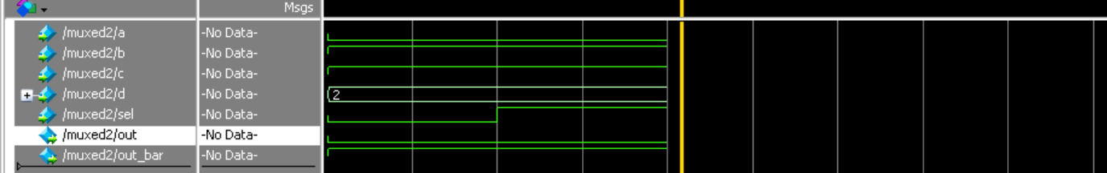

Q3)
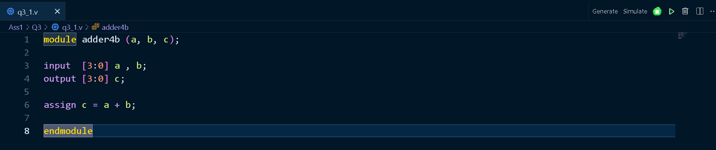
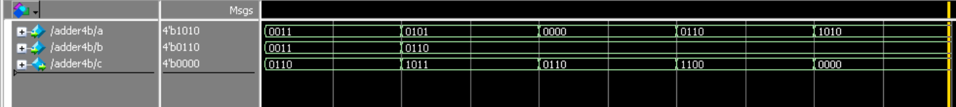
Note: the last test case has 1 in ignored carrier.

Q4)
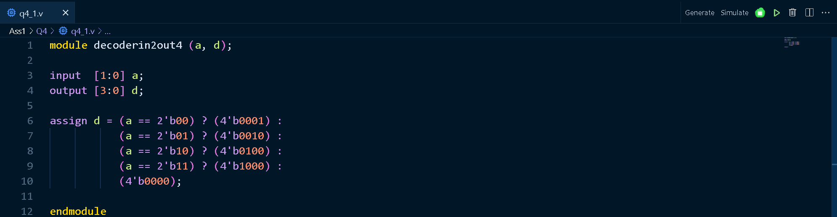

Q5)
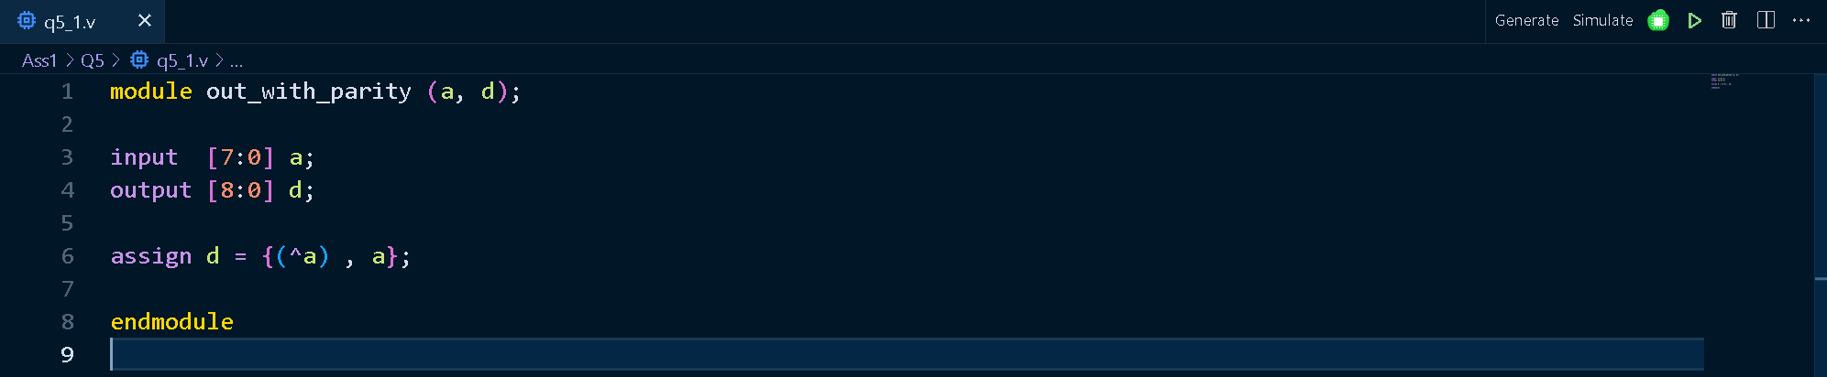
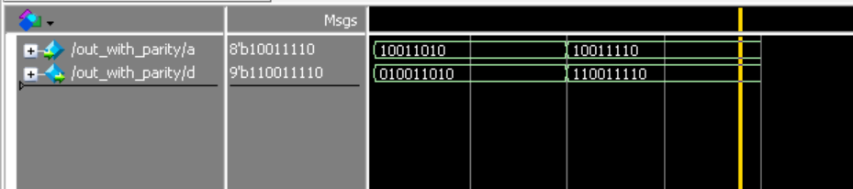

Q6)
