Assignment1 Extended
====================================================================
Name: Ahmed Nour
Sheet ID: 16
====================================================================

Q1)
Code:
module comp (a ,b);
input [3:0] a;
output b;

assign b = (a > 4'b0010 && a < 4'b1000) ? 1 : 0;

endmodule
Simulation:

Q2)
To solve the question, we need to divide the clock into the smallest clock of all of them to make sure that there will not be any clock has 0 and 1 at the same moment.
Note: the bold lines are the dividers, the dashed lines test the value at the clock.
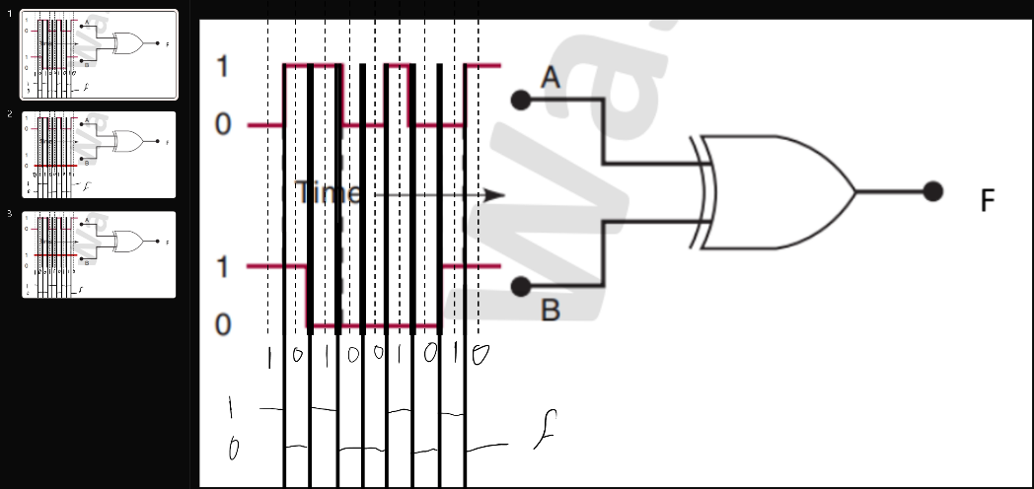

a)

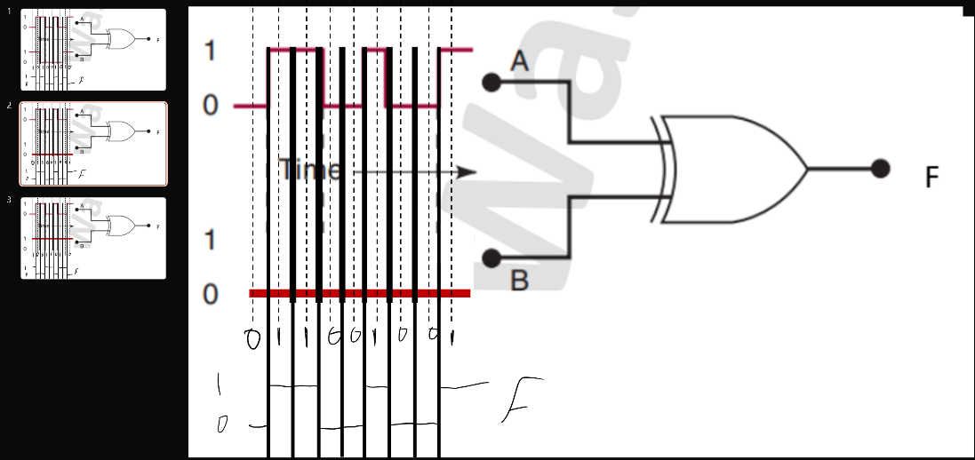

b)

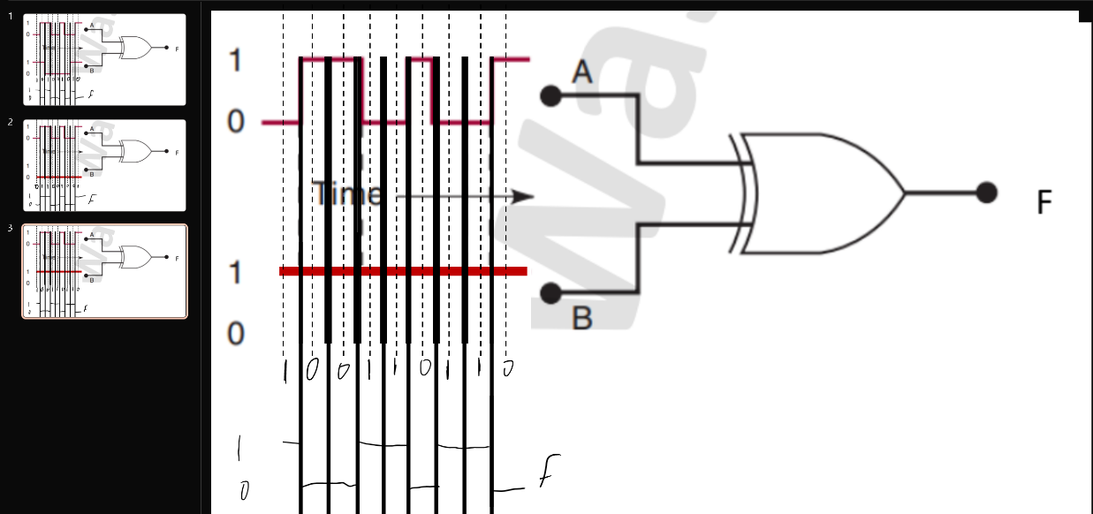

c)

Q3)
Code:
module comp (a, b, c, f);
input a, b, c;
output f;

assign f = ((a ^ b) & (b ~^ c) & c);

endmodule
Simulation:
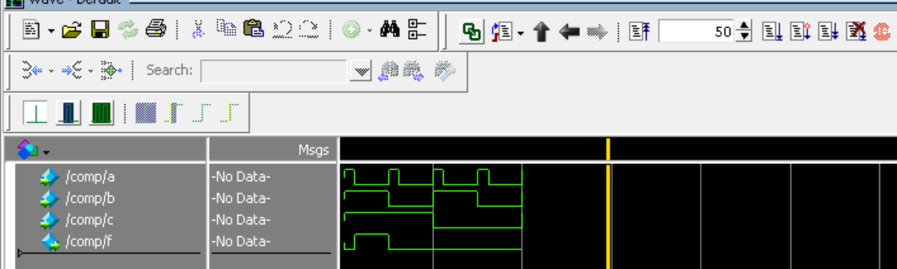
Note: As shown in the simulation the only case that justify f = 1 when a= 0, b = 1 and c = 1.

Q4)
Code:

module comp (a ,b);
input [2:0] a;
output b;

assign b = ~|a;

endmodule

Simulation:
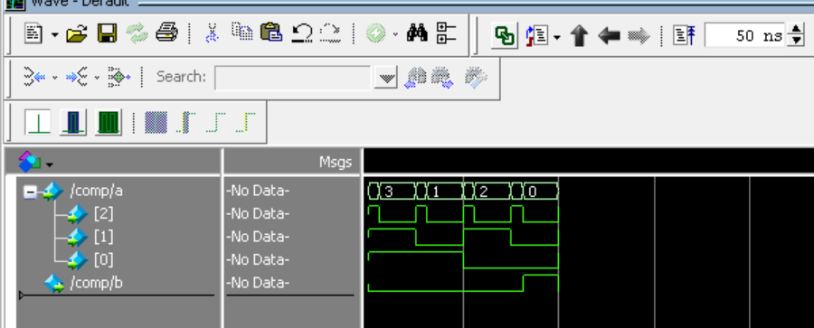
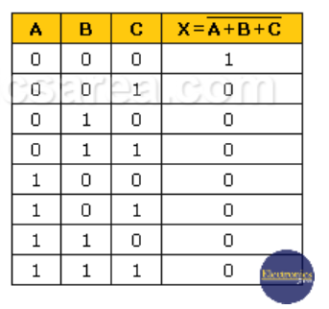
Note: To get 1 only when all bits are 0s and using one gate we use nor due to truth table and the output of the simulation.

Q5)
Code:
module ALU1b (a, b, Ainvert, Binvert, CarryIn, Operation, Result, CarryOut);
input a, b, Ainvert, Binvert, CarryIn;
input [1:0] Operation;
output Result, CarryOut;
wire at , bt;
assign at = (Ainvert)? ~a : a;
assign bt = (Binvert)? ~b : b;
assign {CarryOut, Result} = (Operation == 0)? (at & bt) : (Operation == 1)? (at | bt) : (at + bt + CarryIn);

endmodule
Simulation:
