Assignment_2
====================================================================
Name: Ahmed Nour
Sheet ID: 16
Email: ahmedmohamednoour@gmail.com
====================================================================
Q1)
Main Code for ALU:
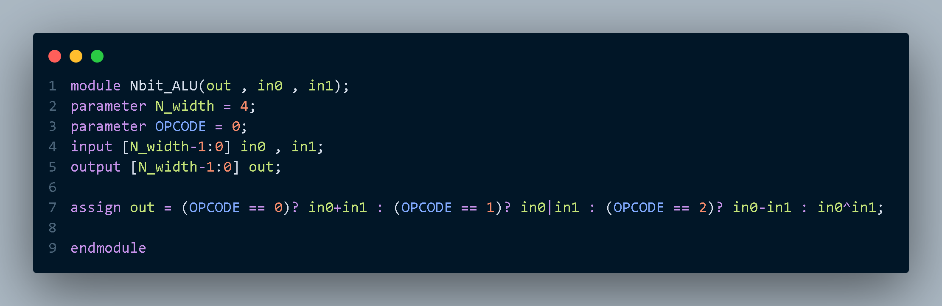

Testbench:
• Testbench 1: N=4 & OPCODE = 0
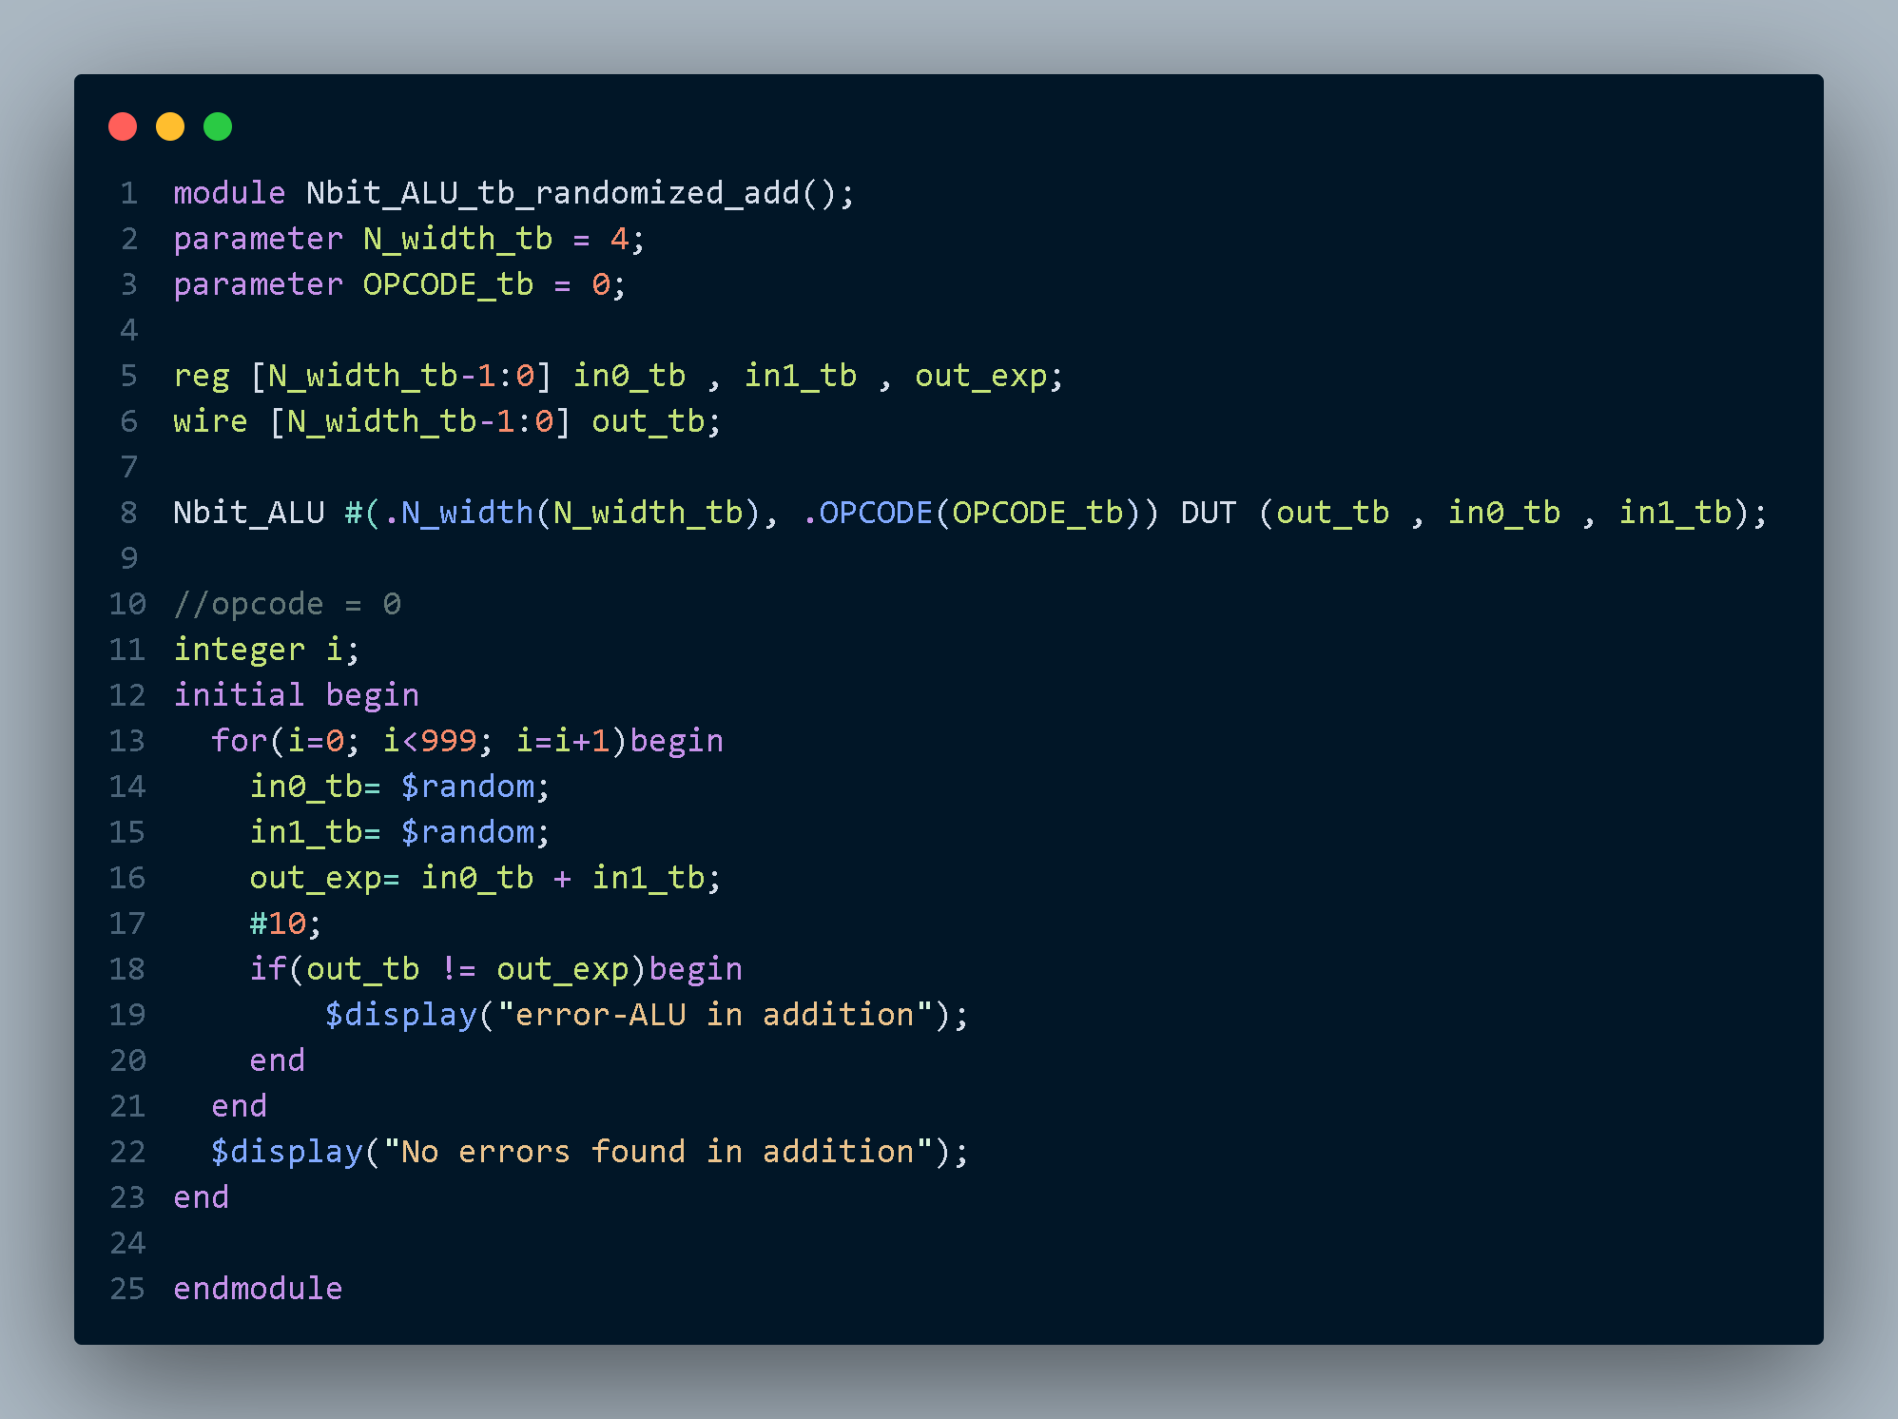
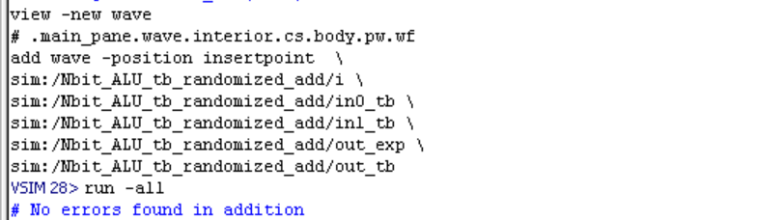

• Testbench 1: N=4 & OPCODE = 1
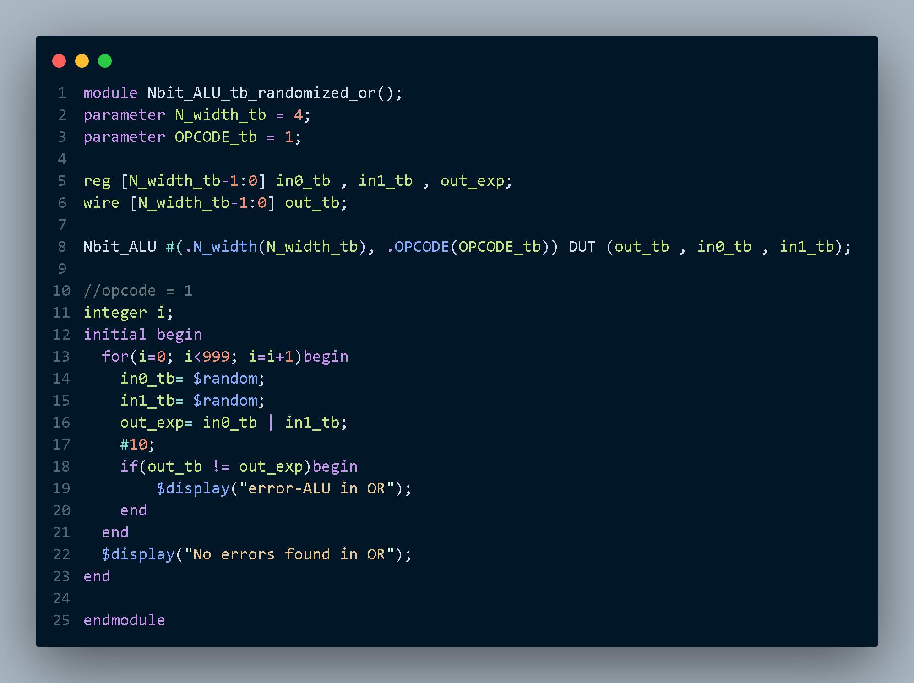
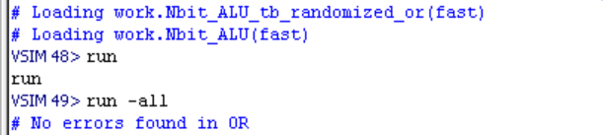

• Testbench 1: N=4 & OPCODE = 2
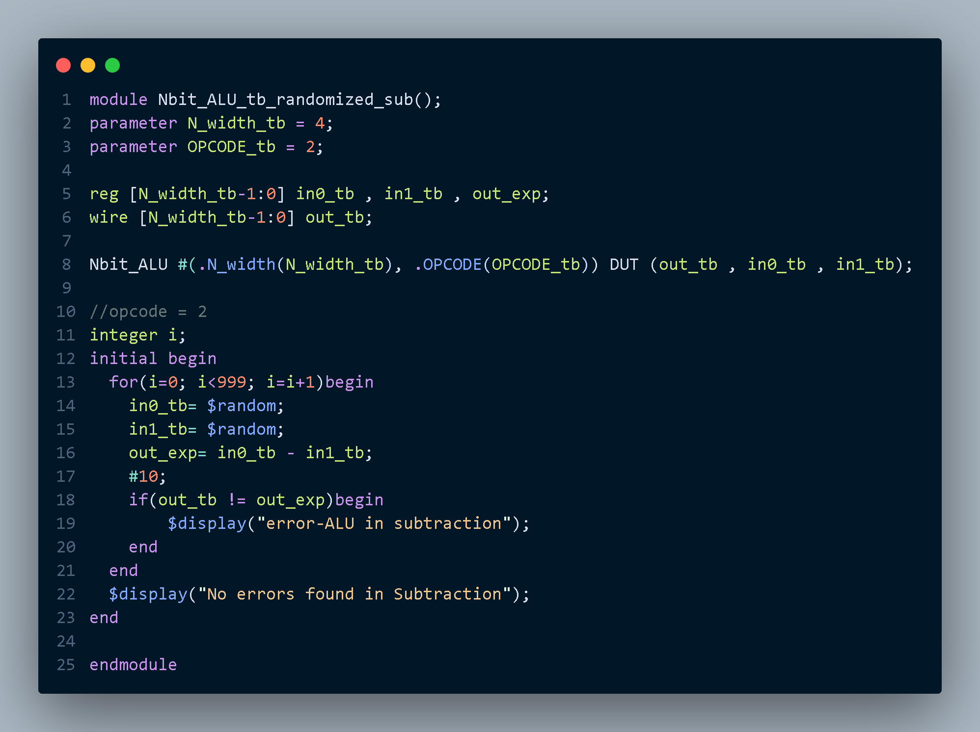
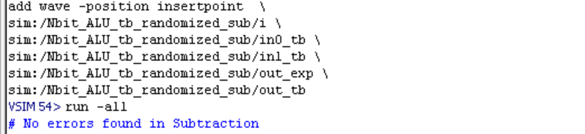

• Testbench 1: N=4 & OPCODE = 3
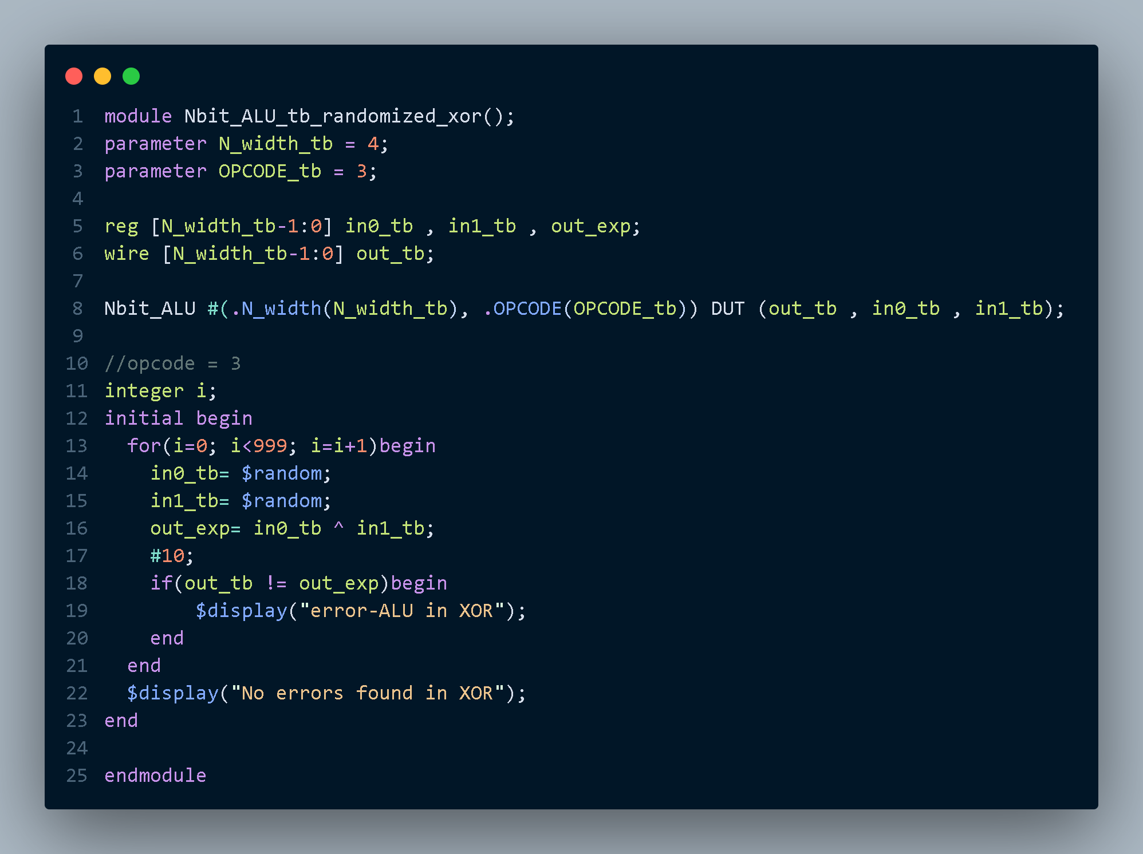
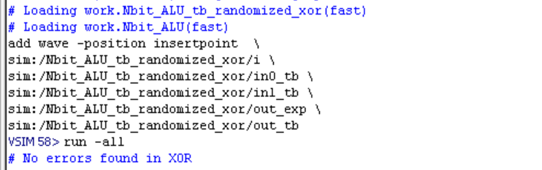

- synthesized schematics of the design with OPCODE = 0
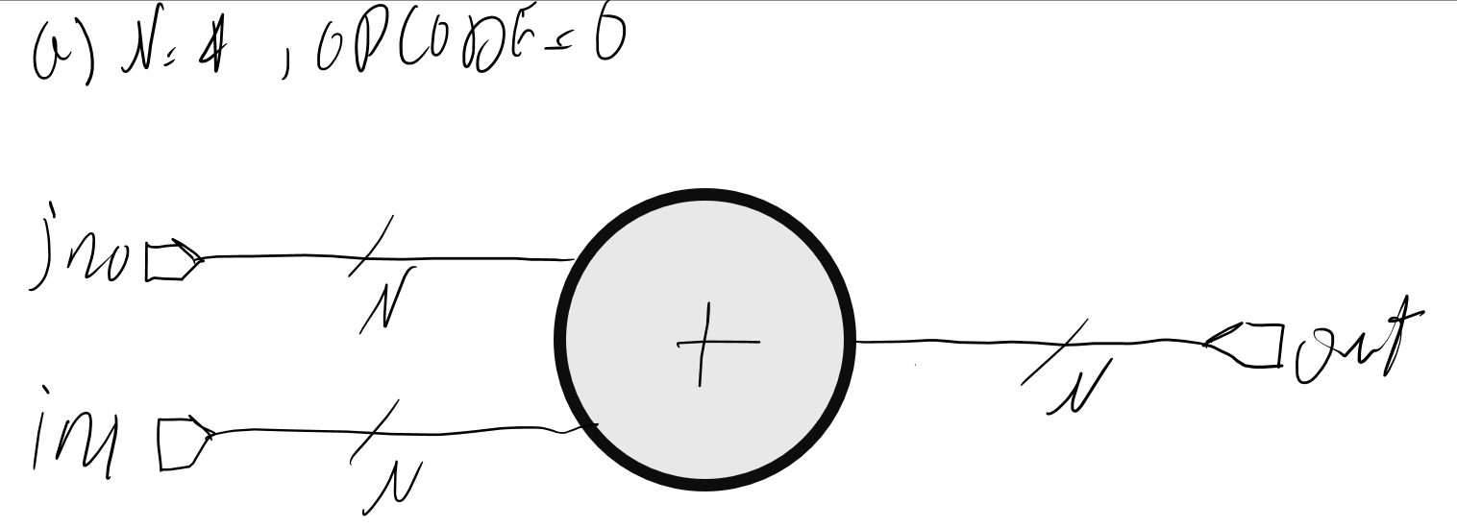
- synthesized schematics of the design with OPCODE = 1
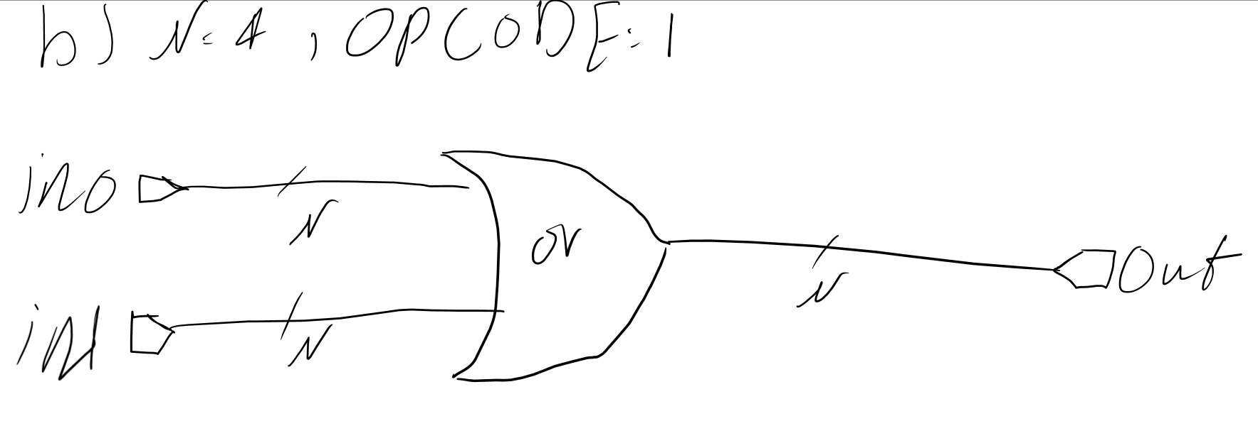
- synthesized schematics of the design with OPCODE = 2
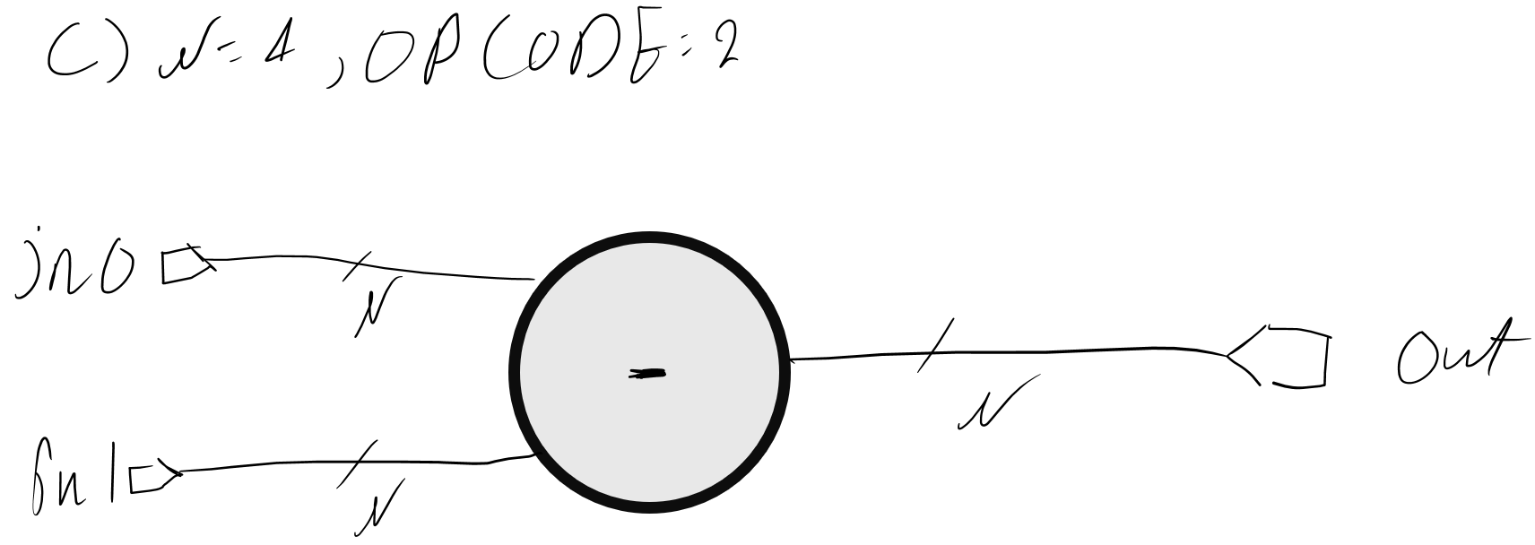
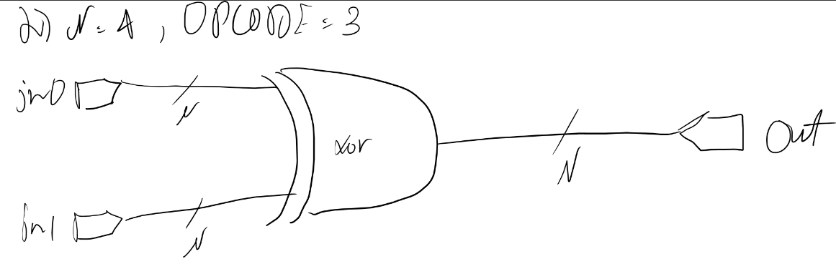
- synthesized schematics of the design with OPCODE = 3

Q2)
Code:
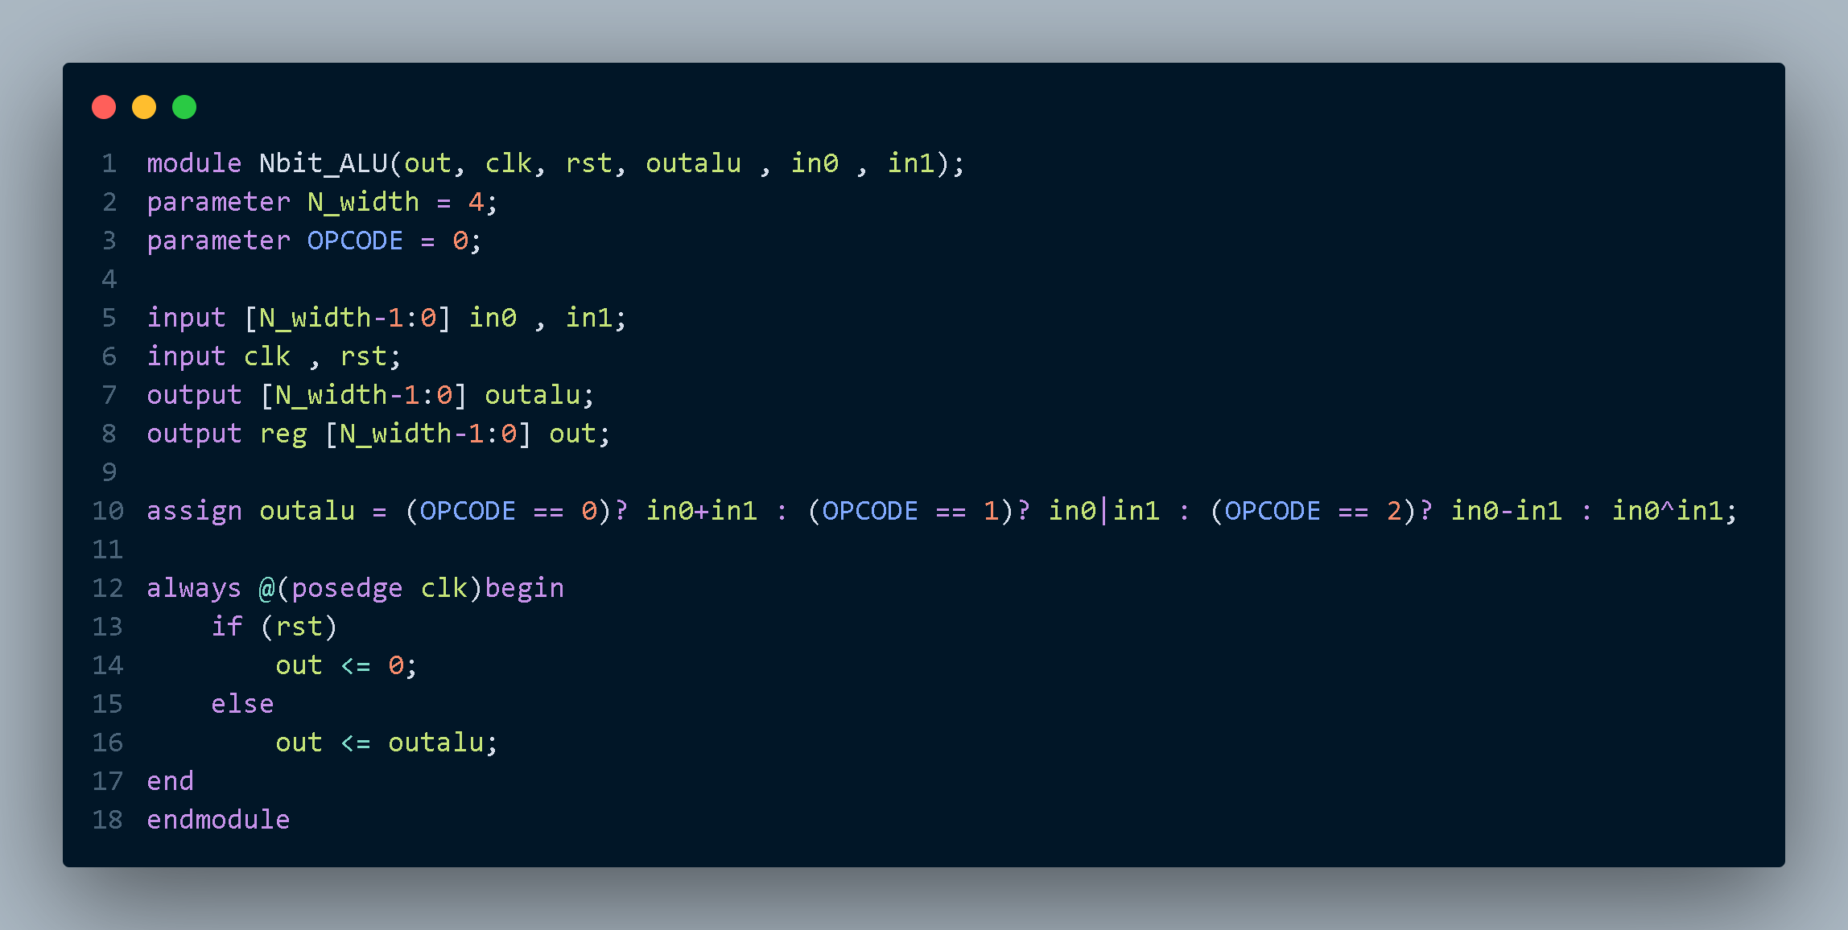
Simulation:
OPCODE = 0:
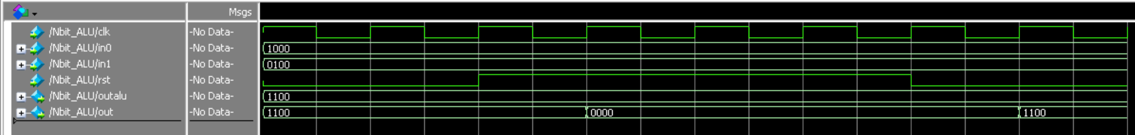
OPCODE = 1:
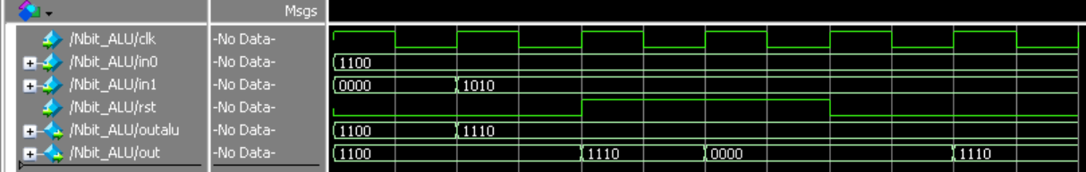
OPCODE = 2:
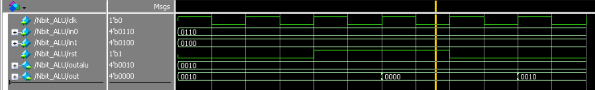
OPCODE = 3:
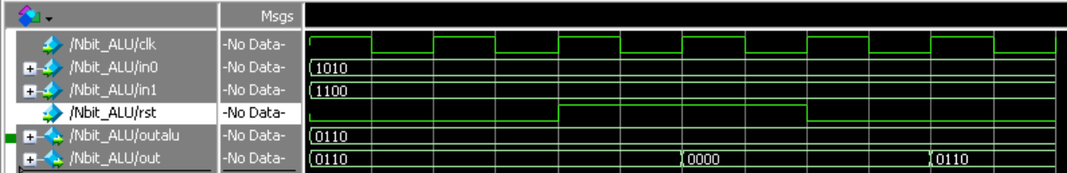
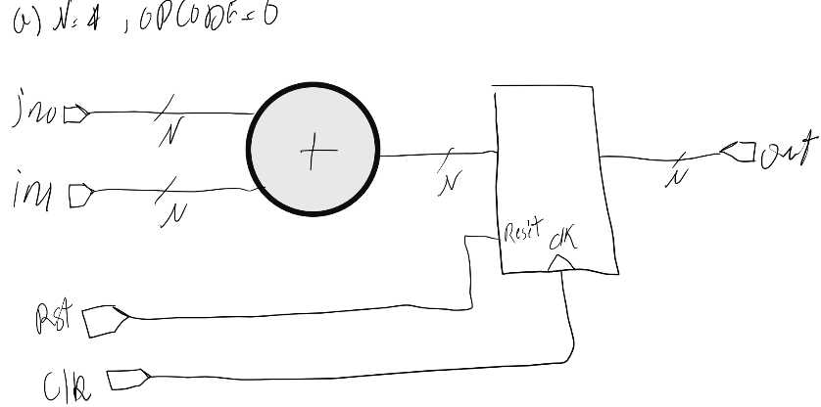
- synthesized schematics of the design with OPCODE = 0

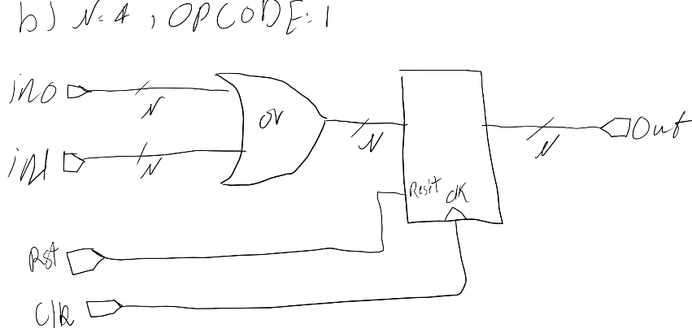
- synthesized schematics of the design with OPCODE = 1

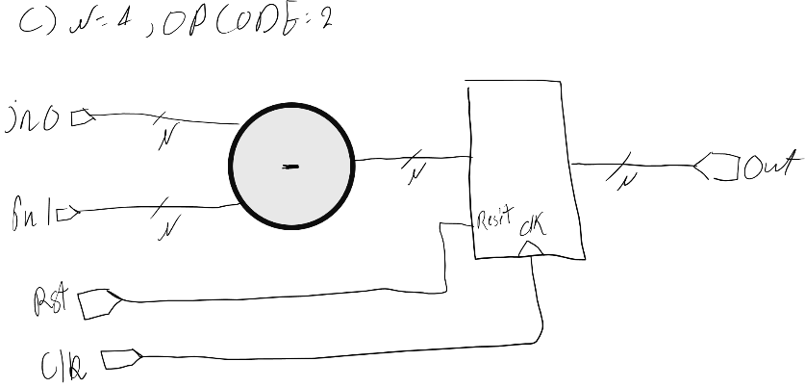
- synthesized schematics of the design with OPCODE = 2

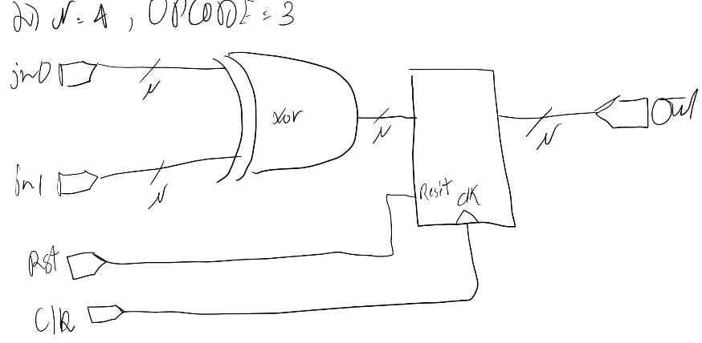
- synthesized schematics of the design with OPCODE = 3

Q3)
Code:
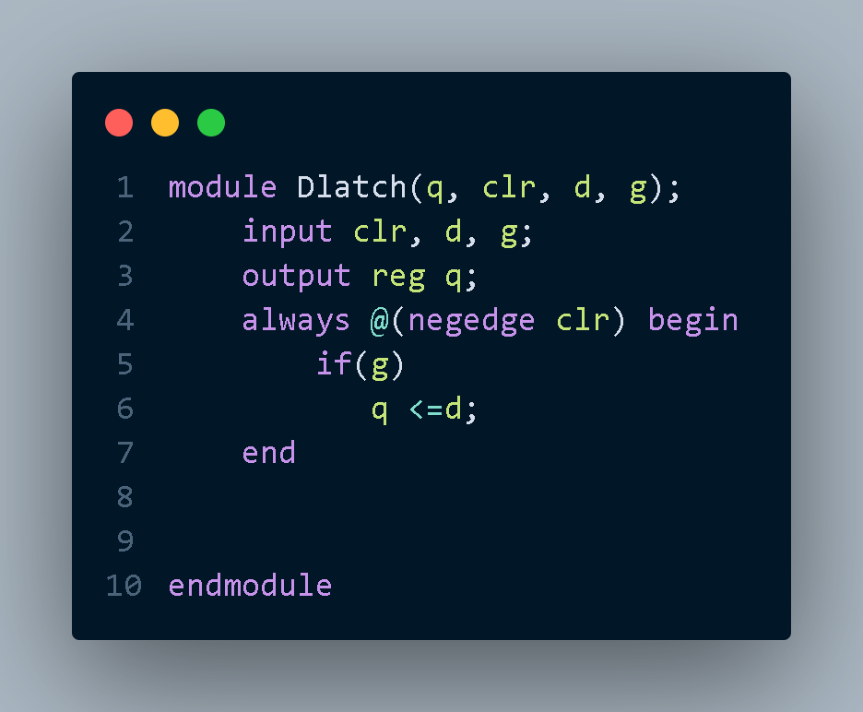
Simulation:
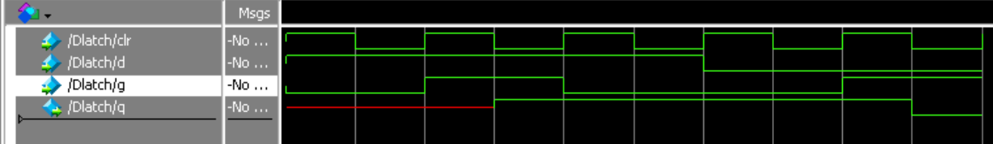

Q4)
Code:
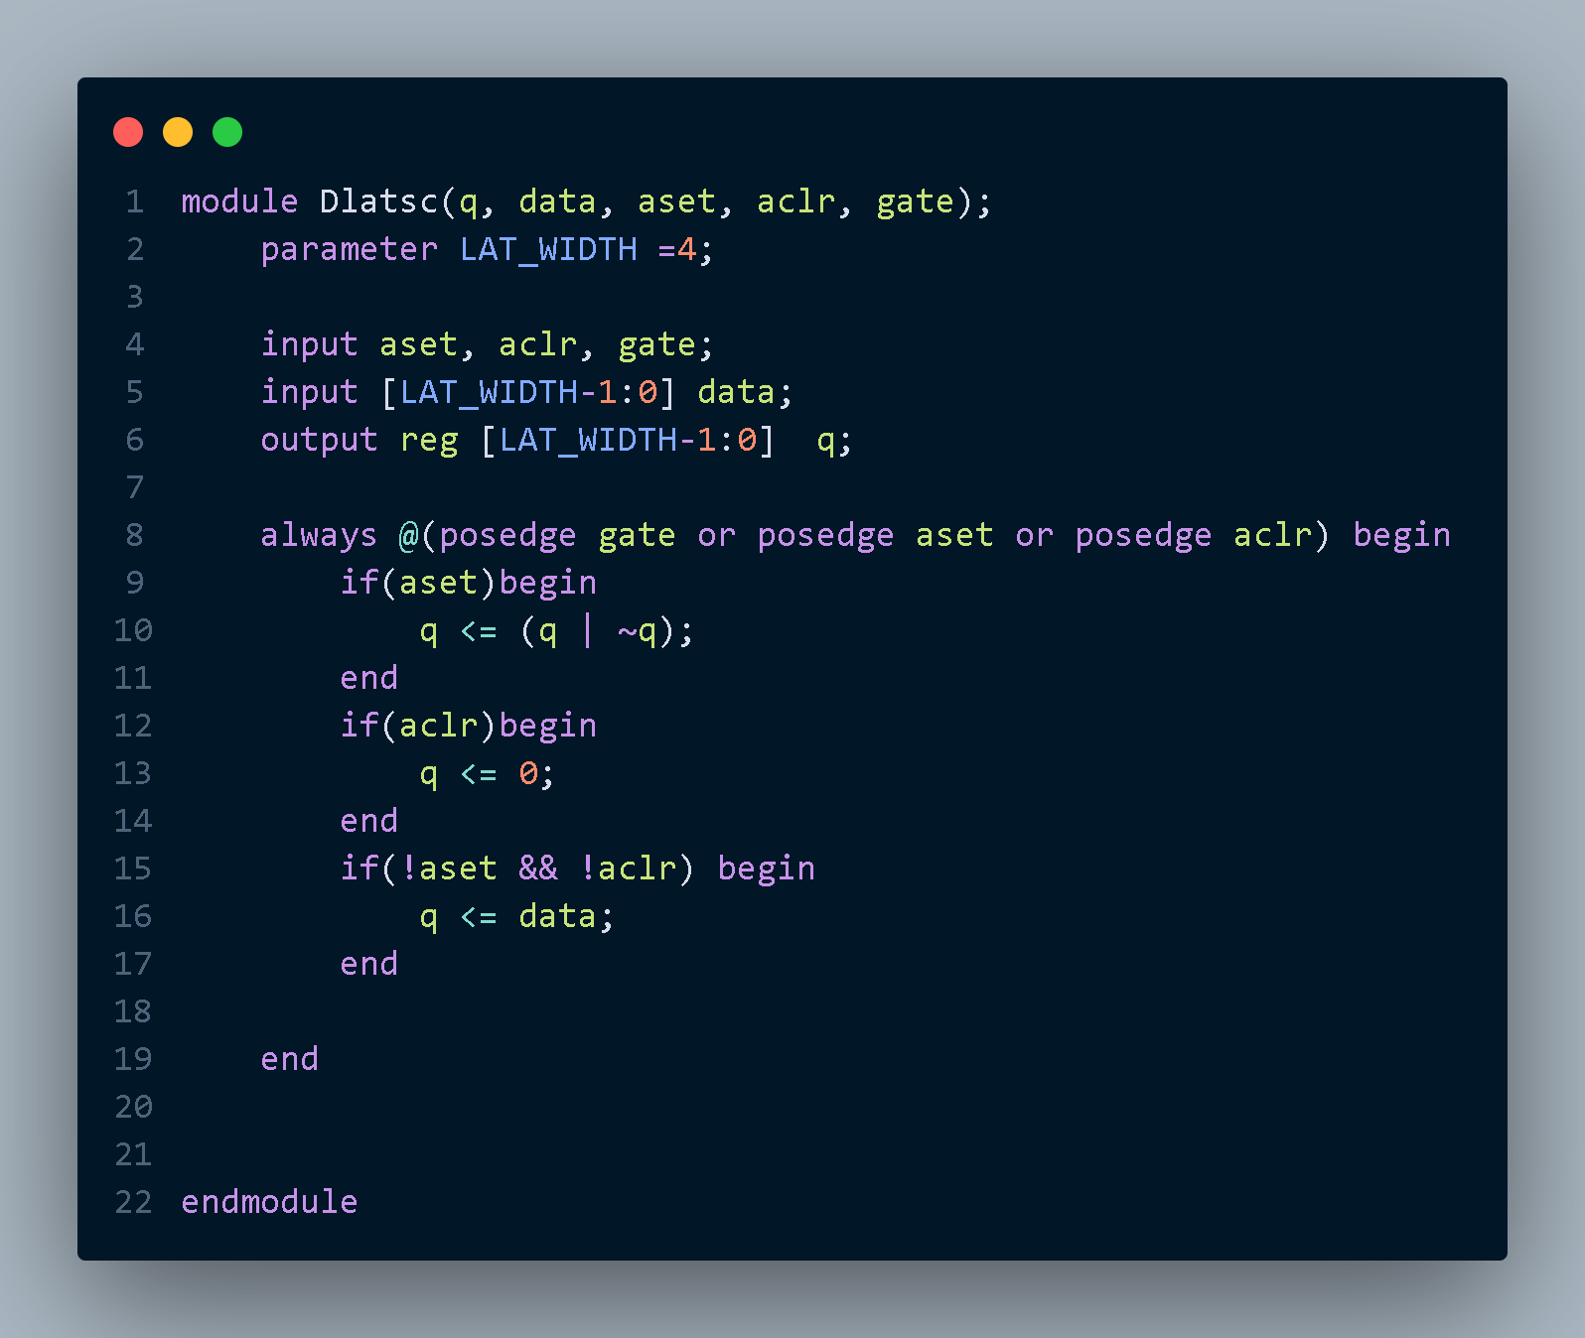
Simulation:
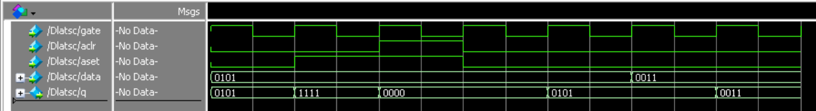

Q5)
a)
Code:
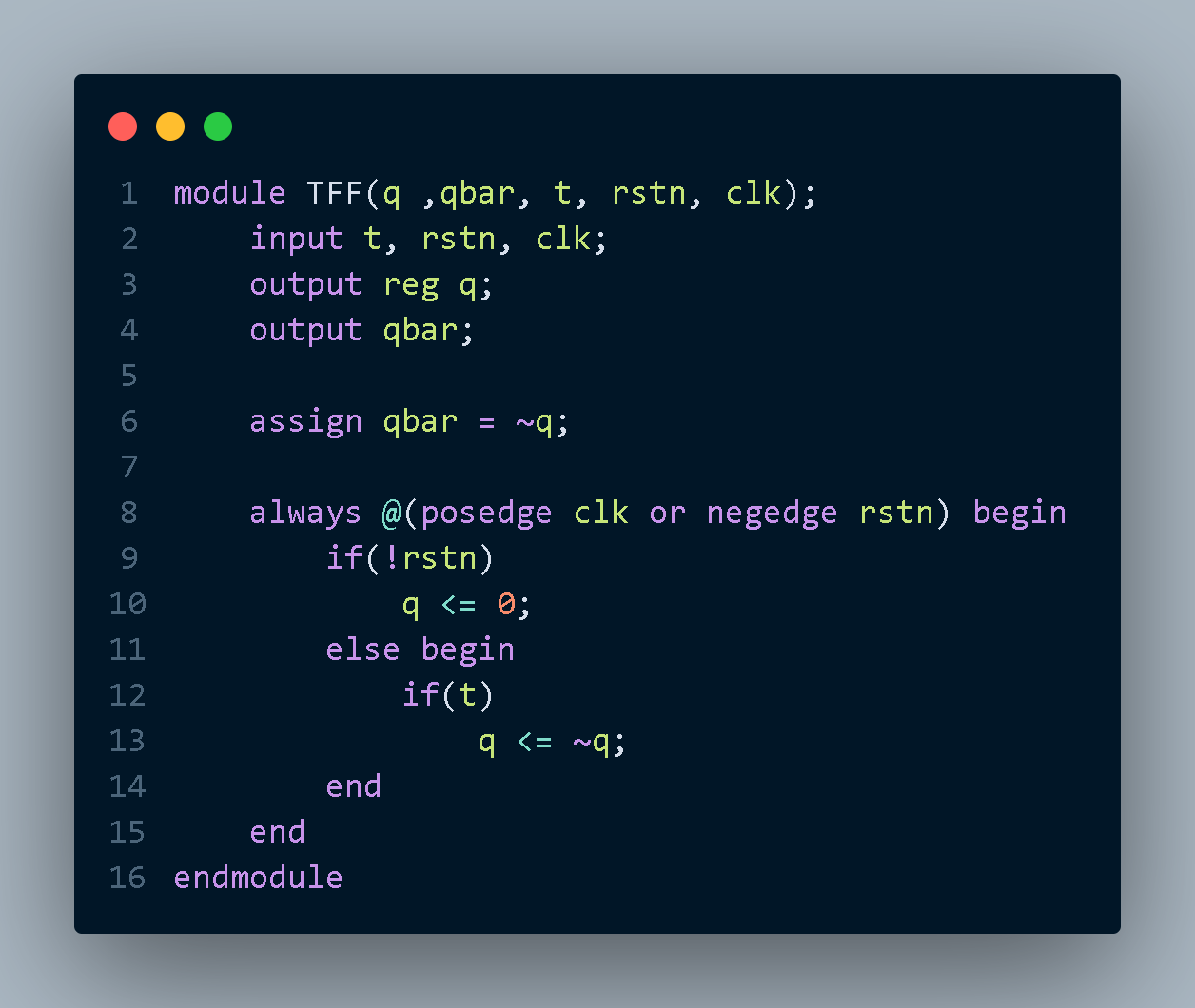
Simulation:
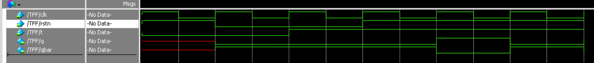

b)
Code:
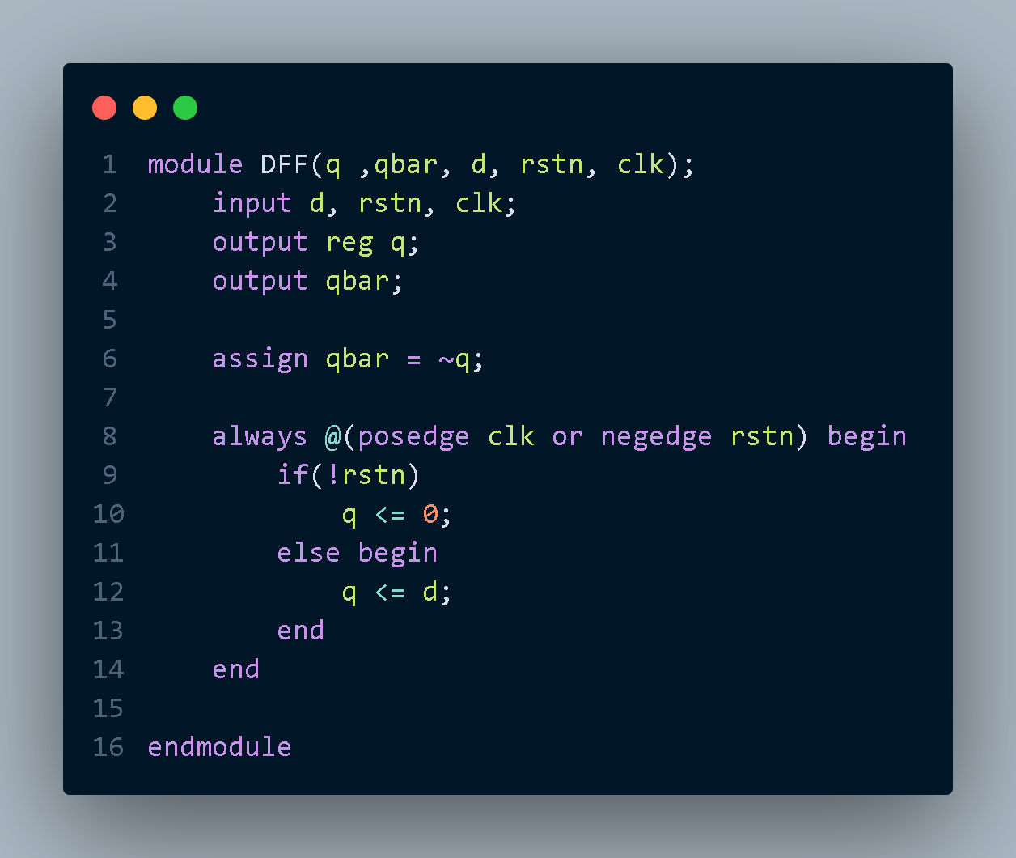
Simulation:
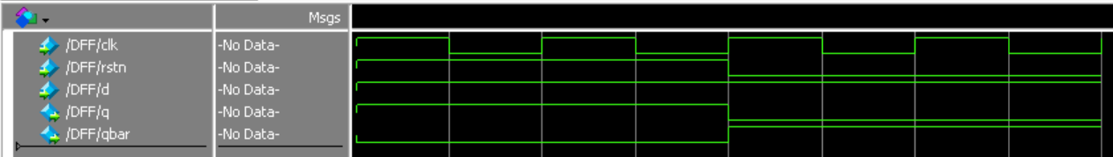

c)
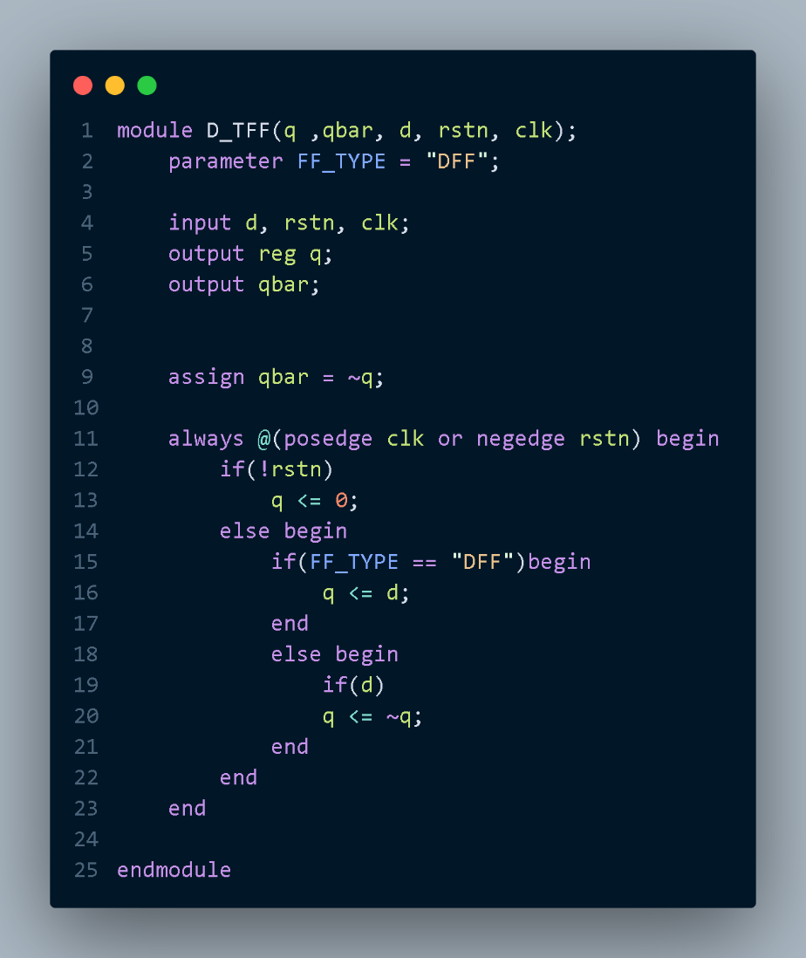
Code:

Simulation:
FF_TYPE = "DFF"
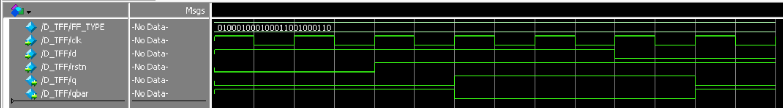
FF_TYPE = "TFF"
