**Smart Home Project**

**Team Member:**

* **Eng. Hadeer Ihab**
* **Eng. Afnan Talaat**
* **Eng. Moaz Adel**
* **Eng. Ahmed Osamaa**

**Project description:**

***• The Project has two Mode Admin & User:***

**Admin mode: The admin can add or delete Users Up to 10 users.**

**User Mode: The User can control on all Electrical devices at home like:**

**- The door**

**- Fans**

**- Air-conditions**

**- The light system for all rooms**

**- Control on home with Bluetooth " In simulation using terminal "**

__________________________________________________________________________________________________

***• the Project consists of Two MCU (ATMega32):***

**First Controller 'Interface':**

**- Connecting with EEPROM by I2C for adding Users Passwords.**

**- Connecting with LCD & Keypad for interfacing with admin or user.**

**- Connecting with Bluetooth Module using USART Protocol “Interrupt" for interfacing with admin or user.**

**- Connecting with Other Controller using SPI Protocol as a master "Polling".**

**Second Controller 'Control’:**

**- Connecting with Other Controller using SPI Protocol as a slave "Interrupt".**

**- Connecting with Electrical Devices at home.**

**- Controlling in Servo with TIMER_1 Mode (14 .**

**- Reading Analog signal "ADC0 "from Temperature Sensor and Control in Air Condition and Firefighting** **system**.

**• if T > 25 >> AirC ON**

**• if T < 18 >> AirC OFF**

**• if T > 25 >> Firefighting system "Pump & Bazzer & LED Alarm" ON**

**• if T > 25 >> Firefighting system "Pump & Bazzer & LED Alarm" OFF**

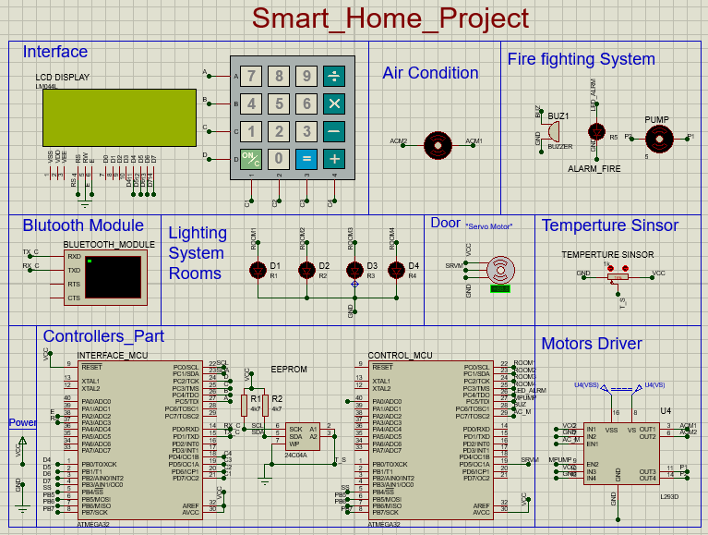***Project Schematic:***

**Thanks ...**