Data Model & Entity Relationship Diagram
EAIS Scheduling Agent Prototype — EAIS-HR-2159-TA-01 — D2 of the engineering document pack

1. Entities and key fields
Entity | Field | Meaning | Scope
SectorManifest | sector (PK) | Sector identifier tag; used for reporting/audit only, never branched on in the core. | Shared schema
SectorManifest | enabled | Whether this sector’s agent is active at all. | Shared schema
SectorManifest | skill_pack_ref (FK) | Which SkillPackConfig to load for this sector. | Shared schema
SectorManifest | approval_required_for | Rule categories that force PENDING_APPROVAL rather than silent auto-correction. | Shared schema
SkillPackConfig | id (PK) | Identifies one sector’s concrete rule set (clinic_v1, restaurant_v1). | Sector-specific instance
SkillPackConfig | required_fields | Fields a booking must contain for this sector (e.g. practitioner vs. party_size). | Sector-specific values
SkillPackConfig | working_hours | When bookings are permitted at all, for this sector. | Sector-specific values
SkillPackConfig | slot_rules | How duration/capacity is computed — fixed slot length (clinic) vs. capacity-by-party-size (restaurant). | Sector-specific values
SkillPackConfig | confirmation_template | Message template rendered on a CONFIRMED decision. | Sector-specific values
Booking | id (PK) | Persisted booking identifier. | Shared schema
Booking | sector (FK) | Which sector this booking belongs to. | Shared schema
Booking | fields | Sector-specific booking data (practitioner+patient, or party_size+seating) as a flexible JSON blob — the schema stays fixed, the content varies per sector. | Shared schema, sector-specific content
Booking | start_time / duration_minutes | Interval the booking occupies — the shared representation both a fixed clinic slot and a flexible restaurant duration reduce to. | Shared schema
Booking | status | CONFIRMED or PENDING_APPROVAL at persistence time. | Shared schema
BookingRequest | raw_text / sector / fields | The structured request produced by intake, before a decision is made. | Shared schema
Decision | status / reason | The approval gate’s output — never a bare boolean. | Shared schema
AuditRecord | input, skill_pack_ref, intent, rules_evaluated, decision, approval_status, timestamp | One immutable record per processed request, regardless of outcome. | Shared schema

2. Relationships and cardinalities
Relationship | Cardinality | Meaning
SectorManifest — SkillPackConfig | 1 : 1 | Each sector declares exactly one skill pack it loads.
SkillPackConfig — Booking | 1 : 0..* | A skill pack’s rules govern zero or more bookings in that sector.
SectorManifest — Booking | 1 : 0..* | Every booking belongs to exactly one sector.
BookingRequest — Decision | 1 : 1 | Every request that reaches the gate produces exactly one decision.
BookingRequest — AuditRecord | 1 : 1 | Every processed request produces exactly one audit record (FR6, AC4) — regardless of decision outcome.
Booking — Booking | 0..* : 0..* | Two bookings in the same sector/resource scope may conflict if their intervals overlap (FR7); this is a same-run check, not a stored relationship.

3. Entity relationship diagram
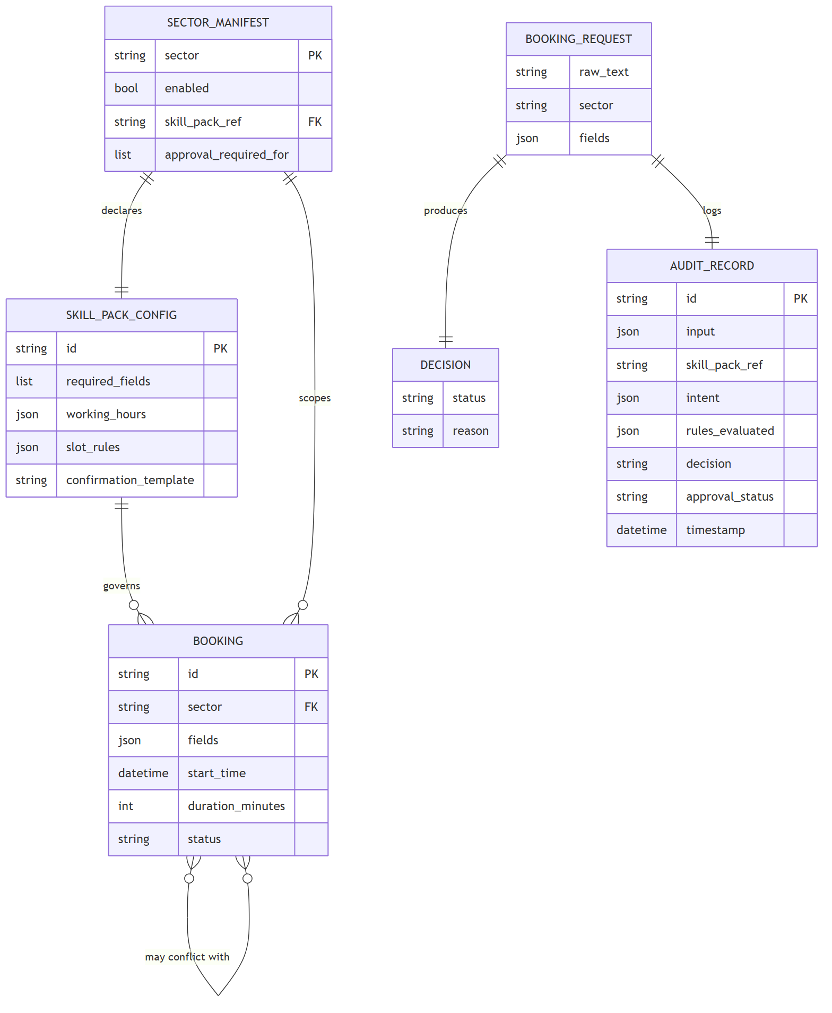
Source: erd.mmd

4. Shared core vs. sector-specific, and how a new sector extends the model
- Shared, fixed schema — SectorManifest, SkillPackConfig, Booking, BookingRequest, Decision, and AuditRecord all have identical structure for every sector. None of these tables/types gain new columns when a sector is added.
- Sector-specific, in data only — a sector’s actual required_fields, working_hours, slot_rules, and confirmation_template live as values inside one SkillPackConfig row/config file, and a booking’s fields JSON blob carries whatever keys that skill pack declares.
- Extending to a third sector — add one new SectorManifest entry, one new SkillPackConfig, and let Booking.fields carry that sector’s field names. No table gains a column, no core type changes shape — this is the same claim ARCHITECTURE.md’s extension-point map makes, expressed here as a data-model guarantee rather than a code guarantee.
This is what makes FR1 (no sector-specific branching in the core) hold at the persistence layer too, not just in the orchestration code: the core never needs a schema migration to support a new sector, only a new configuration row.

