# Ahmad Ali Ahmad Othman - Section 1 - Assignment 1

1. Detect whether these variable names are valid or not:

* bool
* mail@
* _Course
* Two1
* sum
* **Valid identifiers**: bool (not recommended), _Course, Two1, sum (not recommended)
* **Invalid identifier**: mail@

Although bool and sum are reserved words, but python allows using them as variable names which is not recommended because it disables their functionality.

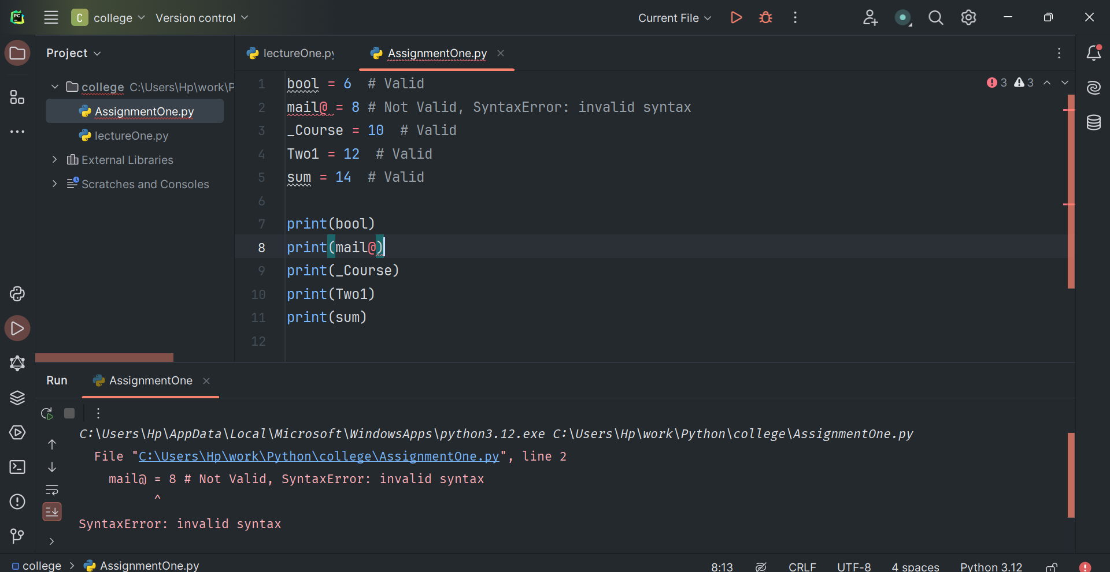

1. Determine the type of errors:

x="student"  
y="hello"  
print("""hello my students ""'+ " "+x+" "+y)

**SyntaxError**: unterminated triple-quoted string literal (detected at line 3)

1. What will be the output of the following code snippet?

print(2**3 + (5 + 6) ** (1 + 1)) # 8 + 11**2 = 8 + 121 + 129

==A) 129== B) 8 C) 121 D) None of the above.

1. What will be the output of the following code snippet?

print(type(5 / 2)) # <class 'float'>  
print(type(5 // 2)) # <class 'int'>

==A) float and int== B) int and float C) float and float D) int and int

1. What will be the datatype of the var in the below code snippet?

var = 10  
print(type(var)) # <class 'int'>  
var = "Hello"  
print(type(var)) # <class 'str'>

1. What is the actual and expected output of this program and if there is an error what is the type of it and how to solve it?

# This program takes two numbers from the user and prints the sum.  
x = input("Enter a number: ") # "3"  
y = input("Enter another number: ") # "4"  
sum = x + y  
print(sum) # "34"

**Expected vs. Actual Output**

* **Expected Output** (if we want the sum as a number): If x = 3 and y = 4, the expected output should be 7.
* **Actual Output**: For the same inputs, the actual output will be 34.

**Type of Error**

* This is a logical/semantic error: **TypeError**, where the program performs concatenation instead of addition because x and y are strings, not integers.

**Solution**

* To fix this, we need to convert x and y to integers (or floats) before adding them:

# This program takes two numbers from the user and prints the sum.  
x = int(input("Enter a number: ")) # 3  
y = int(input("Enter another number: ")) # 4  
sum = x + y  
print(sum) # 7

1. What is the output?

f = 5  
y = 6  
z = 4  
w = 33  
  
p = ((f + y) * z / w) ** F # NameError: name 'F' is not defined.  
print(p)

It will result in a NameError Because F is not defined.

**Error Identification**:

* **NameError**: The variable F (uppercase) in line 6 is undefined, which will raise a NameError when this line is executed.
* **Type of Error**: NameError occurs because F has not been defined in the code. Python is case-sensitive, so f (lowercase) and F (uppercase) are distinct variables.

1. Discover the errors, and keywords for the following sub Python programs which was written by some friends in the same company. Then correct each type of error and Identifiers.

| NO | Before correction | Type of Error | After correcting |
| --- | --- | --- | --- |
| 1 |  | SyntaxError (missing double quote) |  |
| 2 |  | IndentationError (incorrect indentation) |  |
| 3 |  | LogicalError (division precedence) |  |
| 4 |  | SyntaxError (incorrect comment format) |  |
| 5 |  | SyntaxError (invalid variable name) |  |
| 6 |  | ZeroDivisionError (division by zero) | Add a check to avoid division by zero or change X to non-zero. |
| 7 |  | TypeError (string concatenation) |  |

1. Essay Questions:

* Create a program to compute the volume of a sphere. Use the formula V = (4/3) * pi * r^3 where pi is equal to 3.1416 approximately. The r is the radius of sphere. Display the result.

# Prompt the user to enter the radius and convert the input to a float  
radius = float(input("Enter the radius: "))  
PI = 3.1416 # Define the constant value for PI  
volume = (4 / 3) * PI * radius**3 # Calculate the sphere's volume  
  
print(volume)

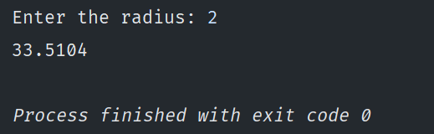

* Write a program that converts the input Celsius degree into its equivalent Fahrenheit degree. Use the formula F = (9 / 5) * C + 32.

Celsius = float(input("Enter Celsius: "))  
Fahrenheit = (9 / 5) * Celsius + 32  
  
print(Fahrenheit)

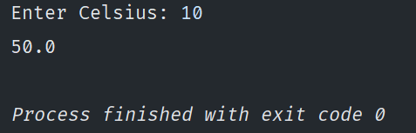

* Write a program that converts the input dollar to its peso exchange rate equivalent. Assume that the present exchange rate is 51.50 pesos for one dollar. Then display the peso equivalent exchange rate.

dollars = float(input("Enter your dollars amount: "))  
peso_dollar_ratio = 51.5  
pesos = dollars * peso_dollar_ratio  
  
# Used formatted strings for better output display  
print(f"{dollars} dollars is {pesos} pesos")

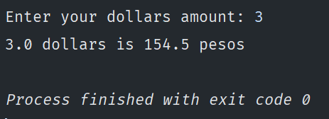

* Write a program that converts the input inches into its equivalent centimeters. Take note that one inch is equal to 2.54 centimeters.

inches = float(input("Enter inches: "))  
  
centimeters = inches * 2.54  
  
# Used formatted strings for better output display  
print(f"{inches} inches is {centimeters} centimeters")

