RetailTec Analytics — Database, Data Warehouse & ERD
Volume 1 of 5 — Technical Handover Documentation
July 2026 · App version 3.1.0 · Warehouse schema v8
Table of Contents

1. Architecture at a Glance
RetailTec Analytics is a two-database system:
Layer | Engine | Role
Source | Oracle 12c+ (RPS schema) | The live Retail Pro Prism database. Read-only for Analytics — the app never writes to it.
Warehouse | DuckDB (single file) | A local star-schema copy optimized for analytics. All dashboards and reports read ONLY from this file.
The sync engine (backend/db/sync.py) extracts from Oracle over the network, transforms in-flight, and loads into DuckDB. Users never wait on Oracle: every screen is served from the local warehouse in milliseconds.
Warehouse file location: one file per Oracle server, named retailtec_<host with dots as underscores>.db (e.g. retailtec_10_0_0_5.db), stored next to the app state (in the packaged install: <install dir>\_internal\). Switching the connection host in Settings switches the active warehouse file, so multiple customers/servers never mix data.

2. The Oracle Source (RPS schema)

2.1 Tables read, per domain
Domain | Oracle tables | Notes
Sales | RPS.DOCUMENT, RPS.DOCUMENT_ITEM, RPS.TENDER | Headers, item lines, and payment lines of POS receipts.
Inventory (on-hand) | RPS.INVN_SBS_ITEM_QTY, RPS.INVN_SBS_ITEM, RPS.INVN_SBS_PRICE + RPS.PRICE_LEVEL | Snapshot quantities, cost, and price level 1.
Inventory history | RPS.INVENTORY_HISTORY | Trigger-log of quantity changes (a Prism customization — the app detects its presence).
Purchases | RPS.VOUCHER, RPS.VOU_ITEM | Receiving vouchers and their lines.
Transfers | RPS.SLIP, RPS.SLIP_ITEM (+ RPS.VOUCHER for the reversing voucher number) | Transfer slips between stores.
Adjustments | RPS.ADJUSTMENT, RPS.ADJ_ITEM, RPS.CONTROLLER | Memo/quantity adjustments; controller supplies a fallback store.
Dimensions | RPS.STORE, RPS.SUBSIDIARY, RPS.EMPLOYEE, RPS.CUSTOMER + RPS.CUSTOMER_PHONE, RPS.INVN_SBS_ITEM, RPS.DCS, RPS.VENDOR | Master data mirrored into DIM_* tables.
Accounting (virtual GL) | RPS.DOCUMENT + RPS.DOCUMENT_ITEM of subsidiary 100 + the Prism touch-menu tables (for the account classification tree) + RPS.INVN_SBS_ITEM (chart of accounts) | See Volume 5 for the full design.
Tenders | RPS.TENDER, RPS.TENDER_CREDIT_CARD | TENDER_CREDIT_CARD joins 1:1 by TENDER_SID; CARD_TYPE_NAME carries the real card brand.

2.2 Source facts every developer must know
- STATUS = 4 means posted/closed — and closed documents are IMMUTABLE. In Prism a closed document of any type can never be voided or reopened; corrections always create a NEW opposite document (a return is its own document). The posted fact stream is therefore append-only at source. This is the foundation of the warehouse’s insert-only load model.
- Hard deletes exist only as DBA actions on subsidiary 100 (the accounting customization’s custom-GL documents). They cannot happen in production for normal transactions. Consequently only FACT_GL needs replace-semantics; every other fact is safe with insert-only loads.
- All RPS text columns are NVARCHAR2. Mixing charsets inside a recursive CTE / CASE / UNION raises ORA-12704 (character set mismatch). Every accounting query wraps literals with TO_NCHAR(...) / N'...' and anchors recursive CTEs with an NVARCHAR2 cast. Any new SQL against RPS must follow the same rule.
- TENDER_TYPE enum (from the DB column comment): 0 Cash, 1 Check, 2 Credit Card, 3 COD, 4 Charge, 5 Store Credit, 6 Split, 7 Deposit, 8 Payments, … 15 Central Gift Card, 17 Central Customer Credit, 18 Loyalty. Values 0–32 are reserved by Retail Pro; this installation uses 19–28 as Custom Tenders 1–10.
- Function-based date indexes exist on the big tables (IDX_DOCUMENT7 on CAST(INVC_POST_DATE AS DATE), IDX_CREATEDDATE_VOU, IDX_CREATEDDATE_SLIP, IDXADJUSTMENT, IDX_INV_HIST_DATE — the latter four on SYS_EXTRACT_UTC(created)). The extraction SQL is written to match these expressions exactly so Oracle uses an index range scan (0.1 s) instead of a full scan of millions of rows. The UTC-based predicates are widened by ±1 day for timezone skew and paired with a plain local-time predicate that filters exactly.
- Index vs full-scan strategy: windows ≤ 92 days get an INDEX hint; wider windows (historical backfills) get FULL(H) — one sequential scan beats hundreds of thousands of scattered ROWID lookups over a WAN. Constant: _INDEX_WINDOW_DAYS = 92 in sync.py.
- Scale (production reference): DOCUMENT ≈ 2.4M rows, DOCUMENT_ITEM ≈ 5.0M, VOU_ITEM ≈ 4.6M, SLIP_ITEM ≈ 4.3M, INVENTORY_HISTORY ≈ 3.1M — roughly 19M fact rows over six years.

2.3 Watermark columns (incremental sync keys)
Domain | Watermark column | Why
Sales | DOCUMENT.INVC_POST_DATE | The business posting date; indexed; designed watermark.
Purchases | VOUCHER.CREATED_DATETIME | No posting timestamp exists on vouchers.
Transfers | SLIP.CREATED_DATETIME | Same.
Adjustments | ADJUSTMENT.CREATED_DATETIME | Same.
Inventory history | INVENTORY_HISTORY.ACTION_DATE | The trigger stamp.
Never watermark on MODIFIED_DATETIME: closed documents are immutable except their notes, and a note edit bumps MODIFIED_DATETIME, which would needlessly re-pull years-old documents.

3. The DuckDB Warehouse
Schema version 8 (SCHEMA_VERSION in backend/db/model.py; the app migrates older files automatically with additive ALTER TABLE IF NOT EXISTS statements). ~29 tables in three groups: 9 dimensions, 11 facts, 9 ETL/control tables. Relationships are implicit (no FK constraints — joins are by convention, documented in §4).

3.1 Dimensions

DIM_DATE
Calendar spine, pre-populated. DATE_KEY (PK), YEAR, QUARTER, MONTH_NUM, MONTH_NAME, WEEK_NUM, DAY_OF_MONTH, DAY_OF_WEEK (0=Monday…6=Sunday), DAY_NAME, IS_WEEKEND.

DIM_STORE
SID (PK), STORE_CODE, STORE_NAME.

DIM_SUBSIDIARY
SID (PK), SBS_NO, SBS_NAME. Subsidiary 100 (the virtual GL) is quarantined from every non-accounting extract and screen and never counts toward the licensed subsidiary limit.

DIM_EMPLOYEE
SID (PK), FULL_NAME.

DIM_CUSTOMER
SID (PK), CUST_ID (human-facing customer number; display/search only), FULL_NAME, PHONE (primary phone via CUSTOMER_PHONE, PRIMARY_FLAG DESC, SEQ_NO, SID pick). Loaded windowed: customers appearing on documents in the loaded range.

DIM_ITEM
SID (PK), SBS_SID, ALU, UPC, DESCRIPTION1/2/3/4, LONG_DESCRIPTION, ATTRIBUTE, ITEM_SIZE, DCS_SID, VEND_SID, ACTIVE, TEXT1–TEXT10, UDF1–UDF5_STRING, PRICE_LVL1/2/3. Fully refreshed every sync (windowed loading once left fact-referenced items missing → “(unknown item)”). The optional columns feed the configurable grid columns feature (server-side whitelist ITEM_EXTRA_FIELDS).

DIM_DCS
Department/Class/Subclass: SID (PK), SBS_SID, DCS_CODE, D_NAME, C_NAME, S_NAME.

DIM_VENDOR
SID (PK), SBS_SID, VEND_CODE, VEND_NAME.

DIM_ACCOUNT (chart of accounts — accounting only)
SID (PK), ACCOUNT_CODE (= the item ALU), ACCOUNT_KEY (= UDF5_STRING, the stable logical key), NAME_EN, NAME_AR, ACCOUNT_CLASS, ACCOUNT_GROUP (level-2 branch of the Prism accounting touch menu; NULL when the account hangs directly under a class), CLASS_SEQ (level-1 branch order → statement section order), CLASS_SOURCE ('tree' = classified in the Prism touch menu, 'default' = built-in integration default, 'manual' = carried over). ACCOUNT_CLASS is deliberately nullable and never inferred from the code range — the COA mixes two numbering schemes, so classification comes only from the accountant’s tree.

3.2 Facts

FACT_SALES_DAILY (aggregate, replaced per window each sync)
PK (POST_DATE, STORE_SID, SUBSIDIARY_SID). SALES_COUNT, RETURN_COUNT, ORDER_COUNT, NET_SALES_WOTAX, INVOICE_DISC, TOTAL_TAX, TOTAL_DEPOSIT, TOTAL_FEES, SHIPPING_AMT, TOTAL_WTAX, GROSS_WOTAX, RETURN_WOTAX, RETURN_UNITS. Rebuilt from FACT_SALES_INVOICES for the synced window — the one fact with replace semantics besides FACT_GL.

FACT_SALES_INVOICES (insert-only)
PK DOC_SID. Header-level: DOC_NO, INVC_POST_DATE, RECEIPT_TYPE (0 sale / 1 return / 2 order), SUBSIDIARY_SID, STORE_SID, EMPLOYEE1_SID, CASHIER_SID, BT_CUID (customer), quantities (SOLD_QTY, RETURN_QTY), money (NET_SALES_WOTAX, TOTAL_TAX, INVOICE_DISC, ITEM_DISC, LOYALTY_DISC, TOTAL_DEPOSIT, TOTAL_FEES, SHIPPING_AMT, TOTAL_WTAX, GROSS_WOTAX, RETURN_WOTAX, RETURN_UNITS) and the tender split (CASH_AMT, CARD_AMT (types 2+11), DEPOSIT_AMT (type 7), OTHER_AMT). NET_SALES_WOTAX and TOTAL_TAX are signed (negative on return documents); return money lives in RETURN_SUBTOTAL_WITH_TAX-family source columns because SALE_* is zero on RECEIPT_TYPE=1 documents.

FACT_SALES_ITEMS (insert-only)
PK DOC_ITEM_SID. DOC_SID, INVC_POST_DATE, SUBSIDIARY_SID, STORE_SID, ITEM_SID, ITEM_TYPE ('Sale'/'Return' — a sale receipt can contain returned items, which is why gross/returns are measured here, not from headers), QTY, unit measures (UNIT_COST, UNIT_ORIG_PRICE_WOTAX/WTAX, UNIT_PRICE_WOTAX, UNIT_TAX_AMT, UNIT_PRICE_WTAX, UNIT_ITEM_DISC, UNIT_RECEIPT_DISC, UNIT_LOYALTY_DISC) and line totals (TOTAL_COST, TOTAL_ORIG_PRICE_WOTAX, TOTAL_PRICE_WOTAX, TOTAL_TAX_AMT, TOTAL_PRICE_WTAX).

FACT_INVENTORY (snapshot upsert)
PK (ITEM_SID, STORE_SID). SUBSIDIARY_SID, ON_HAND_QTY, COST, PRICE1, SYNCED_AT. Guarded: a source read returning 0 rows never empties the existing snapshot.

FACT_INVENTORY_HISTORY (insert-only)
PK HISTORY_SID. ACTION_TYPE, ACTION_DATE, STORE_SID, ITEM_SID, QTY, COST, SBS_SID. Only present where the customization exists (feature-detected).

FACT_TRANSFERS (insert-only)
PK TRANSFER_ITEM_SID. SLIP_SID, SLIP_NO, SLIP_DATE, VOU_NO, VOU_CLASS, VOU_STATUS, OUT_STORE_SID, IN_STORE_SID, ITEM_SID, SENT_QTY, RECV_QTY, UNIT_COST, TOTAL_COST, TOTAL_PRICE.

FACT_ADJUSTMENTS (insert-only)
PK ADJ_ITEM_SID. ADJ_SID, ADJ_NO, ADJ_DATE, STORE_SID (85% of headers have NULL store — the loader falls back to the creating controller’s store, then ORIG_STORE_SID), EMPLOYEE_SID, DOC_TYPE, ITEM_SID, ORIG_QTY, ADJ_QTY, QTY_DIFF, UNIT_COST, COST_DIFF.

FACT_PURCHASES (insert-only)
PK VOU_SID. VOU_NO, VOU_DATE (= CAST(CREATED_DATETIME AS DATE)), STATUS, SUBSIDIARY_SID (the voucher’s own SBS_SID), STORE_SID, VEND_SID, EMPLOYEE_SID (=CLERK_SID), VOU_SUBTOTAL, VOU_TOTAL, DISC_AMT, LINE_COUNT, ORD_QTY, RECV_QTY. Filter: NVL(SLIP_FLAG,0)=0 AND NVL(HELD,0)=0 (transfer-generated and held vouchers excluded).

FACT_PURCHASE_ITEMS (insert-only)
PK VOU_ITEM_SID. VOU_SID, VOU_DATE, SUBSIDIARY_SID (from parent voucher), STORE_SID, VEND_SID, ITEM_SID, ORD_QTY, RECV_QTY, UNIT_COST, UNIT_PRICE, DISC_AMT, TOTAL_COST (=qty×cost), TOTAL_RETAIL (=qty×price).

FACT_GL (window-replace on every load)
PK GL_LINE_SID. One row per GL line of the virtual ledger (subsidiary 100). GL_DOC_SID, GL_DOC_NO, POST_DATE (the ACCOUNTING date — for poster journals the source document’s date carried in NOTE8; for manual entries the sbs-100 document’s own date), GL_POST_DATE (when the books actually received the entry — the sbs-100 document’s own INVC_POST_DATE; both dates are kept because accountants need both, and the reports offer a “date basis” toggle), ACCOUNT_SID, ACCOUNT_CODE, STORE_SID, SUBSIDIARY_SID, source metadata (SRC_SBS_NO, SRC_STORE_CODE, SRC_DOC_SID, SRC_DOC_NO, SRC_DOC_TYPE, BP_ID) and money (DEBIT, CREDIT, AMOUNT = signed, debit-positive). Three derived journal categories (never stored): Payment (SRC_DOC_TYPE LIKE 'P_%'), Transaction (SRC_DOC_SID IS NOT NULL and not Payment), Entry (SRC_DOC_SID IS NULL — a manual journal keyed directly into Prism; its NOTE fields are absent so source columns load as NULL, never faked).

FACT_GL_DOC (derived locally after each GL load)
PK SRC_DOC_SID — holding COALESCE(FACT_GL.SRC_DOC_SID, GL_DOC_SID): the source document for poster journals (which must net to zero across ALL its journals), the GL document itself for manual entries (which must balance within themselves). POST_DATE, GL_POST_DATE, SRC_DOC_NO, SRC_STORE_CODE, STORE_SID, JOURNALS, LINES, NET, IS_BALANCED — drives the reporting gate: unbalanced units are excluded from the statements and surfaced by GL Exceptions, so money is never silently dropped.

3.3 ETL / control tables
Table | Purpose
SYNC_RUN | One row per sync run: type (full/incremental/range), trigger, date range, chunk progress, timing, error.
SYNC_RUN_STATS | Per-table row counts per run.
SYNC_WATERMARK | Per-domain loaded_from / loaded_to — the span actually present, shown in Settings → “Loaded Data”.
SYNC_VALIDATION | Post-load validation results.
FEATURE_AVAILABILITY | Which optional Prism customizations exist on this server (inventory history, accounting).
WAREHOUSE_META | Key/value per warehouse file: source_host (license binding — a copied file on another server shows UNLICENSED COPY), dims_loaded_at (12-h dimension-reload throttle), sub_limit_since (subsidiary-limit grace start).
DIM_USERS | App users, bcrypt password hashes, roles, per-user page permissions, store scoping.
AUDIT_LOG | Admin/user actions (logins, settings saves, loads, license installs…).
USER_PREFS | Saved views, grid column state, UI preferences.

3.4 Load semantics summary
Mode | What happens
Incremental (on-open, scheduled, tray) | Window = last N days, minimum 30 (options 30/60/90). Immutable facts: INSERT-only anti-join on PK (re-reading is harmless). FACT_SALES_DAILY: window rebuilt. FACT_GL: window delete + reload (absorbs sbs-100 DBA wipes within the window). FACT_INVENTORY: snapshot upsert. DIM_ITEM + small dims refreshed (≤ every 12 h).
Full load | Same, over each domain’s configured history window (per-domain “Keep history” setting).
Range load | Explicit From→To, append by default; “Replace this period” checkbox = delete range first (rebuild).
Replace everything (per-domain dropdown) | full-load?rebuild=true for one domain over its own window — delete + reload. Audited.
Retention | Per-domain retain_detail_months prunes old line detail (daily summaries are kept forever).
The 30-day incremental floor makes every refresh a rolling self-healing window: late postings and accounting reposts inside the last 30 days are absorbed automatically.

4. ERD
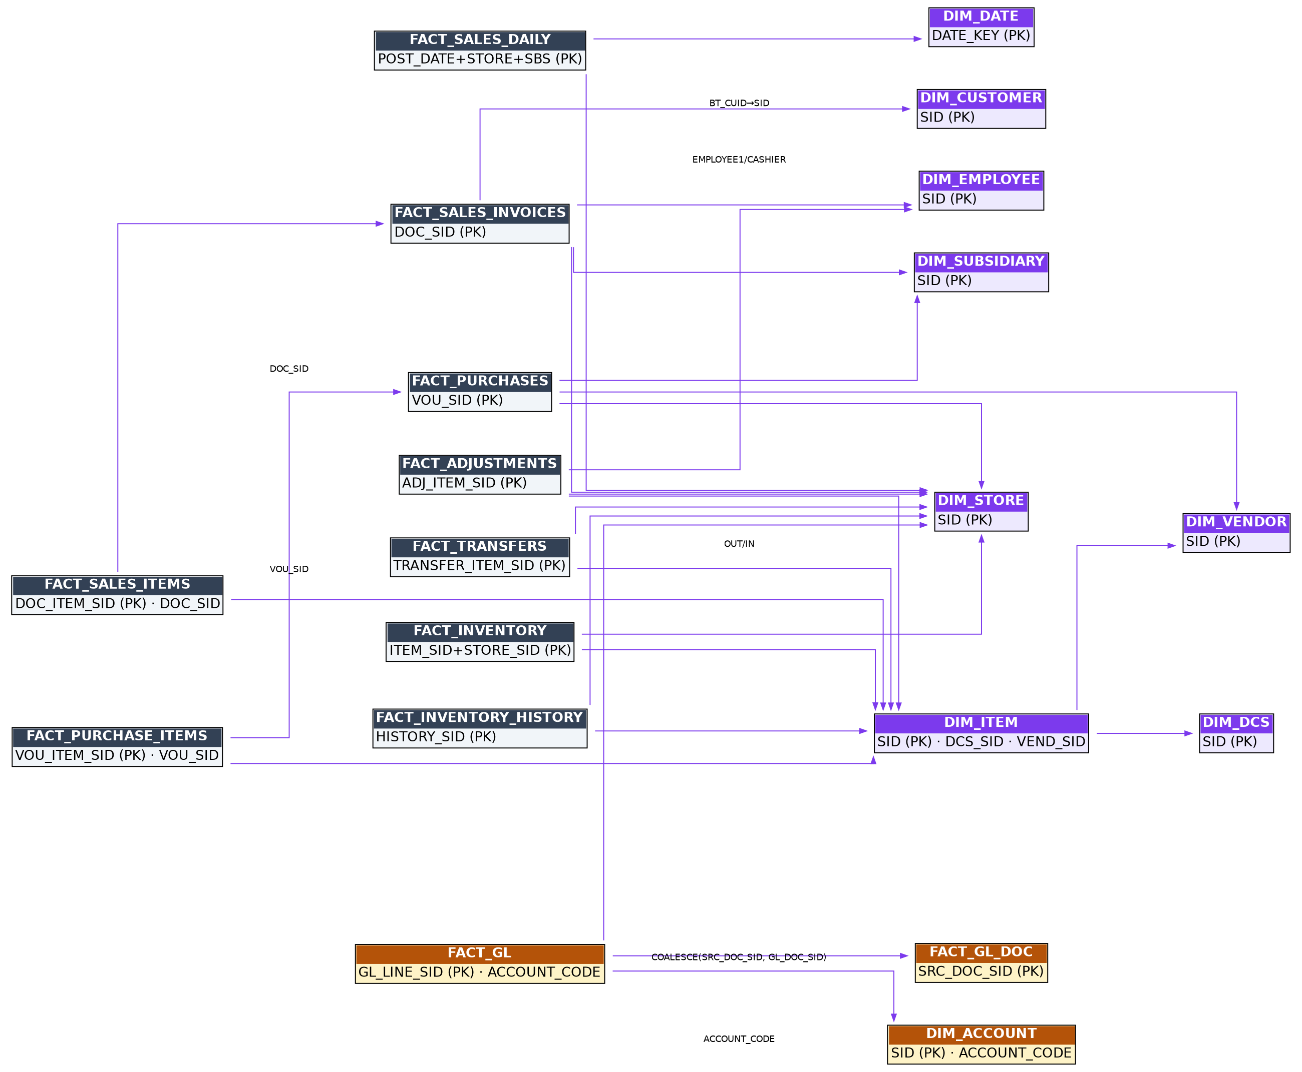
RetailTec Analytics warehouse ERD
Join conventions (implicit — enforce in SQL, not schema):
From | To | On
FACT_SALES_ITEMS | FACT_SALES_INVOICES | DOC_SID
FACT_SALES_* | DIM_STORE / DIM_SUBSIDIARY / DIM_EMPLOYEE / DIM_CUSTOMER | STORE_SID / SUBSIDIARY_SID / EMPLOYEE1_SID,CASHIER_SID / BT_CUID = DIM_CUSTOMER.SID
FACT_SALES_ITEMS / FACT_INVENTORY* / FACT_TRANSFERS / FACT_ADJUSTMENTS / FACT_PURCHASE_ITEMS | DIM_ITEM | ITEM_SID
DIM_ITEM | DIM_DCS / DIM_VENDOR | DCS_SID / VEND_SID
FACT_TRANSFERS | DIM_STORE ×2 | OUT_STORE_SID, IN_STORE_SID
FACT_PURCHASE_ITEMS | FACT_PURCHASES | VOU_SID
FACT_PURCHASES | DIM_VENDOR | VEND_SID
FACT_GL | DIM_ACCOUNT | ACCOUNT_CODE
FACT_GL | FACT_GL_DOC | COALESCE(SRC_DOC_SID, GL_DOC_SID) — always use this COALESCE (_doc_key() in the routers)
any fact date | DIM_DATE | date column = DATE_KEY
A browsable HTML version (RetailTec-Warehouse-ERD.html) ships in the repository.

5. Reliability & Operations
- SQL bind assertion: every warehouse query goes through helpers that assert the ? placeholder count matches the parameter list before execution, failing with a clear message naming the query.
- WAL self-heal: if DuckDB’s write-ahead log is corrupt at startup (force-kill leftovers), the app quarantines it to wal_quarantine\ beside the file, logs loudly, and retries once. Only the last un-checkpointed batch is lost — and the ≥30-day incremental window re-pulls it on the next sync. A WAL merely held by a live instance is never touched.
- Single-writer model: one shared DuckDB connection for sync writes; every API request gets its own cursor (MVCC) so dashboards read concurrently while a sync runs.
- Instance takeover: duckdb.connect retries for up to 120 s when another instance still holds the file (tray Restart overlap).
- Backups: Settings → Maintenance — manual “Backup Now”, weekly CHECKPOINT + monthly backups with retention, and Restore (keeps a pre-restore safety copy). Backups are safe while the app runs.
- Defender/build trap (dev machine): never delete packaging\out right after the app ran — Windows Defender holds the .db for minutes. Build code into out2 and robocopy over, excluding state files.

