Zero-Days Challenges

Level 1
I did following steps to soluve this challenge:
- downloaded rsa-script.py file from moodle
- downloaded rsa1.txt file from zero days
- substituated values of n, e, p, q in rsa-script.py
- run rsa-script.py in pycharm and it encrypted the message
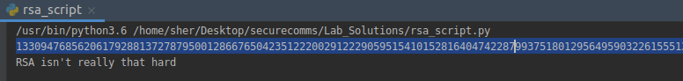
Level 2
Steps taken to soluve this challenge:
- copied the cypher text from zero-days
- substituted in rsa-script.py file and run it
- it decrypted the cypher text
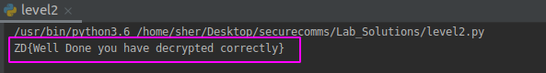
Level 3
Steps taken to soluve this challenge:
- downloaded mykey2 file
- run “openssl asn1parse -in mykey2 -i” command on it
- it gave me values of n, e, d but in hexadecimal
- converted into decimal values using level3.py
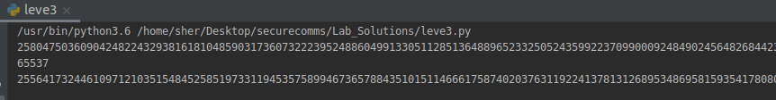
Script is available here:
https://github.com/AhmedPak/securecomms/blob/master/Lab_Solutions/leve3.py
Level 4
Steps taken to soluve this challenge:
- copied cipher text from zero-days site and substituted in level4.py
- downloaded mykey3 file and ran “openssl asn1parse -in mykey2 -i”
- copied values hex values of n, d and substituted in level4.py
- it gave us the flage
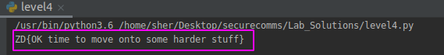
Script is available here:
https://github.com/AhmedPak/securecomms/blob/master/Lab_Solutions/level4.py

Level 4.5
This level was self-explanatory.
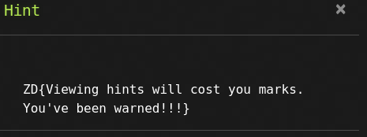

Level 5
Steps taken to soluve this challenge:
- downloaded key.txt file and substituted the values of p, q, dp, dq, pinv, qinv and ciphertext
- used Chinese remaider algorithm to calculate the m (used hint-wiki rsa page)
- used int2string function on m
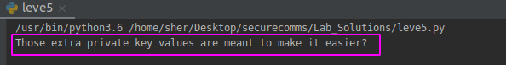
Script is available here:
https://github.com/AhmedPak/securecomms/blob/master/Lab_Solutions/level5.py

Level 6
Steps taken to soluve this challenge:
- downloaded key.txt file and substituted values of p, q, e and ciphertext into level6.py
- calculated value of n using n = p * q
- to calculate the value of d, we needed mod inverse of (p-1 * q-1) used a script from http://rosettacode.org/wiki/Modular_inverse
- substituted the value of d in pow(ciphertxt, d, n)
- used int2string function to get plaintext

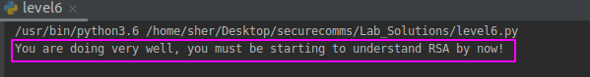
Script is available here:
https://github.com/AhmedPak/securecomms/blob/master/Lab_Solutions/level6.py

Level 7
Steps taken to soluve this challenge:
downloaded public.key file and substituted values of n, e and ciphertext into level7.py
to calculate values of p and q factorized n online using a website http://factordb.com/
substitued values of p and q in level7.py
calculated value of d using code from http://rosettacode.org/wiki/Modular_inverse
used valuses of d, n and c in m = pow (c, d, n) to get decrypted value
used int2string funtion to get plaintext
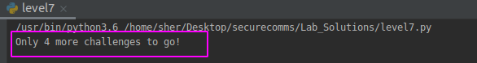
Script is available here:
https://github.com/AhmedPak/securecomms/blob/master/Lab_Solutions/level7.py

Level 8
Steps taken to soluve this challenge:
by looking at values.txt file realised that value of e is very small. We know that when value of e very small the value of m is the value of n. In other words simply factorizing the m gave us our flage. I used factordb.com to facterize m and than used int2string function on it to get our plain text.
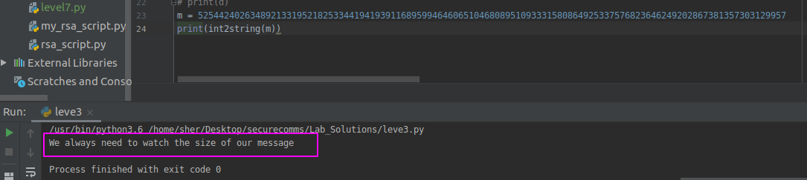

Scripts that were used to soluve these challenges are available at https://github.com/AhmedPak/securecomms/tree/master/Lab_Solutions

