**How to Make a Computer Operating System**

Online book about how to write a computer operating system in C/C++ from scratch.

**Caution**: This repository is a remake of my old course. It was written several years ago [as one of my first projects when I was in High School](https://github.com/SamyPesse/devos), I'm still refactoring some parts. The original course was in French and I'm not an English native. I'm going to continue and improve this course in my free-time.

**Book**: An online version is available at <http://samypesse.gitbooks.io/how-to-create-an-operating-system/> (PDF, Mobi and ePub). It was generated using [GitBook](https://www.gitbook.com/).

**Source Code**: All the system source code will be stored in the [src](https://github.com/SamyPesse/How-to-Make-a-Computer-Operating-System/tree/master/src) directory. Each step will contain links to the different related files.

**Contributions**: This course is open to contributions, feel free to signal errors with issues or directly correct the errors with pull-requests.

**Questions**: Feel free to ask any questions by adding issues or commenting sections.

You can follow me on Twitter [@SamyPesse](https://twitter.com/SamyPesse) or [GitHub](https://github.com/SamyPesse).

**What kind of OS are we building?**

The goal is to build a very simple UNIX-based operating system in C++, not just a "proof-of-concept". The OS should be able to boot, start a userland shell, and be extensible.

[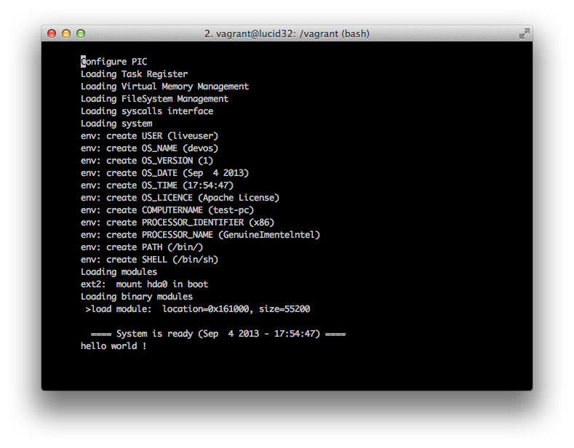](https://github.com/AhmedRaja1/KHUD-KA-OPERATING-SYSTEM/blob/master/preview.png)