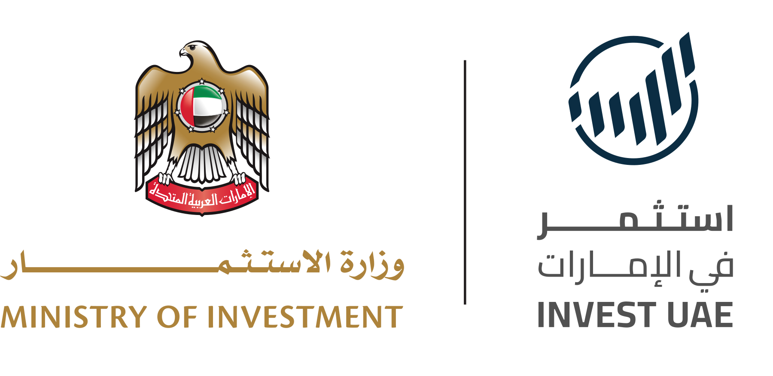
MINISTRY OF INVESTMENT · INVEST UAE
Companies Identified
Live pipeline snapshot from the InvestUAE Signal Intelligence platform
Snapshot generated 2026-04-19 from https://backend-lyart-three-63.vercel.app
This document is the companion output to the main InvestUAE Signal Intelligence pilot delivery. It lists the top twenty-five companies currently in the ranked pipeline, selected by composite score across investability and United Arab Emirates alignment. For each company, the table that follows captures the company name, identified sectors, headquarters, expansion intent, the individual signals detected across the rolling ninety-day window with links to their supporting public sources, and a brief explanation of why the company represents a potential investment opportunity.
This list regenerates automatically on every pipeline refresh. The version presented here was captured live at the timestamp shown on the cover page. The live ranking, additional filters and per-company dossiers are available on the platform.

Top twenty-five companies at a glance
# | Company | Sector | Headquarters | Composite | Signals
1 | Homegrown | Logistics | United Arab Emirates | 55 | 1
2 | Homegrown | Logistics | United Arab Emirates | 55 | 1
3 | Homegrown | Logistics | United Arab Emirates | 55 | 1
4 | CoinMarketCap page going live without any | Fintech, AI, Real Estate | Dubai, United Arab Emirates | 52 | 1
5 | Khabib Nurmagomedov | Real Estate, Tourism | Dubai, United Arab Emirates | 52 | 1
6 | Long time | Fintech, Logistics, Space | Dubai, United Arab Emirates | 51 | 1
7 | Pepeto | Fintech | Dubai, United Arab Emirates | 51 | 1
8 | Pepeto | Fintech | Dubai, United Arab Emirates | 50 | 1
9 | Etihad Airways | Logistics | Abu Dhabi, United Arab Emirates | 49 | 1
10 | Aramco | Manufacturing, Energy, Cleantech | Saudi Arabia | 49 | 1
11 | Via Separations | Manufacturing, Energy, Cleantech | Saudi Arabia | 49 | 1
12 | Modon Real Estate | Fintech, Real Estate | Abu Dhabi, United Arab Emirates | 49 | 1
13 | Tara Park with flexible payment | Fintech, Real Estate | Abu Dhabi, United Arab Emirates | 49 | 1
14 | Modon Real Estate | Fintech, Real Estate | Abu Dhabi, United Arab Emirates | 49 | 1
15 | Infrastructure projects | Logistics, Real Estate, Energy | United Arab Emirates | 49 | 1
16 | ElGoat | Logistics | Saudi Arabia | 47 | 1
17 | Frimex | Healthcare, Logistics, Energy | Riyadh, Saudi Arabia | 47 | 1
18 | Maison Safqa | Logistics, E-commerce | Riyadh, Saudi Arabia | 46 | 1

Per-company detail
Each entry below expands the summary line with the full set of detected signals, their strength tier, the public source that raised the signal, and a brief explanation of why the company is investable. The explanation is generated by the platform’s scoring agent from the company’s signal history, sector fit and geographic alignment.

1. Homegrown
Composite: 55 | Investability: 54 | UAE alignment: 56 | Signals: 1
Sectors: Logistics
Headquarters: United Arab Emirates
Detected signals
Type | Strength | Headline | Source
Funding | High | Homegrown Ventures closes $22.8 million Fund I to back MENA consumer brands | Wamda  http://wamda.com/2026/04/homegrown-ventures-closes-22-8-mil…

2. Homegrown
Composite: 55 | Investability: 54 | UAE alignment: 56 | Signals: 1
Sectors: Logistics
Headquarters: United Arab Emirates
Detected signals
Type | Strength | Headline | Source
Funding | High | Homegrown Ventures closes $22.8 million Fund I to back MENA consumer brands | Wamda  http://wamda.com/2026/04/homegrown-ventures-closes-22-8-mil…

3. Homegrown
Composite: 55 | Investability: 54 | UAE alignment: 56 | Signals: 1
Sectors: Logistics
Headquarters: United Arab Emirates
Detected signals
Type | Strength | Headline | Source
Funding | High | Homegrown Ventures closes $22.8 million Fund I to back MENA consumer brands | Wamda  http://wamda.com/2026/04/homegrown-ventures-closes-22-8-mil…

4. CoinMarketCap page going live without any
Composite: 52 | Investability: 45 | UAE alignment: 59 | Signals: 1
Sectors: Fintech, AI, Real Estate
Headquarters: Dubai, United Arab Emirates
Detected signals
Type | Strength | Headline | Source
Launch | High | Pepeto Announces CoinMarketCap Listing Ahead Of Binance Amid BNB Price Prediction Points Toward $10,000 | GlobeNewswire · Public Companies  https://www.globenewswire.com/news-release/2026/04/18/32765…

5. Khabib Nurmagomedov
Composite: 52 | Investability: 49 | UAE alignment: 54 | Signals: 1
Sectors: Real Estate, Tourism
Headquarters: Dubai, United Arab Emirates
Detected signals
Type | Strength | Headline | Source
Partnership | High | UFC legend lends weight to Dubai real estate company | AGBI · Arab Gulf Business Insight  https://www.agbi.com/real-estate/2026/04/ufc-legend-lends-w…

6. Long time
Composite: 51 | Investability: 45 | UAE alignment: 58 | Signals: 1
Sectors: Fintech, Logistics, Space
Headquarters: Dubai, United Arab Emirates
Detected signals
Type | Strength | Headline | Source
Launch | High | New Crypto Pepeto Second Tier One Exchange Debut Alongside Binance Amid Elon Musk Favorite Crypto Dogecoin News | GlobeNewswire · Public Companies  https://www.globenewswire.com/news-release/2026/04/19/32766…

7. Pepeto
Composite: 51 | Investability: 44 | UAE alignment: 58 | Signals: 1
Sectors: Fintech
Headquarters: Dubai, United Arab Emirates
Detected signals
Type | Strength | Headline | Source
Hiring | High | Crypto News: Ethereum Based Crypto Pepeto Project Stages Advancement Amid Bitcoin Price Prediction Targeting $500,000 | GlobeNewswire · Public Companies  https://www.globenewswire.com/news-release/2026/04/19/32766…

8. Pepeto
Composite: 50 | Investability: 41 | UAE alignment: 58 | Signals: 1
Sectors: Fintech
Headquarters: Dubai, United Arab Emirates
Detected signals
Type | Strength | Headline | Source
Launch | High | Crypto News: Ethereum Based Crypto Pepeto Approaches Binance Listing While the XRP Price Prediction Shifts | GlobeNewswire · Public Companies  https://www.globenewswire.com/news-release/2026/04/18/32765…

9. Etihad Airways
Composite: 49 | Investability: 42 | UAE alignment: 56 | Signals: 1
Sectors: Logistics
Headquarters: Abu Dhabi, United Arab Emirates
Detected signals
Type | Strength | Headline | Source
Expansion | High | Etihad Airways expands Africa network with new routes to 5 countries from Abu Dhabi | Economy Middle East  https://economymiddleeast.com/news/etihad-airways-expands-a…

10. Aramco
Composite: 49 | Investability: 53 | UAE alignment: 45 | Signals: 1
Sectors: Manufacturing, Energy, Cleantech
Headquarters: Saudi Arabia
Detected signals
Type | Strength | Headline | Source
Funding | Medium | Aramco Ventures backs Via Separations in $36 million round | Wamda  http://wamda.com/2026/04/aramco-ventures-backs-separations-…

11. Via Separations
Composite: 49 | Investability: 53 | UAE alignment: 45 | Signals: 1
Sectors: Manufacturing, Energy, Cleantech
Headquarters: Saudi Arabia
Detected signals
Type | Strength | Headline | Source
Funding | Medium | Aramco Ventures backs Via Separations in $36 million round | Wamda  http://wamda.com/2026/04/aramco-ventures-backs-separations-…

12. Modon Real Estate
Composite: 49 | Investability: 40 | UAE alignment: 58 | Signals: 1
Sectors: Fintech, Real Estate
Headquarters: Abu Dhabi, United Arab Emirates
Detected signals
Type | Strength | Headline | Source
Launch | High | Modon Real Estate launches final phase of Tara Park with flexible payment plan on Reem Island | Economy Middle East  https://economymiddleeast.com/news/modon-real-estate-launch…

13. Tara Park with flexible payment
Composite: 49 | Investability: 40 | UAE alignment: 58 | Signals: 1
Sectors: Fintech, Real Estate
Headquarters: Abu Dhabi, United Arab Emirates
Detected signals
Type | Strength | Headline | Source
Launch | High | Modon Real Estate launches final phase of Tara Park with flexible payment plan on Reem Island | Economy Middle East  https://economymiddleeast.com/news/modon-real-estate-launch…

14. Modon Real Estate
Composite: 49 | Investability: 40 | UAE alignment: 58 | Signals: 1
Sectors: Fintech, Real Estate
Headquarters: Abu Dhabi, United Arab Emirates
Detected signals
Type | Strength | Headline | Source
Launch | High | Modon Real Estate launches final phase of Tara Park with flexible payment plan on Reem Island | Economy Middle East  https://economymiddleeast.com/news/modon-real-estate-launch…

15. Infrastructure projects
Composite: 49 | Investability: 40 | UAE alignment: 58 | Signals: 1
Sectors: Logistics, Real Estate, Energy
Headquarters: United Arab Emirates
Detected signals
Type | Strength | Headline | Source
Launch | High | UAE accelerates 2026 infrastructure projects: Energy, water, transport, roads, urban development nationwide | Economy Middle East  https://economymiddleeast.com/news/uae-accelerates-2026-inf…

16. ElGoat
Composite: 47 | Investability: 45 | UAE alignment: 48 | Signals: 1
Sectors: Logistics
Headquarters: Saudi Arabia
Detected signals
Type | Strength | Headline | Source
Funding | Medium | ElGoat raises $266,000 seed to build skill-based football gaming platform | Wamda  http://wamda.com/2026/04/elgoat-raises-266000-seed-build-sk…

17. Frimex
Composite: 47 | Investability: 44 | UAE alignment: 50 | Signals: 1
Sectors: Healthcare, Logistics, Energy
Headquarters: Riyadh, Saudi Arabia
Detected signals
Type | Strength | Headline | Source
M&A | High | Frimex acquires 60% stake in Gulf Neo Care to establish strategic healthcare platform in Saudi Arabia | Saudi Gazette Business  https://saudigazette.com.sa/article/660372/business/frimex-…

18. Maison Safqa
Composite: 46 | Investability: 44 | UAE alignment: 48 | Signals: 1
Sectors: Logistics, E-commerce
Headquarters: Riyadh, Saudi Arabia
Detected signals
Type | Strength | Headline | Source
Funding | Medium | Backed by Sanabil 500, Maison Safqa secures $620,000 pre-seed | Wamda  http://wamda.com/2026/04/backed-sanabil-500-maison-safqa-se…

Sources and methodology
Every signal above traces back to a public source listed in its Source column. The platform ingests twenty-four feeds spanning MENA business press, global technology media, native Arabic-language publishers, founder interviews and primary financial filings. Classification uses a blend of embedding similarity and keyword pattern matching, scored across investability and United Arab Emirates alignment. The pipeline is ninety-day rolling and refreshes on a daily 06:00 UTC cron.
For the full methodology page, the per-company dossier with thesis and recommended next actions, and the live ranking, please visit the platform linked on the cover.

