**Lab # 04**

**OBJECT**

***Examine the Functionality of the Network Address Translation***

**TOPOLOGY:**

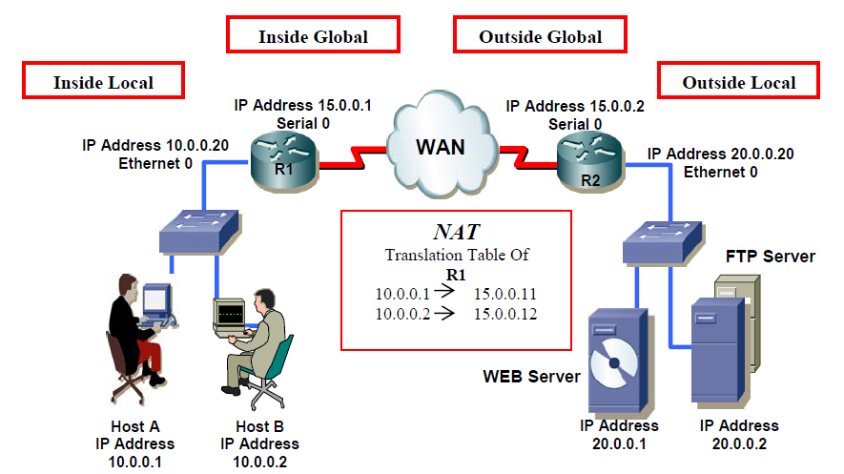

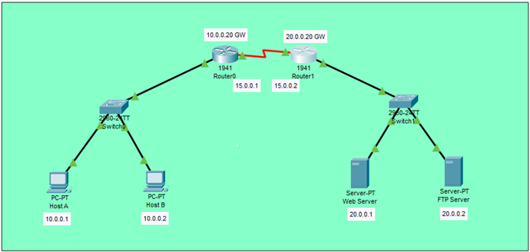

**Part I: Static NAT**

**LAB TASK:**



AhmedRouter(config)#ip nat inside source static 10.0.0.1 15.0.0.11

AhmedRouter(config)#ip nat inside source static 10.0.0.2 15.0.0.12



AhmedRouter(config)#interface gigabit 0/0

AhmedRouter(config-if)#ip nat inside

AhmedRouter(config-if)#



AhmedRouter(config)#

AhmedRouter(config)#interface serial 0/1/0

AhmedRouter(config-if)#ip nat outside

AhmedRouter(config-if)#

**Q1) What command is used to verify NAT?**

**Answer: Show ip nat translations.**

**PINGING THROUGH ROUTER TO CHECK NAT:-**

AhmedRouter>

AhmedRouter>

AhmedRouter>ping 15.0.0.2

Type escape sequence to abort.

Sending 5, 100-byte ICMP Echos to 15.0.0.2, timeout is 2 seconds:

!!!!!

Success rate is 100 percent (5/5), round-trip min/avg/max = 1/10/14 ms

AhmedRouter>

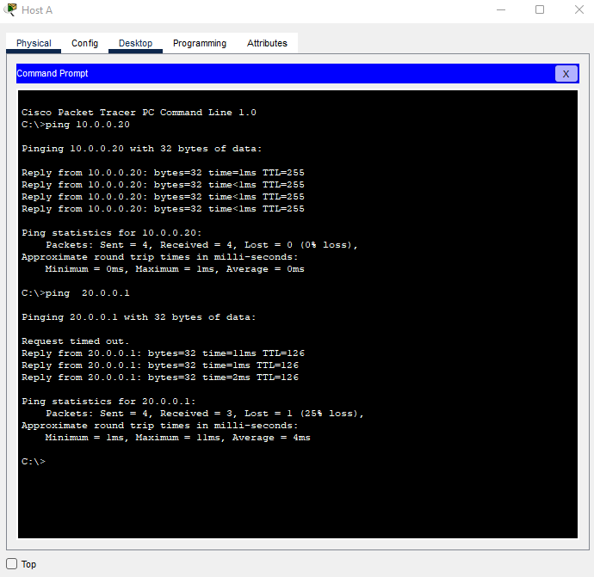

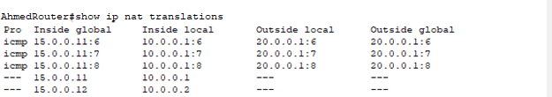

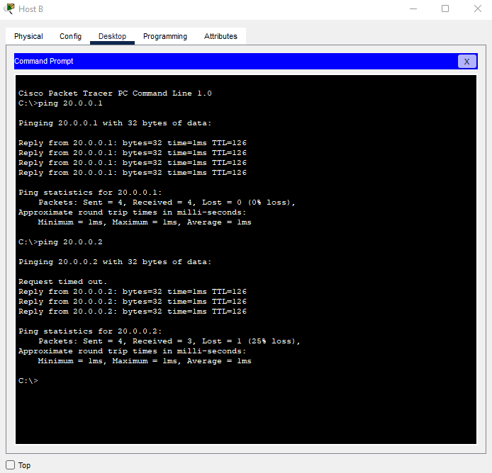



**Part II: Dynamic NAT**

**TOPOLOGY:**

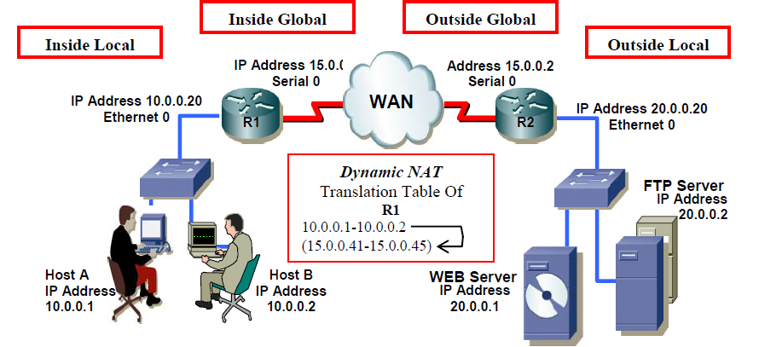



**LAB TASK:**



AhmedRouter(config)#

AhmedRouter(config)#ip nat pool Ahmed 15.0.0.41 15.0.0.45 netmask 255.0.0.0



AhmedRouter(config)#access-list 1 permit 10.0.0.0 255.255.255.0



AhmedRouter(config)#ip nat inside source list 1 pool Ahmed

**Q1) What command is used to clear NAT Table?**

**Answer: To clear dynamic Network Address Translation (NAT) translations from the translation table, use the clear ip nat translation EXEC command.**



AhmedRouter(config)#interface gigabit 0/0

AhmedRouter(config-if)#ip nat inside



AhmedRouter(config-if)#interface serial 0/1/0

AhmedRouter(config-if)#ip nat outside

AhmedRouter#show ip nat translations

AhmedRouter#

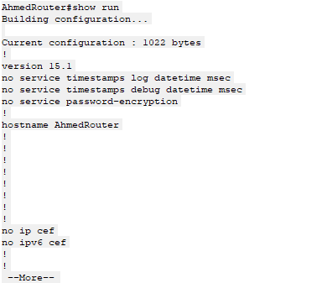

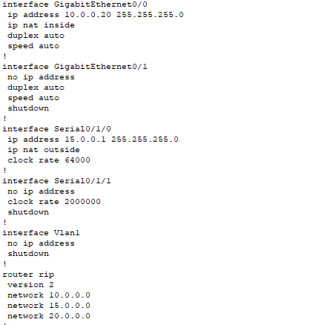

AhmedRouter(config)#no ip nat inside source static 10.0.0.1 15.0.0.11

AhmedRouter(config)#no ip nat inside source static 10.0.0.2 15.0.0.12