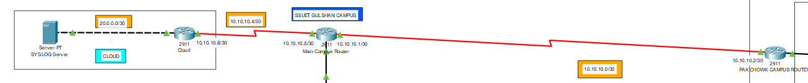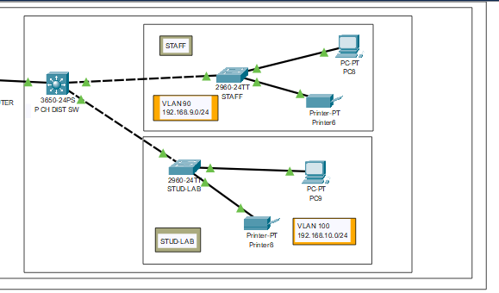

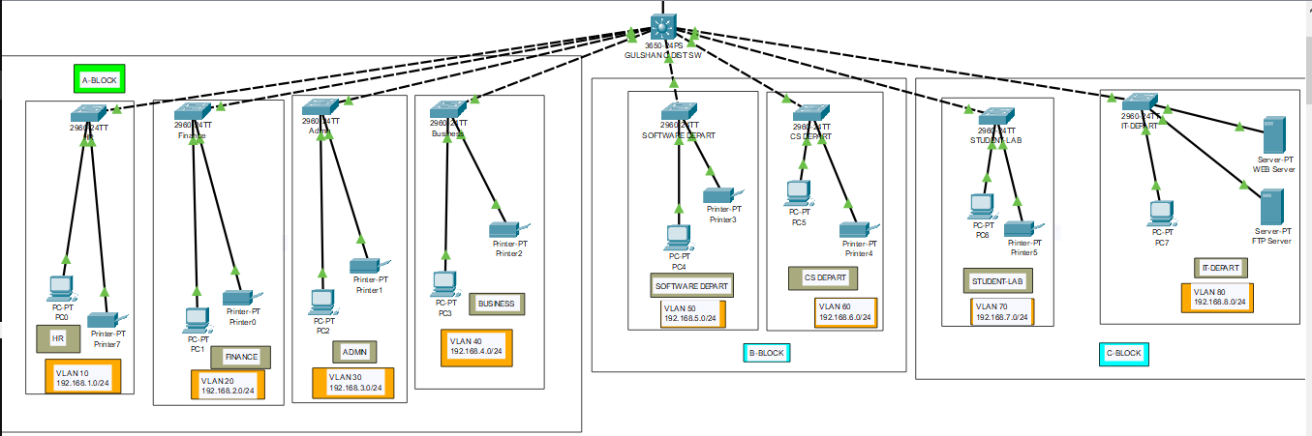

**ROUTER-Cloud**

AHMED-MUSTAFA-ZAID-ROUTER-cloud(config-if)#

%LINK-5-CHANGED: Interface GigabitEthernet0/0, changed state to up

%LINEPROTO-5-UPDOWN: Line protocol on Interface GigabitEthernet0/0, changed state to up

AHMED-MUSTAFA-ZAID-ROUTER-cloud(config-if)#exit

AHMED-MUSTAFA-ZAID-ROUTER-cloud(config)#interface GigabitEthernet0/1

AHMED-MUSTAFA-ZAID-ROUTER-cloud(config-if)#no shutdown

AHMED-MUSTAFA-ZAID-ROUTER-cloud(config-if)#

%LINK-5-CHANGED: Interface GigabitEthernet0/1, changed state to up

shutdown

AHMED-MUSTAFA-ZAID-ROUTER-cloud(config-if)#

%LINK-5-CHANGED: Interface GigabitEthernet0/1, changed state to administratively down

no shutdown

AHMED-MUSTAFA-ZAID-ROUTER-cloud(config-if)#

%LINK-5-CHANGED: Interface GigabitEthernet0/1, changed state to up

AHMED-MUSTAFA-ZAID-ROUTER-cloud(config-if)#exit

AHMED-MUSTAFA-ZAID-ROUTER-cloud(config)#interface GigabitEthernet0/2

AHMED-MUSTAFA-ZAID-ROUTER-cloud(config-if)#no shutdown

AHMED-MUSTAFA-ZAID-ROUTER-cloud(config-if)#

%LINK-5-CHANGED: Interface GigabitEthernet0/2, changed state to up

AHMED-MUSTAFA-ZAID-ROUTER-cloud(config-if)#exit

AHMED-MUSTAFA-ZAID-ROUTER-cloud(config)#interface Serial0/0/0

AHMED-MUSTAFA-ZAID-ROUTER-cloud(config-if)#shutdown

AHMED-MUSTAFA-ZAID-ROUTER-cloud(config-if)#

%LINK-5-CHANGED: Interface Serial0/0/0, changed state to administratively down

%LINEPROTO-5-UPDOWN: Line protocol on Interface Serial0/0/0, changed state to down

no shutdown

AHMED-MUSTAFA-ZAID-ROUTER-cloud(config-if)#

%LINK-5-CHANGED: Interface Serial0/0/0, changed state to up

AHMED-MUSTAFA-ZAID-ROUTER-cloud(config-if)#exit

AHMED-MUSTAFA-ZAID-ROUTER-cloud(config)#interface Serial0/0/1

AHMED-MUSTAFA-ZAID-ROUTER-cloud(config-if)#no shutdown

AHMED-MUSTAFA-ZAID-ROUTER-cloud(config-if)#

%LINEPROTO-5-UPDOWN: Line protocol on Interface Serial0/0/0, changed state to up

AHMED-MUSTAFA-ZAID-ROUTER-cloud(config-if)#do wr

Building configuration...

[OK]

AHMED-MUSTAFA-ZAID-ROUTER-cloud(config-if)#

%LINK-3-UPDOWN: Interface Serial0/0/0, changed state to down

%LINEPROTO-5-UPDOWN: Line protocol on Interface Serial0/0/0, changed state to down

%LINK-5-CHANGED: Interface Serial0/0/0, changed state to up

%LINEPROTO-5-UPDOWN: Line protocol on Interface Serial0/0/0, changed state to up

AHMED-MUSTAFA-ZAID-ROUTER-cloud>en

AHMED-MUSTAFA-ZAID-ROUTER-cloud#conf

Configuring from terminal, memory, or network [terminal]?

Enter configuration commands, one per line. End with CNTL/Z.

AHMED-MUSTAFA-ZAID-ROUTER-cloud(config)#int se0/0/0

AHMED-MUSTAFA-ZAID-ROUTER-cloud(config-if)#ip address 10.10.10.6 255.255.255.252

AHMED-MUSTAFA-ZAID-ROUTER-cloud(config-if)#ex

AHMED-MUSTAFA-ZAID-ROUTER-cloud(config)#

AHMED-MUSTAFA-ZAID-ROUTER-cloud(config)#interface

% Incomplete command.

AHMED-MUSTAFA-ZAID-ROUTER-cloud(config)#interface gig0/0

AHMED-MUSTAFA-ZAID-ROUTER-cloud(config-if)#ip address 20.0.0.1 255.255.255.252

AHMED-MUSTAFA-ZAID-ROUTER-cloud(config-if)#

AHMED-MUSTAFA-ZAID-ROUTER-cloud(config-if)#ex

AHMED-MUSTAFA-ZAID-ROUTER-cloud(config)#do wr

Building configuration...

[OK]

AHMED-MUSTAFA-ZAID-ROUTER-cloud(config)#

AHMED-MUSTAFA-ZAID-ROUTER-cloud>en

AHMED-MUSTAFA-ZAID-ROUTER-cloud#conf

Configuring from terminal, memory, or network [terminal]?

Enter configuration commands, one per line. End with CNTL/Z.

AHMED-MUSTAFA-ZAID-ROUTER-cloud(config)#router rip

AHMED-MUSTAFA-ZAID-ROUTER-cloud(config-router)#v

AHMED-MUSTAFA-ZAID-ROUTER-cloud(config-router)#version 2

AHMED-MUSTAFA-ZAID-ROUTER-cloud(config-router)#network 20.0.0.0

AHMED-MUSTAFA-ZAID-ROUTER-cloud(config-router)#network 10.10.10.4

AHMED-MUSTAFA-ZAID-ROUTER-cloud(config-router)#ex

AHMED-MUSTAFA-ZAID-ROUTER-cloud(config)#do wr

Building configuration...

[OK]

AHMED-MUSTAFA-ZAID-ROUTER-cloud(config)#

AHMED-MUSTAFA-ZAID-ROUTER-cloud(config)#logg

AHMED-MUSTAFA-ZAID-ROUTER-cloud(config)#logging 20.0.0.2

AHMED-MUSTAFA-ZAID-ROUTER-cloud(config)#

AHMED-MUSTAFA-ZAID-ROUTER-cloud(config)#do wr

Building configuration...

[OK]

AHMED-MUSTAFA-ZAID-ROUTER-cloud>en

AHMED-MUSTAFA-ZAID-ROUTER-cloud#config

Configuring from terminal, memory, or network [terminal]?

Enter configuration commands, one per line. End with CNTL/Z.

AHMED-MUSTAFA-ZAID-ROUTER-cloud(config)#logging 20.0.0.2

AHMED-MUSTAFA-ZAID-ROUTER-cloud(config)#int loo

AHMED-MUSTAFA-ZAID-ROUTER-cloud(config)#int loopback 0

AHMED-MUSTAFA-ZAID-ROUTER-cloud(config-if)#

%LINK-5-CHANGED: Interface Loopback0, changed state to up

%LINEPROTO-5-UPDOWN: Line protocol on Interface Loopback0, changed state to up

AHMED-MUSTAFA-ZAID-ROUTER-cloud(config-if)#do wr

**SYSLOG SERVER**

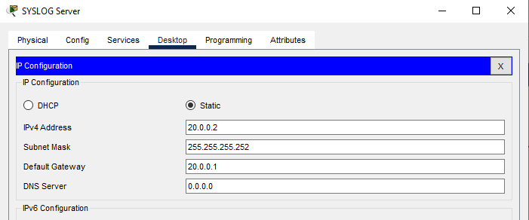

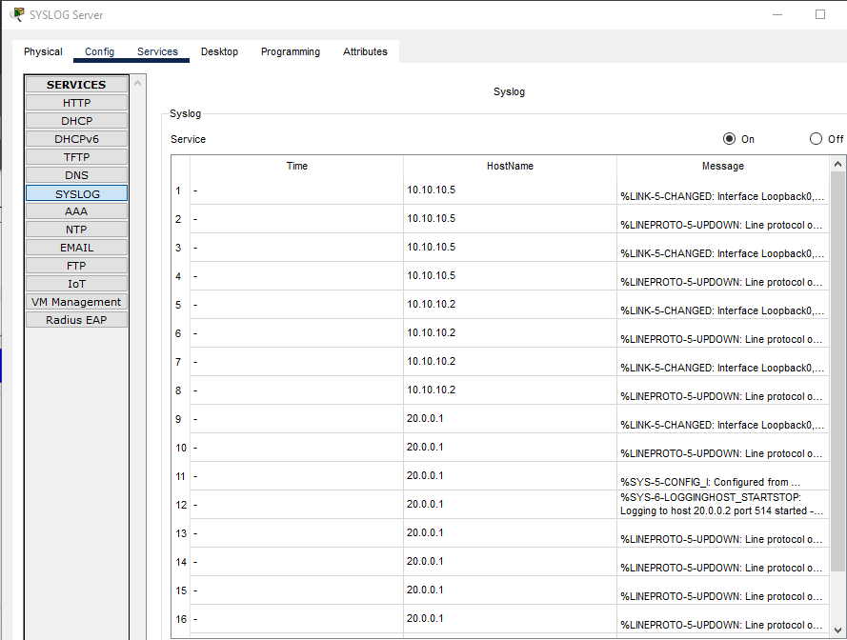

**MAIN CAMPUS ROUTER**

A-M-Z-MC-ROUTER(config)#int gig0/0.20

A-M-Z-MC-ROUTER(config-subif)#

%LINK-5-CHANGED: Interface GigabitEthernet0/0.20, changed state to up

%LINEPROTO-5-UPDOWN: Line protocol on Interface GigabitEthernet0/0.20, changed state to up

A-M-Z-MC-ROUTER(config-subif)#encapsulation dot1Q 10

%Configuration of multiple subinterfaces of the same main

interface with the same VID (10) is not permitted.

This VID is already configured on GigabitEthernet0/0.10.

A-M-Z-MC-ROUTER(config-subif)#encapsulation dot1Q 20

A-M-Z-MC-ROUTER(config-subif)#ip address 192.168.2.1 255.255.255.0

A-M-Z-MC-ROUTER(config-subif)#ex

A-M-Z-MC-ROUTER(config)#

A-M-Z-MC-ROUTER(config)#int gig0/0.30

A-M-Z-MC-ROUTER(config-subif)#

%LINK-5-CHANGED: Interface GigabitEthernet0/0.30, changed state to up

%LINEPROTO-5-UPDOWN: Line protocol on Interface GigabitEthernet0/0.30, changed state to up

A-M-Z-MC-ROUTER(config-subif)#encapsulation dot1Q 30

A-M-Z-MC-ROUTER(config-subif)#ip address 192.168.3.1 255.255.255.0

A-M-Z-MC-ROUTER(config-subif)#ex

A-M-Z-MC-ROUTER(config)#

A-M-Z-MC-ROUTER(config)#int gig0/0.40

A-M-Z-MC-ROUTER(config-subif)#

%LINK-5-CHANGED: Interface GigabitEthernet0/0.40, changed state to up

%LINEPROTO-5-UPDOWN: Line protocol on Interface GigabitEthernet0/0.40, changed state to up

A-M-Z-MC-ROUTER(config-subif)#encapsulation dot1Q 40

A-M-Z-MC-ROUTER(config-subif)#ip address 192.168.4.1 255.255.255.0

A-M-Z-MC-ROUTER(config-subif)#ex

A-M-Z-MC-ROUTER(config)#

A-M-Z-MC-ROUTER(config)#int gig0/0.50

A-M-Z-MC-ROUTER(config-subif)#

%LINK-5-CHANGED: Interface GigabitEthernet0/0.50, changed state to up

%LINEPROTO-5-UPDOWN: Line protocol on Interface GigabitEthernet0/0.50, changed state to up

A-M-Z-MC-ROUTER(config-subif)#encapsulation dot1Q 50

A-M-Z-MC-ROUTER(config-subif)#ip address 192.168.5.1 255.255.255.0

A-M-Z-MC-ROUTER(config-subif)#

A-M-Z-MC-ROUTER(config-subif)#ex

A-M-Z-MC-ROUTER(config)#

A-M-Z-MC-ROUTER(config)#int gig0/0.60

A-M-Z-MC-ROUTER(config-subif)#

%LINK-5-CHANGED: Interface GigabitEthernet0/0.60, changed state to up

%LINEPROTO-5-UPDOWN: Line protocol on Interface GigabitEthernet0/0.60, changed state to up

A-M-Z-MC-ROUTER(config-subif)#encapsulation dot1Q 60

A-M-Z-MC-ROUTER(config-subif)#ip address 192.168.6.1 255.255.255.0

A-M-Z-MC-ROUTER(config-subif)#ex

A-M-Z-MC-ROUTER(config)#

A-M-Z-MC-ROUTER(config)#int gig0/0.70

A-M-Z-MC-ROUTER(config-subif)#

%LINK-5-CHANGED: Interface GigabitEthernet0/0.70, changed state to up

%LINEPROTO-5-UPDOWN: Line protocol on Interface GigabitEthernet0/0.70, changed state to up

A-M-Z-MC-ROUTER(config-subif)#encapsulation dot1Q 70

A-M-Z-MC-ROUTER(config-subif)#ip address 192.168.7.1 255.255.255.0

A-M-Z-MC-ROUTER(config-subif)#ex

A-M-Z-MC-ROUTER(config)#

A-M-Z-MC-ROUTER(config)#int gig0/0.80

A-M-Z-MC-ROUTER(config-subif)#

%LINK-5-CHANGED: Interface GigabitEthernet0/0.80, changed state to up

%LINEPROTO-5-UPDOWN: Line protocol on Interface GigabitEthernet0/0.80, changed state to up

A-M-Z-MC-ROUTER(config-subif)#encapsulation dot1Q 80

A-M-Z-MC-ROUTER(config-subif)#

A-M-Z-MC-ROUTER(config-subif)#ip address 192.168.8.1 255.255.255.0

A-M-Z-MC-ROUTER(config-subif)#ex

A-M-Z-MC-ROUTER(config)#

A-M-Z-MC-ROUTER(config)#service dhcp

A-M-Z-MC-ROUTER(config)#ip dhcp pool A-M-Z-HR-POOL

A-M-Z-MC-ROUTER(dhcp-config)#network 192.168.1.0 255.255.255.0

A-M-Z-MC-ROUTER(dhcp-config)#def

A-M-Z-MC-ROUTER(dhcp-config)#default-router 192.168.1.1

A-M-Z-MC-ROUTER(dhcp-config)#dns-server 192.168.1.1

A-M-Z-MC-ROUTER(dhcp-config)#ex

A-M-Z-MC-ROUTER(config)#

A-M-Z-MC-ROUTER(config)#ip dhcp pool A-M-Z-HR-POOL

A-M-Z-MC-ROUTER(dhcp-config)#ip dhcp pool A-M-Z-FINANCE-POOL

A-M-Z-MC-ROUTER(dhcp-config)#network 192.168.2.0 255.255.255.0

A-M-Z-MC-ROUTER(dhcp-config)#default-router 192.168.2.1

A-M-Z-MC-ROUTER(dhcp-config)#dns-server 192.168.2.1

A-M-Z-MC-ROUTER(dhcp-config)#ex

A-M-Z-MC-ROUTER(config)#

A-M-Z-MC-ROUTER(config)#ip dhcp pool A-M-Z-ADMIN-POOL

A-M-Z-MC-ROUTER(dhcp-config)#network 192.168.3.0 255.255.255.0

A-M-Z-MC-ROUTER(dhcp-config)#default-router 192.168.3.1

A-M-Z-MC-ROUTER(dhcp-config)#dns-server 192.168.3.1

A-M-Z-MC-ROUTER(dhcp-config)#ex

A-M-Z-MC-ROUTER(config)#

A-M-Z-MC-ROUTER(config)#ip dhcp pool A-M-Z-BUSINESS-POOL

A-M-Z-MC-ROUTER(dhcp-config)#network 192.168.4.0 255.255.255.0

A-M-Z-MC-ROUTER(dhcp-config)#default-router 192.168.4.1

A-M-Z-MC-ROUTER(dhcp-config)#dns-server 192.168.4.1

A-M-Z-MC-ROUTER(dhcp-config)#ex

A-M-Z-MC-ROUTER(config)#

A-M-Z-MC-ROUTER(config)#ip dhcp pool A-M-Z-SOFT-DEPART-POOL

A-M-Z-MC-ROUTER(dhcp-config)#network 192.168.5.0 255.255.255.0

A-M-Z-MC-ROUTER(dhcp-config)#default-router 192.168.5.1

A-M-Z-MC-ROUTER(dhcp-config)#dns-server 192.168.5.1

A-M-Z-MC-ROUTER(dhcp-config)#ex

A-M-Z-MC-ROUTER(config)#

A-M-Z-MC-ROUTER(config)#ip dhcp pool A-M-Z-CS-DEPART-POOL

A-M-Z-MC-ROUTER(dhcp-config)#network 192.168.6.0 255.255.255.0

A-M-Z-MC-ROUTER(dhcp-config)#default-router 192.168.6.1

A-M-Z-MC-ROUTER(dhcp-config)#dns-server 192.168.6.1

A-M-Z-MC-ROUTER(dhcp-config)#ex

A-M-Z-MC-ROUTER(config)#

A-M-Z-MC-ROUTER(config)#ip dhcp pool A-M-Z-STUDENT-LAB-POOL

A-M-Z-MC-ROUTER(dhcp-config)#network 192.168.7.0 255.255.255.0

A-M-Z-MC-ROUTER(dhcp-config)#default-router 192.168.7.1

A-M-Z-MC-ROUTER(dhcp-config)#dns-server 192.168.7.1

A-M-Z-MC-ROUTER(dhcp-config)#ex

A-M-Z-MC-ROUTER(config)#

A-M-Z-MC-ROUTER(config)#ip dhcp pool A-M-Z-IT-DEPART-POOL

A-M-Z-MC-ROUTER(dhcp-config)#network 192.168.7.0 255.255.255.0

A-M-Z-MC-ROUTER(dhcp-config)#default-router 192.168.8.1

A-M-Z-MC-ROUTER(dhcp-config)#dns-server 192.168.8.1

A-M-Z-MC-ROUTER(dhcp-config)#ex

A-M-Z-MC-ROUTER(config)#

A-M-Z-MC-ROUTER(config)#do wr

Building configuration...

[OK]

A-M-Z-MC-ROUTER(config)#ip dhcp pool A-M-Z-IT-DEPART-POOL

A-M-Z-MC-ROUTER(dhcp-config)#network 192.168.8.0 255.255.255.0

A-M-Z-MC-ROUTER(dhcp-config)#ex%DHCPD-4-PING_CONFLICT: DHCP address conflict: server pinged 192.168.8.1dns-server 192.168.8.1

A-M-Z-MC-ROUTER(dhcp-config)#ip dhcp pool A-M-Z-IT-DEPART-POOL

A-M-Z-MC-ROUTER(dhcp-config)#network 192.168.8.0 255.255.255.0

A-M-Z-MC-ROUTER(dhcp-config)#default-router 192.168.8.1

A-M-Z-MC-ROUTER(dhcp-config)#dns-server 192.168.8.1

A-M-Z-MC-ROUTER(dhcp-config)#ex

%DHCPD-4-PING_CONFLICT: DHCP address conflict: server pinged 192.168.8.1.

A-M-Z-MC-ROUTER(config)#

A-M-Z-MC-ROUTER(config)#router rip

A-M-Z-MC-ROUTER(config-router)#ve

A-M-Z-MC-ROUTER(config-router)#version 2

A-M-Z-MC-ROUTER(config-router)#network 10.10.10.0

A-M-Z-MC-ROUTER(config-router)#network 10.10.10.4

A-M-Z-MC-ROUTER(config-router)#network 192.168.1.0

A-M-Z-MC-ROUTER(config-router)#network 192.168.2.0

A-M-Z-MC-ROUTER(config-router)#network 192.168.3.0

A-M-Z-MC-ROUTER(config-router)#network 192.168.4.0

A-M-Z-MC-ROUTER(config-router)#network 192.168.5.0

A-M-Z-MC-ROUTER(config-router)#network 192.168.6.0

A-M-Z-MC-ROUTER(config-router)#network 192.168.7.0

A-M-Z-MC-ROUTER(config-router)#network 192.168.8.0

A-M-Z-MC-ROUTER(config-router)#ex

A-M-Z-MC-ROUTER(config)#do wr

Building configuration...

[OK]

A-M-Z-MC-ROUTER(config)#logging 20.0.0.2

A-M-Z-MC-ROUTER(config)#do wr

Building configuration...

[OK]

A-M-Z-MC-ROUTER(config)#logging 20.0.0.2

A-M-Z-MC-ROUTER(config)#int loop

A-M-Z-MC-ROUTER(config)#int loopback 0

A-M-Z-MC-ROUTER(config-if)#

%LINK-5-CHANGED: Interface Loopback0, changed state to up

%LINEPROTO-5-UPDOWN: Line protocol on Interface Loopback0, changed state to up

A-M-Z-MC-ROUTER(config-if)#shut

A-M-Z-MC-ROUTER(config-if)#shutdown

A-M-Z-MC-ROUTER(config-if)#

%LINK-5-CHANGED: Interface Loopback0, changed state to administratively down

%LINEPROTO-5-UPDOWN: Line protocol on Interface Loopback0, changed state to down

A-M-Z-MC-ROUTER(config-if)#exit

**PAK CHOWK ROUTER**

%LINK-3-UPDOWN: Interface Serial0/0/0, changed state to down

%LINEPROTO-5-UPDOWN: Line protocol on Interface Serial0/0/0, changed state to down

%LINK-5-CHANGED: Interface Serial0/0/0, changed state to up

%LINEPROTO-5-UPDOWN: Line protocol on Interface Serial0/0/0, changed state to up

AHMED-MUSTAFA-ZAID-Router-PAKCHOWK>en

AHMED-MUSTAFA-ZAID-Router-PAKCHOWK#conf

Configuring from terminal, memory, or network [terminal]?

Enter configuration commands, one per line. End with CNTL/Z.

AHMED-MUSTAFA-ZAID-Router-PAKCHOWK(config)#int se0/0/0

AHMED-MUSTAFA-ZAID-Router-PAKCHOWK(config-if)#ip address 10.10.10.2 255.255.255.252

AHMED-MUSTAFA-ZAID-Router-PAKCHOWK(config-if)#ex

AHMED-MUSTAFA-ZAID-Router-PAKCHOWK(config)#do wr

Building configuration...

[OK]

AHMED-MUSTAFA-ZAID-Router-PAKCHOWK(config)#int gig0/0.90

AHMED-MUSTAFA-ZAID-Router-PAKCHOW(config-subif)#

%LINK-5-CHANGED: Interface GigabitEthernet0/0.90, changed state to up

%LINEPROTO-5-UPDOWN: Line protocol on Interface GigabitEthernet0/0.90, changed state to up

AHMED-MUSTAFA-ZAID-Router-PAKCHOW(config-subif)#enc

AHMED-MUSTAFA-ZAID-Router-PAKCHOW(config-subif)#encapsulation do

AHMED-MUSTAFA-ZAID-Router-PAKCHOW(config-subif)#encapsulation dot1Q 90

AHMED-MUSTAFA-ZAID-Router-PAKCHOW(config-subif)#ip address 192.168.9.1 255.255.255.0

AHMED-MUSTAFA-ZAID-Router-PAKCHOW(config-subif)#ex

AHMED-MUSTAFA-ZAID-Router-PAKCHOWK(config)#int gig0/0.100

AHMED-MUSTAFA-ZAID-Router-PAKCHOW(config-subif)#

%LINK-5-CHANGED: Interface GigabitEthernet0/0.100, changed state to up

%LINEPROTO-5-UPDOWN: Line protocol on Interface GigabitEthernet0/0.100, changed state to up

AHMED-MUSTAFA-ZAID-Router-PAKCHOW(config-subif)#encapsulation dot1Q 100

AHMED-MUSTAFA-ZAID-Router-PAKCHOW(config-subif)#ip address 192.168.10.1 255.255.255.0

AHMED-MUSTAFA-ZAID-Router-PAKCHOW(config-subif)#ex

AHMED-MUSTAFA-ZAID-Router-PAKCHOWK(config)#do wr

Building configuration...

[OK]

AHMED-MUSTAFA-ZAID-Router-PAKCHOWK(config)#service dhcp

AHMED-MUSTAFA-ZAID-Router-PAKCHOWK(config)#ip dhcp pool A-M-Z-STAFF-POOL

AHMED-MUSTAFA-ZAID-Router-PAKCHOWK(dhcp-config)#network 192.168.9.0 255.255.255.0

AHMED-MUSTAFA-ZAID-Router-PAKCHOWK(dhcp-config)#default-router 192.168.9.1

AHMED-MUSTAFA-ZAID-Router-PAKCHOWK(dhcp-config)#dns

AHMED-MUSTAFA-ZAID-Router-PAKCHOWK(dhcp-config)#dns-server 192.168.9.1

AHMED-MUSTAFA-ZAID-Router-PAKCHOWK(dhcp-config)#ex

AHMED-MUSTAFA-ZAID-Router-PAKCHOWK(config)#ip dhcp pool A-M-Z-STUD-LAB-POOL

AHMED-MUSTAFA-ZAID-Router-PAKCHOWK(dhcp-config)#network 192.168.10.0 255.255.255.0

AHMED-MUSTAFA-ZAID-Router-PAKCHOWK(dhcp-config)#default-router 192.168.10.1

AHMED-MUSTAFA-ZAID-Router-PAKCHOWK(dhcp-config)#dns-server 192.168.10.1

AHMED-MUSTAFA-ZAID-Router-PAKCHOWK(dhcp-config)#ex

AHMED-MUSTAFA-ZAID-Router-PAKCHOWK(config)#do wr

Building configuration...

[OK]

AHMED-MUSTAFA-ZAID-Router-PAKCHOWK(config)#%DHCPD-4-PING_CONFLICT: AHMED-MUSTAFA-ZAID-Router-PAKCHOWK>en

AHMED-MUSTAFA-ZAID-Router-PAKCHOWK#conf

Configuring from terminal, memory, or network [terminal]?

Enter configuration commands, one per line. End with CNTL/Z.

AHMED-MUSTAFA-ZAID-Router-PAKCHOWK(config)#router rip

AHMED-MUSTAFA-ZAID-Router-PAKCHO(config-router)#v

AHMED-MUSTAFA-ZAID-Router-PAKCHO(config-router)#version 2

AHMED-MUSTAFA-ZAID-Router-PAKCHO(config-router)#net

AHMED-MUSTAFA-ZAID-Router-PAKCHO(config-router)#network 192.168.9.0

AHMED-MUSTAFA-ZAID-Router-PAKCHO(config-router)#network 192.168.10.0

AHMED-MUSTAFA-ZAID-Router-PAKCHO(config-router)#network 10.10.10.0

AHMED-MUSTAFA-ZAID-Router-PAKCHO(config-router)#ex

AHMED-MUSTAFA-ZAID-Router-PAKCHOWK(config)#do wr

Building configuration...

[OK]

AHMED-MUSTAFA-ZAID-Router-PAKCHOWK>en

AHMED-MUSTAFA-ZAID-Router-PAKCHOWK#conf

Configuring from terminal, memory, or network [terminal]?

Enter configuration commands, one per line. End with CNTL/Z.

AHMED-MUSTAFA-ZAID-Router-PAKCHOWK(config)#logging 20.0.0.2

AHMED-MUSTAFA-ZAID-Router-PAKCHOWK(config)#int loopback 0

AHMED-MUSTAFA-ZAID-Router-PAKCHOWK(config-if)#

%LINK-5-CHANGED: Interface Loopback0, changed state to up

%LINEPROTO-5-UPDOWN: Line protocol on Interface Loopback0, changed state to up

AHMED-MUSTAFA-ZAID-Router-PAKCHOWK(config-if)#shut

AHMED-MUSTAFA-ZAID-Router-PAKCHOWK(config-if)#shutdown

AHMED-MUSTAFA-ZAID-Router-PAKCHOWK(config-if)#

%LINK-5-CHANGED: Interface Loopback0, changed state to administratively down

%LINEPROTO-5-UPDOWN: Line protocol on Interface Loopback0, changed state to down

AHMED-MUSTAFA-ZAID-Router-PAKCHOWK(config-if)#do wr

**GULSHAN C DIST SW**

MAIN-Campus-SW>en

MAIN-Campus-SW#conf

Configuring from terminal, memory, or network [terminal]?

Enter configuration commands, one per line. End with CNTL/Z.

MAIN-Campus-SW(config)#hostname Main_Campus-DIST-SW

Main_Campus-DIST-SW(config)#inte

Main_Campus-DIST-SW(config)#interface gig1/0/9

Main_Campus-DIST-SW(config-if)#swit

Main_Campus-DIST-SW(config-if)#switchport mode access

Main_Campus-DIST-SW(config-if)#switchport access vlan 10

Main_Campus-DIST-SW(config-if)#ex

Main_Campus-DIST-SW(config)#interface gig1/0/8

Main_Campus-DIST-SW(config-if)#switchport mode access

Main_Campus-DIST-SW(config-if)#switchport access vlan 80

Main_Campus-DIST-SW(config-if)#ex

Main_Campus-DIST-SW(config)#inter

Main_Campus-DIST-SW(config)#interface gig1/0/7

Main_Campus-DIST-SW(config-if)#switchport mode access

Main_Campus-DIST-SW(config-if)#switchport access vlan 70

Main_Campus-DIST-SW(config-if)#ex

Main_Campus-DIST-SW(config)#interface gig1/0/6

Main_Campus-DIST-SW(config-if)#switchport mode access

Main_Campus-DIST-SW(config-if)#switch access vlan 60

Main_Campus-DIST-SW(config-if)#ex

Main_Campus-DIST-SW(config)#interface gig1/0/5

Main_Campus-DIST-SW(config-if)#switchport mode access

Main_Campus-DIST-SW(config-if)#switchport access vlan 50

Main_Campus-DIST-SW(config-if)#ex

Main_Campus-DIST-SW(config)#interface gig1/0/4

Main_Campus-DIST-SW(config-if)#switchport mode access

Main_Campus-DIST-SW(config-if)#switchport access vlan 40

Main_Campus-DIST-SW(config-if)#ex

Main_Campus-DIST-SW(config)#interface gig1/0/3

Main_Campus-DIST-SW(config-if)#switchport mode access

Main_Campus-DIST-SW(config-if)#switchport access vlan 30

Main_Campus-DIST-SW(config-if)#ex

Main_Campus-DIST-SW(config)#interface gig1/0/2

Main_Campus-DIST-SW(config-if)#switchport mode access

Main_Campus-DIST-SW(config-if)#switchport access vlan 20

Main_Campus-DIST-SW(config-if)#ex

Main_Campus-DIST-SW(config)#

Main_Campus-DIST-SW(config)#

Main_Campus-DIST-SW(config)#do wr

Building configuration...

Compressed configuration from 7383 bytes to 3601 bytes[OK]

[OK]

Main_Campus-DIST-SW>en

Main_Campus-DIST-SW#conf

Configuring from terminal, memory, or network [terminal]?

Enter configuration commands, one per line. End with CNTL/Z.

Main_Campus-DIST-SW(config)#gig1/0/1

^

% Invalid input detected at '^' marker.

Main_Campus-DIST-SW(config)#int

Main_Campus-DIST-SW(config)#interface gig1/0/1

Main_Campus-DIST-SW(config-if)#switchport mode trunk

Main_Campus-DIST-SW(config-if)#

%LINEPROTO-5-UPDOWN: Line protocol on Interface GigabitEthernet1/0/1, changed state to down

%LINEPROTO-5-UPDOWN: Line protocol on Interface GigabitEthernet1/0/1, changed state to up

Main_Campus-DIST-SW(config-if)#do wr

Building configuration...

Compressed configuration from 7383 bytes to 3601 bytes[OK]

[OK]

Main_Campus-DIST-SW>en

Main_Campus-DIST-SW#conf

Configuring from terminal, memory, or network [terminal]?

Enter configuration commands, one per line. End with CNTL/Z.

Main_Campus-DIST-SW(config)#logging 20.0.0.2

Main_Campus-DIST-SW(config)#do wr

Building configuration...

Compressed configuration from 7383 bytes to 3601 bytes[OK]

[OK]

Main_Campus-DIST-SW(config)#logging 20.0.0.2

Main_Campus-DIST-SW(config)#int loopback 0

Main_Campus-DIST-SW(config-if)#

%LINK-5-CHANGED: Interface Loopback0, changed state to up

%LINEPROTO-5-UPDOWN: Line protocol on Interface Loopback0, changed state to up

Main_Campus-DIST-SW(config-if)#shut

Main_Campus-DIST-SW(config-if)#shutdown

Main_Campus-DIST-SW(config-if)#

%LINK-5-CHANGED: Interface Loopback0, changed state to administratively down

%LINEPROTO-5-UPDOWN: Line protocol on Interface Loopback0, changed state to down

Main_Campus-DIST-SW(config-if)#no shut

Main_Campus-DIST-SW(config-if)#

%LINK-5-CHANGED: Interface Loopback0, changed state to up

%LINEPROTO-5-UPDOWN: Line protocol on Interface Loopback0, changed state to up

Main_Campus-DIST-SW(config-if)#do wr

Building configuration...

Compressed configuration from 7383 bytes to 3601 bytes[OK]

[OK]

**PAK CH DIST SW:**

PAK-CHOWK-CAMPUS>en

PAK-CHOWK-CAMPUS#config

Configuring from terminal, memory, or network [terminal]?

Enter configuration commands, one per line. End with CNTL/Z.

PAK-CHOWK-CAMPUS(config)#hostname Pak_Chowk_Campus-DIST-SW

Pak_Chowk_Campus-DIST-SW(config)#interface gig1/0/2

Pak_Chowk_Campus-DIST-SW(config-if)#switchport mode access

Pak_Chowk_Campus-DIST-SW(config-if)#switchport access vlan 90

Pak_Chowk_Campus-DIST-SW(config-if)#ex

Pak_Chowk_Campus-DIST-SW(config)#

Pak_Chowk_Campus-DIST-SW(config)#interface gig1/0/3

Pak_Chowk_Campus-DIST-SW(config-if)#switchport mode access

Pak_Chowk_Campus-DIST-SW(config-if)#switchport access vlan 100

Pak_Chowk_Campus-DIST-SW(config-if)#ex

Pak_Chowk_Campus-DIST-SW(config)#do wr

Building configuration...

Compressed configuration from 7383 bytes to 3601 bytes[OK]

[OK]

Pak_Chowk_Campus-DIST-SW(config)#inter

Pak_Chowk_Campus-DIST-SW(config)#interface gig1/0/1

Pak_Chowk_Campus-DIST-SW(config-if)#switchport mode trunk

Pak_Chowk_Campus-DIST-SW(config-if)#ex

Pak_Chowk_Campus-DIST-SW(config)#do wr

Building configuration...

Compressed configuration from 7383 bytes to 3601 bytes[OK]

[OK]

**MAIN CAMPUS DEPARTMENTAL SWITCHES:**

**HR ACCESS SWITCH:**

HR>en

HR#conf

Configuring from terminal, memory, or network [terminal]?

Enter configuration commands, one per line. End with CNTL/Z.

HR(config)#hostname HR-SW

HR-SW(config)#int range fa0/1-24

HR-SW(config-if-range)#switchport mode acces

HR-SW(config-if-range)#switchport mode access

HR-SW(config-if-range)#sw

HR-SW(config-if-range)#switchport acc

HR-SW(config-if-range)#switchport access vl

HR-SW(config-if-range)#switchport access vlan 10

HR-SW(config-if-range)#do wr

Building configuration...

[OK]

**PC 0:**

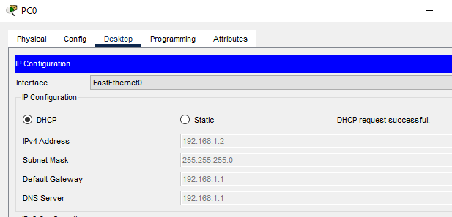

**FINANCE ACCESS SWITCH:**

FINANCE>en

FINANCE#conf

Configuring from terminal, memory, or network [terminal]?

Enter configuration commands, one per line. End with CNTL/Z.

FINANCE(config)#hostname

% Incomplete command.

FINANCE(config)#hostname FINANCE-SW

FINANCE-SW(config)#int range fa0/1-24

FINANCE-SW(config-if-range)#switchport mode access

FINANCE-SW(config-if-range)#switchport access vlan 20

FINANCE-SW(config-if-range)#do wr

Building configuration...

[OK]

**PC 1:**

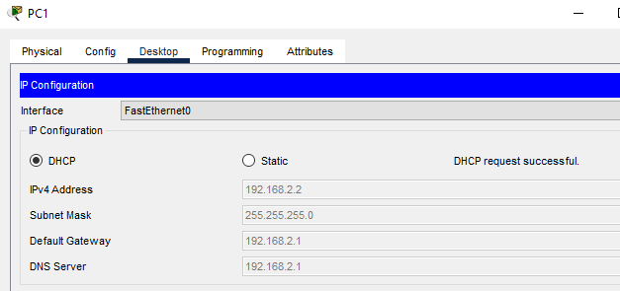

**ADMIN ACCESS SWITCH:**

ADMIN>en

ADMIN#conf

Configuring from terminal, memory, or network [terminal]?

Enter configuration commands, one per line. End with CNTL/Z.

ADMIN(config)#hostname ADMIN-SW

ADMIN-SW(config)#int range fa0/1-24

ADMIN-SW(config-if-range)#switchport mode access

ADMIN-SW(config-if-range)#switchport access vlan 30

ADMIN-SW(config-if-range)#do wr

Building configuration...

[OK]

**PC 2:**

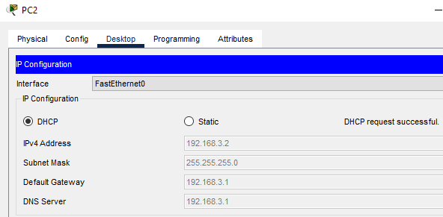

**BUSINESS ACCESS SWITCH:**

Business>en

Business#conf

Configuring from terminal, memory, or network [terminal]?

Enter configuration commands, one per line. End with CNTL/Z.

Business(config)#hostname Business-SW

Business-SW(config)#int range fa0/1-24

Business-SW(config-if-range)#switchport mode access

Business-SW(config-if-range)#switchport access vlan 40

Business-SW(config-if-range)#do wr

Building configuration...

[OK]

**PC 3:**

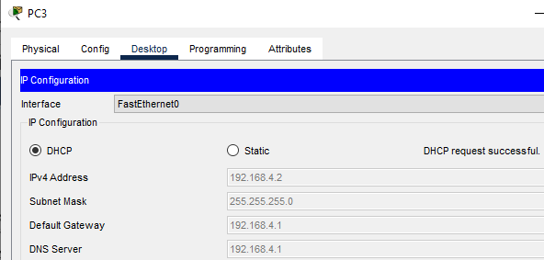

**SOFTWARE DEPART ACCESS SWITCH:**

SOFT_DEPART>en

SOFT_DEPART#conf

Configuring from terminal, memory, or network [terminal]?

Enter configuration commands, one per line. End with CNTL/Z.

SOFT_DEPART(config)#hostname Soft_depart-SW

Soft_depart-SW(config)#int range fa0/1-24

Soft_depart-SW(config-if-range)#switchport mode access

Soft_depart-SW(config-if-range)#switchport access vlan 50

Soft_depart-SW(config-if-range)#do wr

Building configuration...

[OK]

**PC 4:**

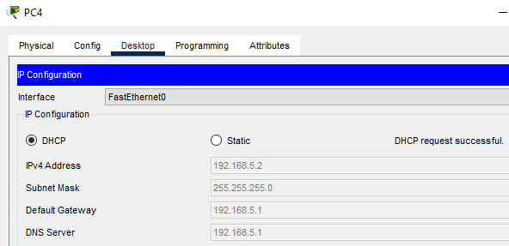

**CS DEPART ACCESS SWITCH:**

CS_DEPART>en

CS_DEPART#conf

Configuring from terminal, memory, or network [terminal]?

Enter configuration commands, one per line. End with CNTL/Z.

CS_DEPART(config)#hostname CS_depart-SW

CS_depart-SW(config)#int range fa0/1-24

CS_depart-SW(config-if-range)#switchport mode access

CS_depart-SW(config-if-range)#switchport access vlan 60

CS_depart-SW(config-if-range)#do wr

Building configuration...

[OK]

**PC 5:**

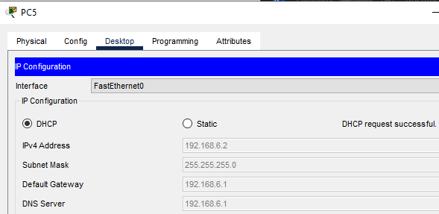

**STUDENT-LAB ACCESS SWITCH:**

STUDENT-LAB>en

STUDENT-LAB#conf

Configuring from terminal, memory, or network [terminal]?

Enter configuration commands, one per line. End with CNTL/Z.

STUDENT-LAB(config)#hostname Student_Lab-SW

Student_Lab-SW(config)#int range fa0/1-24

Student_Lab-SW(config-if-range)#switchport mode access

Student_Lab-SW(config-if-range)#switchport access vlan 70

Student_Lab-SW(config-if-range)#do wr

Building configuration...

[OK]

**PC 6:**

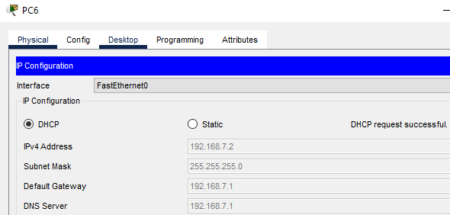

**IT-DEPART ACCESS SWITCH:**

IT-DEPART>en

IT-DEPART#conf

Configuring from terminal, memory, or network [terminal]?

Enter configuration commands, one per line. End with CNTL/Z.

IT-DEPART(config)#hostname IT_depart-SW

IT_depart-SW(config)#int range fa0/1-24

IT_depart-SW(config-if-range)#switchport mode access

IT_depart-SW(config-if-range)#switchport access vlan 80

IT_depart-SW(config-if-range)#do wr

Building configuration...

[OK]

**PC 7:**

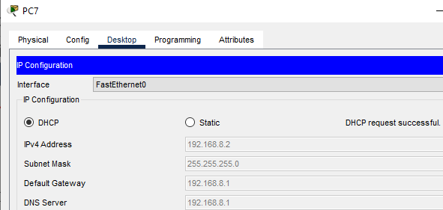

**PAK CHOWK CAMPUS DEPARTMENTAL SWITCHES:**

**STAFF ACCESS SWITCH:**

STAFF>en

STAFF#conf

Configuring from terminal, memory, or network [terminal]?

Enter configuration commands, one per line. End with CNTL/Z.

STAFF(config)#hostname Staff-PC-SW

Staff-PC-SW(config)#int range fa0/1-24

Staff-PC-SW(config-if-range)#switchport mode access

Staff-PC-SW(config-if-range)#switchport access vlan 90

Staff-PC-SW(config-if-range)#ex

Staff-PC-SW(config)#do wr

Building configuration...

[OK]

**PC 8:**

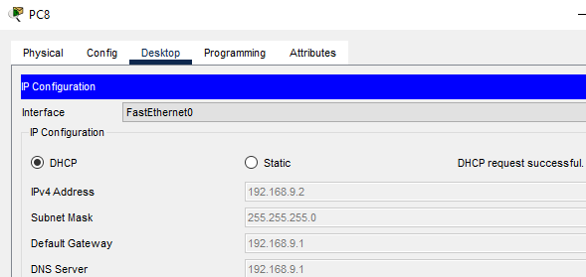

**STUD-LAB ACCESS SWITCH:**

STUD-LAB>en

STUD-LAB#conf

Configuring from terminal, memory, or network [terminal]?

Enter configuration commands, one per line. End with CNTL/Z.

STUD-LAB(config)#hostname Stud_Lab-PC-SW

Stud_Lab-PC-SW(config)#int range fa0/1-24

Stud_Lab-PC-SW(config-if-range)#switchport mode access

Stud_Lab-PC-SW(config-if-range)#switchport access vlan 100

Stud_Lab-PC-SW(config-if-range)#ex

Stud_Lab-PC-SW(config)#do wr

Building configuration...

[OK]

**PC 9:**

