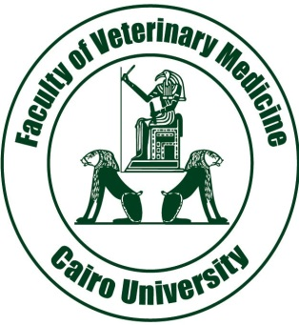 **First International conference of pathology Department** 

|  |  |
| --- | --- |
| **PARTICIPANT** | Name Surname Gender Male( ) Female ( ) |
| Institution Position |
| Correspondence Address |
| City Country |
| Phone ( ) Fax ( ) Email @ |

|  |  |  |  |  |  |
| --- | --- | --- | --- | --- | --- |
| **ACCOMMODATION AND REGISTRATION** |  | **Registration** | | | |
| Accommodation | Double Room (per person) | Single Room | | |
| Participant | 90 $ | 80 $ | | |
| Accompanying person | 90 $ | 80$ | | |
| 1st Child (0-6 Years) | Free | | | |
| 1st Child (7-12 Years) | 50% Discount | | | |
| 2ndChild (3-12 Years) | 50% Discount | | | |
| Registration | 300 $ | | | |
| Type of Participation | ِParticipant Without Abstract | | ِOral Presentation | ِ Poster |
| ----------------- | | ---------------------- | ------------------ |
|

|  |
| --- |
| Total  ­­  $ |

Child reduction, will be valid only if they stay in the same room with two adults.

**Services included to registration and accommodation fee;**

|  |  |  |  |  |  |  |  |  |  |  |  |  |  |  |
| --- | --- | --- | --- | --- | --- | --- | --- | --- | --- | --- | --- | --- | --- | --- |
| **Payment Details** |  | Bank Transfer   |  |  |  |  |  |  | | --- | --- | --- | --- | --- | --- | | Account Holder | Iman Bakr Mohamed Khedr Shaheed | Swift code | NBEGEGCX185 | IBAN CODE | 36000533852 | | Bank Name | National Bank of Egypt, | Branch Name | Mosadak branch | Address of Bank | 3&5 Mosadak street , Dokki ,Giza | |
| I transfer …………. $ ………. / ………/ 2013 |
| (The payment transfer document is enclosed) Date………………… Signature……………. |

|  |  |  |  |  |  |  |  |  |  |  |  |  |
| --- | --- | --- | --- | --- | --- | --- | --- | --- | --- | --- | --- | --- |
| **Cancel** |  | Cancellation both for the accommodation and registration until 30 March 2013 will be refund of 50% of the fee, Cancellation after this date won't refund , All refunds will be processed at the congress | |  |  |  | | --- | --- | --- | | Cancel Type | Late Cancel | Refund Detail | | Early Cancel | 20 May 2013&Before | 50% refund | | Late Cancel | 26 March 2012&After | No refund | |

This form should be faxed or emailed to Congress Secretariat

_________________________________________________________________________________________

Cairo University Faculty of Veterinary Medicine Pathology Department

[Tel: 02-01223779103 Fax](Tel:Fax): 02- 35725240

<http://www.pathology-cairo-conference.org/>