1. Task:

This project is concerned with generation of ethernet frames restricted with specific standards and specific configurations.

1. Goal:

Maintainable reusable project that can be modified and used again for additional standards.

1. Frame Description:

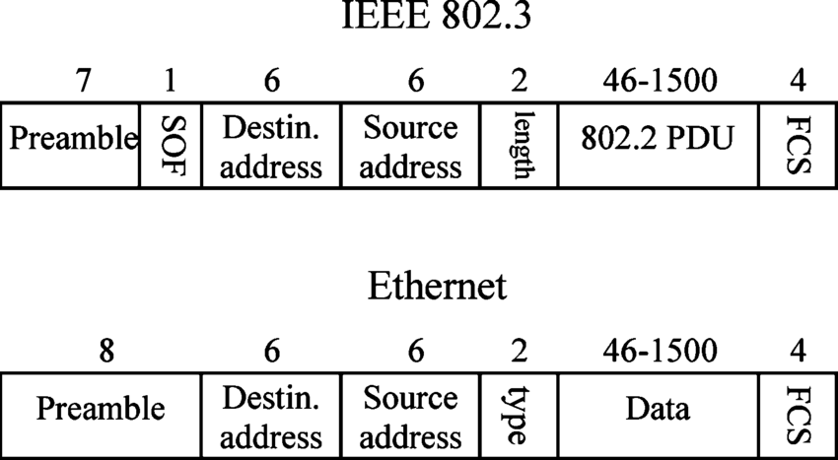

Figure 1 Ethernet and IEEE802.3 standards

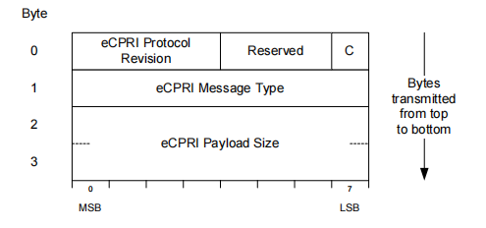

Figure 2 Ecpri frame header

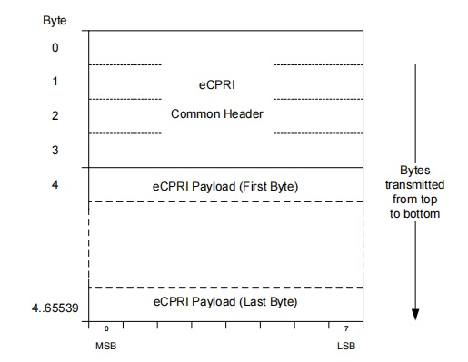

Figure 3 Ecpri Frame description

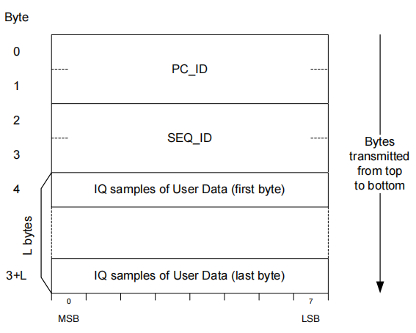

Figure 4 Message type#0 description

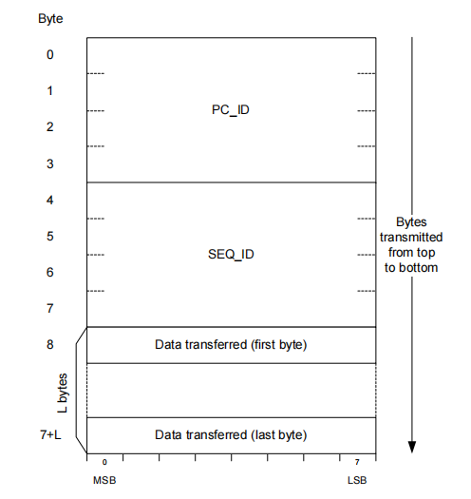

Figure 5 Message type #3 description

1. Paradigm :

The whole project can follow procedural approach which means it can be one source code of procedures happening one after another .

But OOP was used here in order to achieve SOLID principles and make it more maintainable.

.

1. High Level Package Diagram :

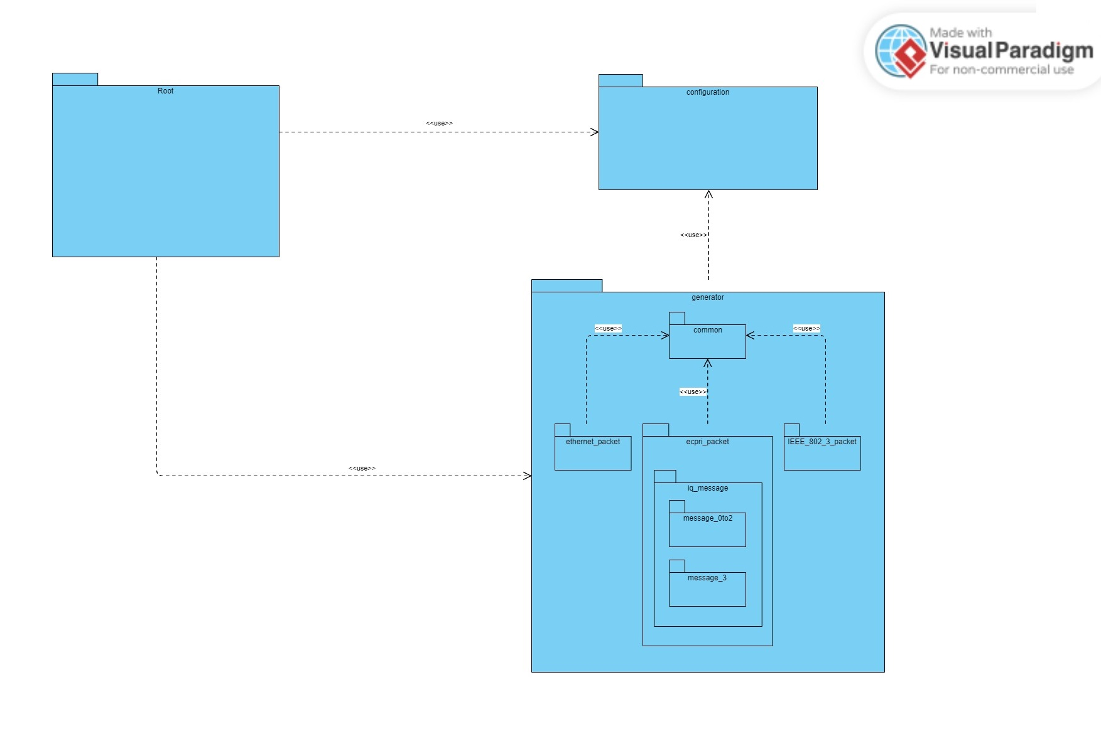

This is a High Level Package Diagram which represents how code is divided into packages and how these packages interact with each other.

1. Low Level Package Diagram :

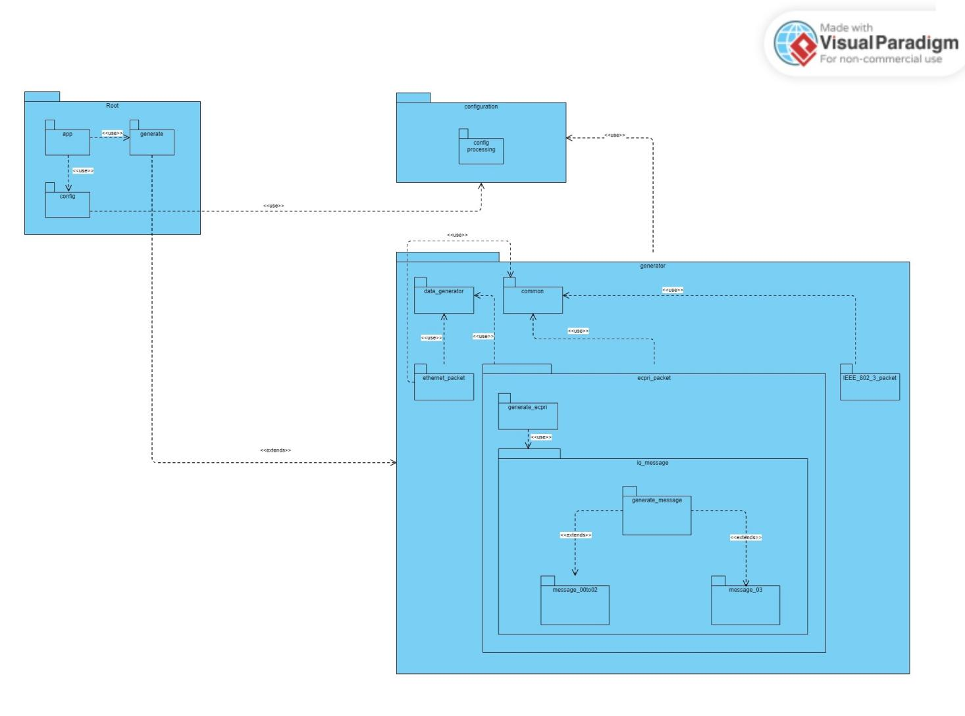

This is a Low Level Package Diagram that describes in depth how packages use each other and what specific module it uses in the other package.

1. Component Diagram :

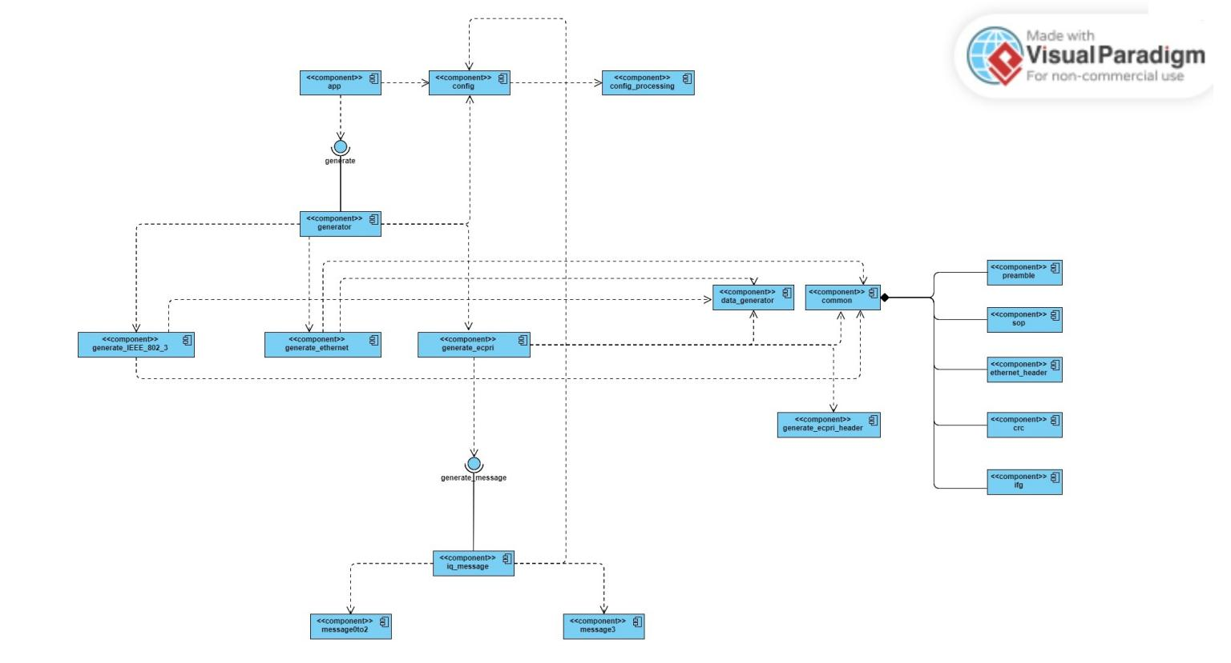

This is a component diagram it describes modules as components and interfaces and which use which achieving single responsibility and interfaces describes how maintainable the code is achieving the (Open for extension - closed for modification) principle.

1. Test Cases :
2. Ethernet Frame :

- Random size ethernet frame.

- Frame size is ranged between minimum size (72) and maximum packet (426) that can be transferred without any data losses.

-No data loss but spare packets in bursts are transformed into ifgs depending on their size and they are of multiple of 4.

; ------------------------ Ethernet frame

[PACKET_CONFIG]

STREAM_DURATION_MS = 1

IFGs = 0x30

SOURCE_ADDRESS = 0x102030405060

DESTINATION_ADDRESS = 0x102030302010

ETHER_TYPE = 0x0800

PAYLOAD_TYPE = RANDOM

MAX_PACKET_SIZE = 426

BURST_SIZE = 3

BURST_PERIODICITY_US = 100

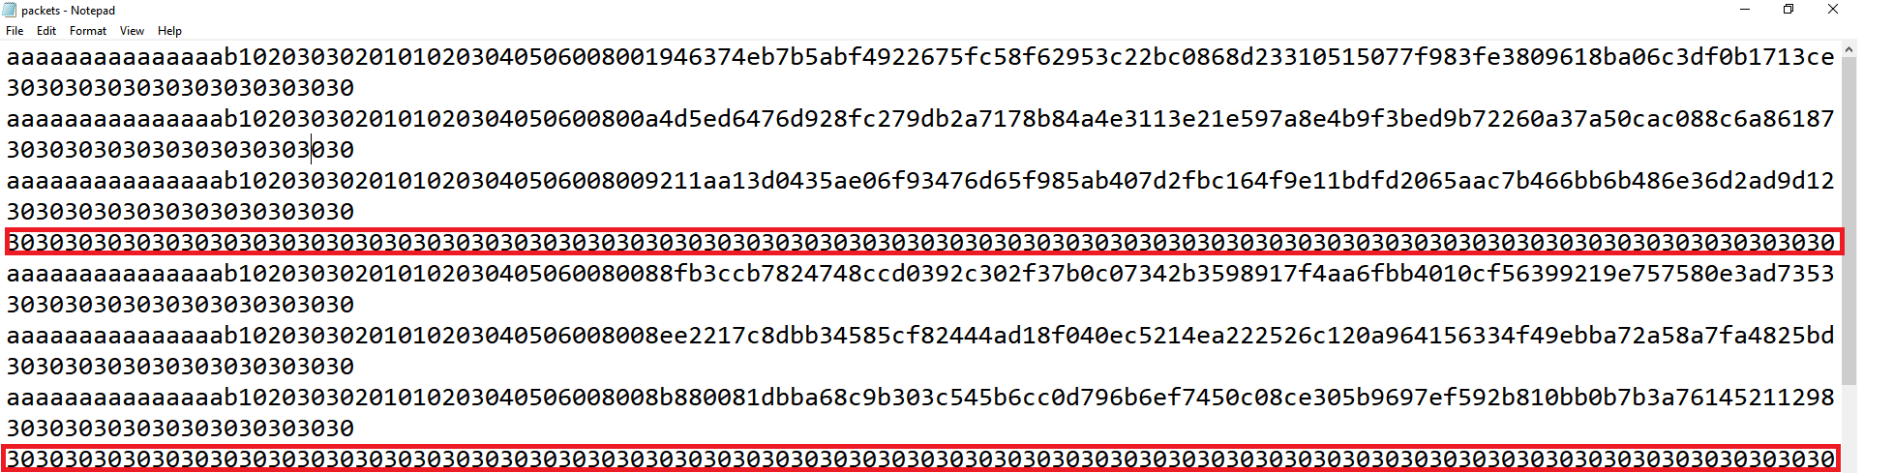

2)

- Fixed size ethernet frame.

- Frame size is fixed and its packet size is (426) that can be transferred without losing data.

-No data loss and packets perfectly fits burst periodicity.

; ------------------------ Ethernet frame

[PACKET_CONFIG]

STREAM_DURATION_MS = 1

IFGs = 0x30

SOURCE_ADDRESS = 0x102030405060

DESTINATION_ADDRESS = 0x102030302010

ETHER_TYPE = 0x0800

PAYLOAD_TYPE = RANDOM

MAX_PACKET_SIZE = 426

BURST_SIZE = 3

BURST_PERIODICITY_US = 100

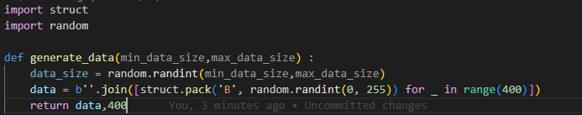

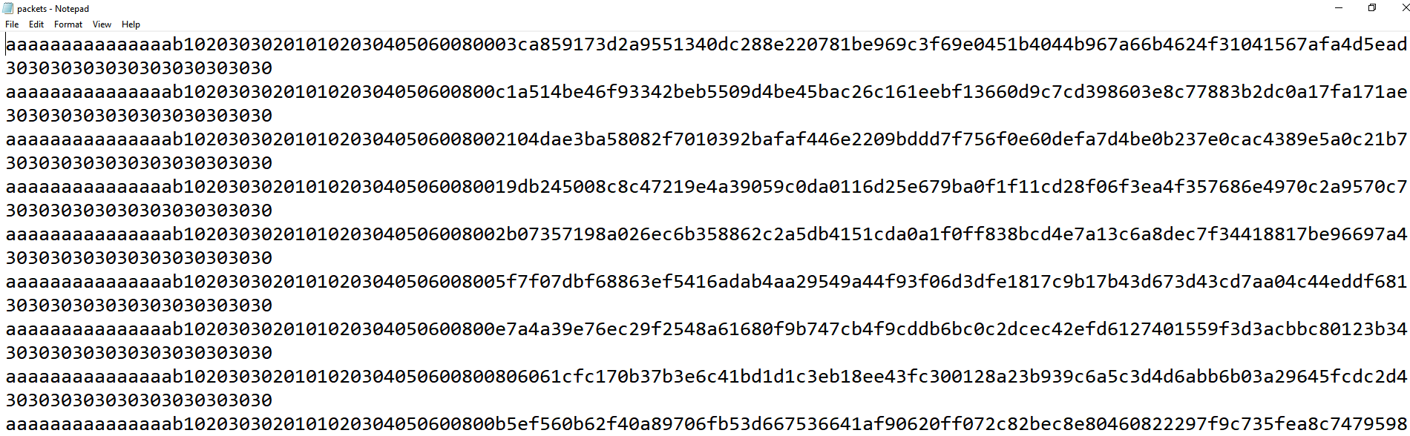

3)

- Fixed size ethernet frame.

- Frame size is fixed and it is greater than maximum packet size(426) that can be transferred without losing data.

-2 packets are sent and there is constant loss of last packets every burst.

; ------------------------ Ethernet frame

[PACKET_CONFIG]

STREAM_DURATION_MS = 1

IFGs = 0x30

SOURCE_ADDRESS = 0x102030405060

DESTINATION_ADDRESS = 0x102030302010

ETHER_TYPE = 0x0800

PAYLOAD_TYPE = RANDOM

MAX_PACKET_SIZE = 426

BURST_SIZE = 3

BURST_PERIODICITY_US = 100

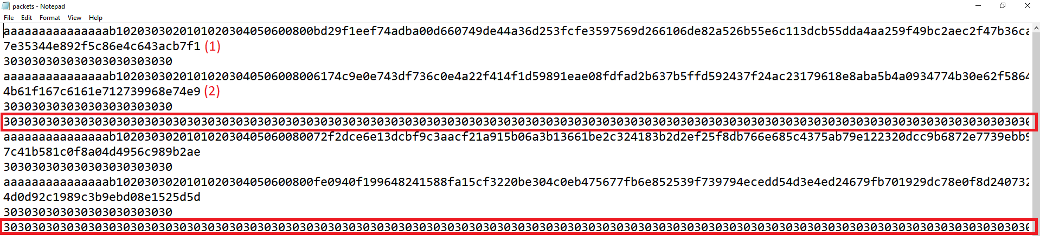

1. Ecpri Frame :

1)

- Ecpri frame of fixed size..

- Maximum packet size that can be transferred without loss is equal to ecpri frame (72).

- No data loss and packets sent perfectly fit the burst period.

; ------------------------ ecpri frame

[PACKET_CONFIG]

STREAM_DURATION_MS = 1

IFGs = 0x30

DESTINATION_ADDRESS = 0x102030302010

SOURCE_ADDRESS = 0x102030405060

ETHER_TYPE = 0xaefe

PROTOCOL_VERSION= 1

CONCATENATION_INDICATOR = 0

MESSAGE_TYPE= 0x00

PAYLOAD_SIZE= 0x0014

PAYLOAD_TYPE = RANDOM

MAX_PACKET_SIZE = 72

BURST_SIZE = 3

BURST_PERIODICITY_US = 100

PC_ID = 0x8068

SEQ_ID = 0x0780

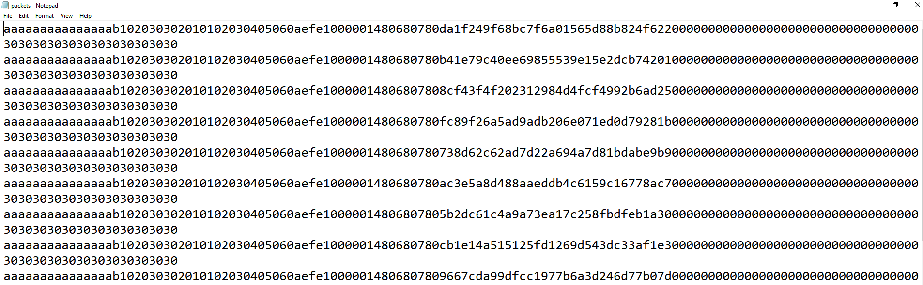

2)

- Ecpri frame of fixed size..

- Maximum packet size that can be transferred without loss is greater than ecpri frame (80).

- No data loss but a spare packet is transformed to ifgs.

; ------------------------ ecpri frame

[PACKET_CONFIG]

STREAM_DURATION_MS = 1

IFGs = 0x30

DESTINATION_ADDRESS = 0x102030302010

SOURCE_ADDRESS = 0x102030405060

ETHER_TYPE = 0xaefe

PROTOCOL_VERSION= 1

CONCATENATION_INDICATOR = 0

MESSAGE_TYPE= 0x00

PAYLOAD_SIZE= 0x0014

PAYLOAD_TYPE = RANDOM

MAX_PACKET_SIZE = 80

BURST_SIZE = 3

BURST_PERIODICITY_US = 100

PC_ID = 0x8068

SEQ_ID = 0x0780

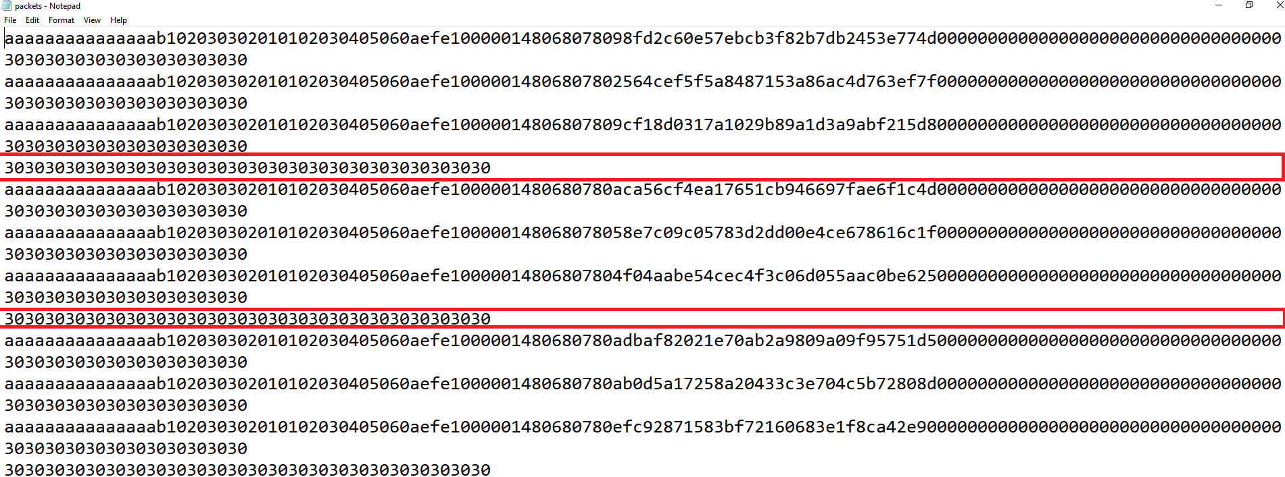

3)

- Ecpri frame of fixed size.

- Maximum packet size that can be transferred without loss is less than ecpri frame (60).

- Constant packet loss every burst.

; ------------------------ ecpri frame

[PACKET_CONFIG]

STREAM_DURATION_MS = 1

IFGs = 0x30

DESTINATION_ADDRESS = 0x102030302010

SOURCE_ADDRESS = 0x102030405060

ETHER_TYPE = 0xaefe

PROTOCOL_VERSION= 1

CONCATENATION_INDICATOR = 0

MESSAGE_TYPE= 0x00

PAYLOAD_SIZE= 0x0014

PAYLOAD_TYPE = RANDOM

MAX_PACKET_SIZE = 60

BURST_SIZE = 3

BURST_PERIODICITY_US = 100

PC_ID = 0x8068

SEQ_ID = 0x0780

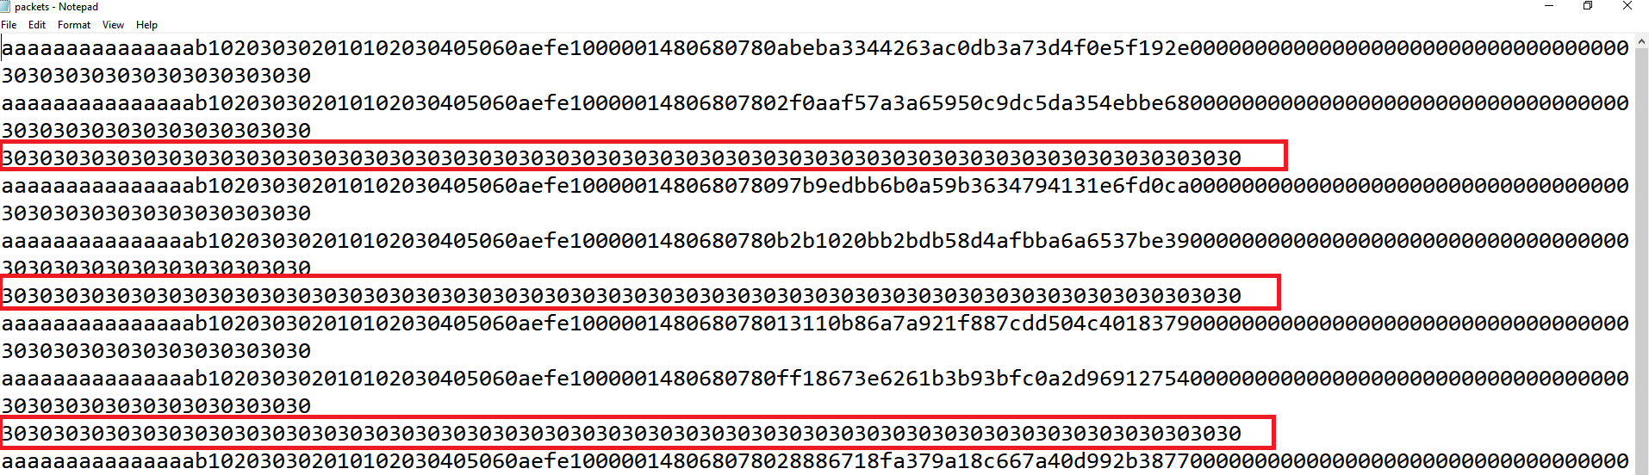

4)

- Trying message type #2.

- Ecpri frame of fixed size.

- Maximum packet size that can be transferred without loss is equal to ecpri frame (72).

- Perfectly fit bursts and message type 2 is applied.

; ------------------------ ecpri frame

[PACKET_CONFIG]

STREAM_DURATION_MS = 1

IFGs = 0x30

DESTINATION_ADDRESS = 0x102030302010

SOURCE_ADDRESS = 0x102030405060

ETHER_TYPE = 0xaefe

PROTOCOL_VERSION= 1

CONCATENATION_INDICATOR = 0

MESSAGE_TYPE= 0x02

PAYLOAD_SIZE= 0x0014

PAYLOAD_TYPE = RANDOM

MAX_PACKET_SIZE = 72

BURST_SIZE = 3

BURST_PERIODICITY_US = 100

PC_ID = 0x8068

SEQ_ID = 0x0780

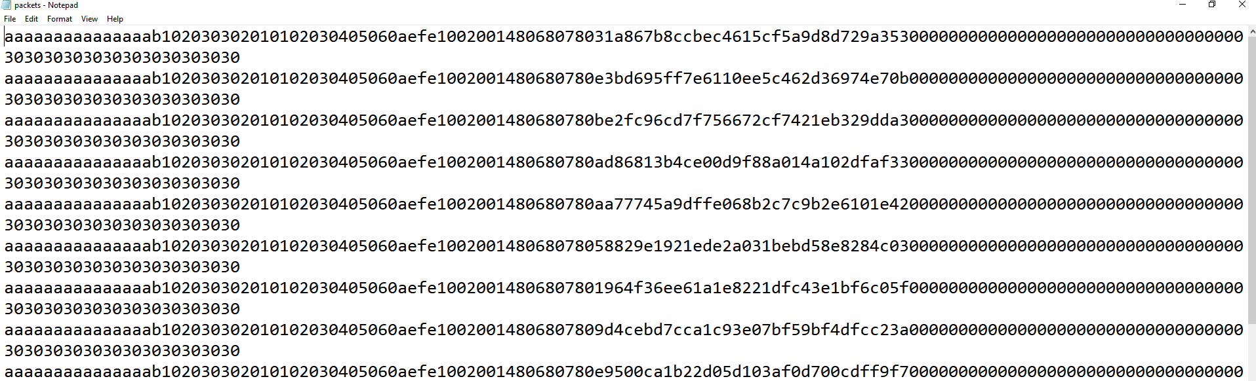

5)

- Trying message type #3.

- Ecpri frame of fixed size.

- Maximum packet size that can be transferred without loss is equal to ecpri frame (72).

- Perfectly fit bursts and message type 3 is applied.

; ------------------------ ecpri frame

[PACKET_CONFIG]

STREAM_DURATION_MS = 1

IFGs = 0x30

DESTINATION_ADDRESS = 0x102030302010

SOURCE_ADDRESS = 0x102030405060

ETHER_TYPE = 0xaefe

PROTOCOL_VERSION= 1

CONCATENATION_INDICATOR = 0

MESSAGE_TYPE= 0x03

PAYLOAD_SIZE= 0x0014

PAYLOAD_TYPE = RANDOM

MAX_PACKET_SIZE = 72

BURST_SIZE = 3

BURST_PERIODICITY_US = 100

PC_ID = 0xa1bc8068

SEQ_ID = 0x8a6c0780

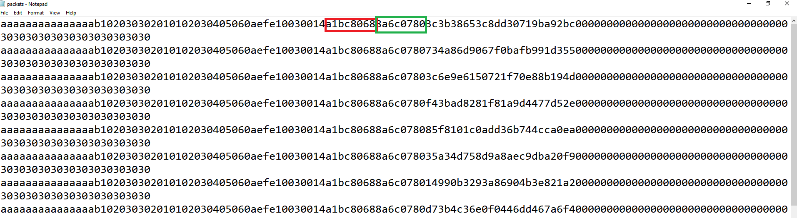

6)

- Changing payload size (001a).

- Ecpri frame of fixed size.

- Maximum packet size that can be transferred without loss is equal to ecpri frame (72).

- Perfectly fit bursts and size is changed.

; ------------------------ ecpri frame

[PACKET_CONFIG]

STREAM_DURATION_MS = 1

IFGs = 0x30

DESTINATION_ADDRESS = 0x102030302010

SOURCE_ADDRESS = 0x102030405060

ETHER_TYPE = 0xaefe

PROTOCOL_VERSION= 1

CONCATENATION_INDICATOR = 0

MESSAGE_TYPE= 0x00

PAYLOAD_SIZE= 0x001a

PAYLOAD_TYPE = RANDOM

MAX_PACKET_SIZE = 72

BURST_SIZE = 3

BURST_PERIODICITY_US = 100

PC_ID = 0x8068

SEQ_ID = 0x0780

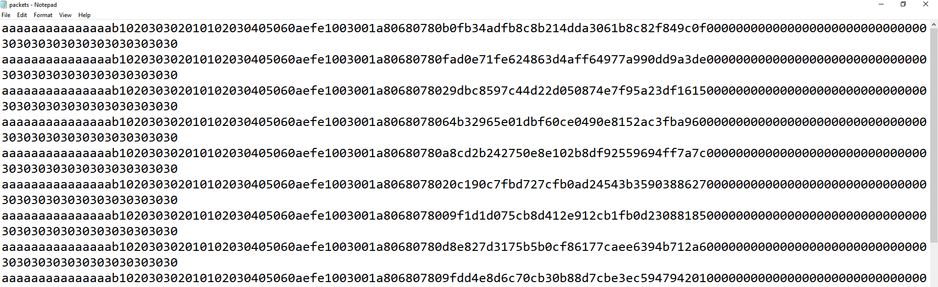

1. IEEE 802.3 Frame :

1)

- Fixed size IEEE 802.3 frame , size = ether_type = 0x0258 = 600.

- Frame size is fixed and it is equal to maximum packet size (626) that can be transferred.

- It perfectly fits the burst periodicity.

; ------------------------ IEEE 802.3

[PACKET_CONFIG]

STREAM_DURATION_MS = 1

IFGs = 0x30

SOURCE_ADDRESS = 0x102030405060

DESTINATION_ADDRESS = 0x102030302010

ETHER_TYPE = 0x0258

PAYLOAD_TYPE = RANDOM

MAX_PACKET_SIZE = 626

BURST_SIZE = 3

BURST_PERIODICITY_US = 100

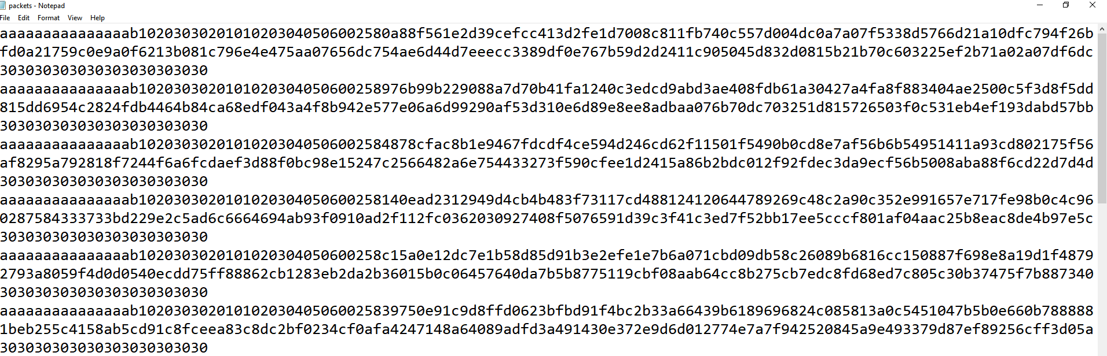

2)

- Fixed size IEEE 802.3 frame , size = ether_type = 0x0258 = 600.

- Frame size is fixed and it is less than maximum packet size (700) that can be transferred without losing data.

- no data loss and spared packets are converted to ifgs.

; ------------------------ IEEE 802.3

[PACKET_CONFIG]

STREAM_DURATION_MS = 1

IFGs = 0x30

SOURCE_ADDRESS = 0x102030405060

DESTINATION_ADDRESS = 0x102030302010

ETHER_TYPE = 0x0258

PAYLOAD_TYPE = RANDOM

MAX_PACKET_SIZE = 700

BURST_SIZE = 3

BURST_PERIODICITY_US = 100

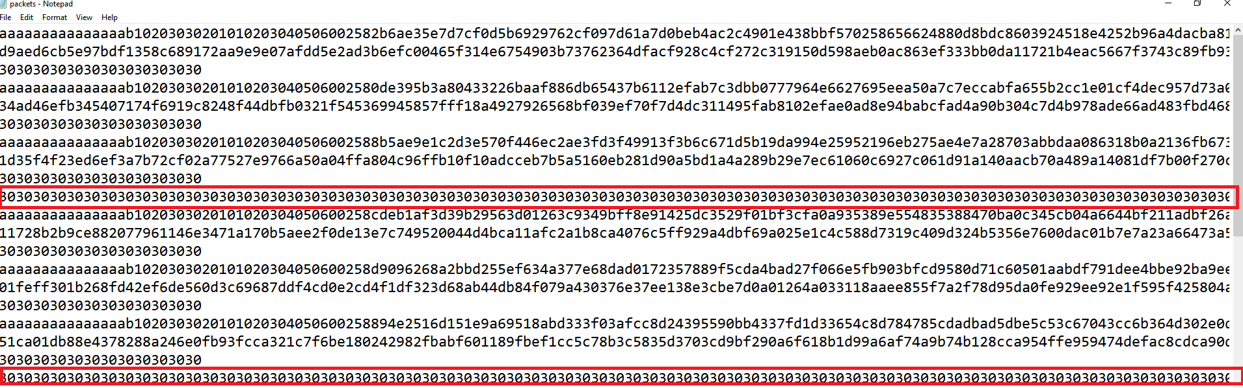

3)

- Fixed size IEEE 802.3 frame , size = ether_type = 0x0258 = 600.

- Frame size is fixed and it is greater than maximum packet size (500) that can be transferred without losing data.

- constant data loss of last packet and sending ifgs instead.

; ------------------------ IEEE 802.3

[PACKET_CONFIG]

STREAM_DURATION_MS = 1

IFGs = 0x30

SOURCE_ADDRESS = 0x102030405060

DESTINATION_ADDRESS = 0x102030302010

ETHER_TYPE = 0x0258

PAYLOAD_TYPE = RANDOM

MAX_PACKET_SIZE = 500

BURST_SIZE = 3

BURST_PERIODICITY_US = 100

