**PROPOSAL**

An Arduino Uno is going to be used for this project to make a simple Stopwatch, which is also able to track time as well as recording it to an SD Card via the SD Module that is going to be used.

The time elapsed will be shown on a 4-digit 7-segment display and the Current time will be shown on a 16x2 LCD Display using RTC module.

Two buttons will be used one to Start/Pause/Continue and one to Stop and save the duration and the time at which it was stopped to the SD card.

**Components**

|  |  |  |
| --- | --- | --- |
| **Name** | **Photo** | **Quantity** |
| Arduino Uno R3 | Arduino Uno R3 SMD CH340 Chipset Klon (Usb Kablo Dahil) | SAMM Market | 1 |
| Arduino Uno Sensor Shield | Quality and Affordable Arduino Sensor Shield Available @  https://mopsnow.com.ng/index.php/pbase/showStoreProductDetail/28 | 1 |
| 10K Ohm Resistors | Tandy - 10KΩ 1/2W 5% Carbon Film Resistors | 2 |
| Medium Breadboard | Breadboard white 400 points - Opencircuit | 1 |
| Male🡺Male Jumper Wires | ZipWire Zipable Jumper Wires - BPS | Mouser | 20 |
| Male🡺Female Jumper Wires |
| Female🡺Female Jumper Wires |
| MicroSD Card 12GB | Micro SD Card | 3D CAD Model Library | GrabCAD | 1 |
| MicroSD Card Module | DEBO MICROSD 2: Developer boards - breakout board for microSD cards at  reichelt elektronik | 1 |
| RTC Module | Modulo RTC DS 1302 - Uso con Arduino UNO | 1 |
| 4-Digit-7-Segment Display | 4 Bits Digital Tube LED Display best quality | 1 |
| 2x16 LCD blue with L2C | Using a 16x2 I2C LCD display with ESP32 - Electronics-Lab.com | 1 |
| Pin Push Button | Tactile button 6x6x5mm - 25 pieces - Opencircuit | 2 |

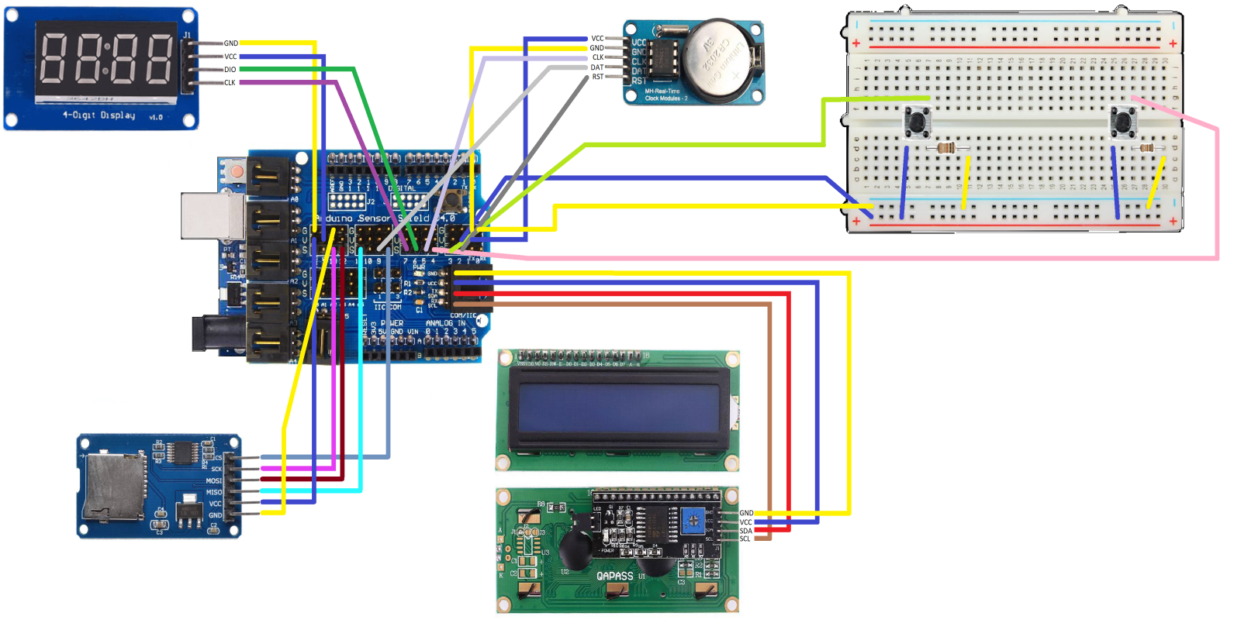Diagram

Code (Double click on it)



Photos

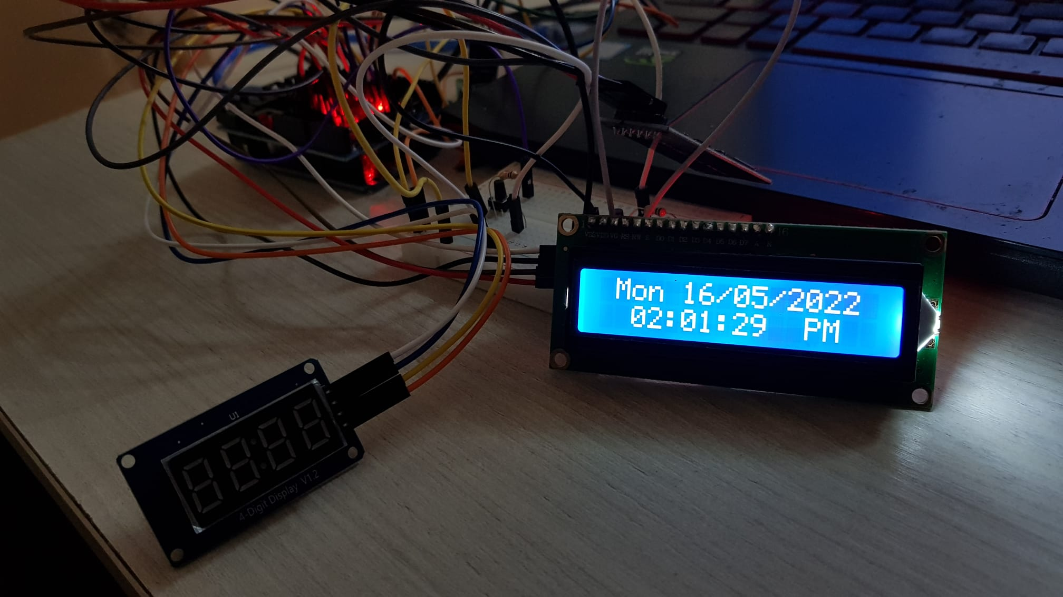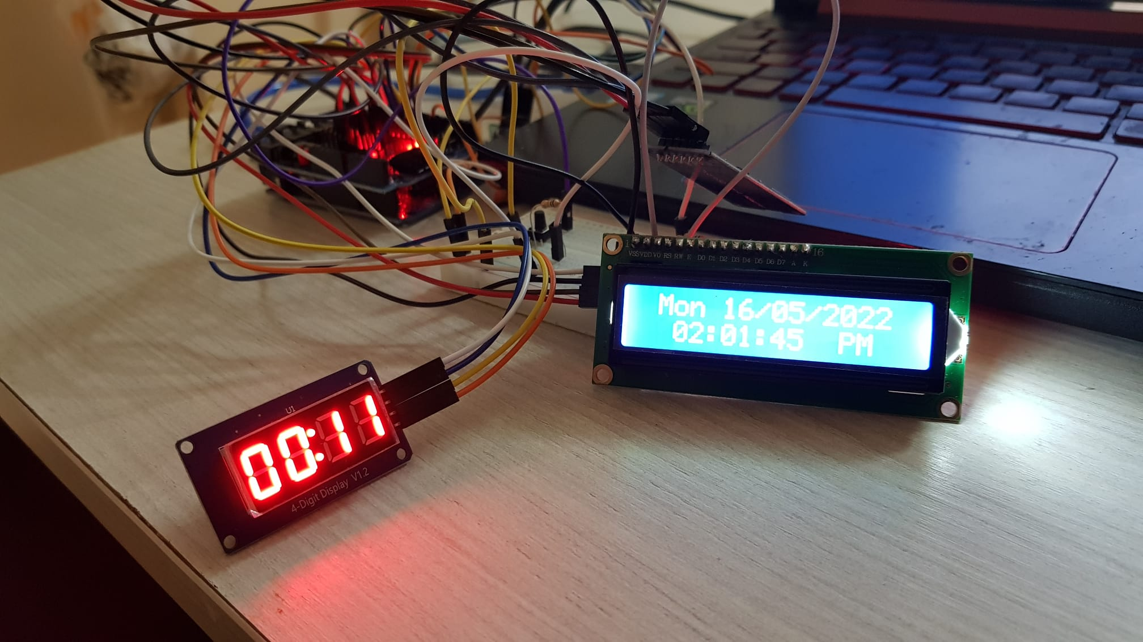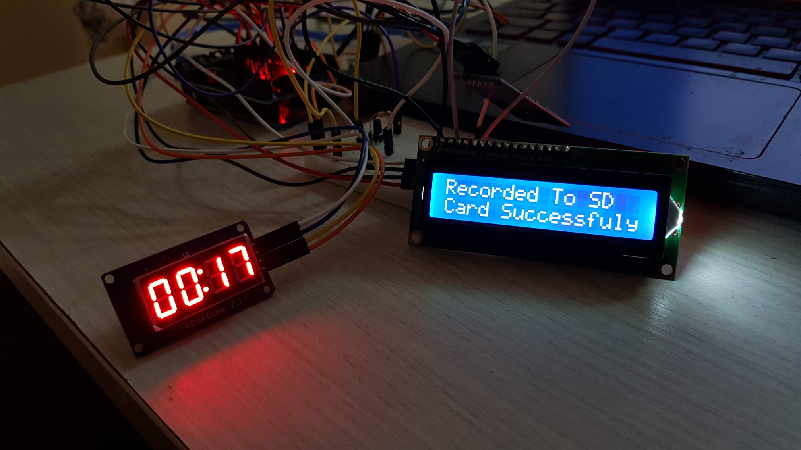

References

- [SD Card Module with Arduino: How to Read/Write Data - Arduino Project Hub](https://create.arduino.cc/projecthub/electropeak/sd-card-module-with-arduino-how-to-read-write-data-37f390)

- [Arduino Stopwatch Using I2C LCD : 5 Steps - Instructables](https://www.instructables.com/Arduino-Stopwatch-Using-I2C-LCD/)

- [Arduino Stopwatch Project - Tutorial45](https://tutorial45.com/arduino-stopwatch-project/)