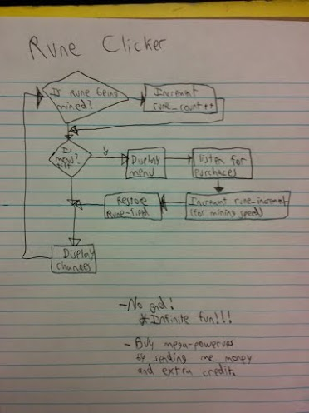

Estimated man hours: 10 hours

Actual man hours: 20 hours

Rune clicker represents all of the aspects of a modern runaway hit game. it contains:

* Mindless but satisfying gameplay with instant gratification.
* Repeated compliments that make you feel good about yourself.
* Pay-to-win strategy. (if you give me 20 bucks I'll set the default score to 999999 or whatever you want).

When I was a kid I spent days at a time just playing runescape where I did nothing but click on ore repeatedly, and now you too can do the same thing, but with the added benefit of portability (as long as you have a USB port to keep it plugged into) and ease of use (a mouse? how on earth does that work?). Touch screens are the future!