**PROJECT DESCRIPTION**

After reading the available content in the form of a readme file and documentation and analyzing components and sectors of the code I was able to conduct that:

UniTime educational scheduling system is a well-designed and efficient system that simplifies complex scheduling tasks and provides an interface for managing course and exam timetables, event scheduling, and student scheduling. By leveraging the power of distributed computing, UniTime allows multiple university and departmental schedule managers to collaborate and build schedules that meet their diverse organizational needs while minimizing student course conflicts.

Knowing that and with the availability of good documentation and the clear purpose and description of the components of the code, I was able to conduct that the top-down approach would be the most fitting for the analysis of this project as I need to understand the nature of the interaction between said components and I already have a clear view of the structure of the codebase.

After conducting a comprehensive top-down analysis of the codebase, I understand the various components of the UniTime educational scheduling system. The four main components, Course Timetabling & Management, Examination Timetabling, Event Management, and Student Scheduling, work together seamlessly to provide a comprehensive set of tools for managing complex scheduling tasks in educational institutions.

Starting with the documentation, I was able to identify the main entry points of the system and trace the flow of control through the code to understand how each component of the system works. The system's architecture and functionality were clear, and I was able to identify the various dependencies and interactions between different parts of the code.

By drilling down into individual sections of the code, I gained a deeper understanding of how the system works. I identified the various data structures used by the system and the algorithms used to manage scheduling tasks. Additionally, I utilized automated tools such as code analysis tools and debuggers to gain additional insights into the code and identify potential issues or bottlenecks in the code.

As I understood from reading the documentation and analyzing the codebase I understood more about the component of this system and what each component does:

**Course Timetabling & Management:**

UniTime's Course Timetabling and Management component is responsible for creating and maintaining schedules of classes that do not conflict with each other. This module incorporates algorithms to solve complex timetabling problems while taking into consideration various constraints such as faculty availability, room preferences, and student conflicts. The Course Management feature allows for modifications to the timetable and suggests alternative times and/or room assignments for classes while minimizing the impact on the overall schedule.

**Examination Timetabling:**

UniTime's Examination Timetabling component is responsible for generating a complete exam schedule that minimizes conflicts for all students. This feature can also minimize back-to-back exams and limit the number of exams a student takes in a day. This is especially useful for institutions that frequently update their course offerings or have a high volume of multi-section courses that do not fit well into mapped exam timetables. The module can generate schedules for mid-term exams as well as final exams.

**Event Management:**

UniTime includes an event management component that allows for the scheduling of various activities in campus spaces beyond just classes and exams. The system automatically creates events for all class meetings and exams in the academic session's events calendar. Using the web-based Events interface, additional events can be scheduled in rooms used by classes or any other campus facility in the system. This interface can be accessed by all staff and students to request events or search for available times and locations. Different event managers can be assigned to control the assignment of different groups of spaces. Notifications are automatically sent to event organizers and can be accessed on the My Events page.

**Student Scheduling:**

UniTime provides a solution to the challenge of scheduling individual students for classes. This process involves matching the sets of classes required by each student to the available class spaces so that all (or as many as possible) of the student's educational requirements are met. UniTime uses knowledge based on curricular course requirements or historical course requests and the existing timetable to determine the expected need for individual course sections. If the expected need for an individual class section is greater than the number of student spaces available, these spaces will be held for students who require that class to build a conflict-free schedule. UniTime's process significantly reduces unmet course needs, making it easier for students to obtain all of their required classes.

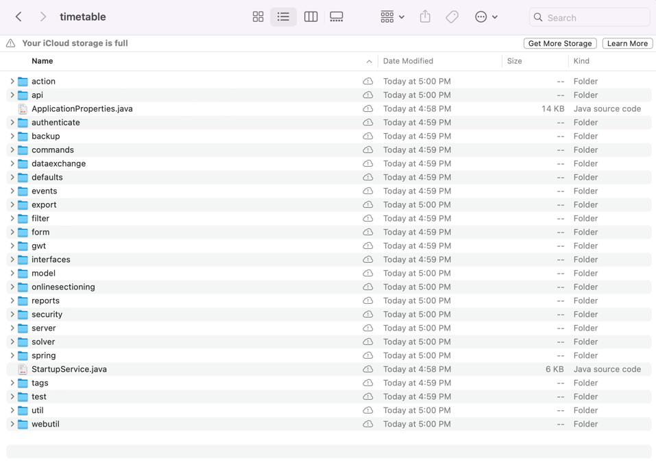

Additionally, within the applications, while analyzing the code several packages are aimed at different and varying functionalities including authentication, security, backups, commands, data exchange, and more.

To summarize we used the access to data available in the form of a Readme file and documentation which explained the application and after analyzing the codebase we gained an understanding of the program and its main components and the relations between them.