Secure DevOps – Project 2
Name: Ahmed Alameri
Student ID: 24528667

1. GitHub repositories
Forked aws-elastic-beanstalk-express-js-sample (contains the Jenkinsfile):
https://github.com/AhmedSamiAlameri/aws-elastic-beanstalk-express-js-sample
Project2-Compose (Docker Compose stack: Jenkins + Docker-in-Docker):
https://github.com/AhmedSamiAlameri/Project2-Compose
Jenkins pipeline: 24528667-Project-2-pipeline (Pipeline script from SCM → the fork's Jenkinsfile on main). Build #2 finished with result SUCCESS.

2. Screenshots
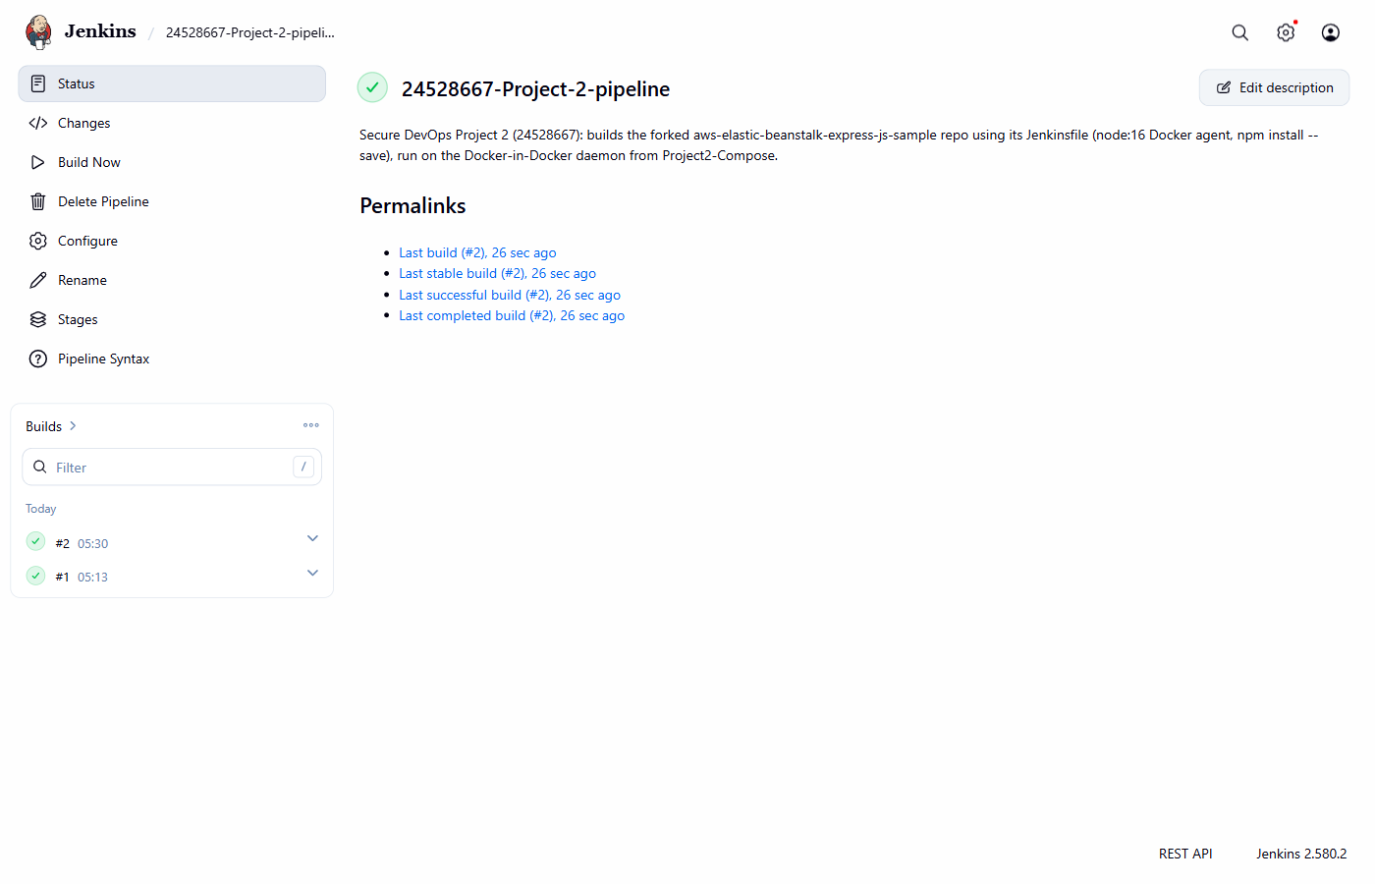
Figure 1. Jenkins job page for 24528667-Project-2-pipeline: the latest build (#2) shows a green tick and is listed as the last successful build.
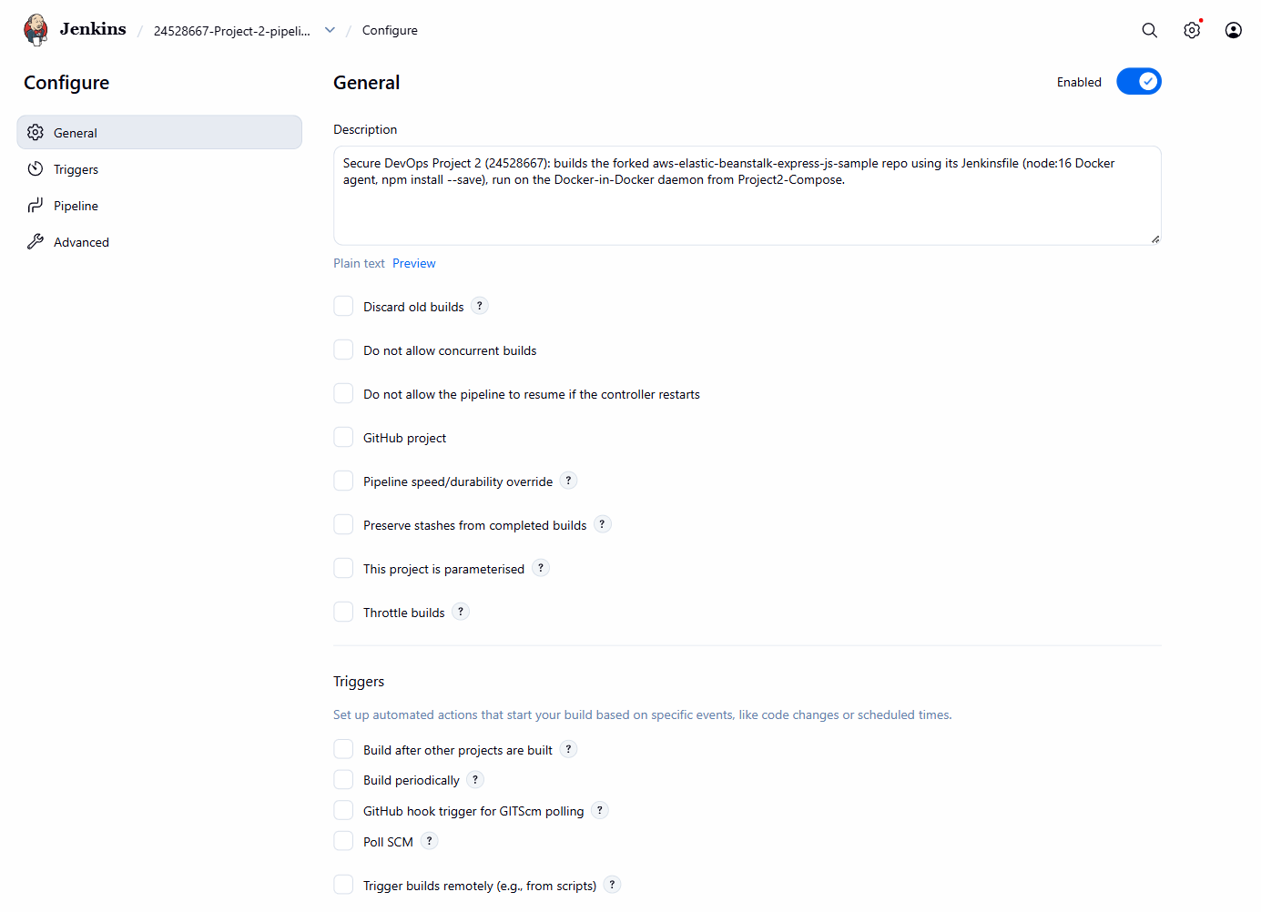
Figure 2 (part 1 of 2). Job configuration page: General and Triggers sections, including the job description.
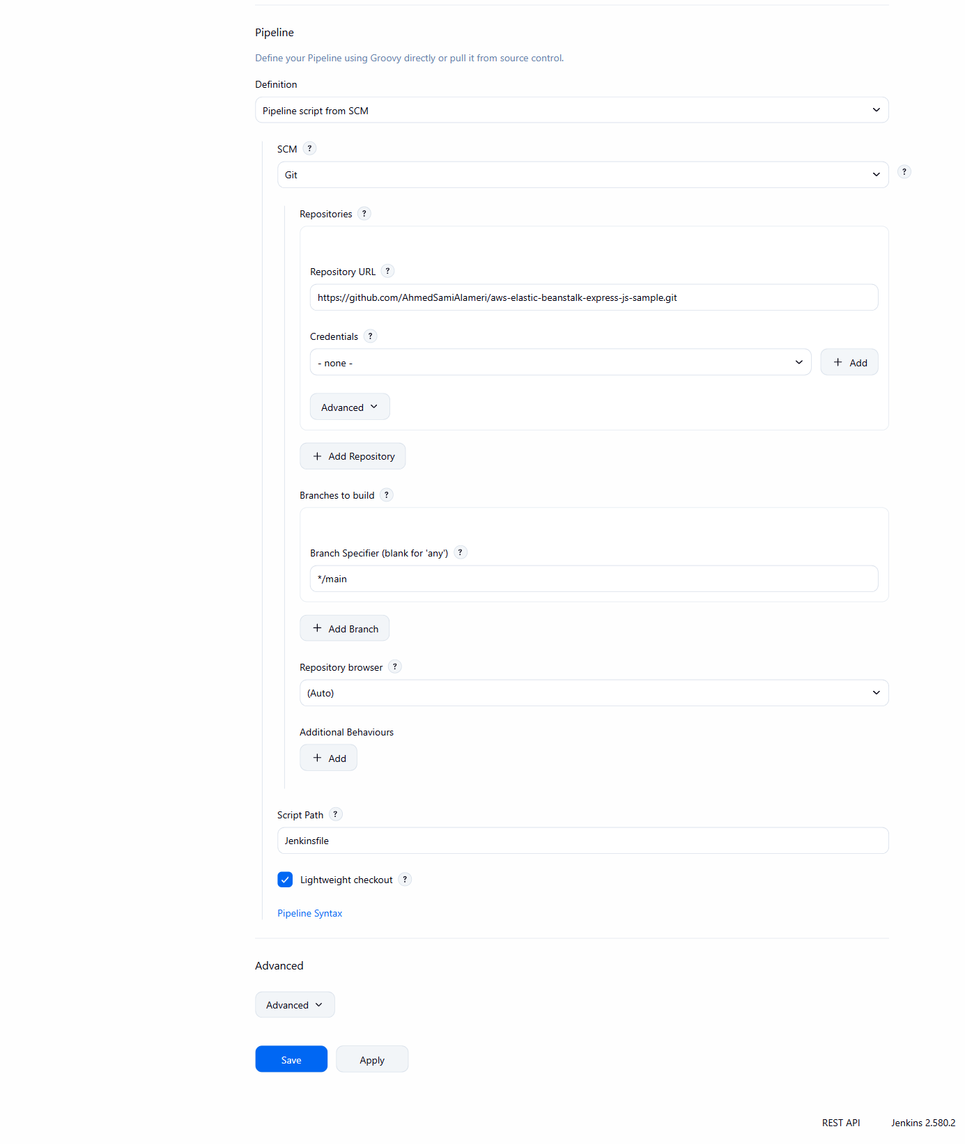
Figure 2 (part 2 of 2). Pipeline section of the job configuration: Definition is “Pipeline script from SCM”, SCM is Git, the repository URL is the forked repo, branch */main and Script Path Jenkinsfile.
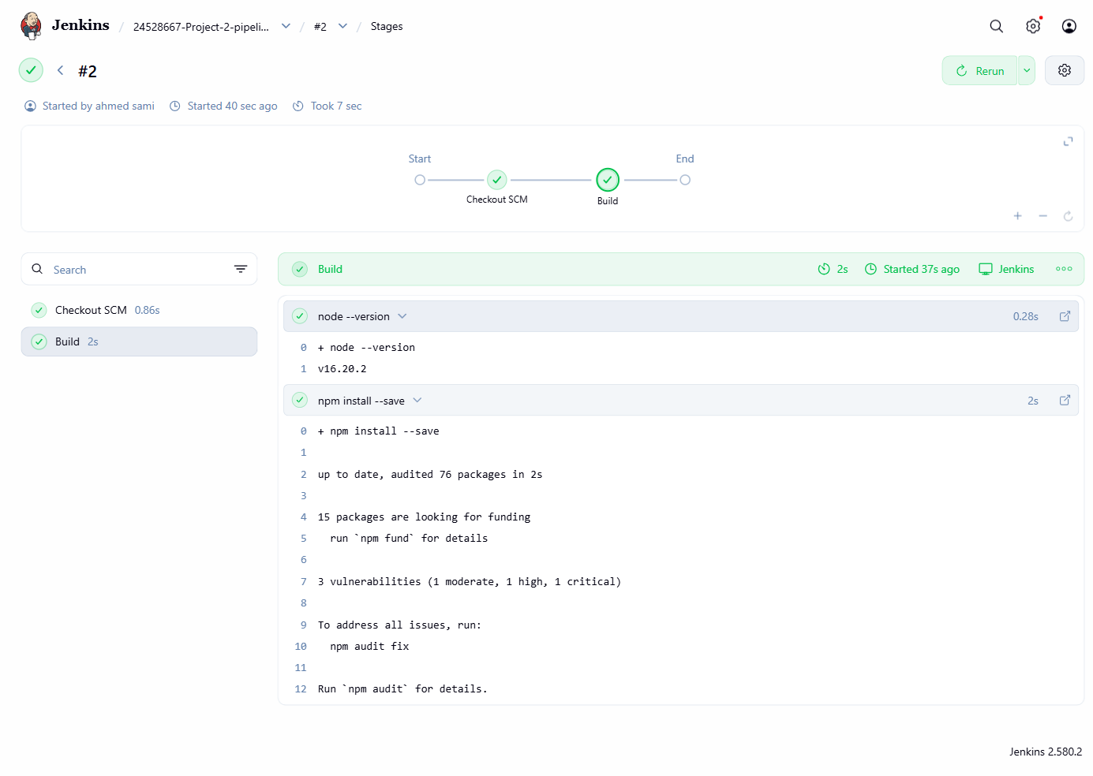
Figure 3. Pipeline Overview for build #2: Checkout SCM and Build stages both passed; node --version prints v16.20.2 and npm install --save completes.
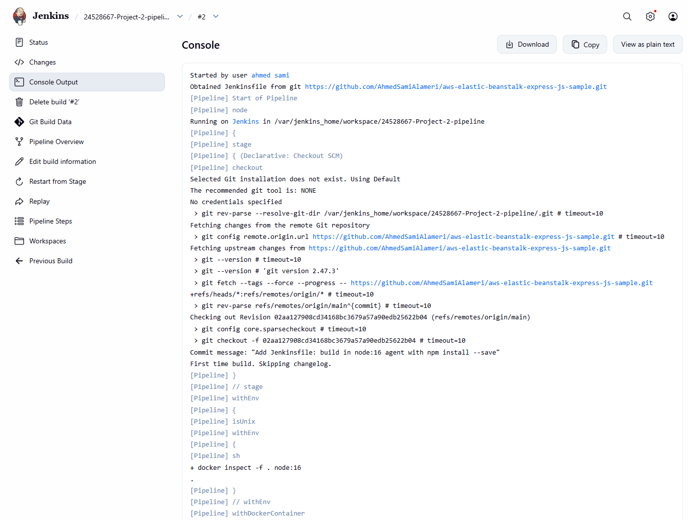
Figure 4 (part 1 of 2). Console output for build #2: the Jenkinsfile is obtained from the fork, commit 02aa127 is checked out, and the node:16 image is found on the Docker-in-Docker daemon.
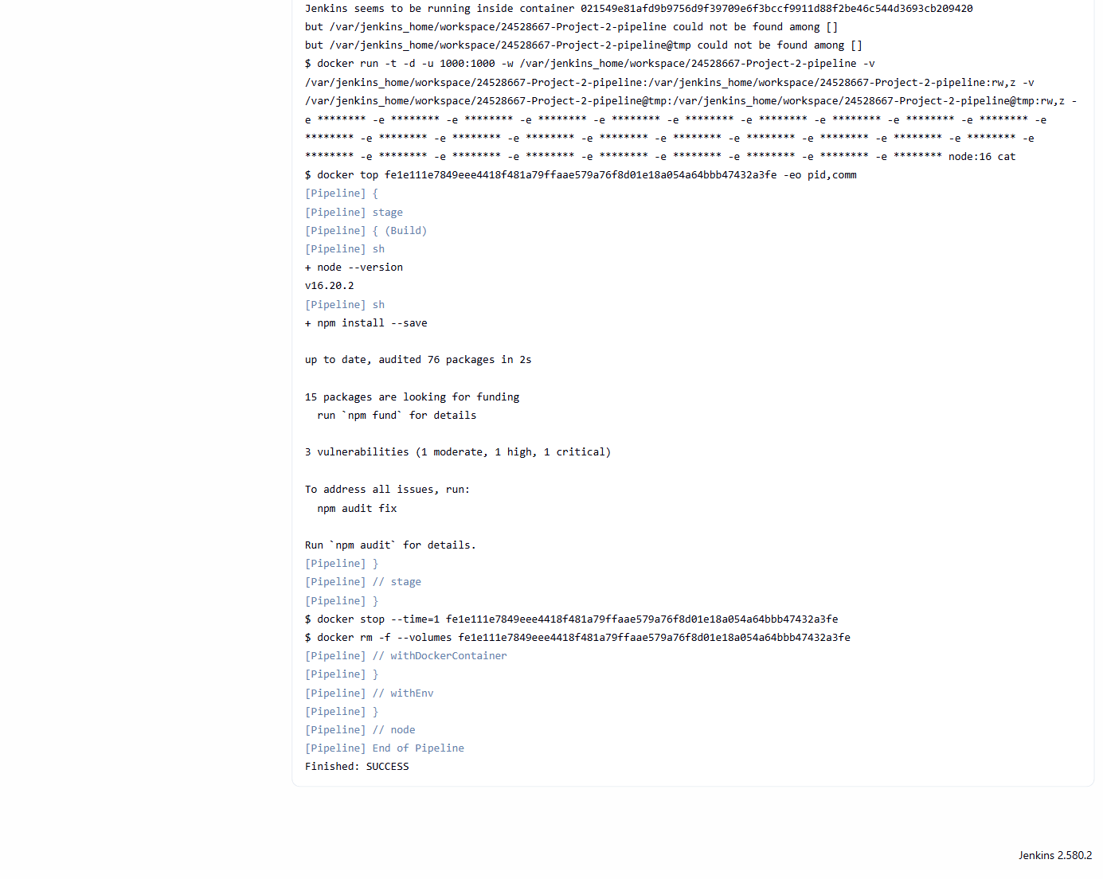
Figure 4 (part 2 of 2). Console output (continued): the build runs inside a node:16 container (docker run … node:16), runs node --version and npm install --save, and ends with “Finished: SUCCESS”.
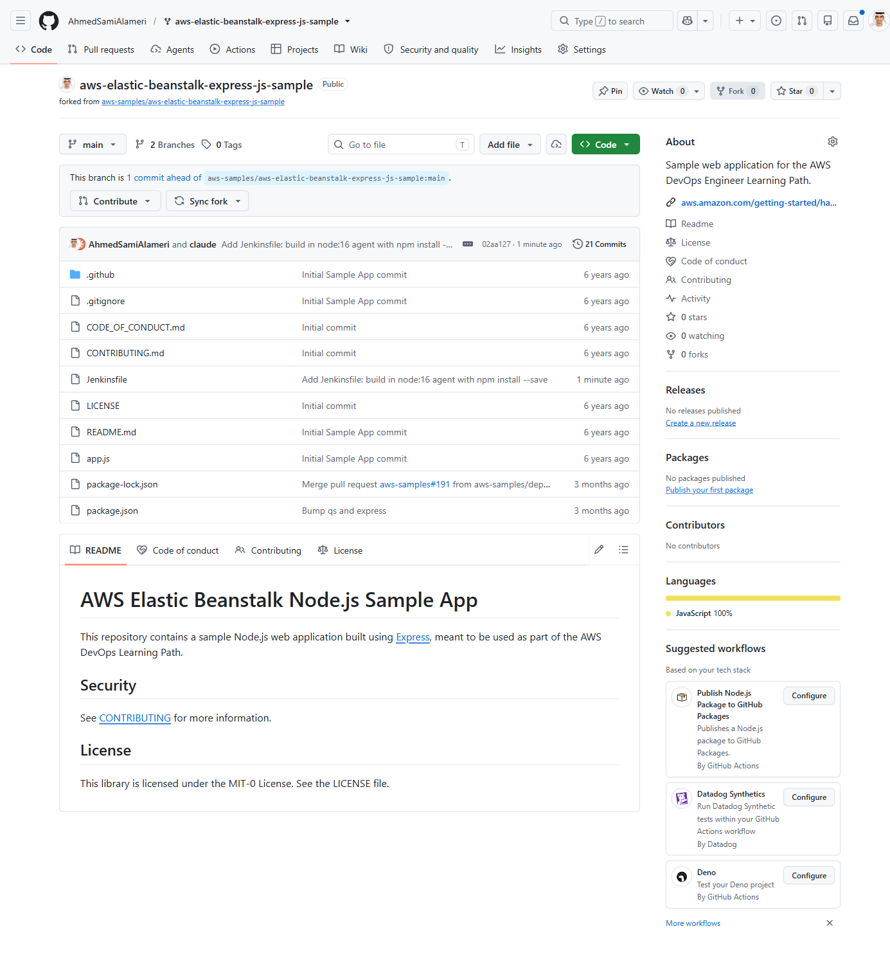
Figure 5. The forked repository on GitHub (forked from aws-samples) with the Jenkinsfile in the repository root on the main branch.
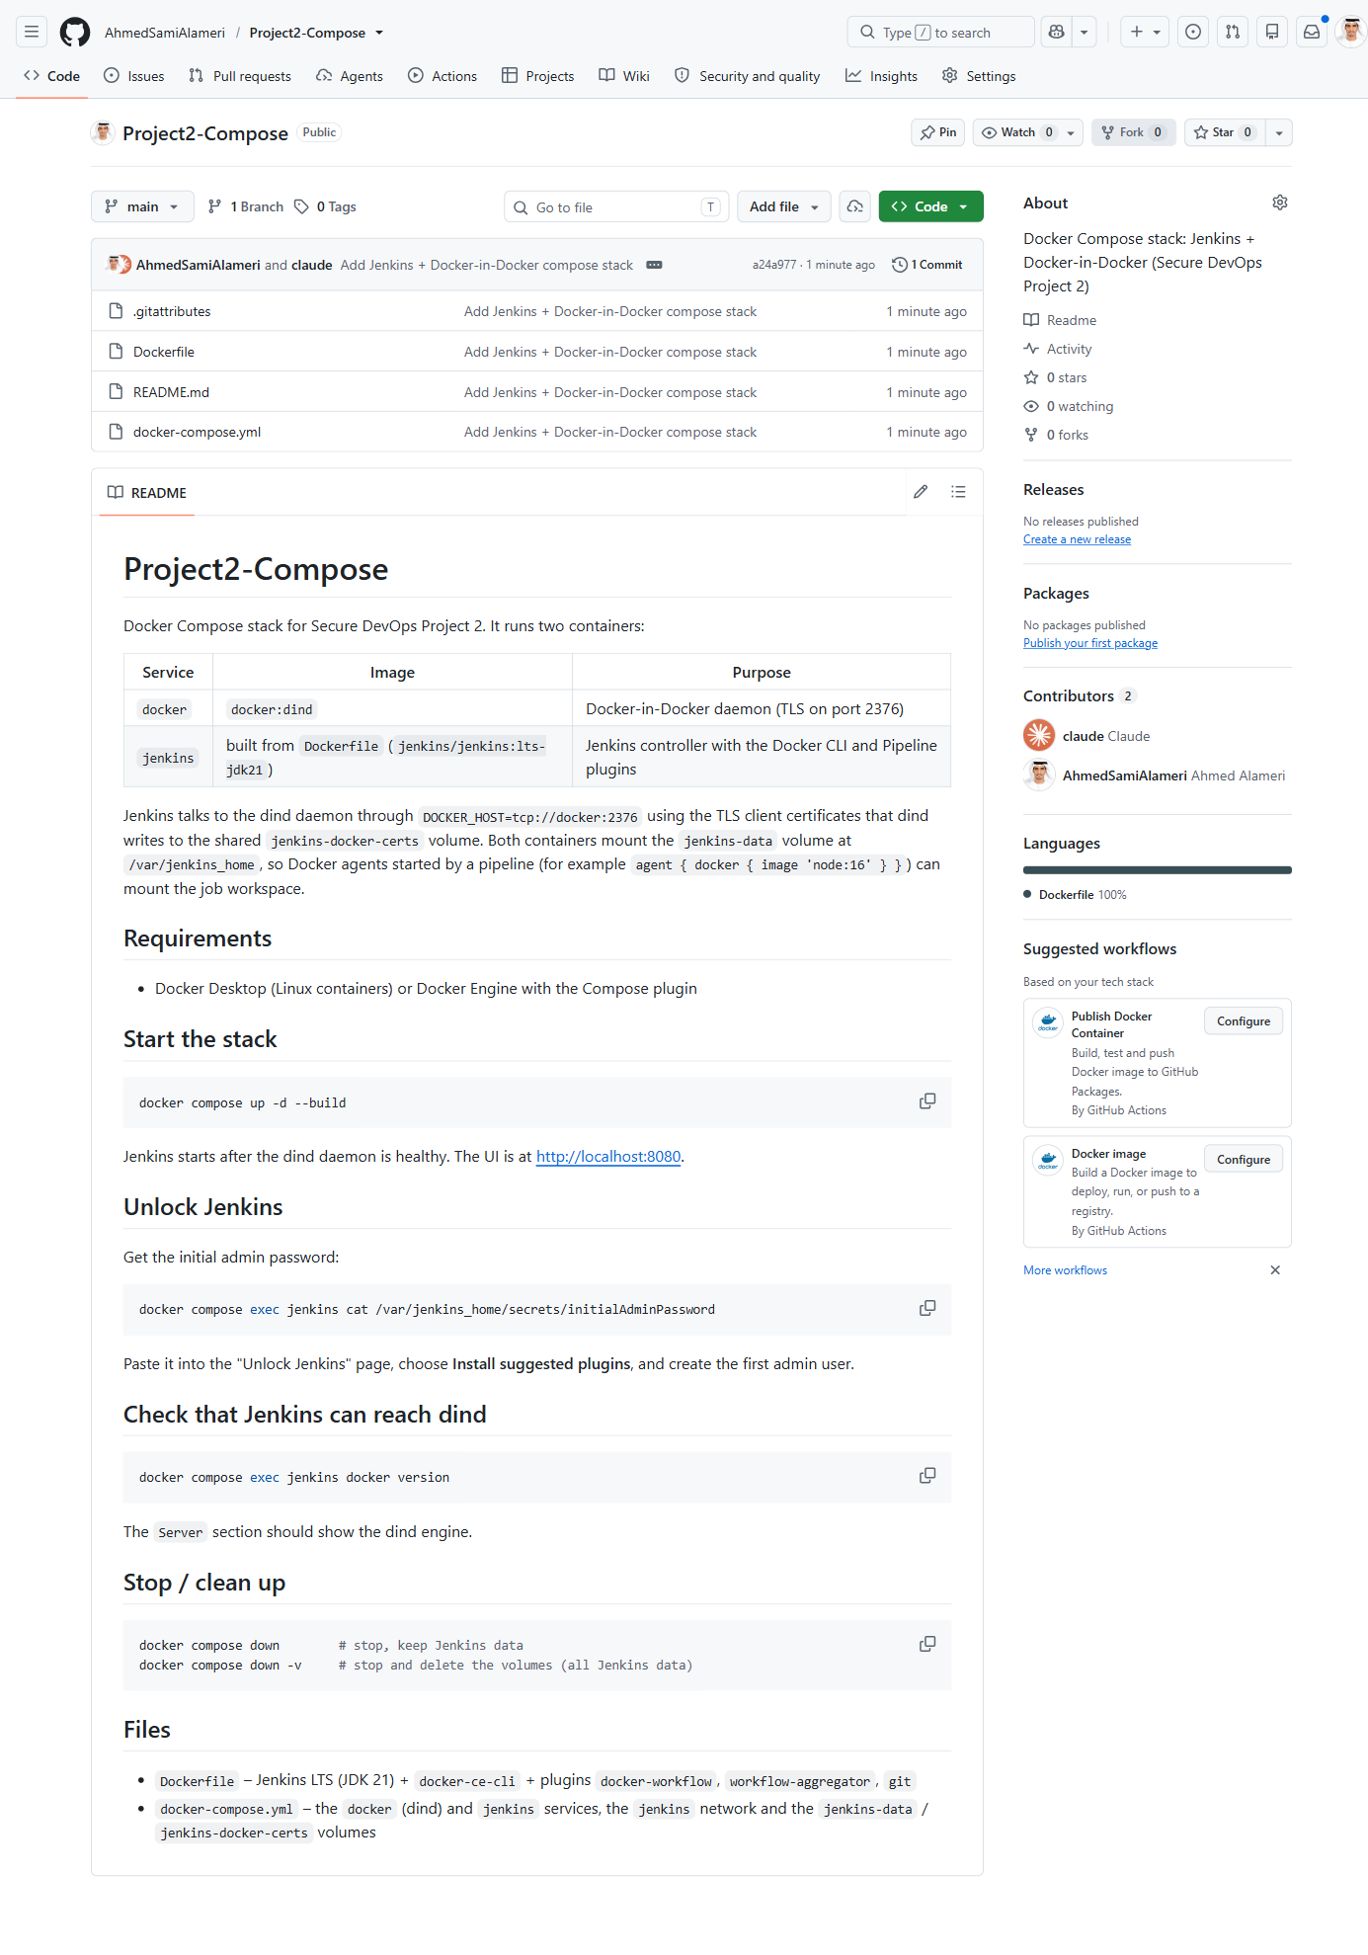
Figure 6. The Project2-Compose repository on GitHub with docker-compose.yml, Dockerfile and README.md on the main branch.

