**Ahmed Samir**

**8120**

**Introduction**

The task was to create a program that sends emails using the SMTP protocol and receives emails using the IMAP protocol. The application was implemented using three scripts: SendEmail.py for sending emails, receive_email.py for receiving emails, and App.py for the GUI.

Initially, **mail.tm** was intended as the testing server, but due to persistent DNS resolution issues, **Gmail** was used instead. This report details the code, usage instructions, dependencies, testing process, and results, fulfilling all assignment requirements.

**Code Description**

The application is split into three Python scripts, each with a specific role, ensuring modularity and readability. Below is a detailed breakdown:

**SendEmail.py**

* **Purpose**: Handles email sending via the SMTP protocol.
* **Implementation**:
  + Uses smtplib to establish a TCP connection to smtp.gmail.com on port 587 with TLS encryption.
  + Constructs emails using email.mime.multipart.MIMEMultipart for headers (From, To, Subject) and MIMEText for the body.
  + Parameters: sender_email, sender_password, recipient_email, subject, body, output_text.
  + Steps: Resolves the SMTP server hostname, connects, enables TLS, logs in, sends the email, and closes the connection.
* **Error Handling**:
  + Catches socket.gaierror for DNS issues, smtplib.SMTPAuthenticationError for login failures, and general exceptions.
  + Outputs status or errors to the output_text widget (GUI) or console (standalone).

**ReceiveEmail.py**

* **Purpose**: Retrieves the latest email from the inbox using IMAP.
* **Implementation**:
  + Uses imaplib.IMAP4_SSL to connect to imap.gmail.com on port 993 with SSL.
  + Parses emails with email.message_from_bytes and decode_header for subject decoding.
  + Parameters: email_user, email_pass, output_text.
  + Steps: Connects securely, logs in, selects the inbox, searches for all emails, fetches the latest one (highest ID), and extracts subject, sender, and body.
* **Error Handling**:
  + Handles connection failures, login errors, and fetch issues with descriptive messages.
  + Checks for empty inboxes and reports “No emails found.”
* **Comments**: Explains key actions, e.g., “Fetch the latest email by ID.”

**App.py**

* **Purpose**: Provides a user-friendly GUI integrating sending and receiving functionalities.
* **Implementation**:
  + Built with tkinter, featuring three windows:
    1. **Choice Window**: Asks “Send” or “Receive” (300x150, non-resizable).
    2. **Send Window**: Full interface (600x700) with fields for sender email, app password, recipient, subject, and body, plus a “Send Email” button.
    3. **Receive Window**: Minimal interface (400x500) with email and password fields, plus a “Receive Latest Email” button.
  + Imports send_email and receive_email from their scripts.
  + Uses scrolledtext for real-time output and messagebox for input validation errors.
* **Design**:
  + Light gray background (#f0f0f0), Helvetica fonts for labels/buttons, Courier for output.
  + Bold buttons and padded layout for a professional look.
* **Comments**: Describes GUI structure and event handling.

**Deviation from Requirements**

* The lab suggested mail.tm for testing, but DNS resolution failures **([Errno 11001] getaddrinfo failed)** with smtp.mail.tm and smtp.temp-mail.io which made me switch to Gmail.

**How to Use the Application**

**Installation**

1. **Scripts**: Download SendEmail.py, ReceiveEmail.py, and App.py into a single directory
2. **Gmail Setup**:
   * Create a Gmail account or use an existing one (e.g., your_email@gmail.com).
   * Enable 2-Step Verification in Google Account settings.
   * Generate an App Password at [myaccount.google.com/apppasswords](https://myaccount.google.com/apppasswords) (16-character code, e.g., xxxx xxxx xxxx xxxx).

**Running the Application**

1. **Launch GUI**: Run python App.py.
2. **Using the GUI**:
   * **Choice Window**:
     + Click “Send Email” to open the send window.
     + Click “Receive Email” to open the receive window.
   * **Send Window**:
     + Enter sender email (e.g., ahmedsamirelboridy@gmail.com), App Password, recipient email (e.g., samarasamir4234@gmail.com), subject, and body.
     + Click “Send Email” to send; view progress in the output area (e.g., “Email sent successfully”).
   * **Receive Window**:
     + Enter email address and App Password.
     + Click “Receive Latest Email” to fetch the latest email; see subject, sender, and body in the output area.

**Dependencies**

The application relies on standard Python libraries, requiring no external installations:

* **smtplib**: Sends emails via SMTP.
* **imaplib**: Receives emails via IMAP.
* **email**: Constructs and parses email messages.
* **socket**: Handles DNS resolution for error checking.
* **tkinter**: Provides GUI functionality (includes ttk, scrolledtext, messagebox).
* **External Service**: Gmail account with an App Password for authentication. No additional pip packages are needed, ensuring easy setup.

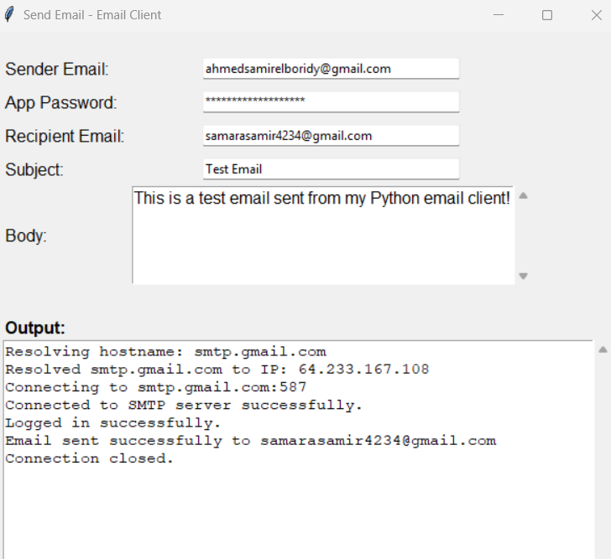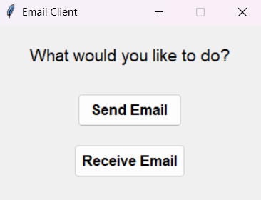**Some testing outputs results :**  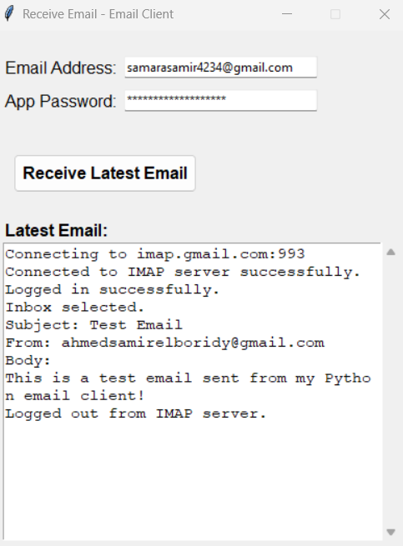

**Conclusion**

The email client fulfills all core requirements, sending and receiving emails with SMTP and IMAP, robust error handling, and clean code structure.