Git & GitHub Commands

**Steps to start making a new project until push it in the remote repository.**

|  |  |
| --- | --- |
| Command | Description |
| git init | command is used to initialize a new Git repository in a specific directory (don’t forget that you have to execute this command in the project directory). After running this command your code in android studio will change the color from black to red. And red color means that this code is not in the staging area and needs to be staged. [Reference link](https://youtu.be/Q6G-J54vgKc?t=4873) |
| git add . | It means **(Stage the changes)** command is used to stage all changes in the current directory and its subdirectories for the next commit. It adds new or modified files to the staging area, preparing them for inclusion in the next commit. |
| git commit -m  "Your message here" | This will permanently save the staged changes with the provided commit message in the Git repository. |
|  | |
|  | |
|  | |
| git remote add origin <URL of repo for cloning> | The git remote add command is used to add a remote repository reference to your local Git repository. This is commonly done when you want to connect your local repository to a remote repository, such as one hosted on a service like GitHub, GitLab, or Bitbucket. |
| git remote -v | Hna law 7abeb ttmn enta 3amel connection m3a meen dwl2ty w msh m7tag tstkhdem el command da law 3ayez t-push 3ala tool. **khoud balak enta kda 3andk esm el remote (ORIGIN) w b3d kda yb2a fl remote branches**    **Remote -> Local**  **Branch -> Branch**  **Commit -> Commit**  The **git remote -v** command is used to view the list of remote repositories that your local Git repository is connected to, along with their corresponding URLs. The **-v** flag stands for "verbose" and provides more detailed output.  This output shows the remote repository named "origin" and its corresponding fetch and push URLs. The fetch URL is used when you pull changes from the remote repository, and the push URL is used when you push your local changes to the remote repository.  If you have added multiple remotes, you'll see a list of all remotes and their URLs. If you haven't added any remotes yet, the output will be empty. |
| I recommend to use this to be familiar in early stage  git push origin  <branch name e.g. master>  If you want to save the data of the remote and branch  git push -u origin  <branch name e.g. master> | The **-u flag** stands for "set upstream," and it establishes a tracking relationship between your local branch and the corresponding branch on the remote repository. Once the upstream relationship is set, you can use **git pull** without specifying the remote and branch name since Git knows which remote to fetch changes from and which branch to merge into your local branch.  After running this command, subsequent pushes and pulls can be done with simpler commands like **git push** and **git pull**. The upstream relationship is set, so Git remembers the remote repository and branch for future interactions. |
| git push  origin [remote name] master [branch name] |  |

**To create or switch to branch.**

|  |  |
| --- | --- |
| Command | Description |
| git branch ahmed [branch name] | Create a new branch |
| git branch -m <old_name> <new_name> | Rename the local branch to the new name |
| git checkout ahmed [branch name] | Switch to a specific branch |
| git push origin [remote name] master [branch name] | Push this branch to the remote |

**To rename remote or change remote URL.**

|  |  |  |
| --- | --- | --- |
| Command | Description | Reference Link |
| git remote rename <old-name> <new-name> | To rename git remote | [reference link](https://stackoverflow.com/questions/33840617/how-do-i-rename-a-git-remote) |
| git remote set-url origin https://gitlab.com/KodeKloud/repository-1.git | to Change Remote Origin in Git | [reference link](https://kodekloud.com/blog/change-remote-origin-in-git/#:~:text=To%20change%20the%20remote%20origin%20URL%2C%20use%20the%20git%20remote,URL%20or%20an%20SSH%20URL.) |

**To change Config -> username, user email**

|  |  |
| --- | --- |
| Command | Description |
| git status | Check status |
| git add [file-name.txt] | To display username |
| git config --global user.name "Ahmed Samir." | To set or change email |
| git config user.email | To display email |
| git config --list | To display all data in the config we have set before |
| Here is the video related to change or set username or email -> [Reference Link](https://youtu.be/Q6G-J54vgKc?t=4553), [Reference link](https://www.youtube.com/watch?v=ky7mtqncd9A&list=PLt1JGE7mvd_-u2qoczj0d7B-AWVsaCu8m&index=3)  How khoud balak da file fe kol m3lomat ely 3amal el code da w fe aktr mn kda bas da ely mashhor | |

**To change Config -> username, user email**

|  |  |
| --- | --- |
| Command | Description |
| git config --global user.name "Ahmed Samir." | To set or change username |
| git config user.email | To display username |
| git config --global user.name "Ahmed Samir." | To set or change email |
| git config user.email | To display email |
| git config --list | To display all data in the config we have set before |

**Tags.**

|  |  |
| --- | --- |
| Command | Description |
| git tag-a V2.0.0 -m "Your message Here" | Tag your commits |
| git show v2.0.0 | show all commits related to this tag |
| git push origin v2.0.0 | Push tag to the remote repo |

**Logs.**

|  |  |
| --- | --- |
| Command | Description |
| Git log --all --graph |  |
| git log --all --oneline |  |

**Undo things**

|  |  |
| --- | --- |
| Command | Description |
| git reset --hard HEAD~1 | undo one commit |

**Installer for git.**

|  |
| --- |
| Programs |
| https://www.sourcetreeapp.com/ |
| https://tortoisegit.org/docs/tortoisegit/tgit-intro-install.html |

**Git flow commands**

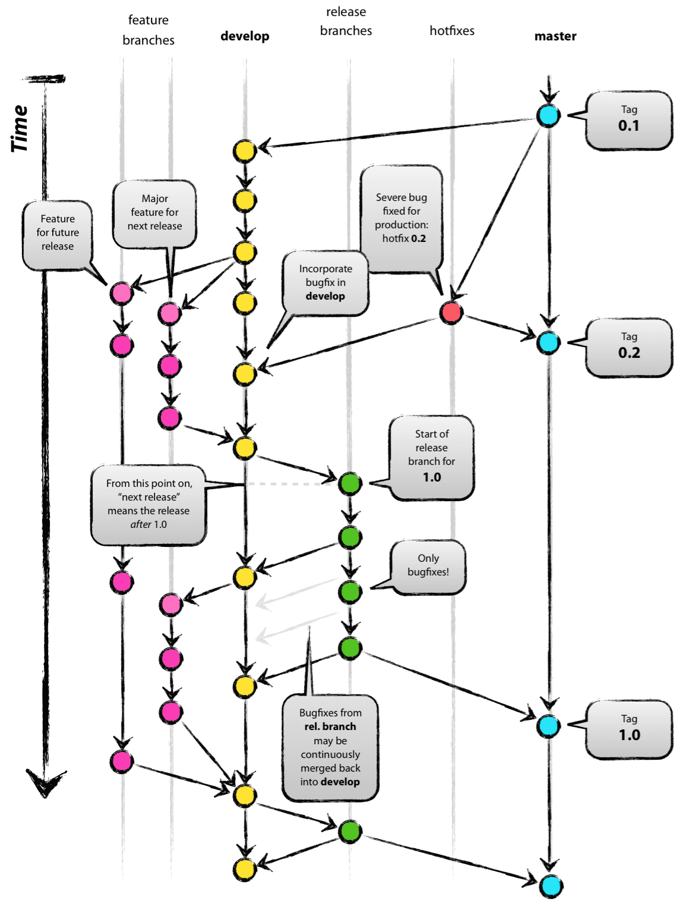

**All Commands**

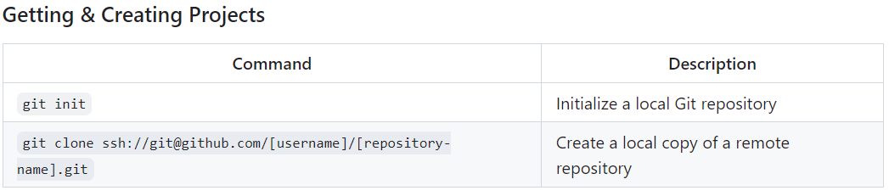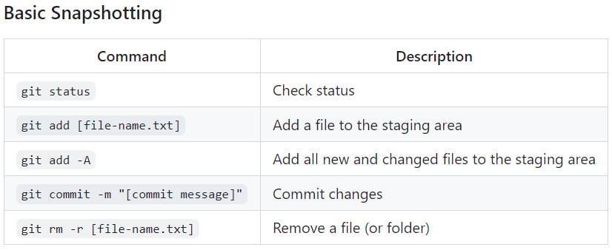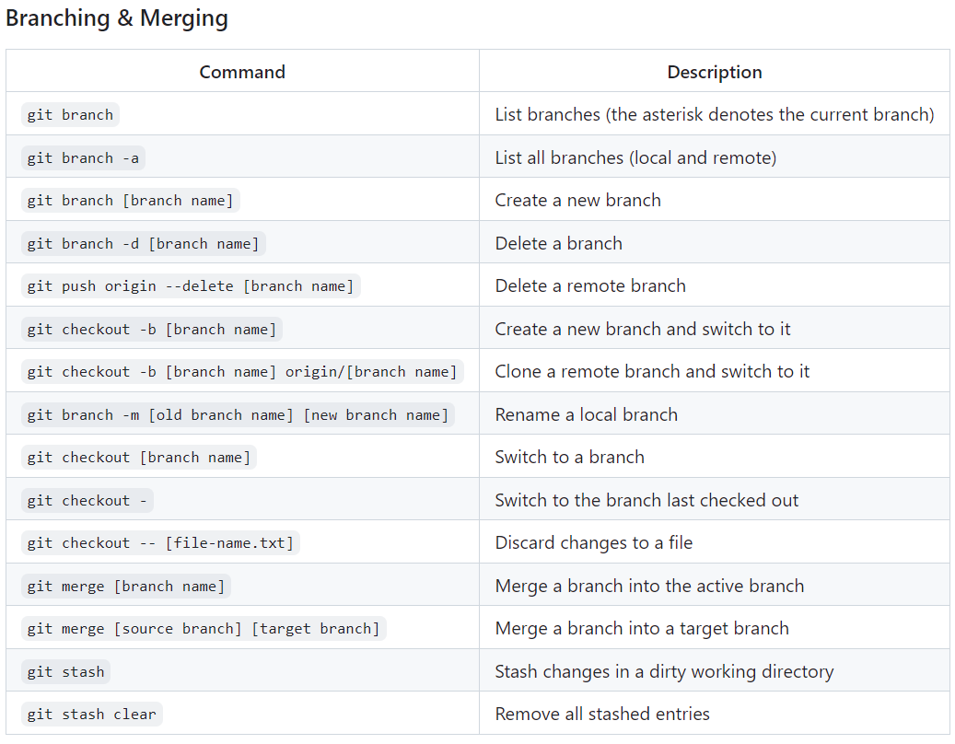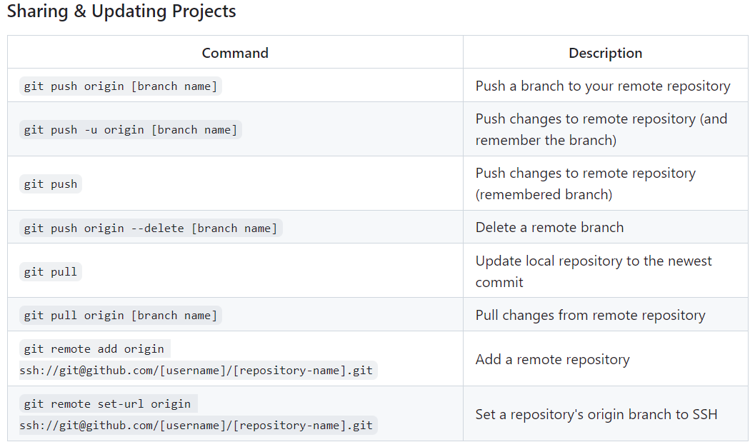

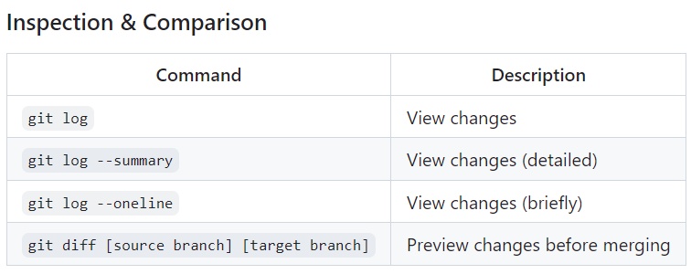

References

|  |  |  |
| --- | --- | --- |
| [A person standing in front of a blue background  Description automatically generated](https://www.youtube.com/watch?v=Q1kHG842HoI) | | [A screenshot of a computer  Description automatically generated](https://www.youtube.com/watch?v=Lj_jAFwofLs) |
| [A screen shot of a video game  Description automatically generated](https://www.youtube.com/watch?v=w3jiY-UKW6I) | | [A screenshot of a video  Description automatically generated](https://www.youtube.com/watch?v=Q6G-J54vgKc) |
| [A person sitting in a chair with a video player  Description automatically generated](https://www.youtube.com/watch?v=gW6dFpTMk8s) | | [A screenshot of a video  Description automatically generated](https://www.youtube.com/watch?v=ACOiGZoqC8w&list=PLDoPjvoNmBAw4eOj58MZPakHjaO3frVMF) |
| [A person pointing to a screen  Description automatically generated](https://www.youtube.com/watch?v=fDkR0TDR9dI&t=3014s) | | [A screenshot of a video  Description automatically generated](https://www.youtube.com/watch?v=Z6C35WqawGs&list=PLYyqC4bNbCIeCHLTRtwdLpQvle_zIavZ-) |
| [A screenshot of a video  Description automatically generated](https://www.youtube.com/watch?v=TUXmJXw1OJg&list=PLtxOBbrOOPH4zeJLOdRNrP4pGft2IfMgo&index=1) | |  |
|  |  | |