**Representation and important applications**

**of graph theory**

**Third Year- Computer Science**

**Spring Semester**

**Submitted to:**

Dr. Mostafa Reda El-Tantawi

**Team members:**

|  |  |
| --- | --- |
| **Name** | **ID** |
| Ahmed Sayed Mansour | 20170022 |
| Ashraf Samir Ali | 20170053 |
| Abdelraman Bahig | 20170143 |
| Atef Magdy | 20170136 |
| Hatem Sayed | 20170084 |
| Ahmed Sayed Ebrahim | 20170021 |
| Mohamed Mostafa | 20170257 |

* **Minimum Spanning Tree problem:-**

Abstraction:

Minimum Spanning tree: Given a connected and undirected graph, a spanning tree of that graph is a subgraph that is a tree and connects all the vertices together. A single graph can have many different spanning trees. A minimum spanning tree (MST) or minimum weight spanning tree for a weighted, connected and undirected graph is a spanning tree with weight less than or equal to the weight of every other spanning tree. The weight of a spanning tree is the sum of weights given to each edge of the spanning tree

Analysis:

we compared between The two algorithms which are used in minimum spanning tree and find that Both **Prim’s and Kruskal’s algorithm** finds the Minimum Spanning Tree and follow the Greedy approach of problem-solving, but there are few **major differences between them**.

|  |  |
| --- | --- |
| PRIM’S ALGORITHM | KRUSKAL’S ALGORITHM |
| It starts to build the Minimum Spanning Tree from any vertex in the graph. | It starts to build the Minimum Spanning Tree from the vertex carrying minimum weight in the graph. |
| It traverses one node more than one time to get the minimum distance. | It traverses one node only once. |
| Prim’s algorithm has a time complexity of O(V^2), V being the number of vertices. | Kruskal’s algorithm’s time complexity is O(logV), V being the number of vertices. |

So, we chose Kruskal Algorithm Based on his Time Complexity

Using Kruskal Algorithm:

Kruskal Implementation Pseudocode

KRUSKAL(G):

A = ∅

For each vertex v ∈ G.V:

MAKE-SET(v)

For each edge (u, v) ∈ G.E ordered by increasing order by weight (u, v):

if FIND-SET(u) ≠ FIND-SET(v):

A = A ∪ {(u, v)}

UNION (u, v)

return A

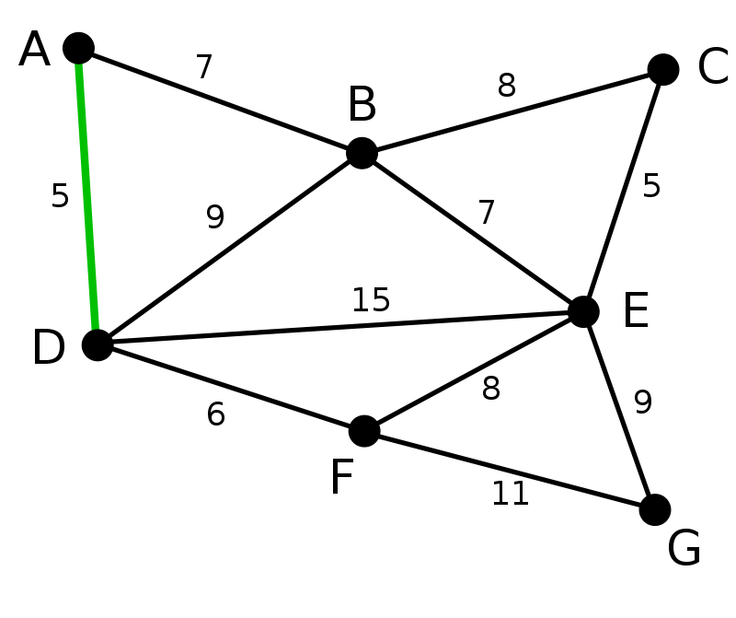

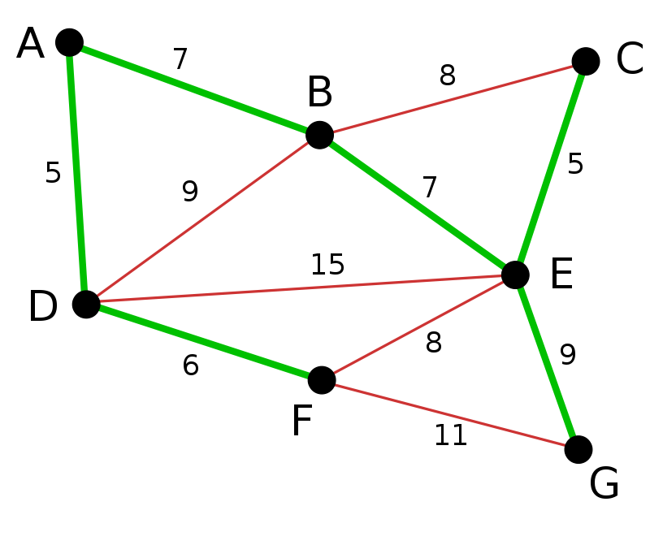

The Program (Run)

Input:

At the first should enter the number of Vertices and number of Edges you want (e.g. 4, 5)

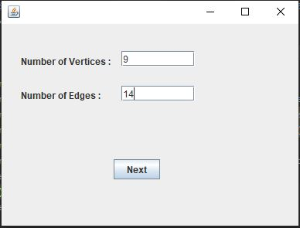

Then Name your Vertices (e.g. 0, 1, 2, 3)

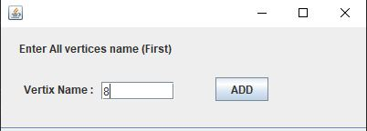

After that you can enter the source edge, destination edge and Weight (e.g. from 0 to 1, weight is 10). Do this as many times as the number of the Edges.

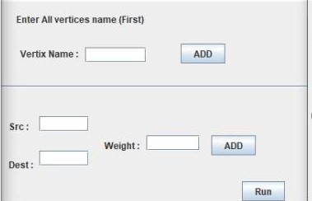

Note:

**Must fill the Vertices names with the number of Vertices you entered. You can’t enter the Edges unless you enter all Vertices name.**

Output:

Two Screens:

|  |  |
| --- | --- |
| Frist Screen  Original Graph | Second Screen  Minimum Spanning Tree |

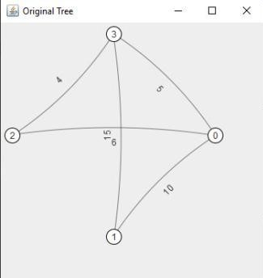

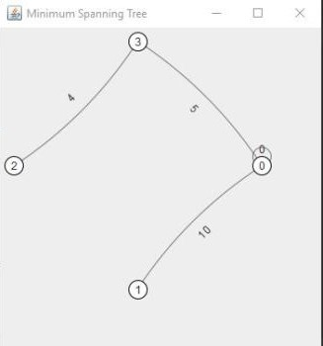

Conclusion:

- Minimum Spanning tree used to reduce cost, time, weight etc. By finding the shortest path between any two nodes.

- Kruskal’s algorithm is an “Edge based algorithm “.

- Kruskal’s algorithm is a good method to find The Minimum Spanning Tree according to its Time Complexity O(logV).

References:

<https://www.ics.uci.edu/~eppstein/161/960206.html>

<https://www.geeksforgeeks.org/kruskals-minimum-spanning-tree-algorithm-greedy-algo-2/>

<https://www.javatpoint.com/kruskals-minimum-spanning-tree-algorithm>

* **Graph Representation :-**

**Abstraction:**

A Graph is a non-linear data structure consisting of nodes and edges. The nodes are sometimes also referred to as vertices and the edges are lines or arcs that connect any two nodes in the graph.

Graphs are used to solve many real-life problems. Graphs are used to represent networks. The networks may include paths in a city or telephone network or circuit network. Graphs are also used in social networks like linkedIn, Facebook. For example, in Facebook, each person is represented with a vertex(or node). Each node is a structure and contains information like person id, name, gender, locale etc.

***How to use the program:***

4

3

2

1

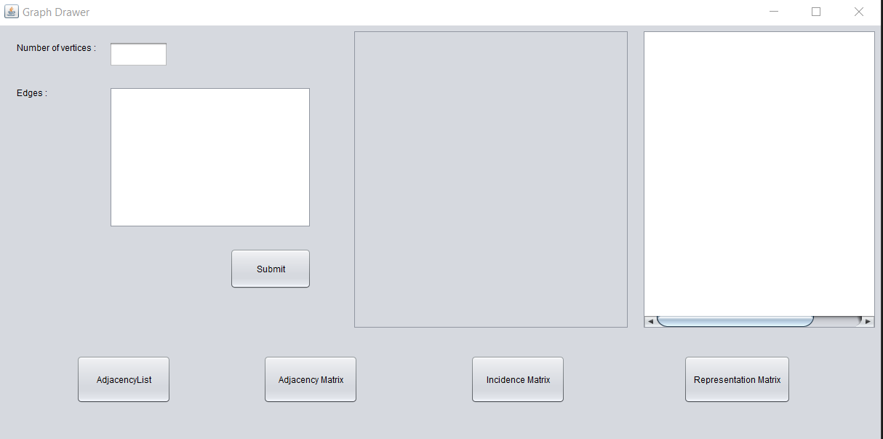

*1. Enter number of vertices*

*2. Enter edges edge by edge*

*Edge input: Vertex ”space” Vertex  
Ex : 1 2*

*2 3*

*3. Click submit*

*4. Output appears.*

***Program in run:***

1

2

4

3

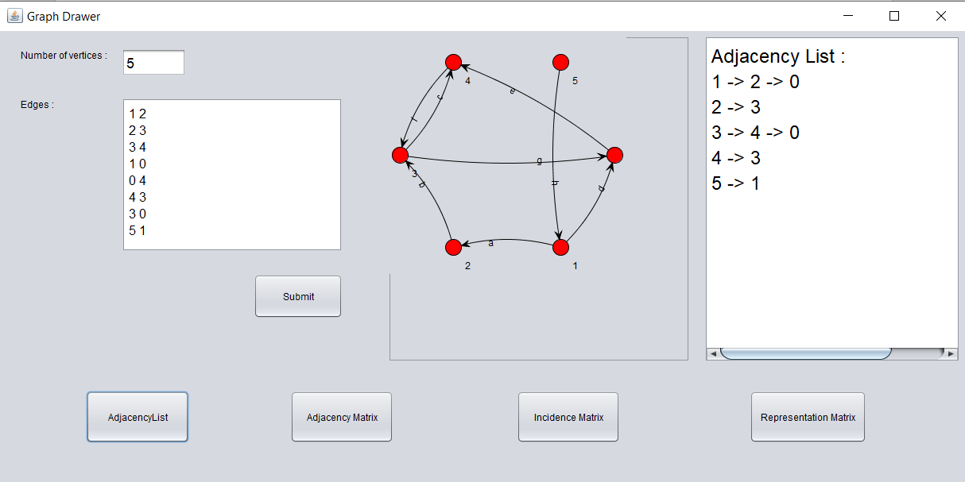

*1 - Adjacency List*

*2 - Adjacency Matrix*

*3 - Incidence Matrix*

*4 - Representation Matrix*

***Pseudo code for my program:***

*Adjacency List:*

Procedure Adjacency-List(maxN, E): // maxN denotes the maximum number of nodes

edge[maxN] = Vector() // E denotes the number of edges

for i from 1 to E

input -> x, y // Here x, y denotes there is an edge between x, y

edge[x].push(y)

edge[y].push(x)

end for

Return edge

*Adjacency Matrix:*

Procedure AdjacencyMatrix(N): //N represents the number of nodes

Matrix[N][N]

for i from 1 to N

for j from 1 to N

Take input -> Matrix[i][j]

endfor

endfor

*Incidence matrix:*

Begin

ed_cnt := ed_cnt + 1

inc_matrix[u, ed_cnt] := 1

inc_matrix[v, ed_cnt] := 1

End

References:

<https://www.geeksforgeeks.org/graph-data-structure-and-algorithms/>

<https://www.javatpoint.com/graph-and-graph-theory-introduction>

* **Coloring Graph problem:-**

***Introduction:***

**The Color-Graph** program target is to represent the (n) vertices entered by user, then connect them with edges labeled alphabetically, after connection the program will color the vertices with random RBG colors every submit. The main target of the program is to color the adjacent vertices (connected by edge) with **different colors**!

(ex: vertex 5 and vertex 4 are blue and purple, not both blue or both purple).

- The image below shows how the adjacent connected vertices are colored differently.

Image revealing the Edges picked by user and the vertices coloring process

***Analysis:***

In order to achieve the different colors for adjacent nodes, adjacency list is used for the graph, which facilitates determining which nodes are adjacent and which are not connected.

***Implementation and Design:***

**Implementation**: The program is implemented by Java.

Adjacency list was used in class graph, which will help in coloring the nodes as if two nodes are adjacent, they get different colors.

**Design**: The program is designed by java swing library which is a set of program component to give the Graphical User Interface. For example (clicks, buttons and input text).

**Graph Implementation**: For the Graph implementation, JUNG library is used to implement the graph.

JUNG — the Java Universal Network/Graph Framework--is a software library that provides modeling, analysis, and visualization of data that can be represented as a graph or network, which in this case its benefits are drawing the graph network.

***How to use the program:***

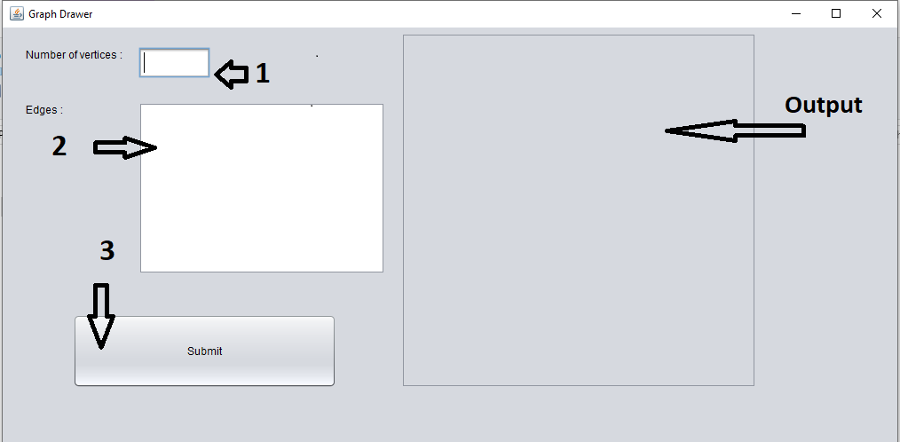

**Input:**

*1. Enter number of vertices (Example : 5)*

*2. Enter edges, edge by edge*

*Edge input: Vertex ”space” Vertex*

Ex : 1 2

2 3

Note:

3 4

4 5

5 1

**If you used a non-existing node while entering the edges,**

**(Example: number of vertices = 5 and edge (1 , 6) )**

**The program will show no result).**

*3. Click submit*

**Output:**

- Number of vertices represented in the window (Example: 1,2,3,4,5)

- Edges connecting all the vertices labeled alphabetically (Example: a,b,c,d,e).

- Vertices are colored randomly, no two vertices connected adjacently have the same color. (Example: node 2 and node 3 are connected by an edge, thus their colors are different: yellow and violet)

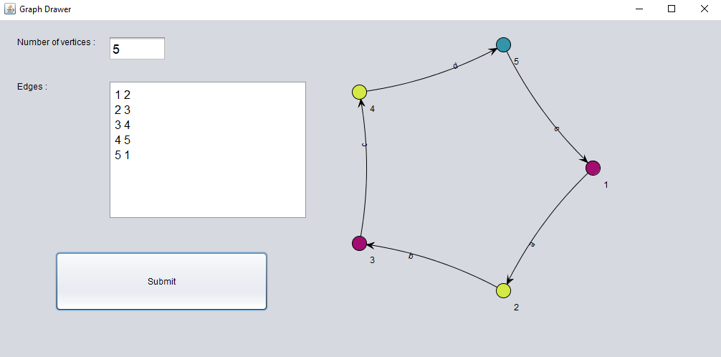*The input and output flows are shown in the picture below:*

This image shows the program draw after submitting the inputs

Pseudo code for the program:

1) Input number of Vertices  
2) Input Edges

3) Color first vertex with first color.

4) Do following for remaining V-1 vertices.

5) Consider the currently picked vertex and color it with the lowest numbered color that has not been used on any previously colored vertices adjacent to it.

6) If all previously used colors appear on vertices adjacent to v,

6.1) assign a new color to it.

7) Output the graph.

Conclusion:

The adjacency list used in the graph class to indicate which node is adjacent to other nodes proved to be efficient and easy for coloring the nodes.

References:

<http://jung.sourceforge.net/doc/index.html>

<https://www.javatpoint.com/java-swing>

<https://www.vainolo.com/2011/02/14/learning-jung-java-universal-networkgraph-framework/>

* **Euler Path problem:-**

***Introduction:***

**The Euler path** In graph theory, an  **Eulerian path** is a trail in a finite graph that visits every edge exactly once (allowing for revisiting vertices). Similarly, an **Eulerian circuit** or **Eulerian cycle** is an Eulerian trail that starts and ends on the same vertex. They were first discussed by [Leonhard Euler](https://en.wikipedia.org/wiki/Leonhard_Euler) while solving the famous [Seven Bridges of Königsberg](https://en.wikipedia.org/wiki/Seven_Bridges_of_K%C3%B6nigsberg) problem in 1736. The problem can be stated mathematically like this:

***Analysis:***

In order to achieve the Euler path for adjacent nodes, adjacency list is used for the graph, which facilitates determining which nodes are adjacent and which are not connected.

***Implementation and Design:***

**Implementation**: The program is implemented by Java.

Adjacency list was used in class graph, which will help in detecting the euler path.

**Design** : The program is designed by java swing library which is a set of program component to give the Graphical User Interface. For example (clicks, buttons and input text).

**Graph Implementation**: For the Graph implementation, JUNG library is used to implement the graph.

JUNG — the Java Universal Network/Graph Framework--is a software library that provides modeling, analysis, and visualization of data that can be represented as a graph or network, which in this case its benefits are drawing the graph network.

*How to use the program:  
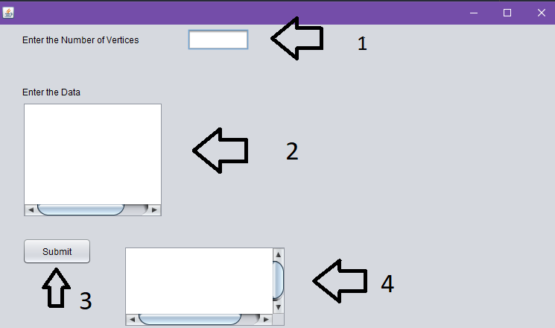*

*1. Enter number of vertices*

*2. Enter edges edge by edge (Representation Matrix)*

*Ex : vertices number = 2*

*1 0*

*0 1*

*3. Click submit*

*4. Euler Path.*

*Program in run:*

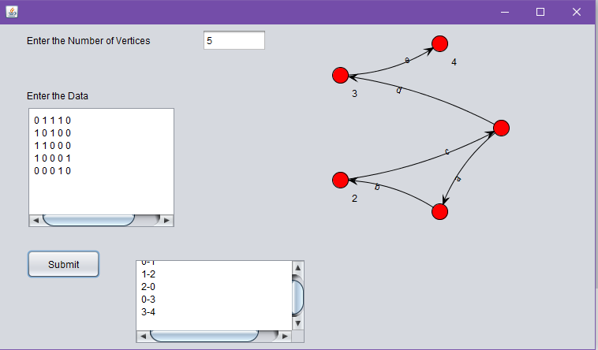

***Pseudo code for my program:***

*->Detect Euler path,Circuit*

Begin

   if isConnected() is false, then

      return false

   define list of degree for each node

   oddDegree := 0

   for all vertex i in the graph, do

      for all vertex j which are connected with i, do

         increase degree

      done

      if degree of vertex i is odd, then

         increase dooDegree

   done

   if oddDegree > 2, then

      return 0

   if oddDegree = 0, then

      return 2

   else

      return 1

End

Conclusion:

The adjacency list used in the graph class to indicate which node is adjacent to other nodes proved to be efficient and easy Euler path detection.

References:

<http://jung.sourceforge.net/doc/index.html>

<https://www.javatpoint.com/java-swing>

<https://www.vainolo.com/2011/02/14/learning-jung-java-universal-networkgraph-framework/>