**Graph coloring problem**

*How to use the program:  
*

*1. Enter number of vertices*

*2. Enter edges edge by edge*

*Edge input: Vertex ”space” Vertex  
Ex : 1 2*

*2 3*

*3. Click submit*

*4. Output appears.*

*Program in run:   
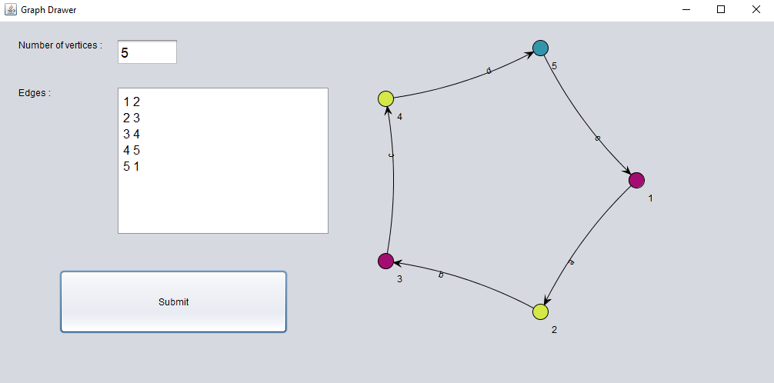*

*Pseudo code for my program:*

1) Input number of Vertices  
2) Input Edges

3) Color first vertex with first color.

4) Do following for remaining V-1 vertices.

5) Consider the currently picked vertex and color it with the lowest numbered color that has not been used on any previously colored vertices adjacent to it.

6) If all previously used colors appear on vertices adjacent to v,

6.1) assign a new color to it.

7) Output the graph.