**Euler Path**

*How to use the program:*

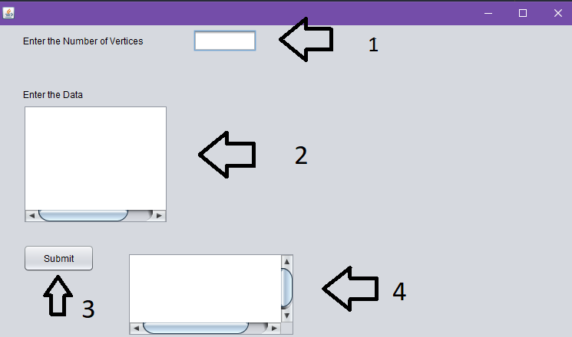

*1. Enter number of vertices*

*2. Enter edges edge by edge (Representation Matrix)*

*Ex : vertices number = 2*

*1 0*

*0 1*

*3. Click submit*

*4. Euler Path.*

*Program in run:*

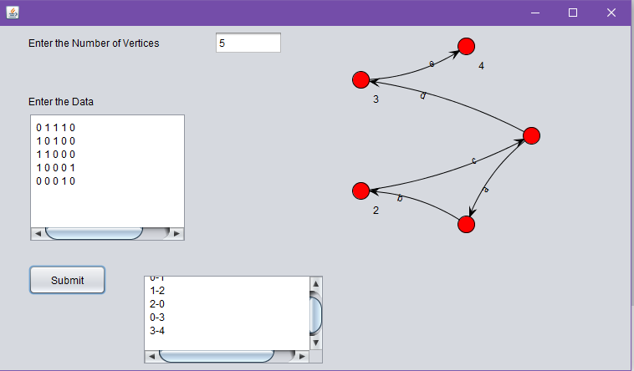

*Pseudo code for my program:*

*->Detect Euler path,Circuit*Begin

   if isConnected() is false, then

      return false

   define list of degree for each node

   oddDegree := 0

   for all vertex i in the graph, do

      for all vertex j which are connected with i, do

         increase degree

      done

      if degree of vertex i is odd, then

         increase dooDegree

   done

   if oddDegree > 2, then

      return 0

   if oddDegree = 0, then

      return 2

   else

      return 1

End