**Graph Representation problem**

*How to use the program:  
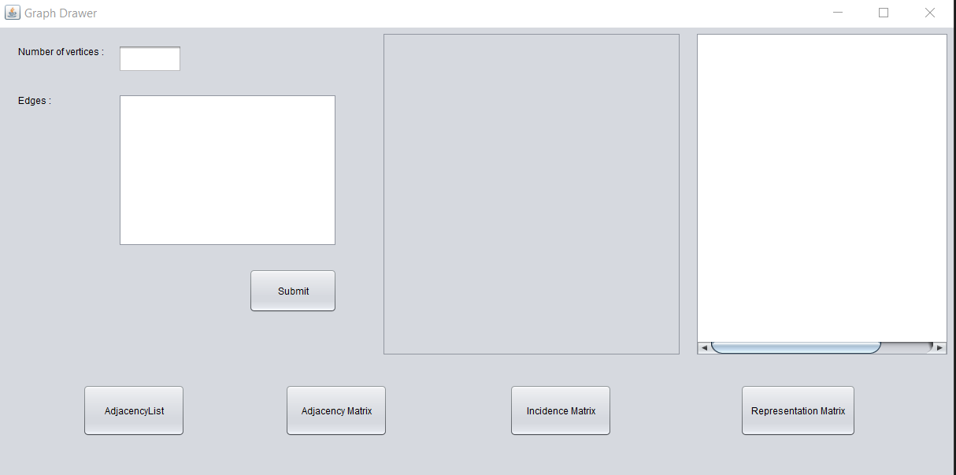*

4

3

2

1

*1. Enter number of vertices*

*2. Enter edges edge by edge*

*Edge input: Vertex ”space” Vertex  
Ex : 1 2*

*2 3*

*3. Click submit*

*4. Output appears.*

*Program in run:   
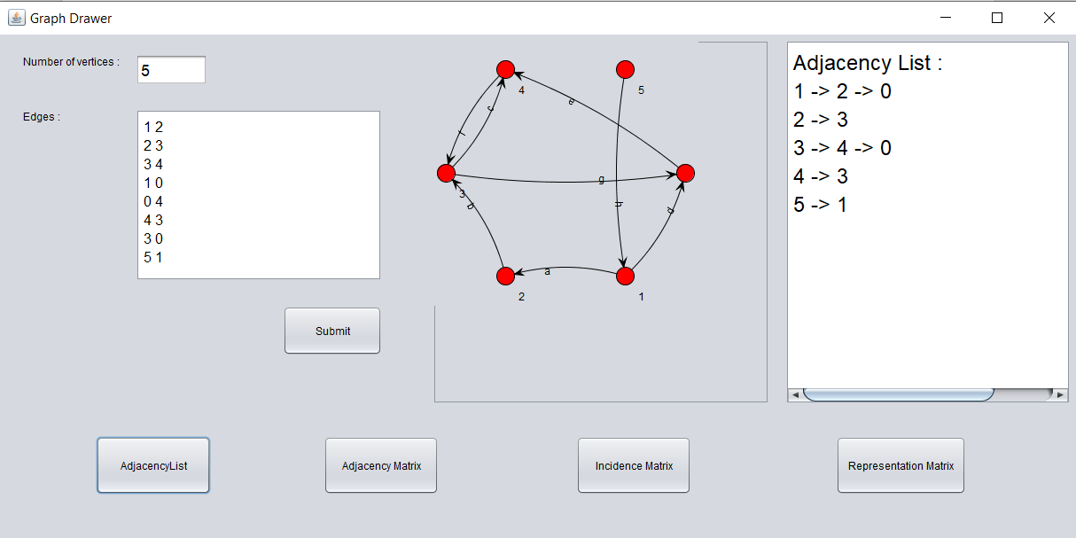*

1

2

4

3

*1 - Adjacency List*

*2 - Adjacency Matrix*

*3 - Incidence Matrix*

*4 - Representation Matrix*

*Pseudo code for my program:*

1) Input number of Vertices  
2) Input Edges

*Adjacency List:*

Procedure Adjacency-List(maxN, E): // maxN denotes the maximum number of nodes

edge[maxN] = Vector() // E denotes the number of edges

for i from 1 to E

input -> x, y // Here x, y denotes there is an edge between x, y

edge[x].push(y)

edge[y].push(x)

end for

Return edge

*Adjacency Matrix:*

Procedure AdjacencyMatrix(N): //N represents the number of nodes

Matrix[N][N]

for i from 1 to N

for j from 1 to N

Take input -> Matrix[i][j]

endfor

endfor

*Incidence matrix:*

Begin

ed_cnt := ed_cnt + 1

inc_matrix[u, ed_cnt] := 1

inc_matrix[v, ed_cnt] := 1

End