Input Example

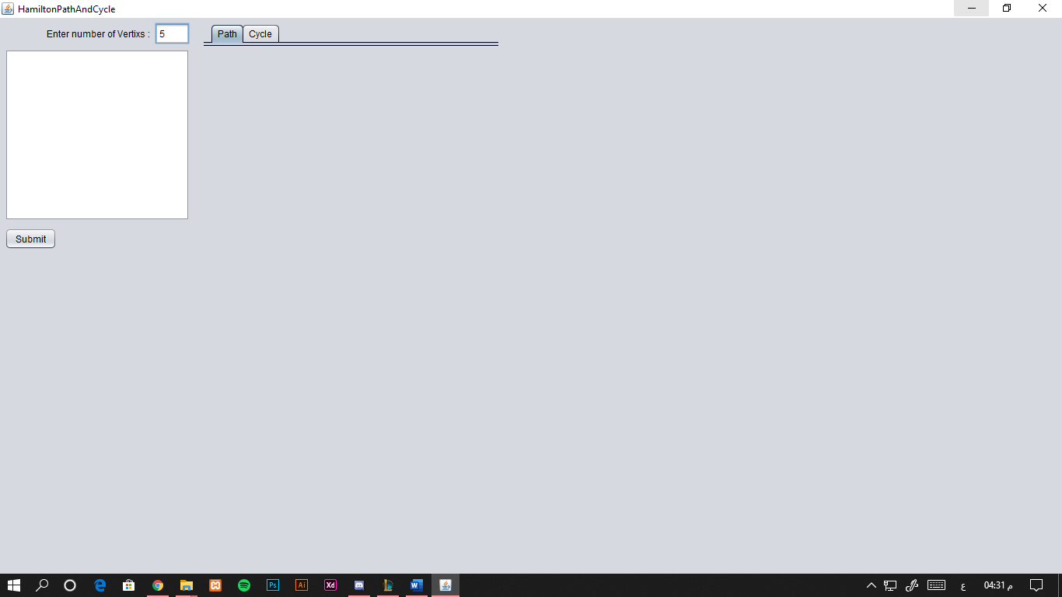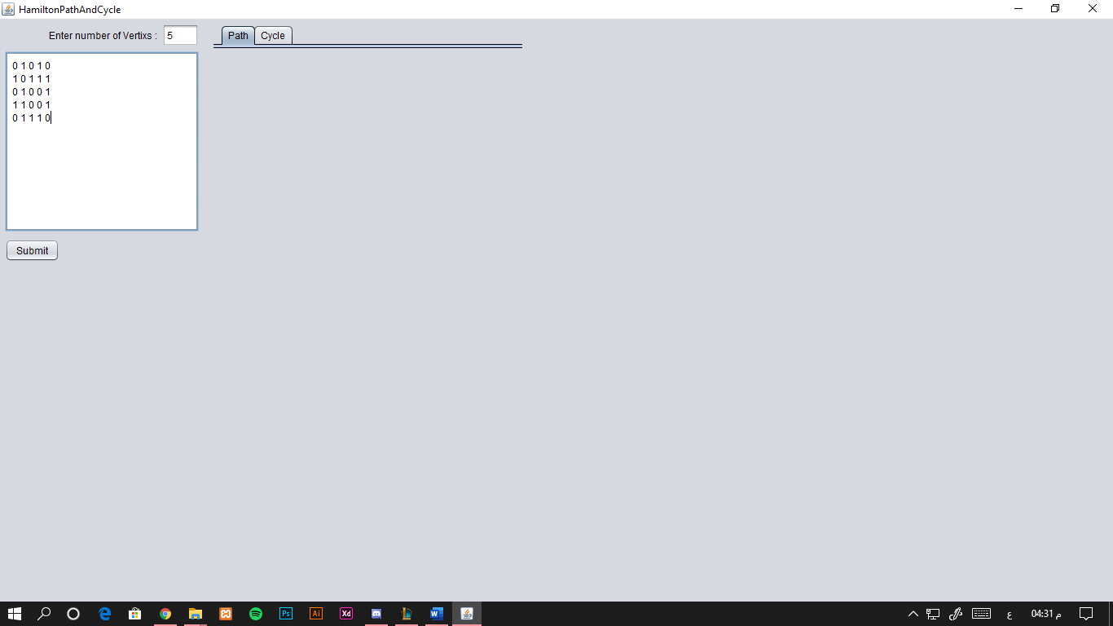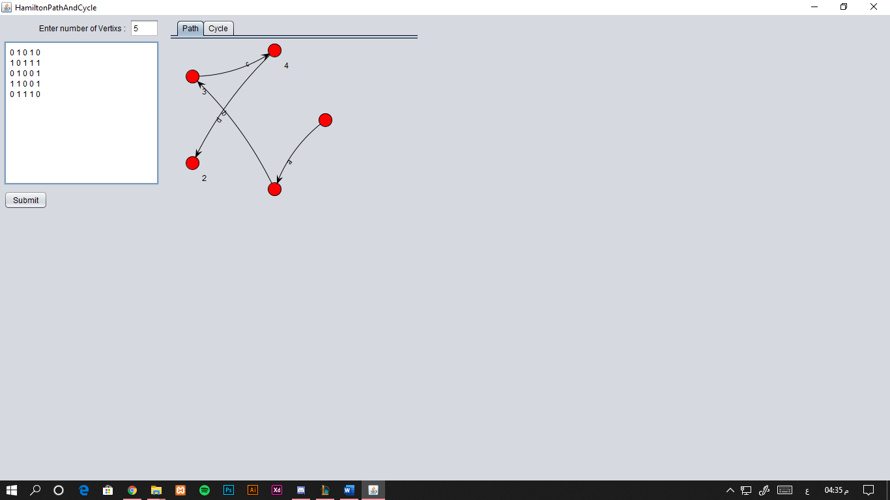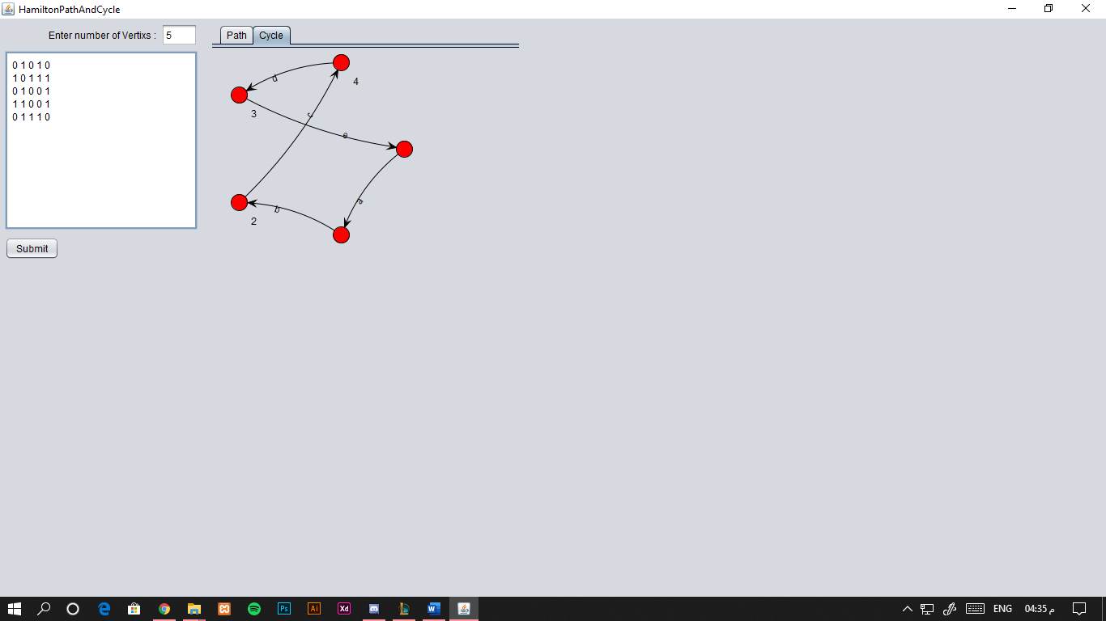

Backtracking Algorithm

Create an empty path array and add vertex 0 to it. Add other vertices, starting from the vertex 1. Before adding a vertex, check for whether it is adjacent to the previously added vertex and not already added. If we find such a vertex, we add the vertex as part of the solution. If we do not find a vertex then we return false.