Hamilton Circuit Documentation

This is the main screen of my program where the user has the ability to freely enter the adjacency matrix of the roads linking the cities with each other, taking in consideration entering the number of Vetricies aka towns

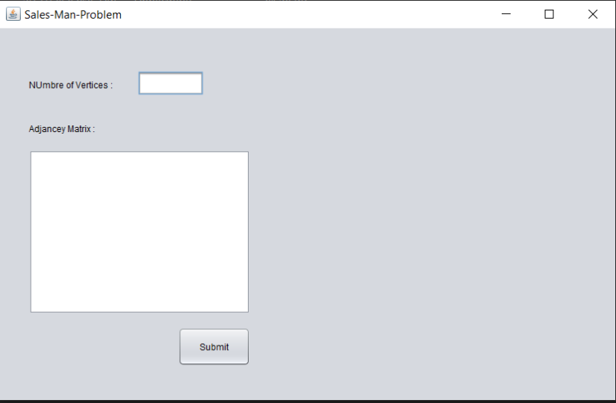

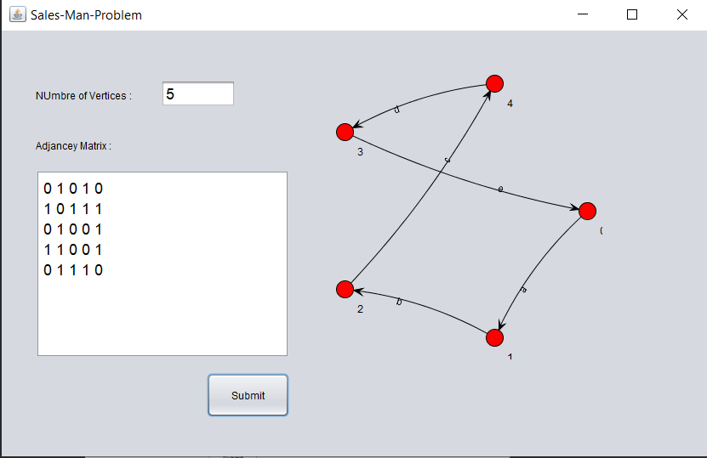When the user enter the towns and the edges details, the user should then press submit to produce the input regarding to his problem the output should follows

This program was mainly written in java but here is the pseudo code you can implement : -

1. Consider city 1 as the starting and ending point. Since route is cyclic, we can consider any point as starting point.
2. Generate all (n-1)! permutations of cities.
3. Calculate cost of every permutation and keep track of minimum cost permutation.
4. Return the permutation with minimum cost.