**Faculty of Computers and Artificial Intelligence**



**Minimum Spanning Tree**

2020

27th March

**Minimum Spanning Tree**

**Using Kruskal Algorithm:**

**Input:** At the first should enter the number of Vertices and number of Edges you want (e.g. 4 , 5 )

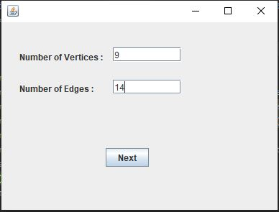

Then Name your Vertices (e.g. 0 , 1 , 2 , 3 )



After that you can enter the source edge , destination edge and Weight (e.g. from 0 to 1 , weight is 10 ). Do this as many times as the number of the Edges.



Note:

**Must fill the Vertices names with the number of Vertices you entered. You can’t enter the Edges unless you enter all Vertices name.**

**Output:**

**The program will draw First the Graph with the Vertices Names and Edges you Entered**

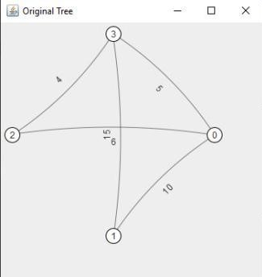

**The Draw the Minimum Spanning Tree Graph.**

