git clean -f ignored: This permanently removes untracked files from the working directory that are already listed

git tag -a javascript 35e32b6a00dec02ae7d7c45c6b7106779a124685 >>Tag a Release (to mark a specific version)

ssh>>This provides secure, password-less communication with the remote repository.

SSH keys are created using a key generation tool. The SSH command line tool suite includes a keygen tool.

Pull request>>Pull requests are a crucial aspect of modern software development, offering numerous advantages for both individual developers and collaborative teams. Here are some of the key benefits of using pull requests:

**git checkout -- <filename>:** Revert unstaged changes in a specific file to the last committed version.

**git clean -f <filename>:** Permanently remove untracked files from the working directory

git log

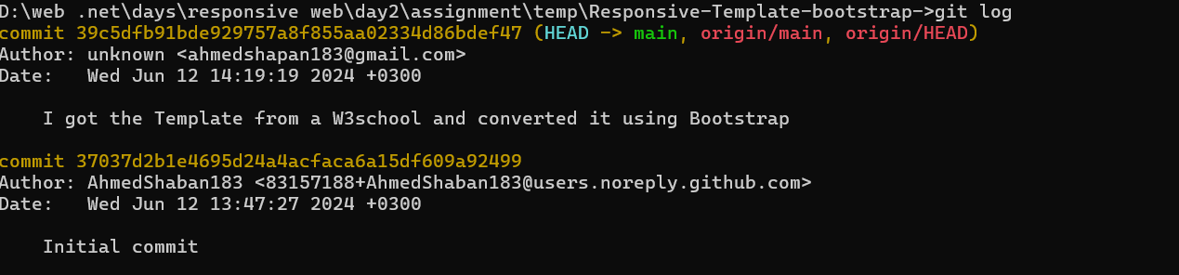

git show>=View a Specific Commit:

git stash drop

This command permanently removes the most recent stash from the list.