University of Engineering and Technology, Lahore (New Campus)

Department of Electrical Engineering and Technology

Data Structures and Algorithms

Lab 7: Linked lists

**Q1):** Write a program that implements the following:

**Functions:**

1. Create () adding the very first node.

void creating_node(int value)

{

try

{

if (start == NULL)

{

start=new node;

start->data=value;

start->next=NULL;

length=length+1;

}

else

{

throw(value);

}

}

catch(int data)

{

cout<<"Linked list already exist, Please try to add instead of creating linked list"<<endl;

}

return;

}

1. Add() the method should insert numbers in sorted order.

void add(int value)

{

if (length==0)

{

cout<<"There is no sign of linked list, Try to create linked list first"<<endl;

}

else

{

node *temp;

temp = start;

while (temp->next!=NULL)

{

temp=temp->next;

}

node * new_node;

new_node = new node;

new_node->data=value;

new_node->next=NULL;

temp->next=new_node;

length = length+1;

}

return;

}

1. Delete() the function should clearly show, with appropriate comments, deleting a

node (if it is present) by enumerating all the elements of the list after deleting the

concerned node, and “not found” if the requested node is not present in the list.

void deleting(int value)

{

try

{

if (length==0)

{

throw(1);

cout<<"Linked list is empty, deleting is not possible"<<endl;

}

else

{

node *current, *prev;

current = start;

while ((current->next!=NULL) && (current->data!= value))

{

prev = current;

current = current->next;

}

if (current->data==value)

{

// if it is first node then

if (current==start)

{

start = current->next;

}

else

{

prev->next=current->next;

}

delete current;

length=length-1;

}

}

cout<<"Noting to delete"<<endl;

}

catch(...)

{

cout<<"Node having value ["<<value<<"] not found, Hence nothing to delete"<<endl;

}

return;

}

1. Traverse() informs the user of the length of the linked list

int sized_of_linked_list()

{

int size=1;

node *temp = start;

while (temp->next!=NULL)

{

temp=temp->next;

size = size +1;

}

return size;

}

1. Traverse () simply prints the elements of the list.

void traverse()

{

try

{

if (length==0)

{

throw(1);

}

else

{

node *temp;

temp = start;

int len=1;

while (temp->next!=NULL)

{

cout<<"["<<len<<"]: "<<temp->data<<" "<<endl;

temp=temp->next;

len = len +1;

}

cout<<"["<<len<<"]: "<<temp->data<<" "<<endl;

}

}

catch(...)

{

cout<<"Linked list is empty, Try create and add then traverse"<<endl;

}

return;

}

**A main( ) function that:**

1. Text calls upon an external file containing the numbers [1, 3, 7, 99, 101, 103,107] (you can create a text file yourself.
2. creates and populates the linked list with all the elements presented to it in the text file of part (2a)
3. thereafter, the function asks the user a series of actions that he/she would like to continue to perform iteratively up until he/she chooses to stop. Actions are:

(i) add a node

(ii) delete a node

(iii) enumerate the elements of the list

(iv) length of the list

(v) end – stop the process and stores the current linked list in an external file called

“output.txt”

**Code:**

int main()

{

ifstream inputFile("sli.txt");

if (inputFile.is_open()) {

int num;

while (inputFile >> num) {

if (start == NULL) {

creating_node(num);

} else {

add(num);

}

}

inputFile.close();

} else {

cout << "Unable to open numbers.txt" << endl;

return 1;

}

int choice;

do

{

cout<<endl;

cout << "Choose any single action:" << endl;

cout << "[1] Add a node?" << endl;

cout << "[2] Delete a node?" << endl;

cout << "[3] Enumerate the elements of the list?" << endl;

cout << "[4] Length of the list?" << endl;

cout << "[5] End and store the current linked list?" << endl;

cout<<"-----------------------------------------------------------------------------"<<endl;

cout << "Enter your choice: ";cin>>choice;cout<<endl;

switch (choice)

{

case 1:{

int input_value;

cout<<"Enter the value of node: ";cin>>input_value;cout<<endl;

add(input_value);

break;

}

case 2:{

int input_value;

cout<<"Enter the value of node that you want to delete: ";cin>>input_value;cout<<endl;

deleting(input_value);

break;

}

case 3:{

traverse();

break;

}

case 4:{

cout<<"Length of the single linked list: "<<size_of_linked_list()<<endl;

break;

}

case 5:{

saveListToFile();

break;

}

default:

cout << "Invalid choice. Please try again." << endl;

}

}while(choice!=5);

return 0;

}

Output:

Command Prompt:

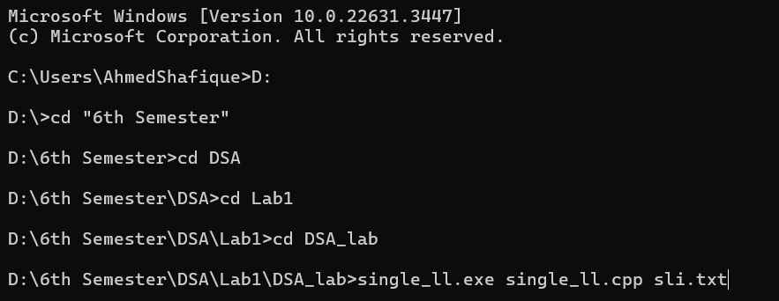

Fig: 01 Programming running on CMD

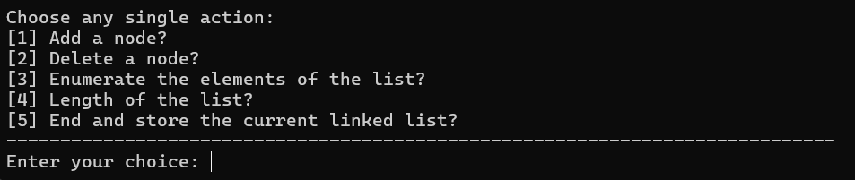

Fig: 02 Accepting Options

Fig: 03 Traversing Linked list

Fig: 04 Adding node

Fig: 05 Deleting node

Fig: 06 Linked lists length

Fig: 07 Saving text file

Methodology:

First, we added required header files to run the program which are:

#include <iostream>

#include <new>

#include <fstream>

using namespcace std;

The according to the requirement of making structure of linked list we code the structure of linked list which are as follows:

struct node

{

int data;

node *next;

};

Then we initialize the linked list to zero because there is no sign of linked list initially using following code:

int length = 0;

node *start = NULL;

We declare them as global because now these can easily calls in any function so there is no need to additionally passed them into function as a argument. Then we coded the creating_node function to create the node as user input text file. Then we coded traverse function, the traverse function prints the value in whole linked list and we set that if there no node then it return nothing and we use while loop and pass the condition that it stops where the next structure pointer points to NULL.

We coded the add function to add additional nodes from the user and then, we coded another function called deleting to delete the node of linked list that user want to delete based on the value of the node input by the user.

We coded size_of_linked_list function to calculate the length of linked list, it same as some portion of traverse function but it have one statement different from traverse which is:

length = length + 1;

then it returning length using return length;

At last we coded the last part of program in which user can save the linked list data into the output text file. So, We initialize the file input in main function then we pass one condition that if there is no sign of linked list and it initialize to zero then it calls the creating_node function to create the node in the linked list and initialize it to 1. Else it add the nodes in the linked list using add function.