Microprocessors: Project Report

Implementation

1. Memory Organization:
- MemoryHandler is responsible for dealing with the memory unit.
- Every cache and the main memory extend a common abstract class “Stroage” which has two methods: fetch and write.
- Every cache level is composed of Cache sets, each of which is composed of cache blocks. Each cache may have different different size, block size, associativity, writing policy and access time.
- Every cache communicates with the next memory level in words, such that the cost of accessing a word from each level in case of a miss is calculated as the reading cost in this level added to the reading cost for every word in this block from the next level.

2. Processor: the processor unit handles the flow of instructions. It connects reservation stations, reorder buffer, instruction fetch unit and the register file. In each clock cycle, the processor:
- allows the InstructionFetch unit to fetch a new instruction (if it has already been read from memory) and add it to the instruction queue.
- issues new instruction from the queue front if there are reservation stations and reorder buffer entries available for them taking into consideration the pipeline width.
- executes instructions whose operands are ready.
- write result for instructions that finished their execution stage.
- commit the head entry of the reorder buffer if it's ready.

3. Simulation
- The simulator takes memory configurations and constructs the memory handler, then takes the processor configurations and constructs the processor, and then initializes the data in the memory according to the user's request. And the processor is then run until the termination command is committed. Then the required information are printed to the console.

Bonus features added
- The user can provide an assembly program.
- Unit Testing with a coverage test 99%

Team Work:
Pair/Triple programming
- Soliman/Teefa/Kammola: Memory Organization
- Teefa/Kammola: Unit Testing/Parser
- Soliman/Teefa/Kammola/Sagheer: Processor units (reservation stations, reorder buffer, processor, integration... etc)
- Soliman/Kammola: Simulator

3. A user guide including a full simulation example step-‐‐by-‐‐step with snapshots.
- Enter the memory configurations.
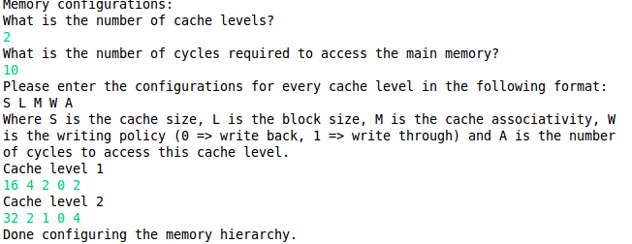
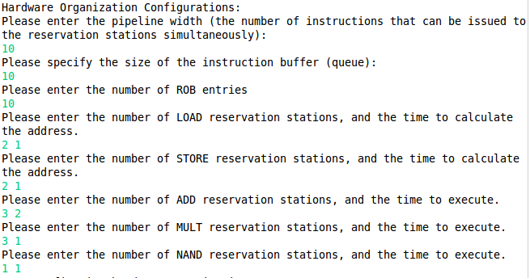
- Enter the hardware configurations.
- Determine the path to the file containing the assembly code.
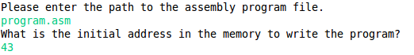
- Enter the starting address in the memory to write the program.
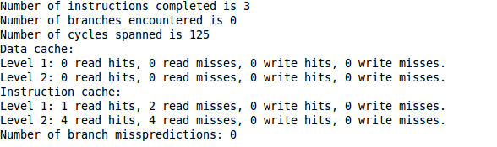
- Optionally initialize the memory with data.

4. A list of programs (and associated data if any) you simulated. You should at least
provide 3 programs. The programs must cover all instructions supported and one
of them at least must have a loop.
Check test/TrickyProgramsTests.java file and test/InstructionsTests.java.
5. The hardware configurations (including memory hierarchy configurations) you used to simulate each program and the results obtained from each simulation. You must simulate each program with at least two different configurations.
Configurations 1:
- Memory access time: 2 cycles
- 1 cache level
- Cache size: 8 words, block size: 2 words, associativity: 1 way, writing policy: write-back, access time: 1 cycle.
- Pipeline width: 1
- ROB size: 4
- Instructions queue size: 4
- 2 LOAD reservation stations, 1 cycle to calculate address.
- 2 STORE reservation stations, 1 cycle to calculate address.
- 2 ADD reservation stations, 2 cycles to execute.
- 2 MULT reservation stations, 2 cycles to execute.
- 1 NAND reservation station, 2 cycles to execute.
- Program start address: 100
- Memory[32] = 2
- Memory[44] = 3
Configuration 2:
- Memory access time: 10 cycles
- 3 cache level
- Cache 1 size: 4 words, block size: 2 words, associativity: 1 way, writing policy: write-back, access time: 1 cycle.
- Cache 2 size: 8 words, block size: 2 words, associativity: 2 way, writing policy: write-back, access time: 3 cycle.
- Cache 3 size: 16 words, block size: 4 words, associativity: 4 way, writing policy: write-back, access time: 5 cycle.
- Pipeline width: 2
- ROB size: 5
- Instructions queue size: 5
- 1 LOAD reservation stations, 2 cycle to calculate address.
- 1 STORE reservation stations, 2 cycle to calculate address.
- 1 ADD reservation stations, 2 cycles to execute.
- 1 MULT reservation stations, 2 cycles to execute.
- 1 NAND reservation station, 2 cycles to execute.
- Program start address: 100
- Memory[i] = i + 1, 0 <= i < 20

6. A brief discussion of the obtained results. TODO

