SP1 COMPLETION BRIEF
What Sprint Package 1 Achieved
A plain-language summary for the Product Owner and Executive Team
Audience: Product Owner, Executive Sponsors and Business Stakeholders
Status: SP1-T1 and SP1-T2 completed; adversarial review addressed
Evidence basis: Completed implementation specifications dated 5-6 August 2026
Production posture: Synthetic-local proof only; live promotion remains disabled

SP1 IN ONE SENTENCE SalesFlow can now accept business information only in a defined, checkable format and can change the approved version through a controlled, traceable, reversible process.

WORK PACKAGES | BUSINESS PACKS GOVERNED | ACTIVE VERSION PER PACK
2 completed | 5 controlled | 1 at a time

Executive summary
Before SP1, important business information could be stored and used, but the controls were not strong enough for confident business review. Unexpected fields could slip into otherwise valid-looking documents, and saving a change also activated it immediately.
SP1 closes those gaps. It separates preparation from approval, keeps every saved version unchanged, records who activated each change, allows rollback to an older version, and prevents two simultaneous approvals from both winning.
The result is a safer governance foundation for the sales assistant. It reduces accidental changes and makes decisions easier to explain and reconstruct. It is not production approval and it does not replace human review of the business meaning of the content.

1. What SP1 delivered

Work package 1 — Structured business information
SP1 defined five separate information packs that business stakeholders can understand and review. Each pack now has exact allowed fields, required values, valid ranges and relationship checks. Missing, mistyped, out-of-range or undocumented information is rejected before it can become active.
Business information pack | What it controls
Product Knowledge | Approved product facts and the source references attached to them.
Sales Policy | Commercial boundaries such as quiet hours and policy limits.
Qualification | The conditions used to assess readiness and trigger Handoff.
Consent & Template References | Consent rules, opt-out and human-request signals, and provider-owned template references.
Handoff Dispatch Settings | Where a Handoff request is sent and how it is dispatched.

Work package 2 — Controlled publication and rollback
SP1 replaced the former “save and activate immediately” behavior with a controlled lifecycle. A valid version is first saved as inactive. An authorized operator can then activate it as a separate approval action. Every actual activation records the previous version, the selected version, the approving actor and the database time.
How an approved change moves through SalesFlow
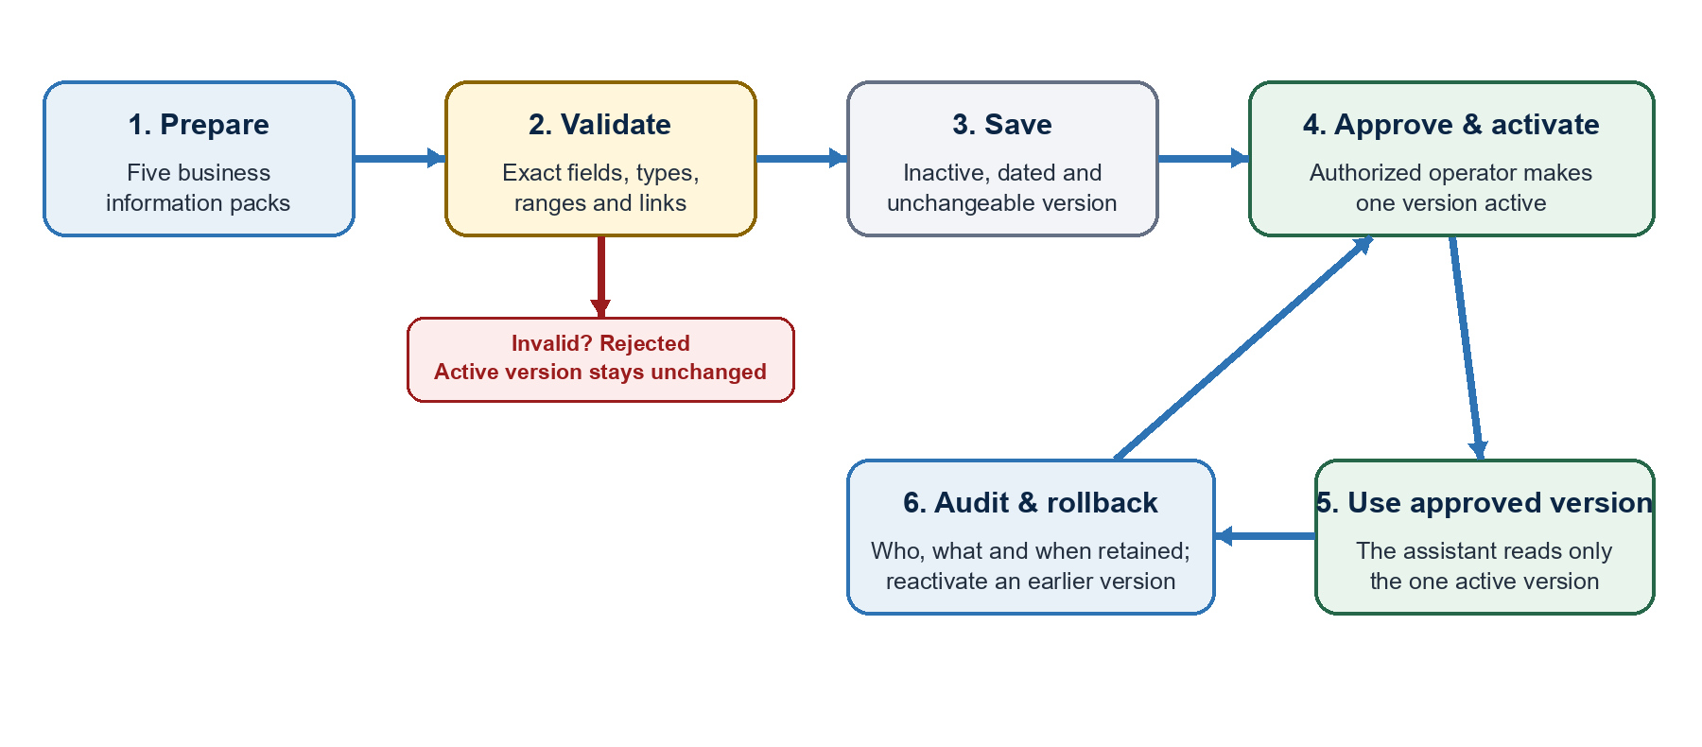
Invalid information stops at validation; it does not change the active business rules.

Before and after SP1
Before SP1 | After SP1
Unexpected fields could pass inside valid-looking documents. | Only documented fields and structures are accepted.
Saving and activating happened together. | Saving and approval are separate actions.
Review before activation was limited. | Inactive versions can be reviewed before approval.
Rollback was not an explicit controlled action. | Any older saved version can be reactivated safely.
Concurrent approvals could be difficult to explain. | Exactly one competing activation wins; the other receives a clear stale result.

2. Business value achieved
Fewer accidental rule changes. Invalid or undocumented information is rejected before it can affect the assistant.
Clear approval responsibility. Activation is an explicit authorized action, separate from preparing or saving content.
Explainable history. Every version remains available and every real activation records who approved what and when.
Safer recovery. An older approved version can be restored without deleting or rewriting history.
Predictable behavior under pressure. If two people attempt conflicting activations at the same time, only one succeeds.

3. Evidence and safeguards
Evidence | What was demonstrated | Why it matters
Contract tests | Valid examples accepted; missing, wrong, extra and conflicting values rejected. | Bad structure cannot silently become business authority.
Lifecycle tests | Save, activate, retry, rollback and immutable history all exercised. | The approval process behaves consistently and can be reconstructed.
Concurrency test | Two competing approvals produced one winner and one bounded denial. | Simultaneous decisions cannot create two active versions.
Adversarial review | Upgrade, authorization, immutability and race findings were corrected and retested. | The result was challenged beyond the happy path.
Release control | Reviewed hashes remained bound while live promotion stayed disabled. | Local success cannot be mistaken for production approval.

4. What SP1 does not mean
IMPORTANT BOUNDARY SP1 proves the controls in a disposable synthetic-local environment. It does not authorize production use.

No automatic business approval. The system validates structure and limits; people still approve the meaning and wording.
No new administration screen. SP1 established the controlled database and operations boundary, not a custom business-user interface.
No two-person approval rule. An authorized operator can activate a version; a separate maker-checker role remains a future governance decision.
No live provider proof. Real Meta, production LLM, CRM/Handoff, managed database and compliance approvals remain external gates.

5. Executive takeaway and next actions
SP1 established the governance foundation needed before business information can safely direct an AI sales workflow. The system now knows what a valid business-information package looks like, separates preparation from approval, preserves history and supports controlled recovery.
- Confirm content ownership. Name the business owner for each of the five information packs.
- Confirm approval policy. Decide whether production requires the current authorized-operator model or a formal two-person maker-checker rule.
- Keep production gated. Do not enable live promotion until real provider, managed infrastructure, legal/privacy and named production-owner evidence is approved.

Evidence basis
This brief summarizes observed repository evidence from:
_bmad-output/implementation-artifacts/spec-sp1-t1-structured-business-information.md
_bmad-output/implementation-artifacts/spec-sp1-t2-versioned-business-information.md
_bmad-output/implementation-artifacts/test-evidence.md
docs/component-inventory.md and docs/project-context.md

