 

**Wireless patient monitoring system for cardiovascular diseases**

Ahmed Tarek, Hossam Khaled, Rahma El-Dreny, Reem Ibrahem, Youssef Mohamed

Department of Medical Informatics, Helwan University, Egypt

**June 2023**

**Abstract:**

This paper describes a wireless patient monitoring system designed to provide real-time readings of a patient's vital measurements, with the aim of assisting the cardiologist in diagnosing and monitoring CVDs by offering accurate and timely diagnosis and warnings to medical staff. Additionally, the system's predictive capabilities allow for the assessment of a patient's future vital state of the heart based on previous readings.

**1-Introduction**

Cardiovascular diseases (CVDs) are a leading cause of mortality and morbidity worldwide. Early detection, accurate diagnosis, and prompt intervention are crucial in improving patient outcomes and preventing complications. Wireless patient monitoring systems have emerged as a promising technological solution for providing real-time monitoring of patients' vital measurements and assisting in the diagnosis and management of CVDs.

This paper describes a wireless patient monitoring system designed specifically for the diagnosis and monitoring of CVDs. The system offers real-time readings of a patient's vital measurements, such as heart rate, and oxygen saturation, and provides accurate and timely diagnosis and warnings to medical staff. In addition, the system's predictive capabilities enable the assessment of a patient's future vital state based on previous readings, potentially enabling preventative measures to be taken.

The development of this wireless patient monitoring system has significant implications for the management of CVDs. By providing medical staff with timely and accurate information, the system has the potential to improve patient outcomes and assist in the development of new technologies for managing CVDs. The remainder of this paper will provide a detailed description of the system and its features, as well as a discussion of its potential impact on the field of cardiovascular medicine.

**2-Backgroud overview**

Between 2017 and 2022, several models were developed using various technologies to monitor and diagnose patients. One such model used Bluetooth wireless communication with ZigBee technology to transmit diagnostic information from wearable devices, such as ECG, SPO2, NIBP, and temperature, to an Android app [1]. Another model utilized Wi-Fi communication and machine learning algorithms to diagnose the early stages of diseases [2]. Furthermore, different networking protocols, such as MQTT, were used in monitoring systems [3]. In a specific case, a monitoring system was used to track the stress levels of football players during training and matches to determine their health status [4]. The system allowed medical professionals to remotely monitor the players' health during training sessions or real competitions, potentially saving lives in emergencies.

However, existing monitoring systems have limitations. While some systems offer portability through Wi-Fi, they lack communication with doctors and nurses, and others use ML models that are costly and not portable. Some monitoring systems are based on simple circuitry and low-level controllers, which may lead to serious situations.

We propose a system that offers portability, prediction, monitoring, and accuracy in one package. The system provides real-time monitoring with reliable internet communication for doctors, nurses, and patients alike.

**3-Methedology:**

Our system employs a portable device attached to the patient's body, which wirelessly reads the patient's ECG and heart rate. This data is then transmitted to a local server equipped with a machine learning model, which processes the data alongside any manually entered information by the doctor. The resulting predictions provide doctors with fast and accurate possibilities to rely on, making it easier for medical staff to monitor large numbers of patients in less time and with less effort. All data, including patient personal information, medical history, diagnosis, and treatment plans, are stored and saved. Nurses use this information to monitor the patient's case.

Our system also includes an additional service for aftercare, where patients can be monitored at home using the wearable device. Patients can attach the device at home and enter any additional data as an attachment file on their doctor-created account to see the predicted future state of their heart. The doctor monitors this process, receiving any warnings, emergencies, notes, or edits.

Our system architecture consists of four layers. The first layer is the wearable device, which reads the patient's heart rate and ECG. The second layer involves the transfer of extracted data to the web server, where a machine learning model with a random forest algorithm predicts the future state of the heart. The third layer involves data exchange between the web server and Firebase. Lastly, the fourth layer provides end users, including doctors, nurses, and patients, with a mobile app for monitoring, communication, and data access. Alternatively, a website portal can be used by hospital managers and administrators to control the system, edit accounts, grant access, and access other features. The system architecture is depicted in the following figure.

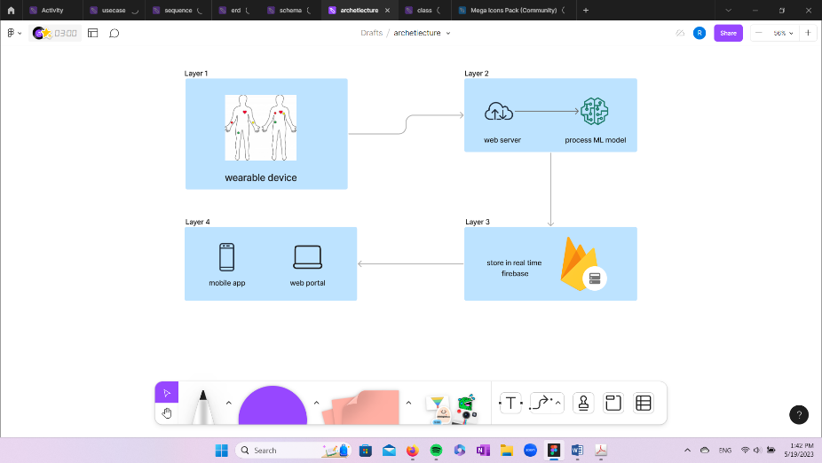

Figure 1 System architecture

1. System communication:

The system utilizes Wi-Fi network connectivity to demonstrate its portability and wireless capabilities. The device is equipped with a Wi-Fi module, which sends data to the web server. The web server is connected to Firebase, and the mobile app also communicates with Firebase. Therefore, the primary feature of the system is its ability to connect via Wi-Fi.

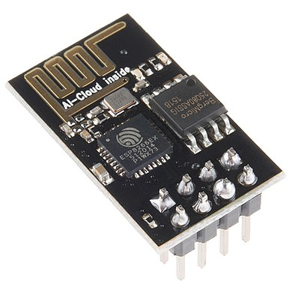

Figure 2 Wi-Fi module

1. Machine learning model

The purpose of incorporating a machine learning model is to predict the future state of the patient's heart, aiding medical staff in making informed decisions and providing optimal care and treatment plans. We evaluated several machine learning models, such as KNN, DT, and MLP, to determine the most effective approach.

After a thorough analysis, we concluded that the Random Forest model was the most suitable option, offering a high accuracy level of 94.16%. This algorithm is commonly utilized in machine learning for classification and regression problems, employing the concept of ensemble learning. Essentially, this involves combining multiple classifiers to solve complex problems, enhancing overall model performance.

1. hardware device

The schematic diagram describes the hardware simplified model we are working on, which is an Arduino function as our microcontroller to receive the data from sensors and send it to the server to start the processing phase.

The main sensor in this model is AD8232 which is known commercially as the electrocardiogram (ECG) to monitor heart activity by recording electrical signals in the heart as it will help in diagnosis if there is any heart failure that might happen or not usually for 24 to 48 hours.

Also, the Wi-Fi module (ESP8266) connects the Arduino and the server to exchange data and different processes.

All these components will make a small, portable, and usable model to monitor heart activity with variable usages, a patient may use it at home to monitor his health under the supervision of his doctor, and it also may be used in an ambulance car with a patient who suspected to have a problem in heart to have all the possible information before they reached the hospital and in this way the medical staff can prepare any required preparations until the patient arrives to start immediately without any waste of time, or the basic use in hospital rooms to monitor the patients.

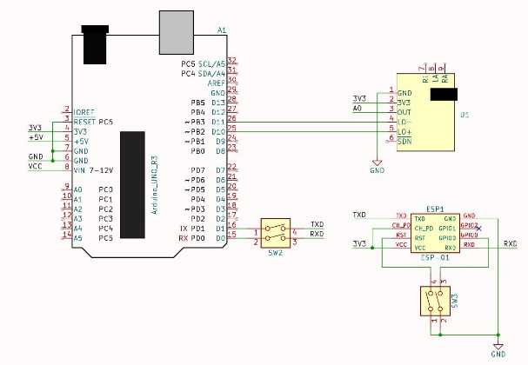

Figure 3 Schematic diagram

And this is a 3D view for the designed system, describes the placing of the sensor in small limited area to give it more portable view.

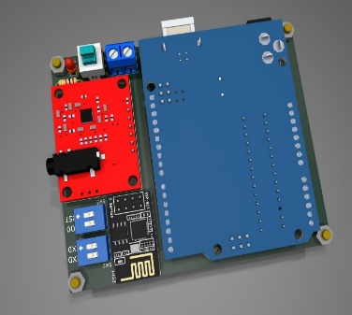

Figure 4 3D model

1. Software system

The software is divided into two parts: a website portal for managers and administrators to control the system, view all users and track their activity, add or remove users, and edit accounts. The website was created using React, HTML, and CSS. The second part is a mobile app that serves as the user portal. Medical staff such as doctors or nurses can log in or register, and patients can be added by doctors who can activate the home service and allow patients to log in to add lab results and monitor their heart. The doctor monitors all activity and has the ability to add or remove patients, edit patient accounts, write instructions for nurses to follow the treatment plan, and view patient information. Nurses can view patient information and provide required care but have no access to edit patient information. The mobile app was developed using Flutter.

To establish a successful real-time connection, the software uses Firebase, a NoSQL database.

1. Test and results

We did unit testing while programming each function on the program, and the integration testing is done after that. We also did test cases and all the functions passed the testing and the expected results meet the actual results.

Giving results of successful system, passed all the functional and non-functional requirements.

1. Future work
2. Our project has the potential to improve even further with future developments in various areas. One key area of development is the implementation of chat functionality between doctors and nurses, as well as between doctors and patients. This communication system could improve collaboration within healthcare teams and enable personalized and efficient communication with patients.
3. Another important area of development is the integration of a chatbot system for patients. This system could provide 24/7 support and assistance for common health inquiries and help patients who may not have immediate access to medical professionals.
4. A screen on the device to display the reading of the ECG sensor could provide real-time feedback and insights to healthcare providers. Moreover, the implementation of text recognition for uploaded files from patients could enable machine learning predictions to be generated from uploaded files alone.
5. Expanding the system to work for other diseases and conditions is also an important future development. We plan to use larger datasets and train models to work with a variety of medical conditions, thereby increasing the reach and impact of our project.
6. Additionally, we plan to add doctors from other specialties to work with cardiovascular disease patients, as these patients require specialized care and attention.
7. On the hardware side, we plan to use Raspberry Pi due to its compact size, low power consumption, and cost-effectiveness. This could enable us to develop a more portable and accessible system for healthcare providers.
8. Conclusion

Our Wireless Patient Monitoring System for Cardiovascular Diseases is a comprehensive and innovative solution that aims to improve the diagnosis and management of cardiovascular disease. Our project represents a significant advancement in healthcare technology by integrating software, hardware, and machine learning to provide a scalable, efficient, and user-friendly system for healthcare providers and patients.

The software component of our system includes a mobile app for doctors and nurses to remotely monitor patients' health through ECG sensors. This feature facilitates timely medical intervention and reduces the risk of complications, resulting in better patient outcomes. The website for administrators provides a centralized platform to control the system and manage patient data, enhancing collaboration and communication within the healthcare team.

Our machine learning algorithm is a key component of the system, as it predicts the risk of heart disease based on patient data. The algorithm takes into account various factors, such as age, gender, and medical history, to provide accurate and reliable predictions. This feature enables healthcare providers to take proactive measures to prevent the onset of heart disease and provide personalized care for patients.

We have utilized the latest technological advancements, such as Firebase integration and ECG sensors, to develop a scalable and efficient system that makes it easier for healthcare providers to manage cardiovascular disease patients. The home service feature provides patients with greater access to their health information, allowing them to track their progress and upload lab tests for doctors' review.

Overall, our project has the potential to make a significant impact in the healthcare industry by improving patient outcomes, enhancing communication and collaboration within healthcare teams, and promoting the safe and efficient operation of the healthcare system. Our Wireless Patient Monitoring System for Cardiovascular Diseases represents a major step forward in the field of healthcare technology, providing a comprehensive and innovative solution to cardiovascular disease management. We are proud of the hard work and dedication that went into this project and are excited about the potential impact it can have on patient care. By leveraging the latest advancements in technology and continuing to innovate, we believe our system can continue to make a positive impact on the healthcare industry, improving patient outcomes and enhancing the quality of care healthcare providers are able to provide.

**4-Acknowledgment**

We would like to express our deepest gratitude and appreciation to the Faculty of Computer Science at Helwan University for their support and guidance throughout the course of our research. Their commitment to excellence in education, research, and community service has been a source of inspiration and motivation for us.

We would also like to extend our sincere thanks and appreciation to our supervisor, Dr. Ahmed Salah, for his invaluable support, guidance, and encouragement throughout this project. His expertise, feedback, and advice have been instrumental in shaping our research and achieving our goals. We are grateful for his unwavering dedication and commitment to the success of our project.

**Reference**

[1] Wordh Ul Hasan, Mohammad Sultan Khaja, Saif Ahmed & Mohammad Monirujjaman Khan, Wireless Health Monitoring System, 2018.

[2][Yar Muhammad , 1 Moteeb Almoteri , 2 Hana Mujlid , 3 Abdulrhman Alharbi , 4 Fahad Alqurashi , 5 Ashit Kumar Dutta , 6 Sultan Almotairi , 7,8 and Hamad Almohamedh 9, "An ML-Enabled Internet of Things Framework for Early Detection of Heart Disease",2022](https://downloads.hindawi.com/journals/bmri/2022/3372296.pdf)

[3] [Hoe Tung Yew , Ming Fung Ng , Soh Zhi Ping , Seng Kheau Chung , Ali Chekima and Jamal A. Dargham from Universiti Malaysia Sabah, 2020.](https://sci-hub.se/https:/ieeexplore.ieee.org/abstract/document/9068699/)

[4] [Fawaz Yaseen Abdallah, Mohammad Tariq Yaseen, Yasir Mahmoud Hussien,” Portable heartbeat rate monitoring system using LabVIEW”, 2021.](https://www.researchgate.net/profile/Fawaz-Abdullah/publication/343295211_Portable_Heartbeat_Rate_Monitoring_System_by_WSN_Using_LABVIEW/links/606f8390299bf1c911ba16e4/Portable-Heartbeat-Rate-Monitoring-System-by-WSN-Using-LABVIEW.pdf)