GDD

This file contains all the information concerning the Global Design Document (High Level Document)

needed to specify the Autonomous car components in the MCAL and HAL Layers used in this project.

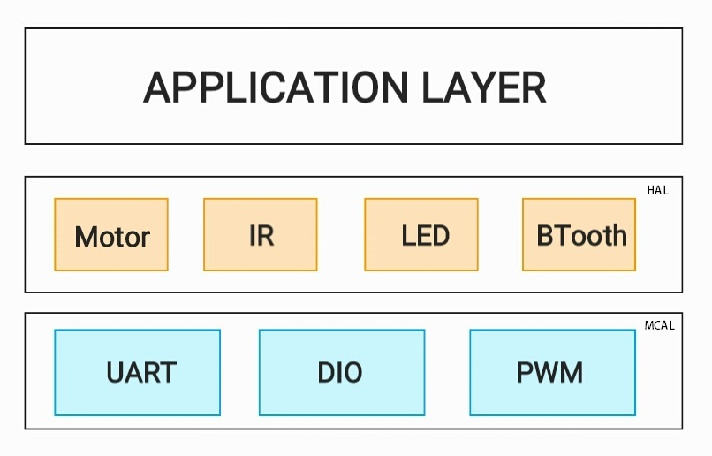

|  |  |
| --- | --- |
| Component ( 1 ) | UART (MCAL) |
| Description | This is the Universal Asynchronous Receiver-Transmitter Peripheral Driver to be used in the MCAL layer. This Driver will be responsible of sending and receiving the data from and to the used micro controller. |
| API (1) | UART_u8Init ( ) ; |
| Description | This API is used in initializing the UART pins to be used and the baud rate to send and receive on.  This API must be called before using the following APIs. |
| API (2) | UART_u8Send ( u8 Copy_u8Data) ; |
| Description | This API is used to send the “Copy_u8Data” Data through the UART communication. |
| API (3) | UART_u8Receive ( u8 * PCopy_u8Data ) ; |
| Description | This API is used to receive the data sent to the device on the pointer to u8 variable called “ PCopy_u8Data ” |

|  |  |
| --- | --- |
| Component ( 2 ) | DIO (MCAL) |
| Description | This is the Digital Input-Output Peripheral Driver to be used in the MCAL layer. This Driver is responsible for controlling the Digital Pins on the Microcontroller used. |
| API (1) | DIO_u8Init ( u8 Copy_u8PinNB ) ; |
| Description | This API is used in initializing the DIO pin “Copy_u8PinNB”to be used.  This API must be called before using the following APIs. |
| API (2) | DIO_u8SetPinDirection ( u8 Copy_u8Direction ) ; |
| Description | This API is used to set direction of the Pin initialized before. It can be either “ Output “ direction or “ Input ” direction and these value can specified more in the “Interface” File. |
| API (3) | UART_u8SetPinValue ( u8 Copy_u8PinValue ) ; |
| Description | This API is used to set the value of a predefined-output pin to either “High” or “Low”. |
| API (4) | UART_u8GetPinValue ( u8 * PCopy_u8PinValue ) ; |
| Description | This API is used to get the value of a predefined-input pin, either its “High” or “Low”. |

|  |  |
| --- | --- |
| Component ( 3 ) | PWM (MCAL) |
| Description | This is the Pulse Width Modulation Peripheral Driver to be used in the MCAL layer. This Driver will be responsible for generating or receiving analog signals. |
| API (1) | PWM_u8Init ( u8 Copy_u8PinNB ) ; |
| Description | This API is used in initializing the PWM pin “Copy_u8PinNB” to be used.  This API must be called before using the following APIs. |
| API (2) | PWM_u8On ( u8 Copy_u8PinNB) ; |
| Description | This API is used to assign the analog value to the “Copy_u8PinNB”. |
| API (3) | UART_u8Off (u8 Copy_u8PinNB) ; |
| Description | This API is used to switch off the analog value in the “Copy_u8PinNB”. |

|  |  |
| --- | --- |
| Component ( 1 ) | Motor (HAL) |
| Description | This is the Motor Hardware Driver to be used in the HAL layer. This Driver will be responsible for rotating the motor using the DIO driver. |
| API (1) | Motor_u8Init ( ) ; |
| Description | This API is used in initializing the Motor pins assigned in the configuration file to be used.  This API must be called before using the following APIs. |
| API (2) | Motor_u8RotateClockwise ( ) ; |
| Description | This API is used to assign value on the pins mentioned in the configuration file to rotate the motor clockwise direction. |
| API (3) | Motor_u8RotateAntiClockwise ( ) ; |
| Description | This API is used to assign value on the pins mentioned in the configuration file to rotate the motor Anti-Clockwise direction. |

|  |  |
| --- | --- |
| Component ( 2 ) | LED (HAL) |
| Description | This is the LED Hardware Driver to be used in the HAL layer. This Driver will be responsible for turning the LED on and off using the DIO driver. |
| API (1) | LED_u8Init ( ) ; |
| Description | This API is used in initializing the LED pins assigned in the configuration file to be used.  This API must be called before using the following APIs. |
| API (2) | LED_u8TurnOn ( ) ; |
| Description | This API is used to assign value on the pins mentioned in the configuration file to turn on the LED. |
| API (3) | Motor_ u8TurnOff ( ) ; |
| Description | This API is used to assign value on the pins mentioned in the configuration file to turn off the LED. |

|  |  |
| --- | --- |
| Component ( 3 ) | IR (HAL) |
| Description | This is the IR Hardware Driver to be used in the HAL layer. This Driver will be responsible for getting distance reading using the DIO driver. |
| API (1) | IR_u8Init ( ) ; |
| Description | This API is used in initializing the IR pins assigned in the configuration file to be used.  This API must be called before using the following APIs. |
| API (2) | IR_u8GetDistance ( u8 Copy_u8Distance ) ; |
| Description | This API is used to get the distance and save it in the variable “PCopy_u8Distance”. |

|  |  |
| --- | --- |
| Component ( 4 ) | Bluetooth (HAL) |
| Description | This is the Bluetooth Hardware Driver to be used in the HAL layer. This Driver will be responsible for controlling the Bluetooth communication protocol using the DIO driver. |
| API (1) | Bluetooth_u8Init ( ) ; |
| Description | This API is used in initializing the Bluetooth Tx and Rx pins assigned in the configuration file to be used.  This API must be called before using the following APIs. |
| API (2) | LED_u8Read (u8 * PCopy_u8ReadVariable ) ; |
| Description | This API is used to assign value that has been read on the “PCopy_u8ReadVariable” variable. |
| API (3) | Motor_ u8Write ( u8 Copy_u8Data ) ; |
| Description | This API is used to send the value in “Copy_u8Data” variable over the Bluetooth. |