Write a program for Encapsulating CAN packets that takes the following inputs from the user:-

1. ID type (0 for normal, 1 for external) (1 Byte long)
2. ID value (0x20 for air condition, 0x80 for left door lock, 0x110 for right door lock)(4 Bytes long)
3. DLC(length of data from 0 to 7)(1 Byte long)
4. Data (from 0 to 7 bytes long)

And encapsulate it as shown in the following picture:

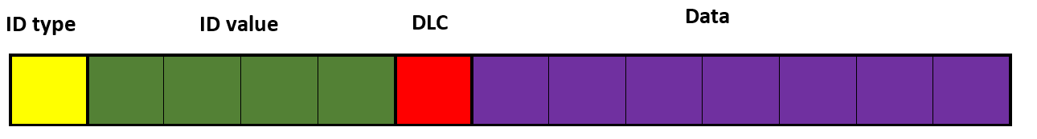

And store the inputs in a structure using Dynamic Linked Lists as shown in the following diagram