Project 1 – Team 6

Data Investigation into the Effect of Weather on Flight Disruption at UK Airports

Ahmed Abdullahi, Dalitso Kapitao, Simon Butler, Stanley N Aboagye

Data Analytics Project| 12/22

This report is an outline of our findings for the study of the correlations between weather conditions and flight cancellations in Four major airports in the UK. We will first provide an outline of our hypothesis followed by some details of our study and findings.

# Hypotheses

* Weather Conditions have an effect on Flight Cancellations Across UK Airports
* Weather Conditions have an effect on Flight Delays Across UK Airports
* Season Extremes have an effect on Flight Cancellations at Selected UK Airports
* Season Extremes have an effect on Flight Delays at Selected UK Airports

# Scatter Plots and Linear Regression for All UK Airports

The data for all UK airports in the dataset was used to perform linear regression and then overlay onto the scatter plots produced.

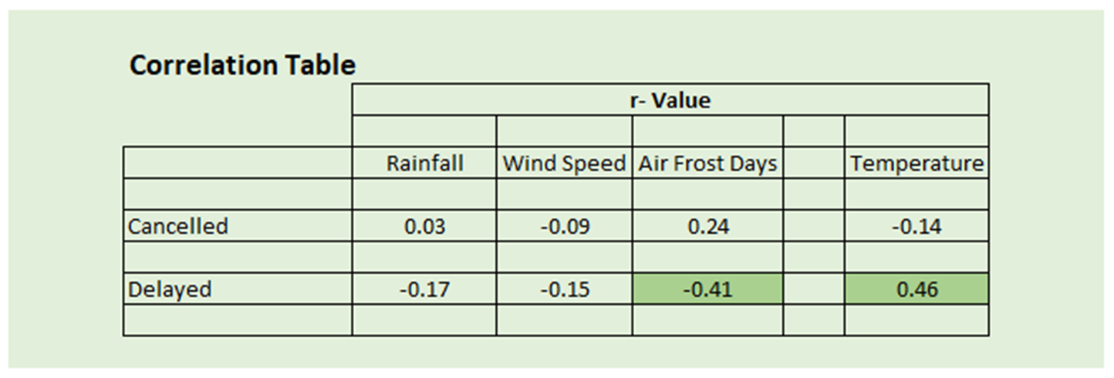The analysis showed no or very weak correlation in general. However, two values of “r” showed values above 0.4 which is approaching a weak to moderate correlation.

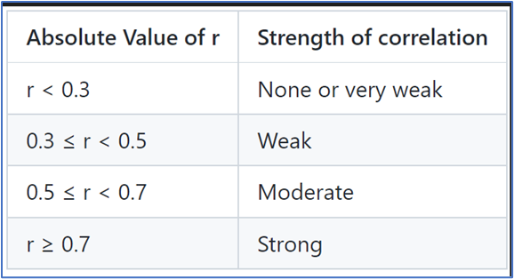

This was subsequently analyzed. A counterintuitive result was observed where for delays to flights an increase was observed as the number of frost days decreased. Similarly, the delays decreased for increasing temperature. Therefore, this data illustrates that perhaps there are other seasonal effects that may be in operation at specific airports.

# Data Cancellations Analysis

We have three distinct analyses for this presentation. The first analysis (All Available Data - Scatter Plots for UK Airports) addresses hypotheses 1 and 2.

The second analysis (Analysis of four UK Airports across season extremes (Winter and Summer) addresses hypotheses 3 and 4.

Lastly, the third analysis shows map plots of UK Airports showing the size of cancellations and delays.

This chart shows data for all four airports combined during the winter and summer period. The winter cancellations are twice as much as the summer cancellation. Worth noting that both sets are under 1% cancellation.

This data set shows data for all four airports, summer and winter cancellations. Heathrow Airport had the highest cancellation during the summer with Minimal seasonal deviation. Cardiff Wales Airport had the Highest cancellation during the winter and Belfast International had the Lowest summer and winter cancellations. Of the four airports discussed, Glasgow and Belfast are the closest distance-wise, but the data shows a huge deviation in the cancellations rate.

# Flight Delays in four UK Airports

This section will take a closer look at the correlation between flight delays in our chosen 4 airports. Let’s first take a look at Belfast International Airport.

As we can see from the bar graph above, there are slightly more delays in winter than in summer, but since the difference is only slight, we cannot conclude that is caused by weather alone.

In this bar graph, we can see Cardiff has a higher number of flight delays during the summer months compared to Belfast International Airport. The difference here is highly significant we are not yet sure if all the delays are mainly because of weather conditions.

In addition to the data collected from our first two airports, we see Glasgow Airport has a similar trend to the one in Cardiff. Possibly suggesting weather may have an effect but nothing conclusive.

The above bar graph shows a comparison of Flight delays for Heathrow airport in summer and winter. Like Belfast International we see a similar trend but it is too soon to conclude.

As a conclusion for the delays, we can see that the data findings for flight delays for both summer and winter are split 50/50. As a result, we can conclude that flight delays for our chosen 4 UK airports are due to bad weather conditions alone. We can see during the summer (more ideal weather), some airports still have a higher rate of cancellations which means we would need to consider other factors before making our conclusions.

1. Mean Flight Cancellations For All UK Airports:

* Southampton Airport and Aberdeen Airport both show the highest cancellation rates closely followed by Luton Airport.
* Southampton Airport despite its relatively accommodating weather year-round, still shows unforgiving rates of cancellations on average across both seasons.
* Bournemouth on the other hand shows a relatively good punctuality rate despite its closest neighbour’s failing.
* Heathrow despite how busy it is year-round, fairs better than the aforementioned airports signifying potential readiness to deal with extreme weather and also other non-weather-related challenges.
* Belfast international is the most reliable airport. It obviously shows that they are able to potentially deal with weather-related issues that might have affected departures.

1. Mean Flight Delays For All UK Airports:

* Birmingham International is the worst when it comes to Delays of 6 hours or more Followed closely by Bristol Airport
* Heathrow still performs better than most other airports
* Belfast’s George Best and Luton are the best performers
* Bournemouth does worse than Southampton in this case even though they should be affected by relatively the same type of weather conditions. Again, it can be concluded that weather isn’t the only factor for either delays or cancellations as other airport-related factors will need to be looked at.

1. Conclusions

From the analysis carried out, the alternative hypothesis cannot be proved i.e.; the null hypothesis cannot be disproved.

The data indicates that there are likely more critical factors that may affect either flight cancellations or delays such as:

Airport operations

Capacity

Mechanical faults

Usage across seasonal variations

1. Scope for future work

Carry out a more in-depth analysis of variation in specific airports, especially relating to detailed reasons for cancellations or delays.

When more accurate and detailed data is available, use advanced techniques such as ANOVA, t-tests etc. to confirm other hypotheses.