**The University Of Azad Jammu & Kashmir,**

**Muzaffarabad**

**Department of Software Engineering**

**LAB TASK 03**

**Database Systems**

**Course Code**: **CS-2204**

**Submitted To:**

Engr. Tahir Jahangir

**Submitted By:**

Ahmed Ali

**Roll No:**

2023-SE-41

**Session**: 2023-2027

Contents

**Task 01: Installation and Configuration** 2

**Task 02: Conceptual Questions** 4

**What is SQL Server? Explain the purpose of the Database Engine and SQL Server Agent.** 4

**Mention any two post-installation steps that must be done to verify successful installation. Identify two common installation errors and how to fix them** 5

**How many types of instances are available in SQL Server? Differentiate between them.** 5

**How many authentication modes are available in SQL Server? Which one is best to use and why?** 6

**What are SQL Server Analysis Services (SSAS)?** 6

**REFLECTION AND LEARNINGS:** 6

# **Task 01: Installation and Configuration**

**Objective:** Ensure students successfully install SQL Server and SSMS, configure it properly, and connect to their named instance.

**Step by step:**

* Download SQL Server Developer Edition
* Launch SQL Server Installer
* Setup Support Rules
* License Terms
* Feature Selection
* Instance Configuration
* Server Configuration
* Database Engine Configuration
* Install
* Download & Install SSMS
* Connect to Server via SSMS

**Instructions:**

1. **Install SQL Server Developer Edition** (or Express) on your system.

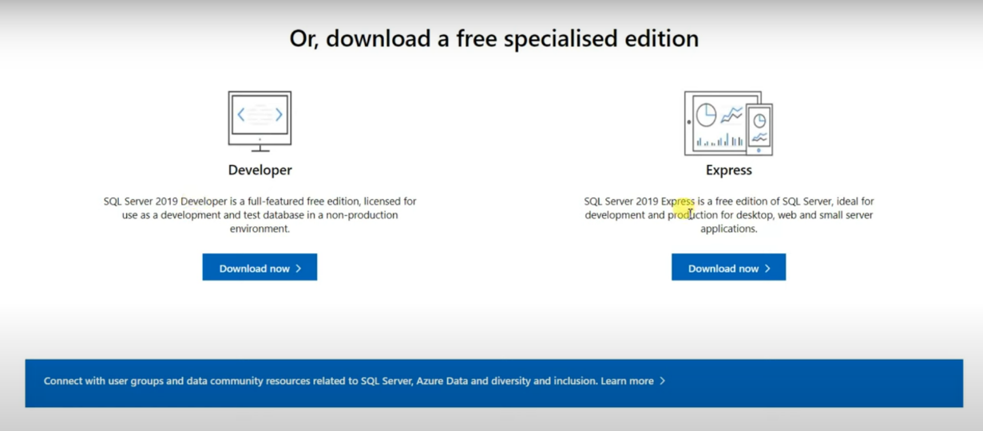

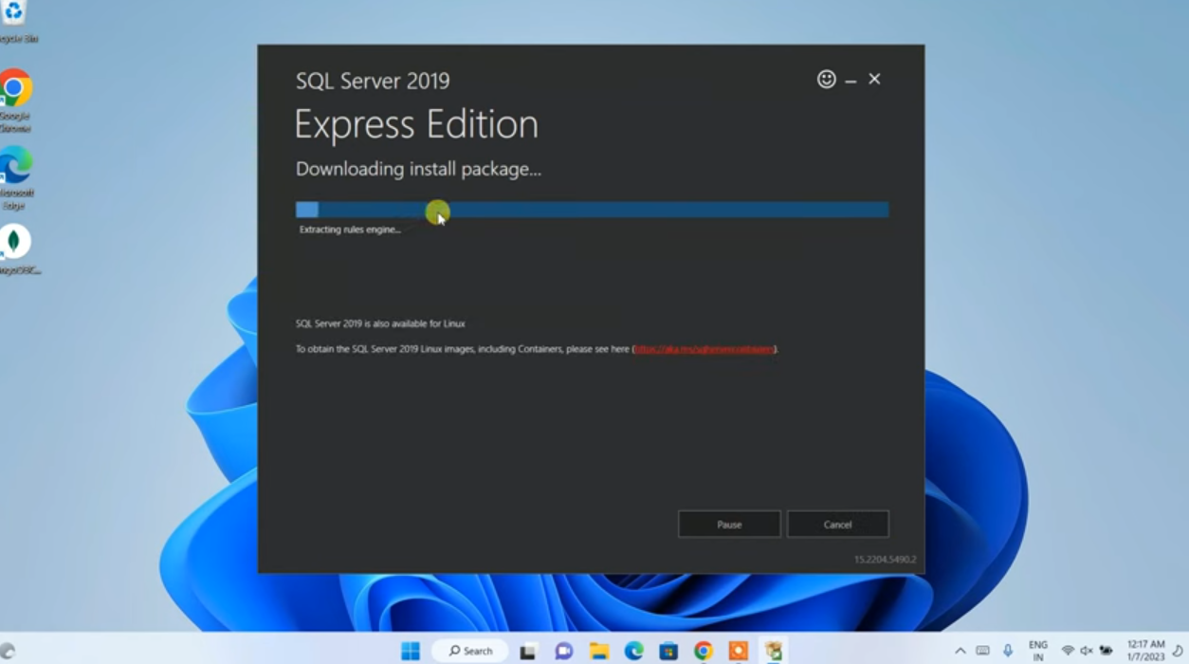

1. **During Instance Configuration**, choose **Named Instance** and enter your full name in uppercase with underscore.

o For example, if your name is Hammad Ahmed, your instance name will be HAMMAD_AHMED.

1. **Install SQL Server Management Studio (SSMS)** and connect to your SQL Server instance.

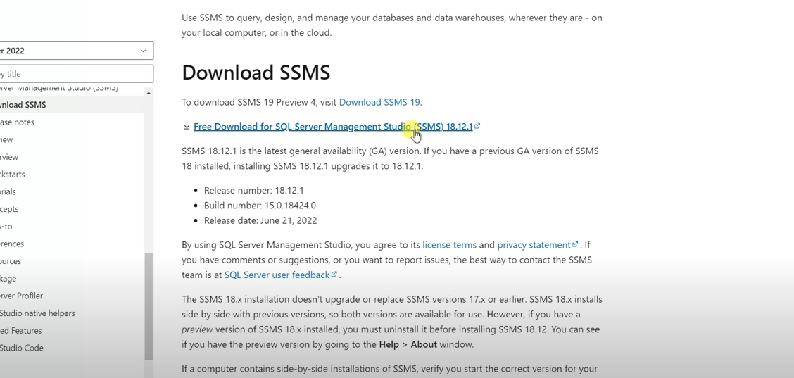

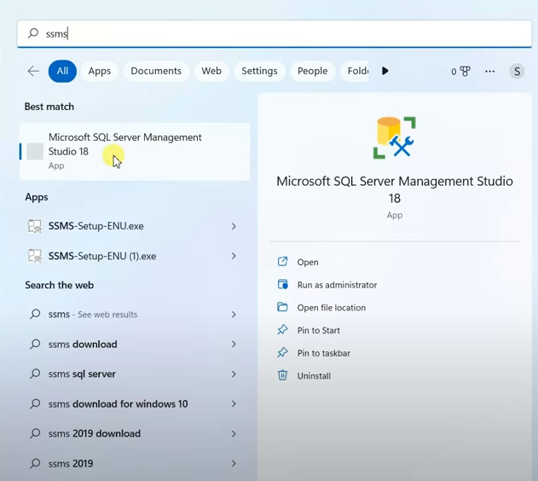

1. Provide a **step-by-step procedure** of installation in your lab report.
2. **Take a screenshot** of a successful connection to your SQL Server instance via SSMS. o Instance name and authentication type must be visible.

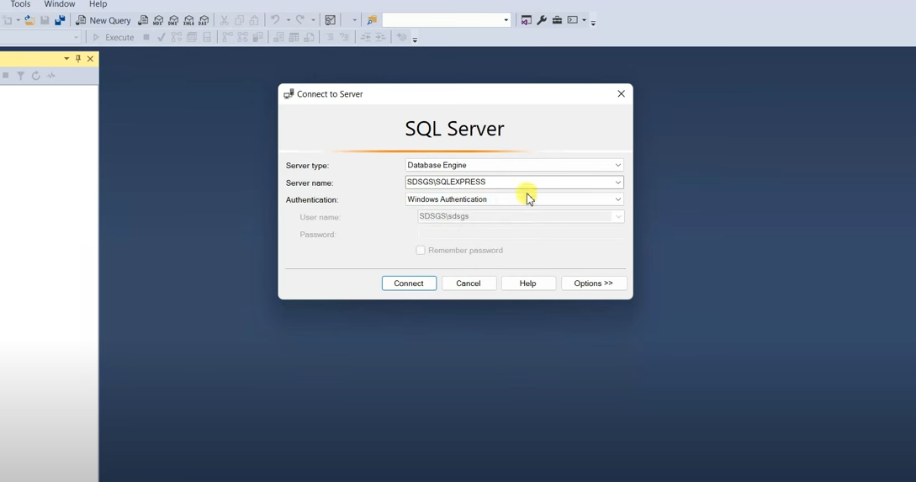

1. Open SQL Server from the Start menu and take a screenshot of the main layout. Ensure that your **server name is visible**.

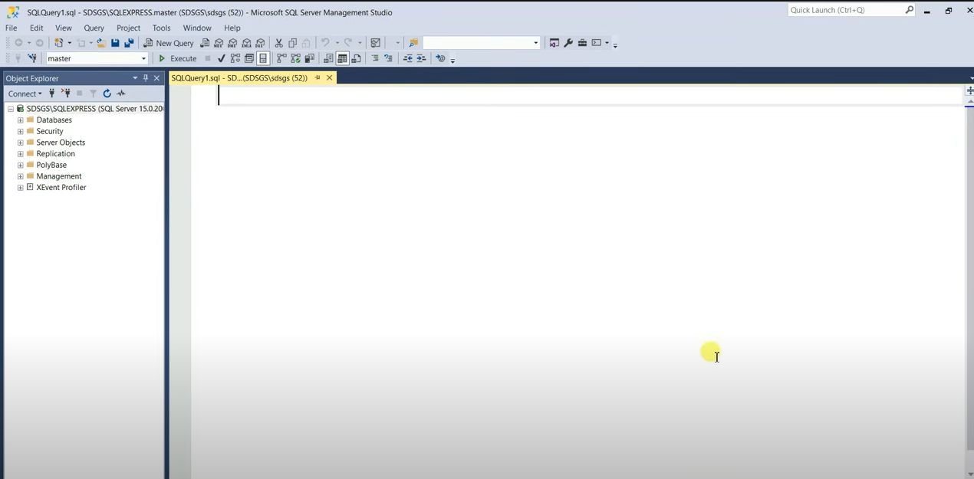

# **Task 02: Conceptual Questions**

**Objective:** Reinforce understanding of SQL Server basics and key services.

**Instructions:**

Read reliable literature or official documentation and **answer the following questions briefly and accurately** in your own words.

## **What is SQL Server? Explain the purpose of the Database Engine and SQL Server Agent.**

SQL Server is a relational database management system (RDBMS) developed by Microsoft that is used to store, retrieve, and manage data for various types of applications. It supports SQL (Structured Query Language) for querying and managing databases.

**Database Engine:** This is the core component responsible for data storage, processing, and security. It manages databases, handles transactions, ensures data integrity, and supports operations such as creating tables, storing data, and running queries.

**SQL Server Agent:** This is a background service that enables automation of tasks such as scheduled backups, job execution, and maintenance activities. It is essential for managing repetitive tasks and improving database administration efficiency.

## **Mention any two post-installation steps that must be done to verify successful installation. Identify two common installation errors and how to fix them**

**Post-Installation Steps:**

1. Connect to the SQL Server instance using SSMS to confirm that the server is active and the named instance is accessible.

2. Verify that essential services (like SQL Server and SQL Server Agent) are running using SQL Server Configuration Manager.

**Common Installation Errors and Fixes:**

**1. Instance Connection Failure:** Often due to incorrect instance name or server not started. Fix this by checking the exact instance name and ensuring SQL Server services are running.

**2. Port or Firewall Issues:** SQL Server may be blocked by Windows Firewall. This can be fixed by allowing SQL Server ports (e.g., TCP 1433) through the firewall settings.

## **How many types of instances are available in SQL Server? Differentiate between them.**

There are two types of instances in SQL Server:

**1. Default Instance:**

Uses the computer's name as the server name.

Only one default instance can exist on a single machine.

Can be accessed using just the computer name or a dot (.).

**2. Named Instance:**

A custom name is assigned during installation (e.g., MY_NAME_SQL).

Multiple named instances can be installed on one machine.

Accessed using ComputerName\InstanceName.

Difference: The default instance is simpler to connect to, while named instances allow for multiple SQL Server environments on a single machine with unique configurations.

## **How many authentication modes are available in SQL Server? Which one is best to use and why?**

SQL Server supports two authentication modes:

**1. Windows Authentication:** Uses the Windows user account credentials for login. It’s more secure because it relies on Active Directory and enforces operating system policies.

**2. SQL Server Authentication (Mixed Mode):** Requires manually created SQL logins and passwords. It's more flexible, especially for non-Windows clients or applications.

**Recommended Mode:** Windows Authentication is preferred due to better security, integration with Windows permissions, and centralized user management.

# **What are SQL Server Analysis Services (SSAS)?**

SQL Server Analysis Services (SSAS) is a component of SQL Server that provides tools for online analytical processing (OLAP) and data mining. It enables users to analyze large volumes of data from multiple perspectives using multidimensional data structures called cubes.

SSAS is widely used in business intelligence environments to support reporting, trend analysis, forecasting, and decision-making by aggregating and summarizing data efficiently.

# **REFLECTION AND LEARNINGS:**

During the SQL Server installation lab, I gained valuable hands-on experience setting up a professional database management system. Creating a named instance with my own name was an interesting way to personalize the installation. I encountered a few challenges during configuration, particularly with the network settings, but troubleshooting these issues helped me understand the underlying architecture better.

The most valuable takeaway was learning about the different authentication modes. While Windows Authentication is more secure with integrated security, SQL Server Authentication offers more flexibility for remote connections. Understanding these tradeoffs will be important for my future database projects.

**......................................................................................................................................**