**The University Of Azad Jammu & Kashmir,**

**Muzaffarabad**

**Department of Software Engineering**

**LAB TASK 10**

**Database Systems**

**Course Code**: **CS-2204**

**Submitted To:**

Engr. Tahir Jahangir

**Submitted By:**

Ahmed Ali

**Roll No:**

2023-SE-41

**Session**: 2023-2027

Contents

🔧 Lab Task – 10: Entity Relationship Diagram (ERD) – Part II 5

🎯 Objective: 5

📘 Task 01: Understanding Relationship Types through Scenario Mapping 5

Instructions: 5

📘 Task 02: ERD with Relationships – Guided Design 6

Instructions: 6

Relationships 7

📘 Task 03: Modeling M:N Relationships with Associative Entities 7

Scenario: 8

Instructions: 8

📘 Task 04: Relationship Attribute Modeling 8

Scenario: 8

Instructions: 8

📘 Task 05: Complete ERD Design from Real-World Scenario 9

Scenario: 9

• Students, Courses, Faculty, Departments 9

Rules: 9

Instructions: 9

**Entities & Attributes** 9

Reflection: 11

# 🔧 Lab Task – 10: Entity Relationship Diagram (ERD) – Part II

# 📘 Task 01: Understanding Relationship Types through Scenario Mapping

🎯 **Objective:** Identify and classify relationships by type and participation.

## Instructions:

Given the hospital system scenario:

* Identify relationships between entities.
* Determine the type of relationship: 1:1, 1:M, M:N.
* Specify participation (total/partial). • Present findings in a table like:

|  |  |  |  |  |
| --- | --- | --- | --- | --- |
| **Entity A** | **Entity B** | **Relationship** | **Type** | **Participation** |
| Doctor | Patient | Treats | 1:M | Partial |
| Patient | Medication | Prescribed | M:N | Total |
| Room | Patient | Assigned | 1:1 | Total |

**Table of Relationships**

| **Entity A** | **Entity B** | **Relationship** | **Type** | **Participation** |
| --- | --- | --- | --- | --- |
| Doctor | Patient | Treats | 1:M | Partial (not every doctor has patients, but every patient must have a doctor) |
| Patient | Medication | Prescribed | M:N | Total (every medication must be linked to at least one patient and vice versa) |
| Room | Patient | Assigned | 1:1 | Total (a patient must be assigned a room, and each room holds one patient at a time) |
| Nurse | Patient | Cares for | M:N | Partial (not all nurses are assigned patients at all times, and patients may be cared for by multiple nurses) |
| Doctor | Department | Belongs to | M:1 | Total (every doctor belongs to one department, but a department has many doctors) |
| Patient | Bill | Generates | 1:1 | Total (every patient generates one bill, and every bill corresponds to one patient) |
| Test | Patient | Conducted on | M:1 | Partial (not all patients undergo tests, but each test belongs to a patient) |
| Doctor | Appointment | Schedules | 1:M | Total (each appointment is linked to one doctor, but a doctor may have many appointments) |
| Patient | Appointment | Books | 1:M | Total (each appointment belongs to one patient, but a patient can have many appointments) |

# 📘 Task 02: ERD with Relationships – Guided Design

🎯 **Objective:** Extend a prior ERD with relationship modeling.

## Instructions:

* Expand the **Department–Faculty** model from Lab 9:
  + One department has many faculty.
  + Faculty supervises multiple projects.
* Include relationships with:
  + Crow’s foot notation or ERDPlus symbols or any other notation. o Clear cardinality and participation labeling.

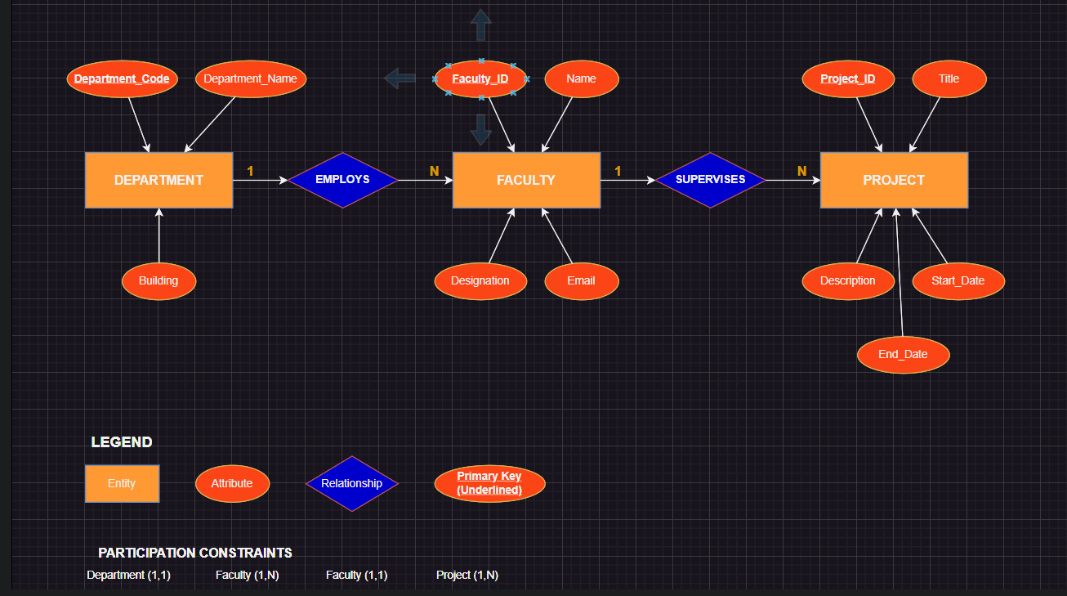

### Relationships

1. **Department–Faculty**
   * One department has many faculty
   * Relationship: **"Has"** (or "Contains")
   * Cardinality: **1 Department → Many Faculty**
   * Participation: Each **Faculty** must belong to exactly one Department (Total Participation on Faculty side).
2. **Faculty–Project**
   * Faculty supervises multiple projects
   * Relationship: **"Supervises"**
   * Cardinality: **1 Faculty → Many Projects**
   * Participation: Each Project must have one supervisor (Faculty), so Total Participation on Project side.

# 📘 Task 03: Modeling M:N Relationships with Associative Entities

🎯 **Objective:** Model a real-world many-to-many relationship using a bridge entity.

## Scenario:

* Students ↔ Courses (M:N)
* Additional data: Grade, Semester

## Instructions:

* Create an **ENROLLMENT** entity to resolve the M:N.
* Add relevant attributes (Grade, Semester). • Use correct ERD notation.

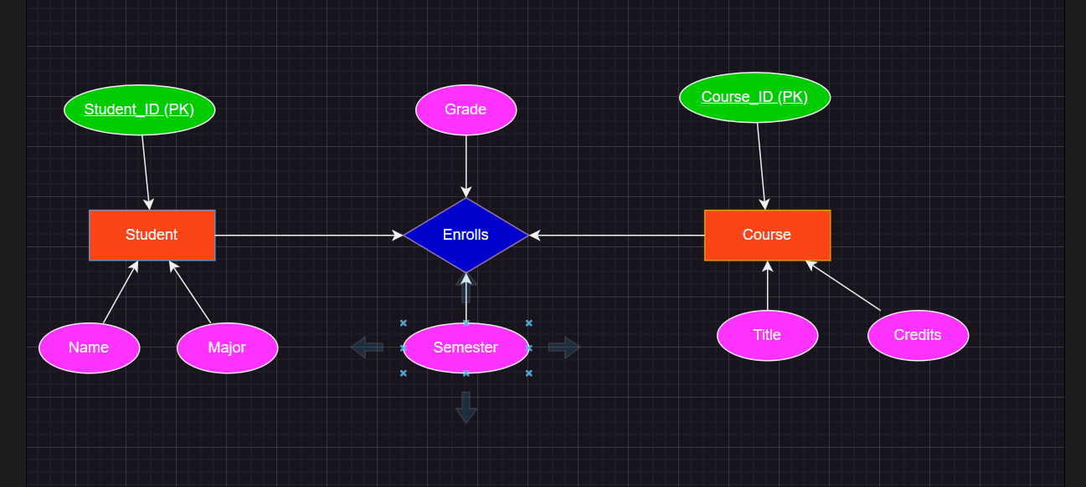

# 📘 Task 04: Relationship Attribute Modeling

🎯 **Objective:** Represent attributes belonging to a relationship.

## Scenario:

* Suppliers supply Products.
* “Supplies” has a relationship attribute: **DeliveryDate**

## Instructions:

• Create a diagram showing: o Supplier, Product, and their M:N relationship. o Include **DeliveryDate** inside the relationship diamond (or associative entity). o Use proper notations.

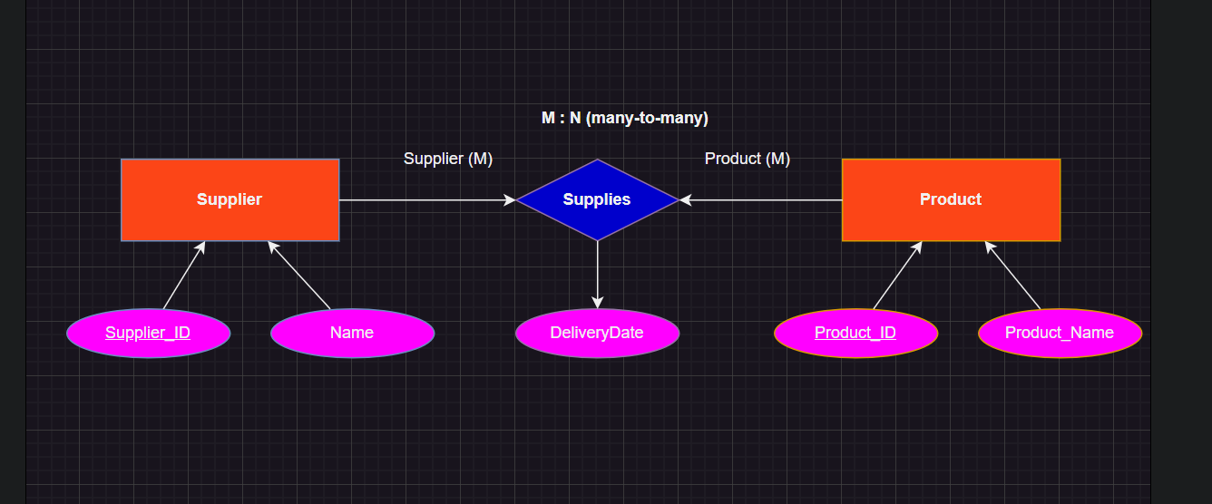

# 📘 Task 05: Complete ERD Design from Real-World Scenario

🎯 **Objective:** Design a complete ERD with multiple relationships.

## Scenario:

## • Students, Courses, Faculty, Departments

## Rules:

* Students enroll in multiple courses (M:N)
* Each course is taught by one faculty (1:M)
* Faculty belongs to one department (M:1) .

### **Entities & Attributes**

1. **Student**
   * Student_ID (PK)
   * Name
   * Major
2. **Course**
   * Course_ID (PK)
   * Title
   * Credits
3. **Faculty**
   * Faculty_ID (PK)
   * Name
   * Designation
4. **Department**
   * Department_Code (PK)
   * Department_Name
5. **Enrollment** (Associative entity for Student ↔ Course)
   * Student_ID (FK)
   * Course_ID (FK)
   * Grade
   * Semester

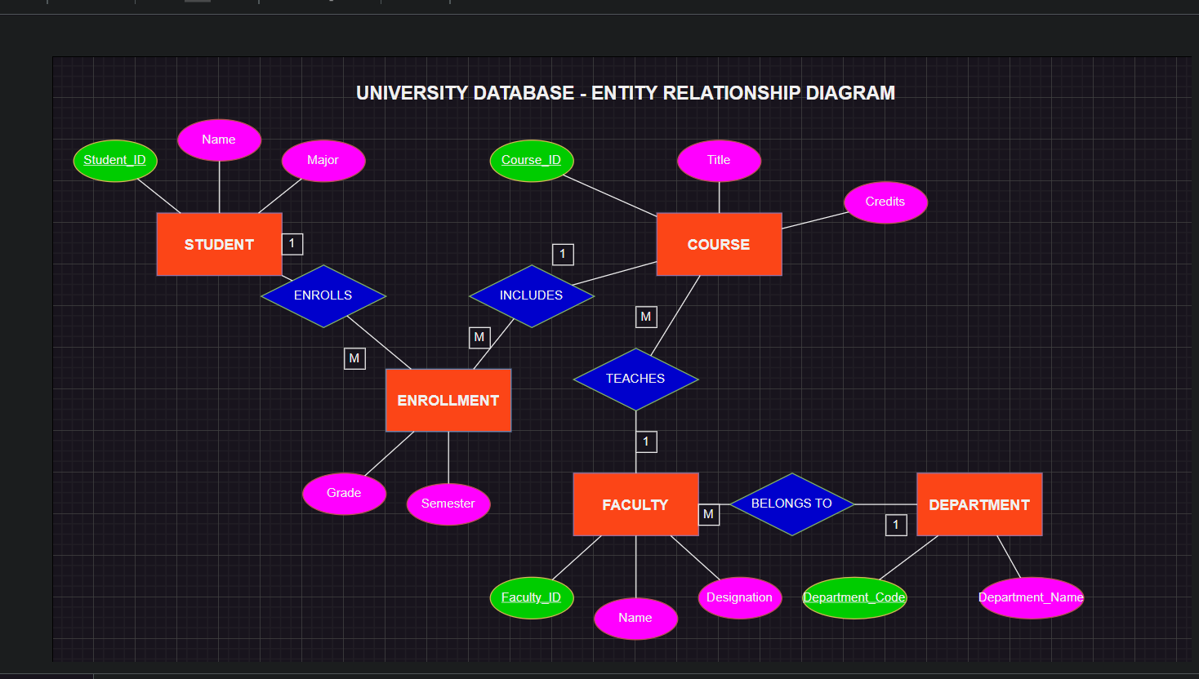

# Reflection:

In Lab Task 10, I learned to model complex relationships between entities in a database using ERDs, including 1:1, 1:M, and M:N relationships with clear cardinality and participation constraints. I practiced representing entities, primary keys, attributes, and associative entities, such as Enrollment for resolving M:N relationships between Students and Courses, while also incorporating relationship attributes like Grade and Semester. Extending the Department–Faculty–Project model taught me to show hierarchical and supervisory relationships, and modeling Suppliers–Products highlighted how attributes can belong to relationships. Overall, this lab strengthened my understanding of database structure, relational integrity, and how real-world scenarios can be translated into formal, well-connected ER diagrams.